Supplemental Figure 1
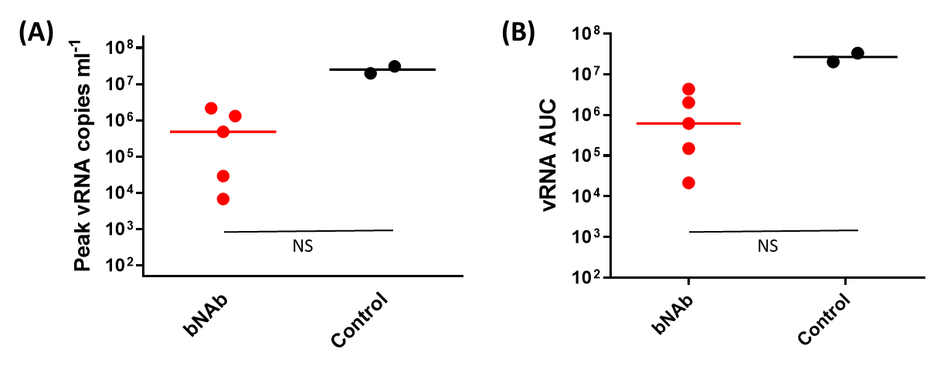
Plasma viremia following intravenous SHIV_{AD8-EO} infection
(A) Peak plasma viremia or (B) vRNA area under the curve through 11 weeks post-infection following intravenous SHIV infection among bNAb-treated macaques or untreated controls. Lines denote medians for each group, NS = not significant (Mann-Whitney, two-tailed).

