Supplemental Digital Content

Figure S1. ISR incidence over time through Month 12ª

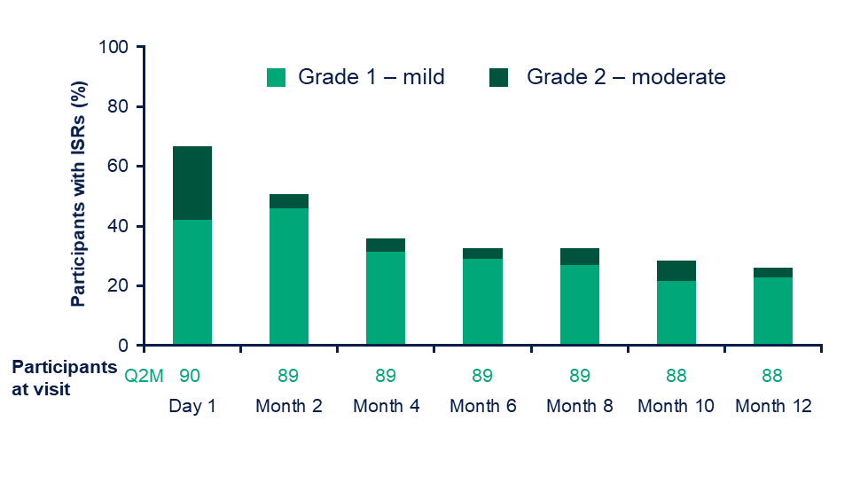
ªIncidence is derived relative to the number of participants who received injections at each respective study visit. There were no Grade 3 or Grade 4 ISRs.
Figure S1 was presented previously at IDWeek; October 21–25, 2020; Virtual; Oral.
ISR, injection site reaction; Q2M, every 2 months.

Figure S2. Mean HIVTSQcª individual item scores at Month 12
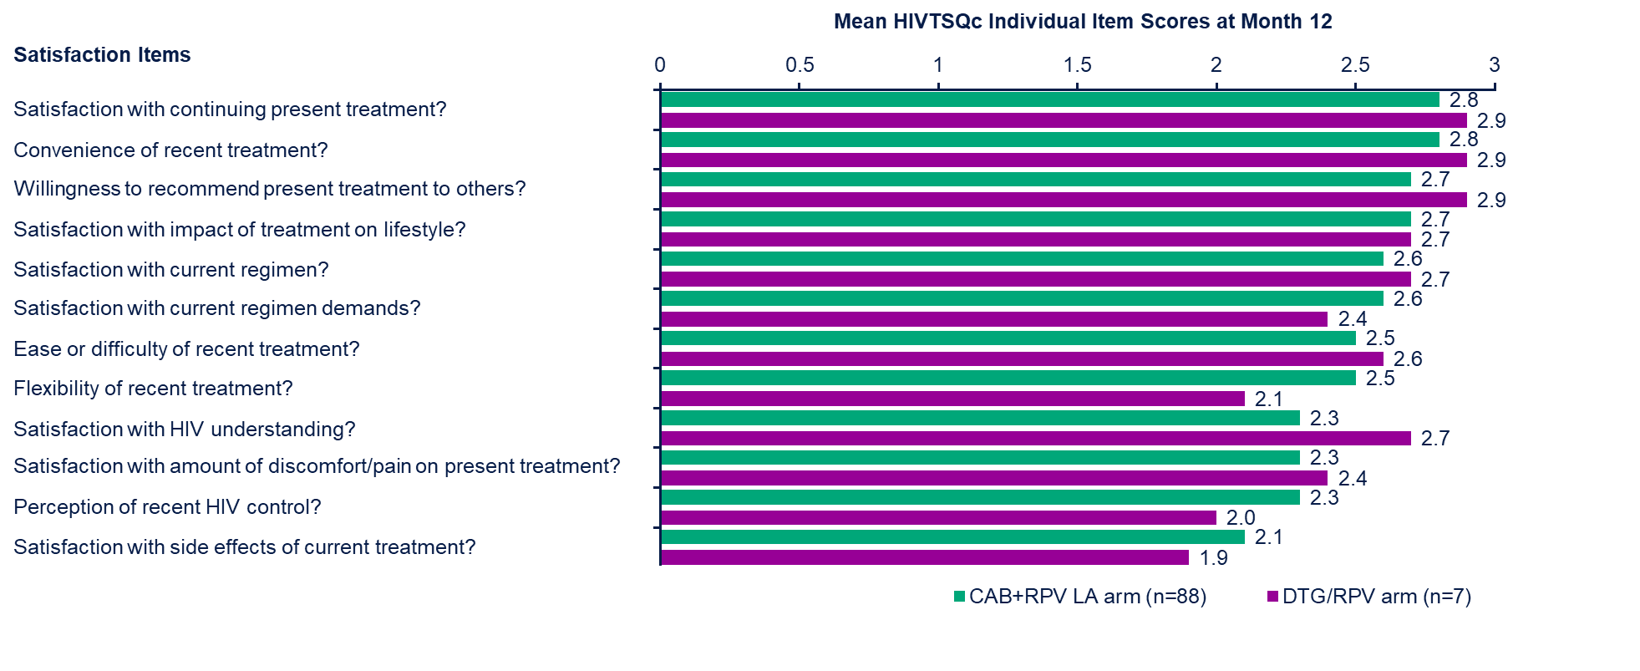
ªIndividual HIVTSQc items are rated on a 6-point Likert scale, ranging from –3 (much less satisfied now) to 3 (much more satisfied now).
CAB, cabotegravir; DTG, dolutegravir; HIVTSQc, HIV Treatment Satisfaction Questionnaire change version; LA, long-acting; RPV, rilpivirine.

Table S1. Efficacy outcomes at Month 12

Outcome, n (%) | IM CAB+RPV LA  Q2M arm  n=90 | Oral DTG/RPV  QD arm  n=7
HIV-1 RNA ≥50 copies/mL | 0 | 0
HIV-1 RNA <50 copies/mL | 88 (97.8) | 7 (100)
Data in window not below threshold | 0 | 0
Discontinued for lack of efficacy | 0 | 0
Discontinued for other reason while not below threshold | 0 | 0
Change in background therapy | 0 | 0
No virologic data | 2 (2.2) | 0
Discontinued due to AE | 1 (1.1)ª | 0
Discontinued due to death | 0 | 0
Discontinued study for other reason | 1 (1.1)^{b} | 0
On study but missing data in window | 0 | 0

ªParticipant discontinued due to a drug-related AE of depression.
^{b}Participant was lost to follow-up.
Table S1 was presented previously at IDWeek; October 21–25, 2020; Virtual; Oral.
AE, adverse event; CAB, cabotegravir; DTG, dolutegravir; IM, intramuscular; LA, long-acting; QD, once daily; Q2M, every 2 months; RPV, rilpivirine.

Table S2. ISR overview

Parameter | IM CAB+RPV LA Q2M arm  n=90
Number or participants receiving injections, n | 90
Number of injections, n | 1534
ISR events,ª n | 463
Pain, n (% of injections) | 414 (27)
Discomfort, n (% of injections) | 20 (1)
Swelling, n (% of injections) | 11 (<1)
Nodule, n (% of injections) | 6 (<1)
Grade ≥3 ISR events, n | 0
Median (IQR) duration of ISRs, days | 3 (2, 4)
Withdrawals due to ISR or injection intolerability, n (%) | 0

ªOnly ISRs with an incidence of >5 events are listed.
Table S2 was presented previously at IDWeek; October 21–25, 2020; Virtual; Oral.
CAB, cabotegravir; IM, intramuscular; ISR, injection site reaction; IQR, interquartile range; LA, long-acting; Q2M, every 2 months; RPV, rilpivirine

