Supplemental Digital Content
Supplemental Digital Content 1. Study designs
- ATLAS and FLAIR
251658240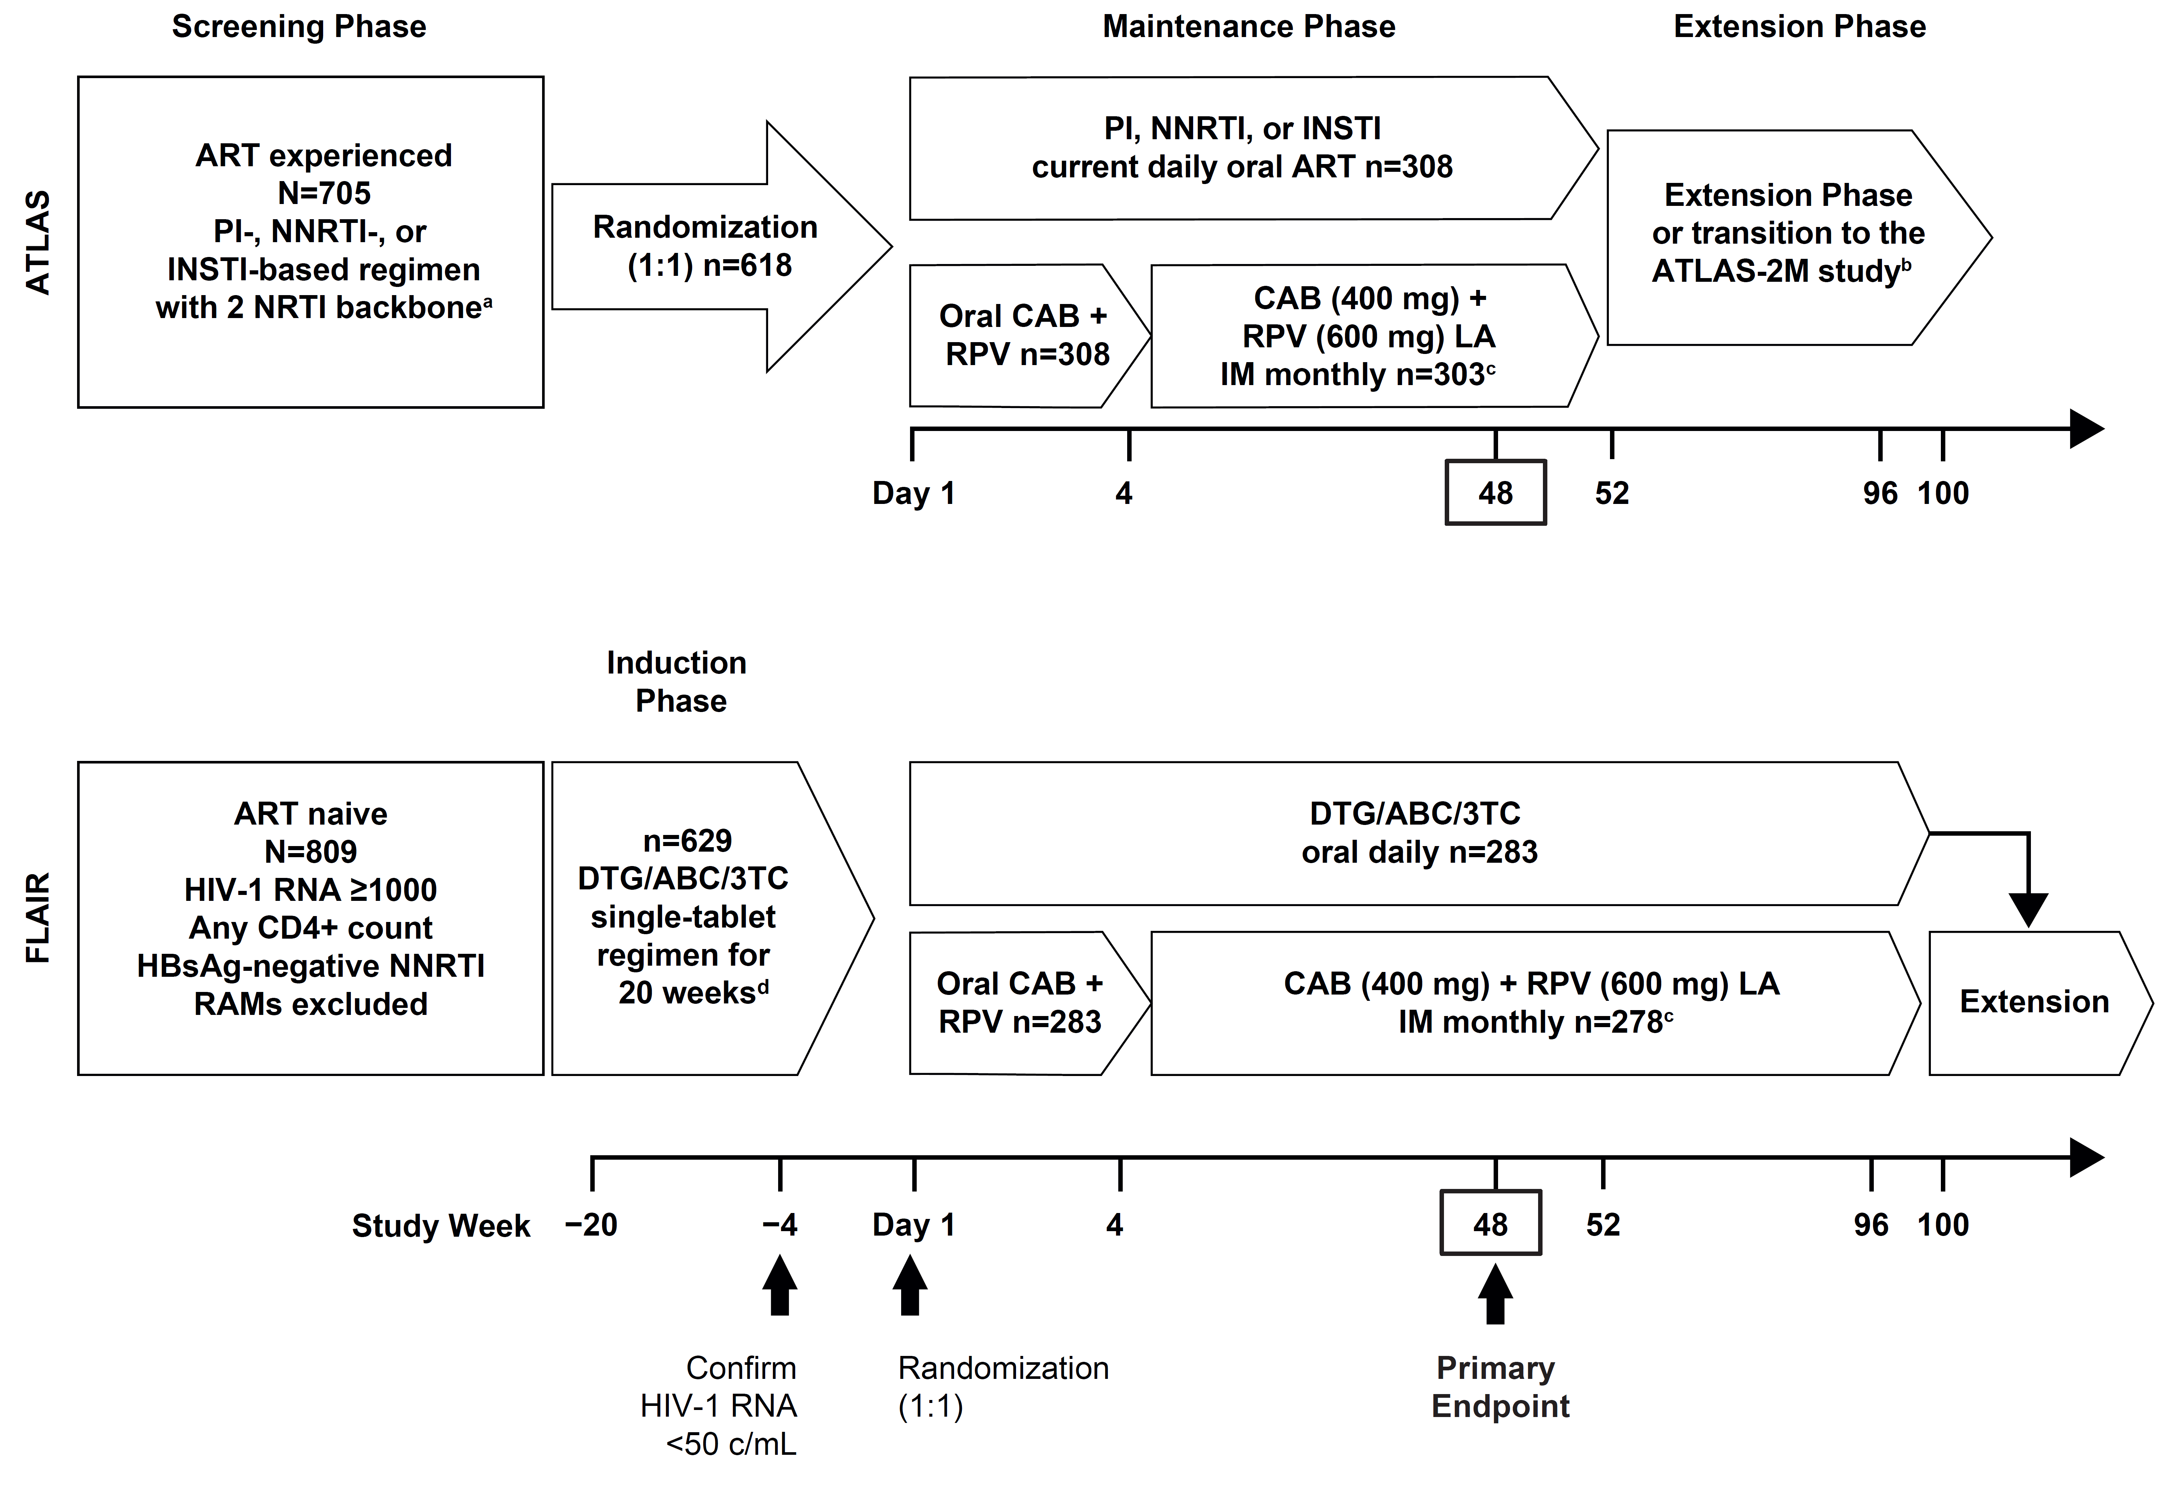

ª Uninterrupted ART for 6 months and VL <50 copies/mL at screening, 2 × VL <50 copies/mL ≤12 months (one within the 6- to 12-month window, and one within 6 months prior to screening); DTG/ABC/3TC excluded from study.
^{b} Optional switch to CAB+RPV LA at Week 52 for those on CAR.
^{c} Participants received an initial loading dose of CAB LA (600 mg) and RPV LA (900 mg) at Week 4. From Week 8 onwards, participants received CAB LA (400 mg) + RPV LA (600 mg) injections every 4 weeks.
^{d} For participants who were HLA-B*5701 positive, DTG was taken with a non-ABC NRTI backbone, chosen by the investigator.
Figure adapted from Murray M, Antela A, Mills A, et al. Patient-Reported Outcomes in
ATLAS and FLAIR Participants on Long-Acting Regimens of Cabotegravir and Rilpivirine Over 48
Weeks. AIDS Behav. 2020. https:// doi.org/10.1007/s10461-020-02929-8, under a Creative Commons Attribution 4.0 International License, http://creativecommons.org/licenses/by/4.0/.
3TC, lamivudine; ABC, abacavir; ART, antiretroviral therapy; CAB, cabotegravir; CAR, current antiretroviral therapy; DTG, dolutegravir; IM, intramuscular; INSTI, integrase strand transfer inhibitor; HBsAg, hepatitis B surface antigen; HLA, human leukocyte antigen; LA, long-acting; NNRTI, non-nucleoside reverse transcriptase inhibitor; NRTI, nucleoside reverse transcriptase inhibitor; PI, protease inhibitor; RAM, resistance-associated mutation; RPV, rilpivirine; VL, viral load.
- ATLAS-2M
251658240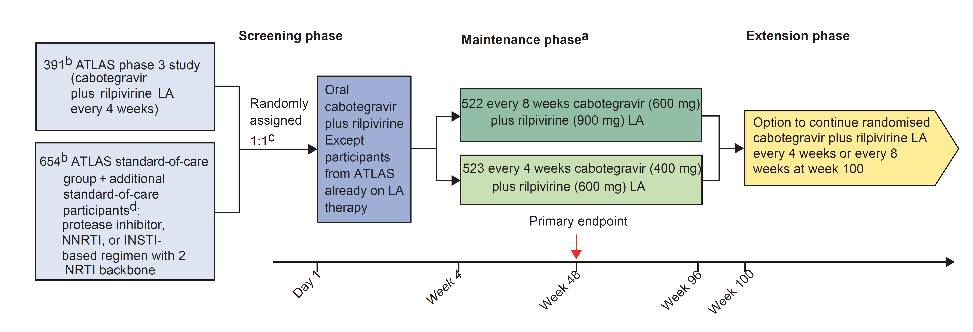
ª ATLAS participants on every 4 weeks group—transition to ATLAS-2M day 1 onwards:
cabotegravir LA (400 mg) plus rilpivirine LA (600 mg) intramuscularly every 4 weeks or cabotegravir LA (600 mg) plus rilpivirine LA (900 mg) intramuscularly every 8 weeks. New ATLAS-2M participants naive to LA at day 1—all participants initiate 4-week oral lead-in followed by LA injections: every 4 weeks group—loading dose of cabotegravir LA (600 mg) plus rilpivirine LA (900 mg) intramuscularly at week 4, then cabotegravir LA (400 mg) plus rilpivirine LA (600 mg)
intramuscularly every 4 weeks; every 8 weeks group—initial dose of cabotegravir LA (600 mg) plus rilpivirine LA (900 mg) at week 4 and week 8, then continue same intramuscular dose every 8 weeks. Participants who withdraw from the intramuscular regimen must go into 52-week long-term follow-up if randomized regimen is not yet locally approved and commercially available. Doses were scheduled on the basis of a fixed treatment date, and that target date of the month
or every other month was carried forward. For participants transitioning from standard of care in either group and those transitioning from every 4 weeks to every 8 weeks, there was a −7-day dosing window for the second and third intramuscular injections and a ±7-day window thereafter. For those continuing every 4 week dosing from ATLAS, there was a ±7-day window for injections.
^{b} Intention-to-treat exposed population.
^{c} 1149 participants were screened, and 1049 participants were randomly assigned. However, four participants did not receive study drug and were therefore not part of the intention-to-treat exposed population.
^{d} Standard-of-care participants not transitioning from the ATLAS study were to be on uninterrupted current regimen (either the initial or second combined ART regimen) for at least 6 months before screening. Documented evidence was required of at least two plasma HIV-1 RNA measurements <50 copies per mL in the 12 months before screening: one within the 6–12-month window, and one within 6 months before screening. Participants were excluded if they had a history of virological failure; evidence of viral resistance based on the presence of any resistance-associated major INSTI or NNRTI mutation (except K103N) from previous genotype assay results; or current or previous history of etravirine use.
Reprinted from The Lancet, Volume 396, Overton et al., Long-acting cabotegravir and rilpivirine dosed every 2 months in adults with HIV-1 infection (ATLAS-2M), 48-week results: a randomised, multicentre, open-label, phase 3b, non-inferiority study, Pages 1994–2005. Copyright (2020), with permission from Elsevier.

ART, antiretroviral therapy; INSTI, integrase strand transfer inhibitor; LA, long-acting; NNRTI,
non-nucleoside reverse transcriptase inhibitor; NRTI, nucleoside reverse transcriptase inhibitor; PI, protease inhibitor.

Supplemental Digital Content 2. Methodology of genotypic and phenotypic procedures
For viral genotype and phenotype analysis, samples were collected at screening for FLAIR, and at baseline and suspected virologic failure (SVF; first of two consecutive visits with HIV-1 RNA ≥200 copies/mL) for all studies. For FLAIR, screening plasma samples were used for reverse transcriptase genotype analysis with either Monogram Biosciences or Q² Solutions assays. Integrase was sequenced retrospectively at the induction baseline (Week –20) using stored plasma samples. Baseline genotyping of participant samples from the ATLAS and ATLAS-2M studies was carried out retrospectively in peripheral blood mononuclear cell (PBMC) samples. In participants with confirmed virologic failure, baseline viral genotype and phenotype were determined using stored plasma samples at induction baseline for FLAIR, PBMCs at baseline for ATLAS and ATLAS-2M, and plasma samples at SVF for all studies. Viral genotype and phenotype were analyzed from plasma samples using Monogram Biosciences PhenoSense® GT, PhenoSense® Integrase, and/or GenoSeq® Integrase assays (Sanger-based sequencing), and from PBMCs with the Monogram Biosciences GenoSure Archive® assay (next-generation sequencing).

Supplemental Digital Content 3. Mutations potentially associated with resistance to INSTI or NNRTI

Class | Mutations
INSTI | Prespecified INSTI mutations:ª  H51Y, T66A/I/K, L68V/I, L74I/M, E92Q/V/G, Q95K, T97A, G118R, F121Y, E138A/K/D/T, G140A/C/R/S, Y143C/H/R/K/S/G/A, P145S, S147G, Q148H/K/R, V151I/L/A, S153F/Y, N155H/S/T, E157Q, G163R/K, G193E, S230R, R263K
NNRTI | IAS–USA mutations associated with resistance to NNRTI:^{b}  V90I, A98G, L100I, K101E/H/P, K103N/S, V106A/I/M/T, V108I, E138A/G/K/Q/R, V179D/F/L/T, Y181C/I/V, Y188C/H/L, G190A/E/S, H221Y, P225H, F227C/L/R, M230I/L, L234I
IAS–USA major mutations associated with resistance to RPV:^{c}
L100I, K101E/P, E138A/G/K/Q/R, V179L, Y181C/I/V, Y188L, H221Y, F227C, M230I/L

ª Mutations (H51Y, L74I, L68V/I, E92V, Q95K, E138D, Y143K/S/G/A, P145S, Q146P, V151I/L/A, N155S/T, E157Q, G163R/K, G193E, S230R) were identified during in vitro passage of DTG or seen in a previous DTG study in INSTI-experienced participants (NCT01328041); all other mutations in this prespecified list were identified per the IAS–USA mutations associated with resistance to bictegravir, CAB, DTG, elvitegravir, or raltegravir.^{[18]}
^{b} IAS–USA mutations associated with resistance to doravirine, efavirenz, etravirine, nevirapine, or RPV.^{[18]}
^{c} IAS–USA major mutations associated with resistance to RPV.^{[18]} These are identical to the ones mentioned in the Edurant® prescribing information, except for L100I, which is only mentioned in combination with K103N.
CAB, cabotegravir; DTG, dolutegravir; INSTI, integrase strand transfer inhibitor; NNRTI, non-nucleoside reverse transcriptase inhibitor; RPV, rilpivirine.
Supplemental Digital Content 4. Analyses conducted

251658240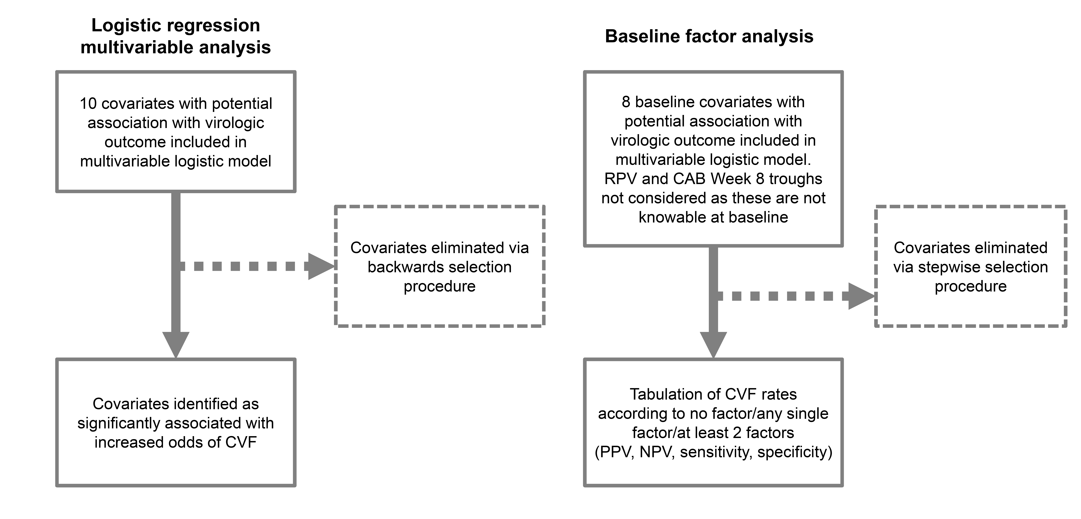
CAB, cabotegravir; CVF, confirmed virologic failure; NPV, negative predictive value; PPV, positive predictive value; RPV, rilpivirine.

Supplemental Digital Content 5. Disposition of participants included in this analysis
- Overall population

251658240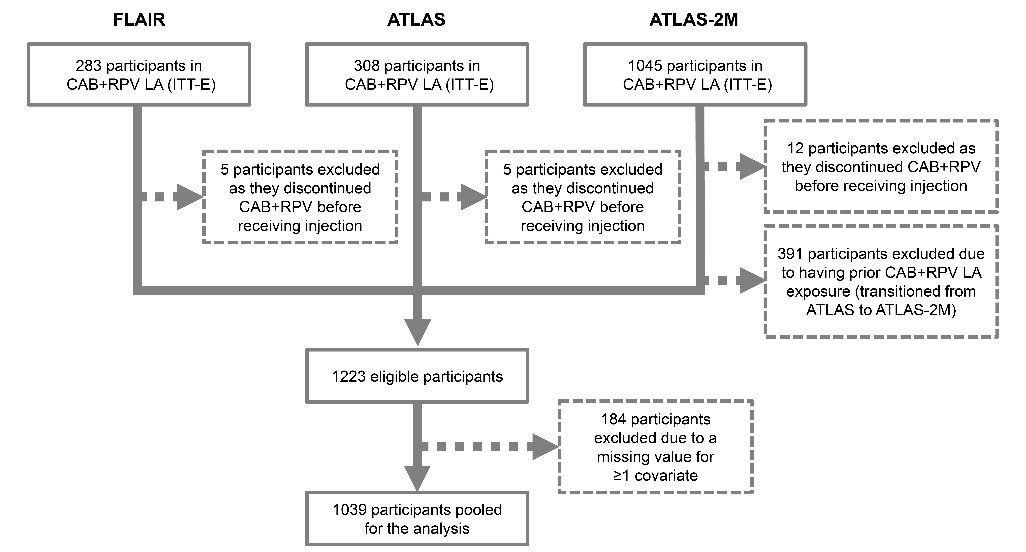

- CVF population
251658240

CAB, cabotegravir; CVF, confirmed virologic failure; ITT-E, intention-to-treat exposed population; LA, long-acting; RPV, rilpivirine.

Supplemental Digital Content 6. Multivariable Cox regression analysis of time to CVF through Week 48 – maximum likelihood
n | Parameter | Full model  HR (95% CI), p-valueª | Backwards elimination  model  HR (95% CI), p-valueª | Per Firth’s method for low event rate  HR (95% CI), p-valueª
1026 | RPV RAM(s) at baseline | 31.33 (7.69–>99), <0.001 | 43.86 (11.72–>99), <0.001 | 42.91 (12.13–>99), <0.001
 | L74I (non-mixture) INSTI polymorphism at baseline | 2.24 (0.54–9.68), 0.267 | 5.14 (1.65–16.49), 0.005 | 4.95 (1.65–15.24), 0.005
 | BMI (kg/m²) at baseline | 1.11 (1.00–1.22), 0.045 | 1.12 (1.02–1.22), 0.019 | 1.12 (1.02–1.21), 0.017
 | Log₂ of time-updated observed CAB trough concentration | 1.96 (0.95–3.23), 0.064 | 1.89 (0.95–3.03), 0.066 | 2.00 (1.00–3.12), 0.049
 | Log₂ of time-updated observed RPV trough concentration | 2.04 (0.91–4.17), 0.082 | 2.33 (1.08–4.35), 0.033 | 2.38 (1.06–4.35), 0.036
 | Prespecified INSTI mutation (excluding L74I non-mixture) at baseline | 0.14 (0.01–0.86), 0.031 | 0.15 (0.01–0.85), 0.029 | 0.21 (0.02–0.99), 0.048
 | Baseline HIV-1 subtype (A, A1, AG combined vs. B) | 3.51 (0.67–18.73), 0.135
 | Baseline HIV-1 subtype (C vs. B) | 1.62 (0.07–15.36), 0.713
 | Baseline HIV-1 subtype (other vs. B) | 1.57 (0.08–11.57), 0.710
 | NNRTI RAM(s) (excluding RPV RAMs) at baseline | 1.99 (0.54–6.87), 0.290
 | Female (sex at birth) | 1.64 (0.45–6.27), 0.456
 | Q8W regimen | 0.76 (0.19–2.70), 0.675

ª 95% penalized profile confidence intervals and penalized likelihood ratio p-values are provided. Backwards elimination was performed using maximum likelihood, as the full model would not converge using Firth’s method and used a significance threshold of alpha=0.2. CAB and RPV pharmacokinetic parameters were log₂-transformed; therefore, the corresponding hazard ratios are per halving of each variable.
BMI, body mass index; CAB, cabotegravir; CI, confidence interval; CVF, confirmed virologic failure; HR, hazard ratio; INSTI, integrase strand transfer inhibitor; NNRTI, non-nucleoside reverse transcriptase inhibitor; Q8W, every 8 weeks; RAM, resistance-associated mutation; RPV, rilpivirine.

Supplemental Digital Content 7. Week 48 CVF outcome by presence of key baseline factors (RPV RAMs, HIV-1 subtype A6/A1, and BMI ≥30 kg/m²)

251658240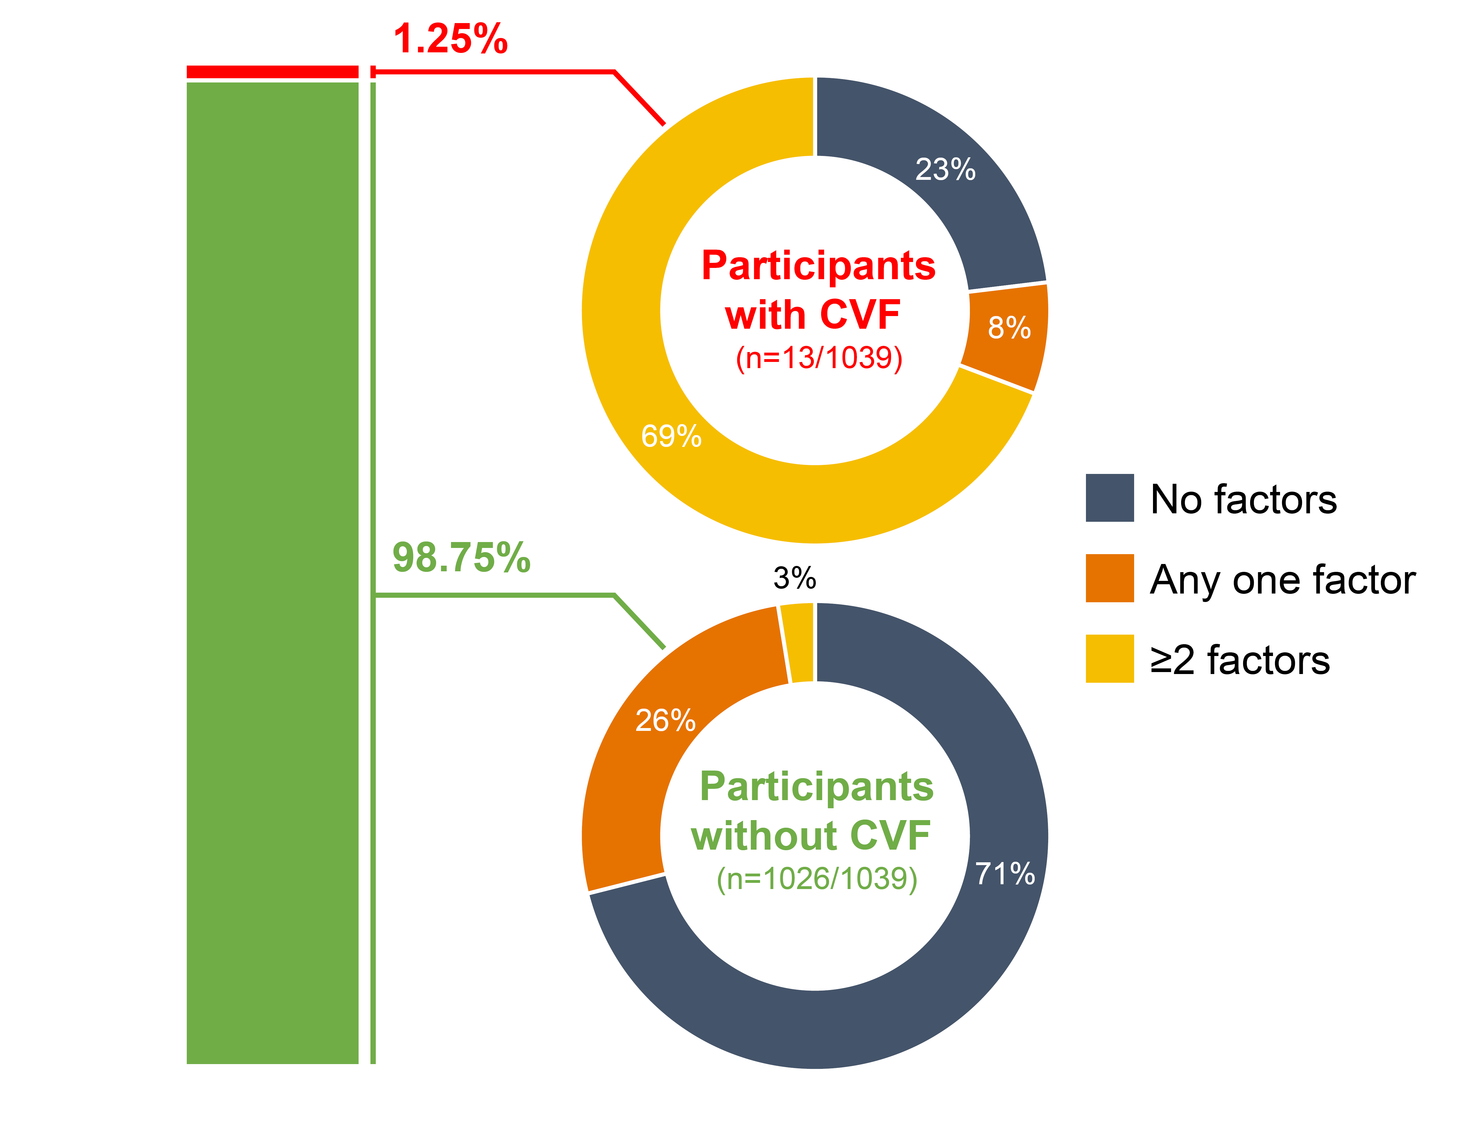
BMI, body mass index; CVF, confirmed virologic failure; RAM, resistance-associated mutation; RPV, rilpivirine.

Supplemental Digital Content 8. Subtype distribution by the presence of L74I

251658240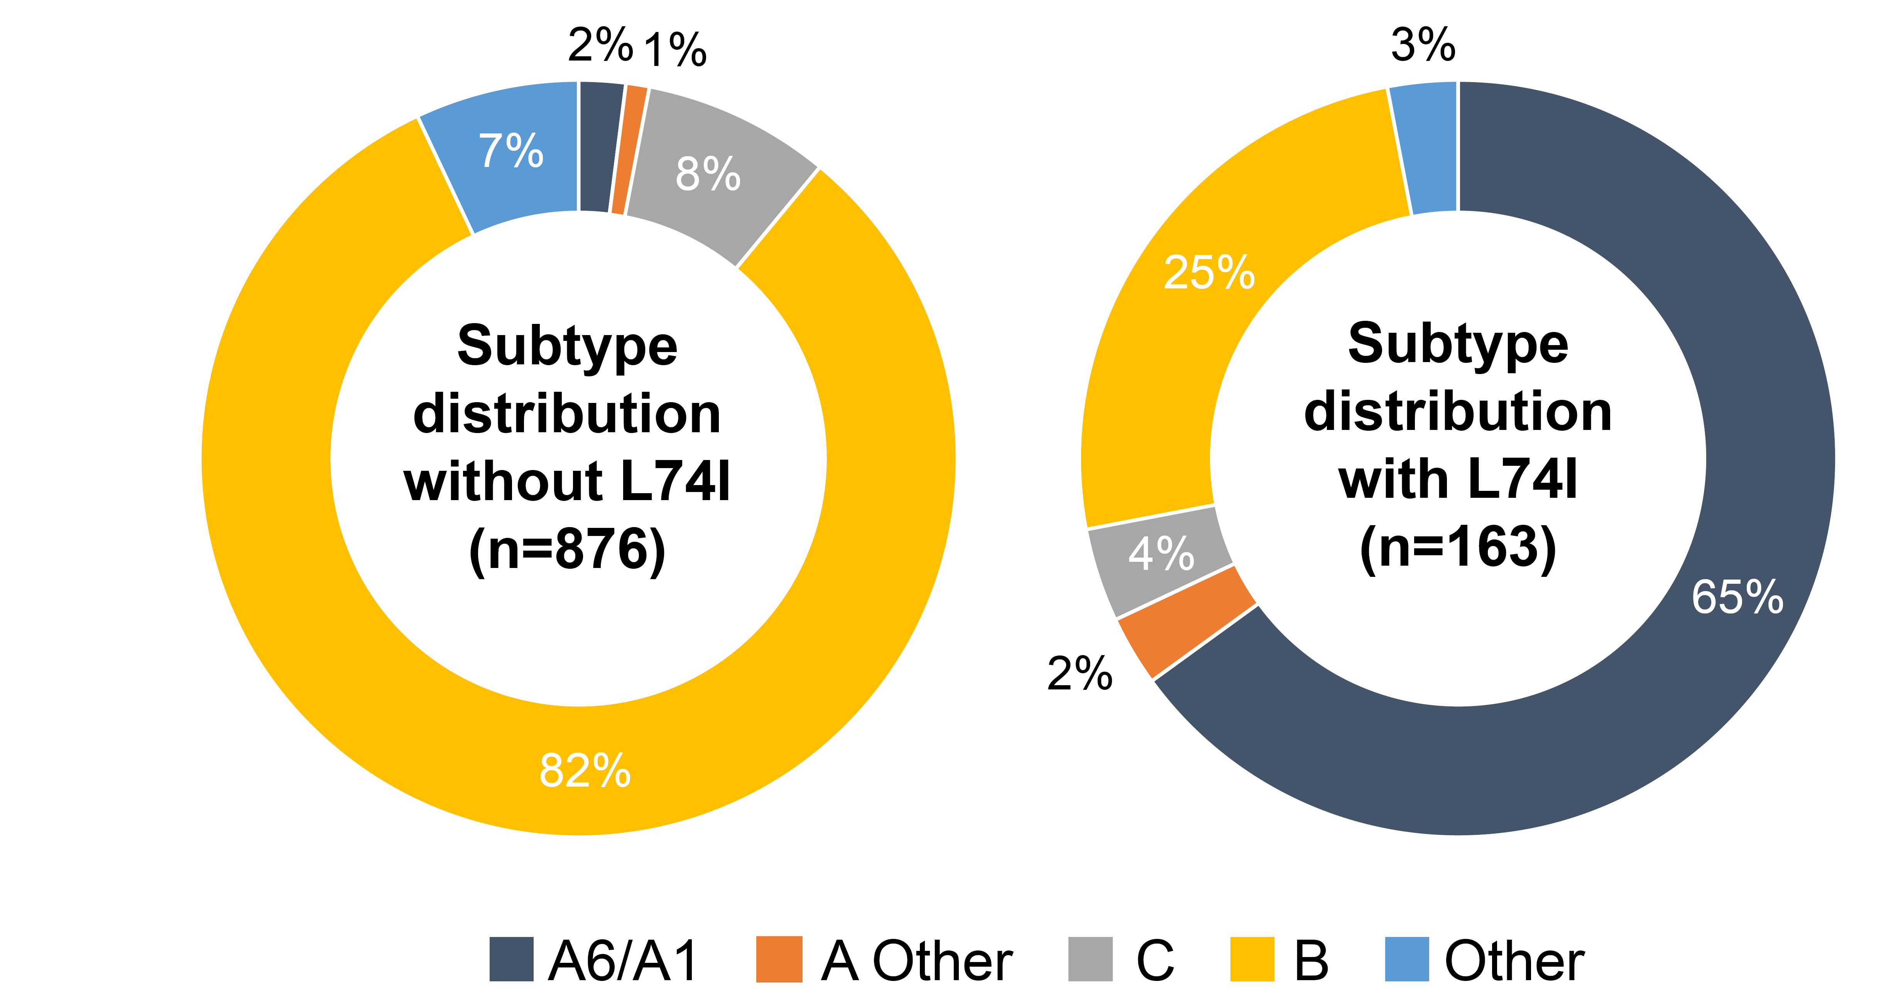
Supplemental Digital Content 9. Association between HIV-1 subtype and L74I integrase polymorphism in the context of CVF

 | With L74I |  | Without L74I
Subtype | Participants with CVF  n (%) | 95% CIª | Participants with CVF  n (%) | 95% CIª
A6/A1 | 7/106 (6.6) | (2.7–13.1) | 0/14 | (0.0–23.2)
A other | 0/4 | (0.0–60.2) | 0/13 | (0.0–24.7)
C | 1/7 (14.3) | (0.4–57.9) | 0/70 | (0.0–5.1)
B | 0/41 | (0.0–8.6) | 4/714 (0.6) | (0.2–1.4)
Other | 0/5 | (0.0–52.2) | 1/65 (1.5) | (0.0–8.3)
Total | 8/163 (4.9) | (2.1–9.4) | 5/876 (0.6) | (0.2–1.3)

ª Confidence intervals are based on the exact method.
CI, confidence interval; CVF, confirmed virologic failure.
Supplemental Digital Content 10. Association between HIV-1 subtype A6/A1 and L74I integrase polymorphism in the context of CVF

 | L74I  (excluding mixtures with L74M) | Subtype A6/A1 | CVF  n (%) | 95% CI
1 | Yes | No | 1/57 (1.8) | (0.04–9.4)
2 | No | Yes | 0/14 | (0.0–23.2)
3 | No | No | 5/862 (0.6) | (0.2–1.4)
4 | Yes | Yes | 7/106 (6.6) | (2.7–13.1)

CI, confidence interval; CVF, confirmed virologic failure.

