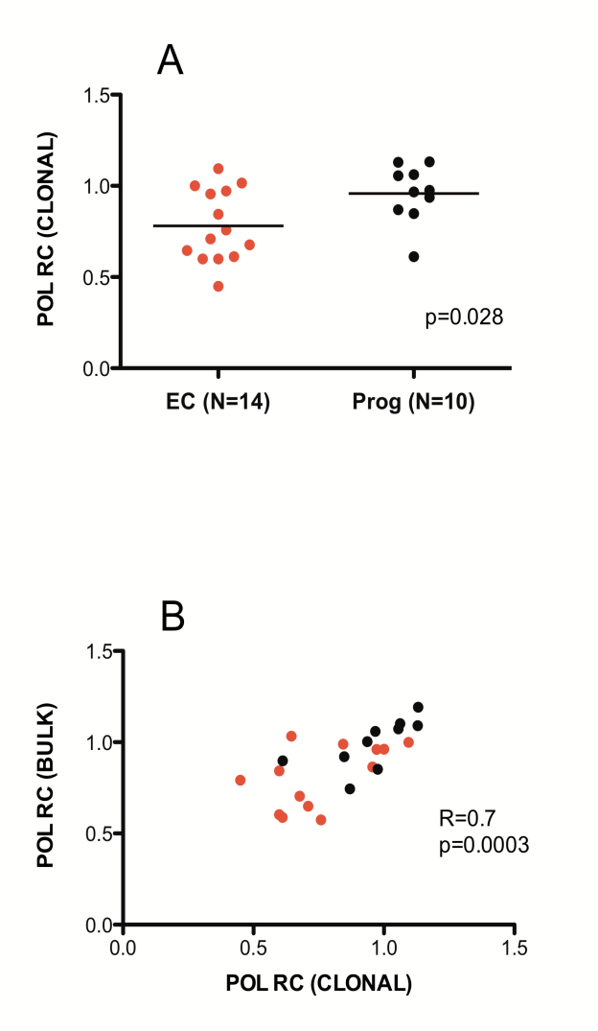

Supplemental Digital Content 2 - Figure 2: Replication capacities of cloned RT-Integrase recombinant viruses derived from elite controller and chronic progressor sequences. Panel A: RT-Integrase recombinant viruses were generated from cloned sequences for a random panel of N=14 controllers and N=10 progressors. Consistent with results from bulk (quasispecies-containing) recombinant stocks, controller-derived viruses encoding clonal RT-Integrase sequences exhibited significantly lower RC than those derived from progressors (p=0.028). Panel B: Robust agreement is observed between the original RC of bulk (quasispecies-containing) and clonal recombinant virus stocks from the same individual (R=0.70; p=0.0003)

