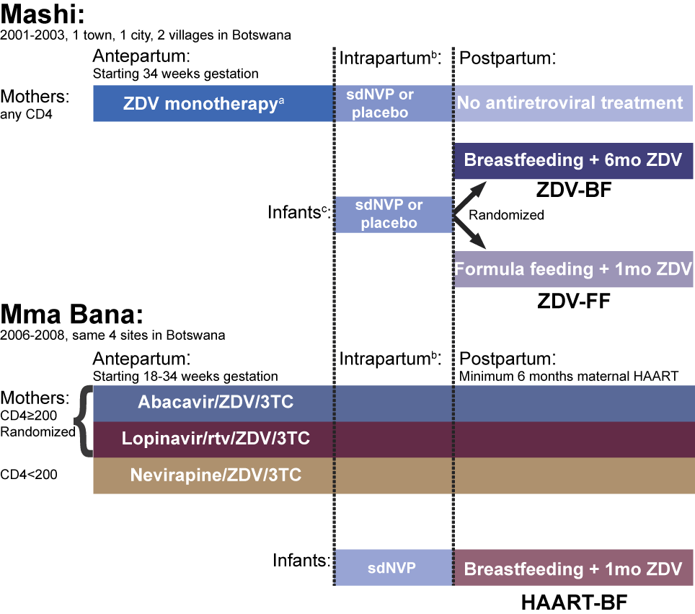

Figure A, Supplemental Digital Content 1. Schematic of maternal and infant exposures in the Mashi and Mma Bana studies forming the study groups. ZDV zidovudine, sdNVP single-dose nevirapine, 3TC lamivudine, rtv ritonavir, NVP nevirapine, BF breastfeeding. FF formula feeding, HAART, highly-active antiretroviral therapy.
ª HAART became available through a national program in October 2002 (19 months into study), subsequently women in the Mashi study with CD4 count less than 200 cells/mm³ (or AIDS-defining illness) were offered HAART. Infants born to these women are excluded from the analysis.
^{b} Mothers received supplemental zidovudine during labor and delivery.

^{c} Infants were randomized to either sdNVP or placebo until August 2002 (17 months into study), after which protocol was modified to provide sdNVP to all infants.

