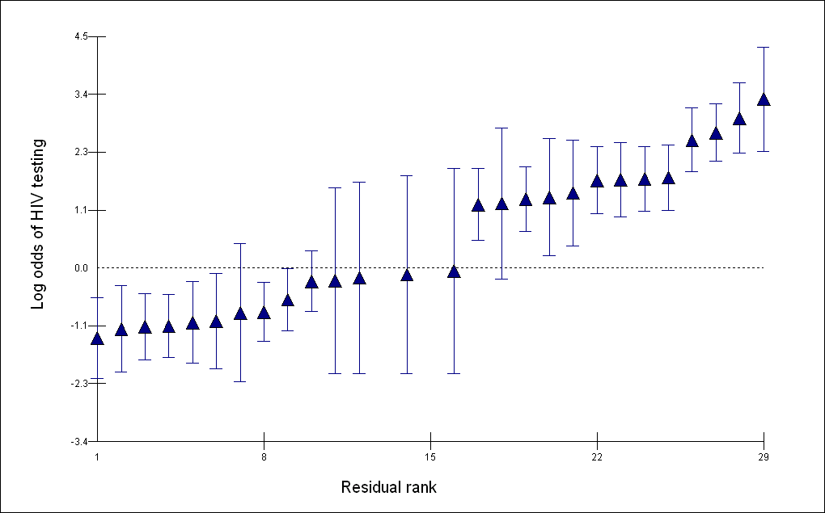

Supplemental Digital Content 1 – Figure 1. Residuals from log odds of HIV testing.

