Supplemental Digital Content 2- Figure 2: Health Planning Areas of Rio de Janeiro, Brazil, 2004
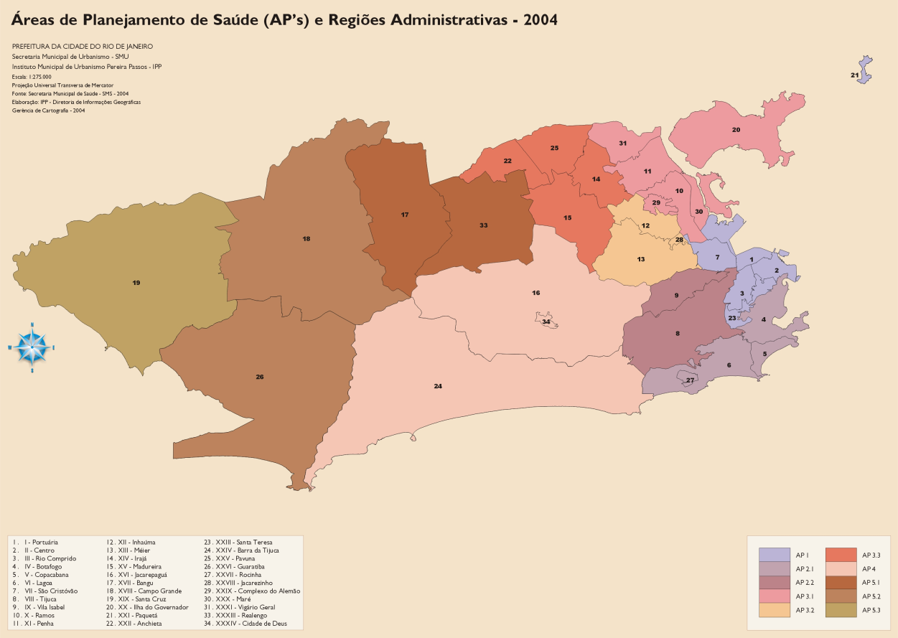
Source: Pereira Passos Institute. Available at: http://www.armazemdedados.rio.rj.gov.br

