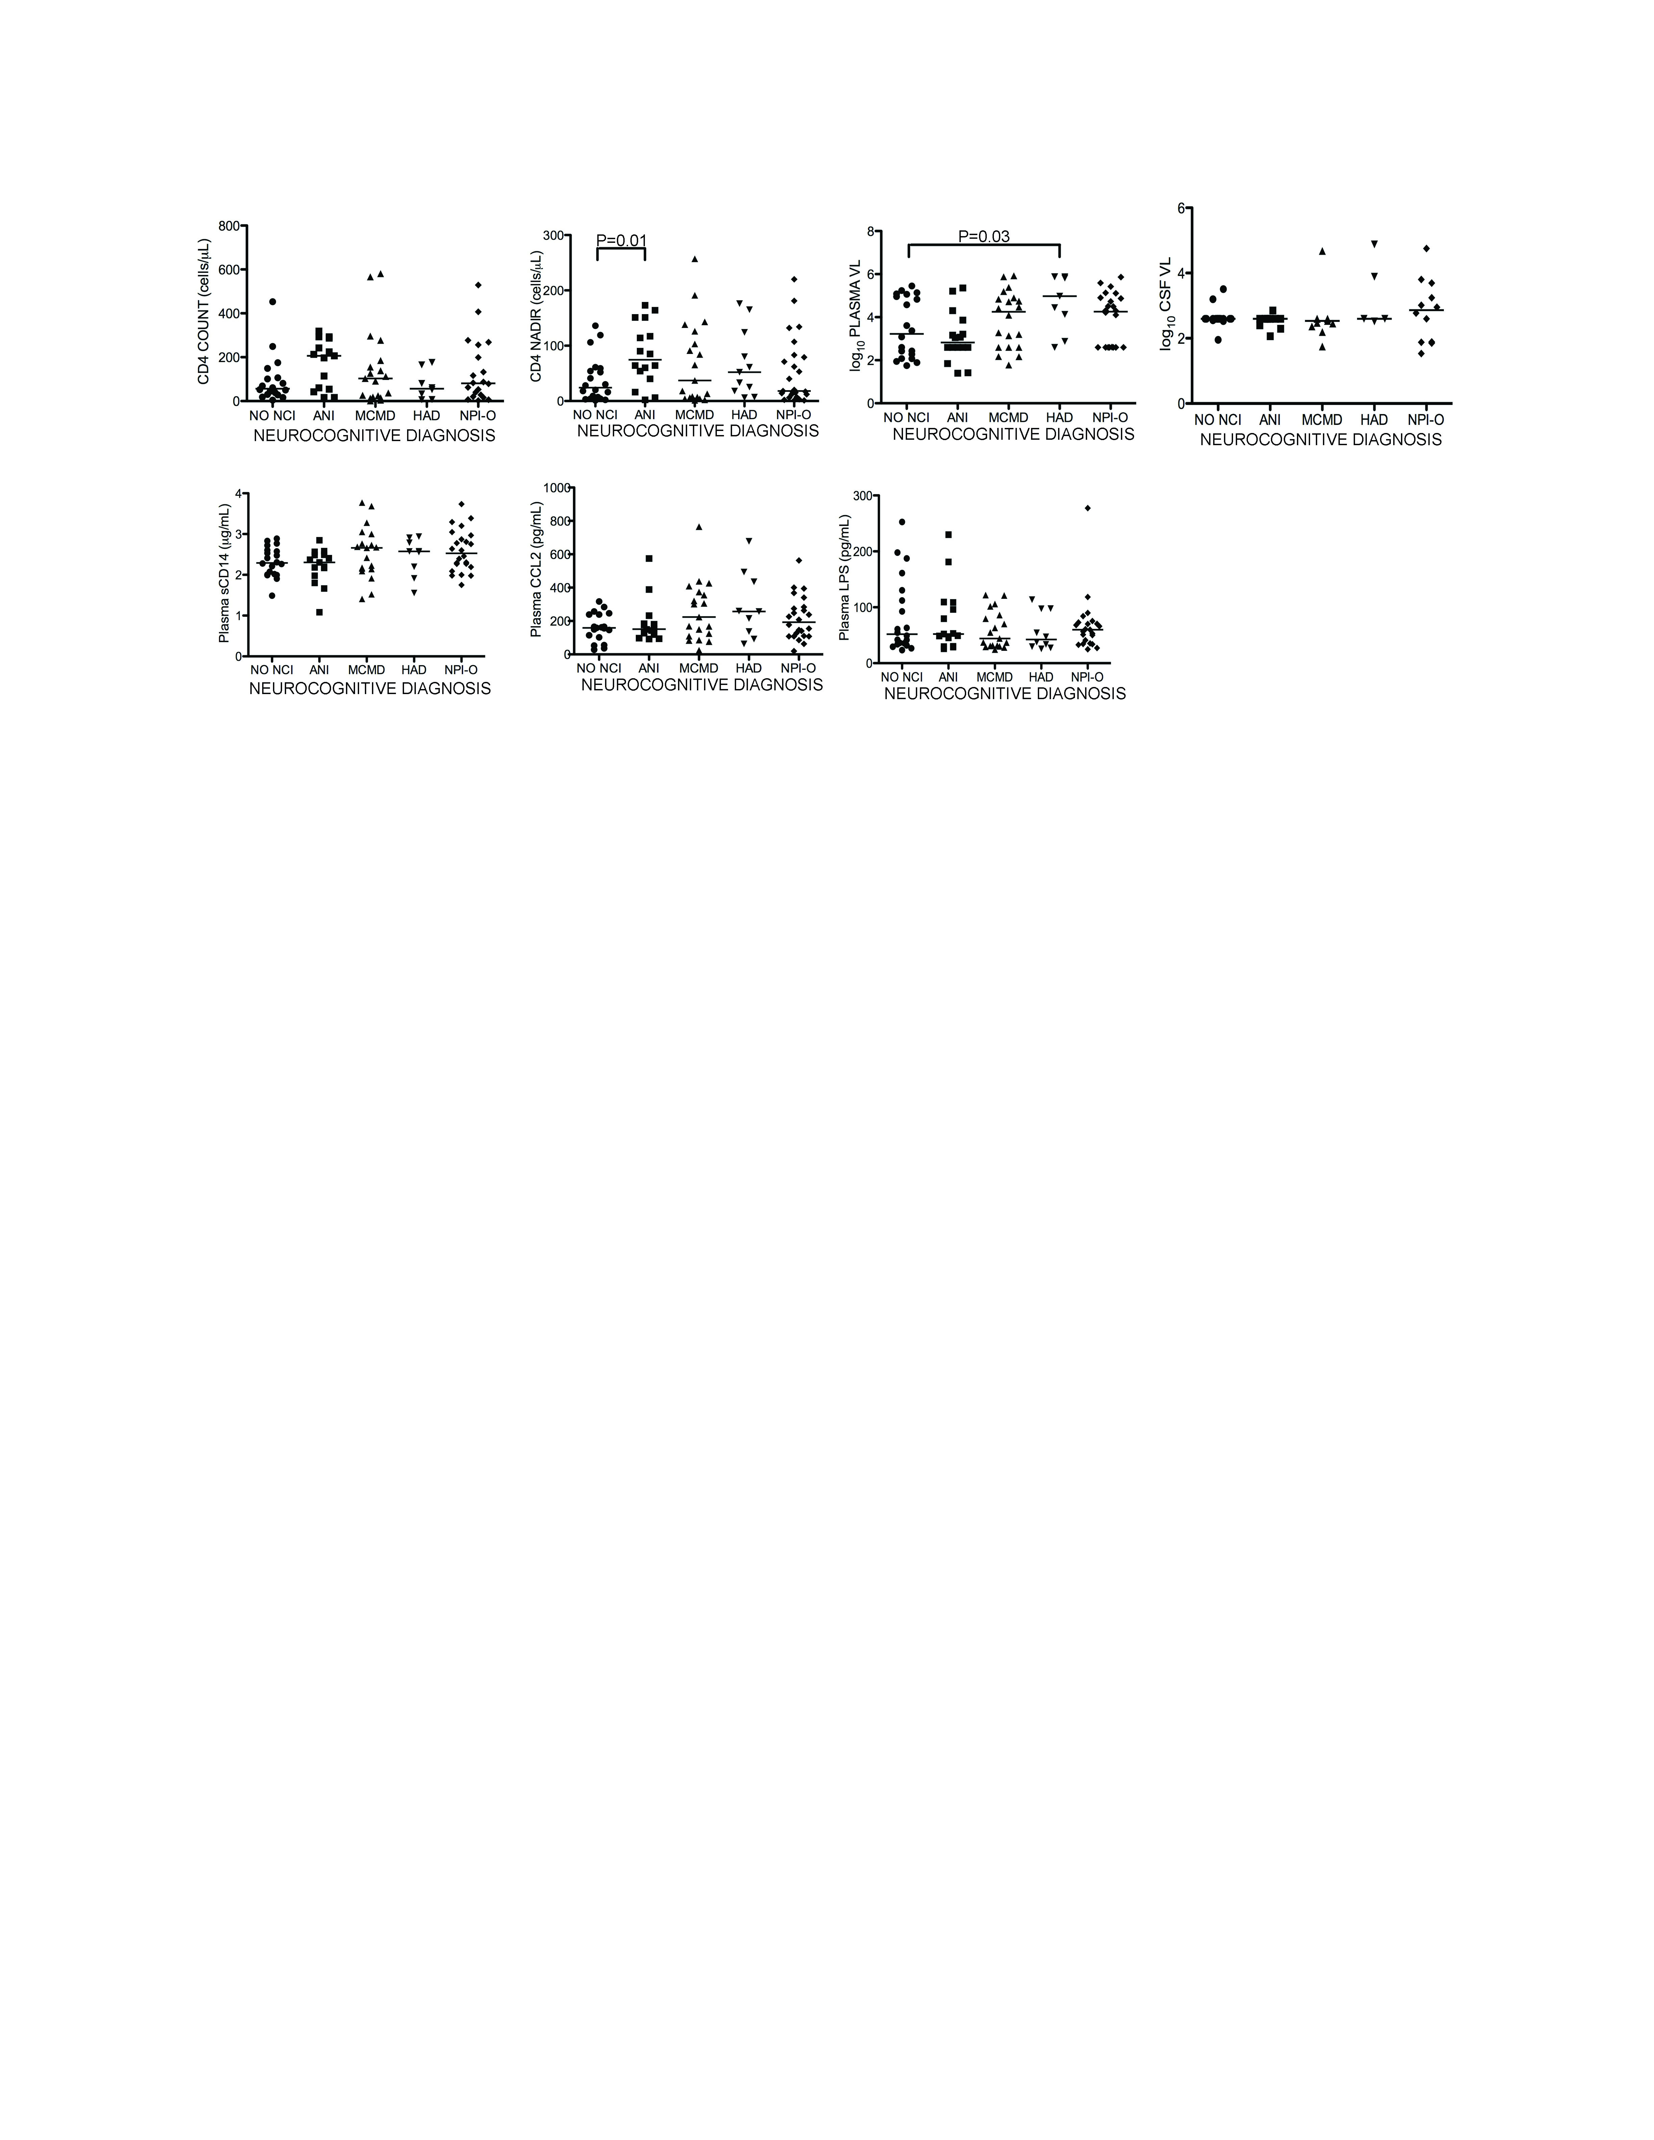
Supplemental Digital Content 1: Plasma sCD14, CCL2, and LPS do not distinguish between subjects stratified by HAND clinical diagnosis. Subjects were grouped according to HAND diagnosis to compare plasma VL, CD4 count, CD4 nadir, sCD14, CCL2, LPS and CSF VL between subjects with diagnosis of no impairment and each HAND diagnosis. No consistent differences were found in any markers. (VL, viral load; NCI, neurocognitive impairment; ANI, asymptomatic neurocognitive impairment; MCMD, minor cognitive-motor disorder; HAD, HIV-associated dementia; NPI-O, other neuropsychiatric impairment). Median values are indicated as horizontal lines. Statistical significance between groups was calculated using the two-tailed Mann-Whitney test; significant differences (p<0.05) are indicated.

