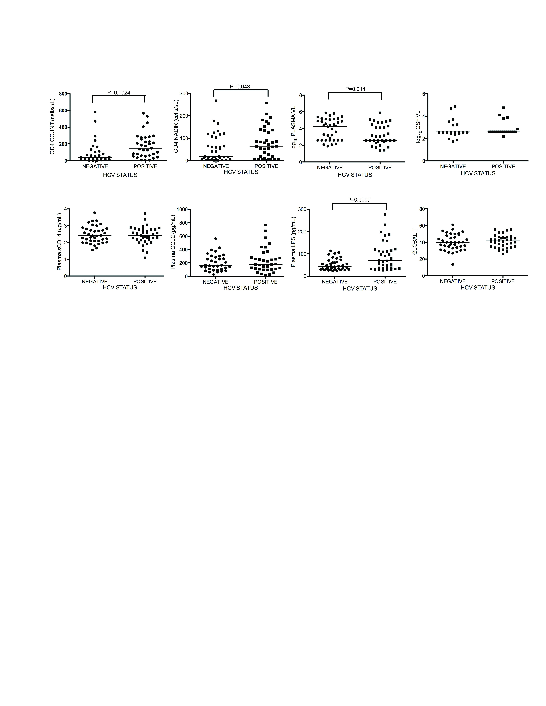
Supplemental Digital Content 2: HCV co-infection is associated with higher plasma LPS levels, but no difference in global T scores or plasma sCD14 levels. Subjects were grouped according to HCV serostatus in order to examine differences in CD4 count, nadir CD4 count, plasma VL, CSF VL, plasma sCD14, plasma CCL2, plasma LPS, and global T score. HCV+ subjects had higher plasma LPS than HCV- subjects (second row, third panel) and higher CD4 counts, higher nadir CD4 counts, and lower plasma VL (top row, first three panels), but there was no difference in global T scores between HCV+ and HCV- subjects (second row, far right panel). (VL, viral load). Median values are indicated as horizontal lines. Statistical significance between groups was calculated using the two-tailed Mann-Whitney test; significant differences (p<0.05) are indicated.

