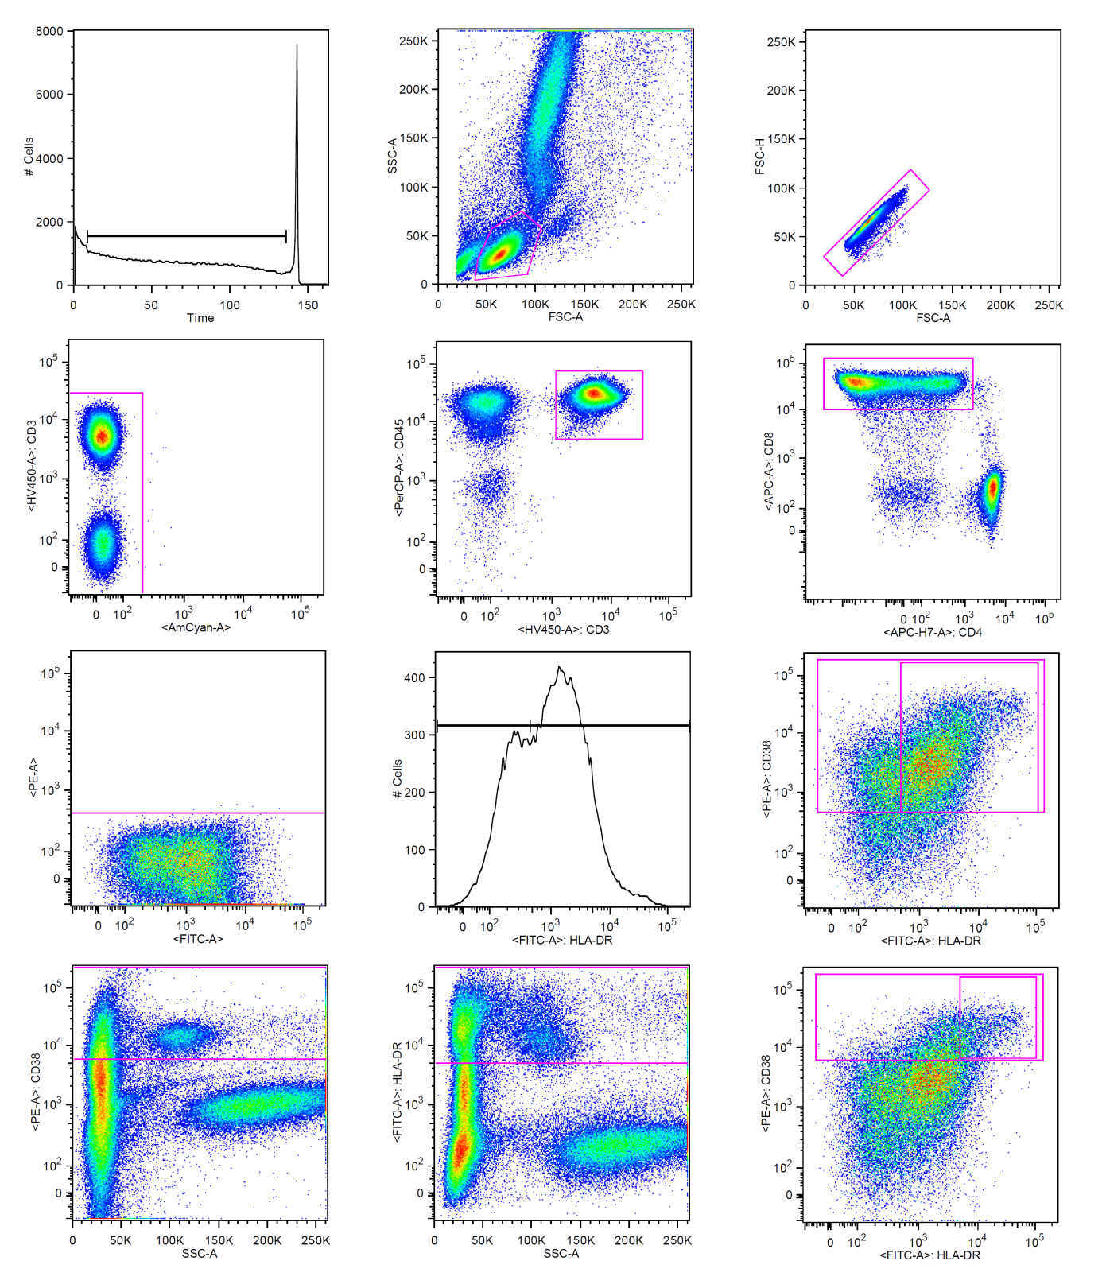
A
B
C
I
G
E
F
D
H
X
Y
J
i
ii
iii
iv
A
B
C
I
G
E
F
D
H
X
Y
J
i
ii
iii
iv

Sequential gating was made on (A) time of acquisition, (B) lymphocytes, (C) single cells, (D) non-autofluorescent cells, (E) CD3⁺ T-cells, and (F) CD8⁺ T-cells. A shown in figures X and Y, the CD8⁺ T-cells were gated as (i)CD8⁺CD38⁺, (ii)CD8⁺CD38⁺HLA-DR⁺, (iii)CD8⁺CD38^{high},(iv) or CD8⁺CD38^{high}HLA-DR^{high}

- CD38⁺: gating based on fluorescence minus one (FMO) controls (G).
- HLA-DR⁺:gating position based on distribution on histogram(H)
- CD38^{high}: gating position determined by placing the cursor between CD38-bright monocytes and CD38-positive granulocytes on an ungated side-scatter plot (adapted from Steel et al. HIV medicine) (I)
- HLA-DR^{high}: gating position determined by placing the cursor between HLA-DR-bright monocytes and HLA-DR-positive granulocytes on an ungated side-scatter plot (J)

