Supplementary Table 1. Summary of RT Resistance Mutations Detected Pretreatment
Mutation Classª | Number of Subjects n (%)
 | E/C/F/TAF+DRV  (N = 89) | Baseline Regimens  (N = 46) | All  (N = 135)
Number of Subjects With Data | 89 | 46 | 135
NNRTI-Associated; n (%) | 79 (88.8) | 40 (87) | 119 (88.1)
Average Number of NNRTI-R Mutations | 2.2 | 2.5 | 2.3
V90I | 8 (9.0) | 5 (10.9) | 13 (9.6)
A98G | 4 (4.5) | 3 (6.5) | 7 (5.2)
L100I | 11 (12.4) | 8 (17.4) | 19 (14.1)
K101E/H/P | 13 (14.6) | 2 (4.3) | 15 (11.1)
K103N/S | 51 (57.3) | 34 (73.9) | 85 (63.0)
V106A/I/M | 10 (11.2) | 1 (2.2) | 11 (8.1)
V108I | 14 (15.7) | 11 (23.9) | 25 (18.5)
E138A/G/K/Q/R | 6 (6.7) | 3 (6.5) | 9 (6.7)
V179D/F/L/T | 8 (9.0) | 2 (4.3) | 10 (7.4)
Y181C/I/V | 14 (15.7) | 12 (26.1) | 26 (19.3)
Y188C/H/L | 10 (11.2) | 1 (2.2) | 11 (8.1)
G190A/E/Q/S | 14 (15.7) | 5 (10.9) | 19 (14.1)
H221Y | 6 (6.7) | 7 (15.2) | 13 (9.6)
P225H | 8 (9.0) | 5 (10.9) | 13 (9.6)
NRTI-Associated; n (%) | 84 (94.4) | 44 (95.7) | 128 (94.8)
Average Number of NRTI-R Mutations | 2.6 | 2.5 | 2.6
TAMs | 39 (43.8) | 18 (39.1) | 57 (42.2)
M41L | 19 (21.3) | 5 (10.9) | 24 (17.8)
E44D | 3 (3.4) | 0 | 3 (2.2)
A62V | 3 (3.4) | 5 (10.9) | 8 (5.9)
K65R | 18 (20.2) | 14 (30.4) | 32 (23.7)
D67N | 12 (13.5) | 6 (13) | 18 (13.3)
T69D/N | 6 (6.7) | 1 (2.2) | 7 (5.2)
T69 Insertion | 0 | 0 | 0
K70E/R | 14 (15.7) | 9 (19.6) | 23 (17)
L74I/V | 14 (15.7) | 8 (17.4) | 22 (16.3)
V75I | 3 (3.4) | 0 | 3 (2.2)
F77L | 1 (1.1) | 0 | 1 (0.7)
Y115F | 4 (4.5) | 2 (4.3) | 6 (4.4)
V118I | 10 (11.2) | 5 (10.9) | 15 (11.1)
Q151M | 0 | 0 | 0
M184V/I | 76 (85.4) | 36 (78.3) | 112 (83)
L210W | 8 (9) | 2 (4.3) | 10 (7.4)
T215Y/F | 19 (21.3) | 7 (15.2) | 26 (19.3)
K219E/N/Q/R | 12 (13.5) | 10 (21.7) | 22 (16.3)

NNRTI = nonnucleoside reverse transcriptase inhibitor; NRTI = nucleoside/nucleotide reverse transcriptase inhibitor; −R = resistant

Supplementary Table 2. Pharmacokinetic Substudy Results
Mean (%CV)  (N=15) | AUC  (ng•h/mL) | C_{max}  (ng/mL) | C_{trough}  (ng/mL)
EVG | 26400 (44) | 2180 (35) | 464 (79)
DRV | 76500 (43) | 6670 (25) | 1250 (99)
COBI | 7900 (43) | 997 (30) | 36 (129)
TAF | 89.9 (45) | 98.1 (58) | NA
TFV | 367 (33) | 19.3 (32) | 13.0 (34)

AUC was calculated using the linear up/log down trapezoidal rule.

AUC = area under the plasma/serum concentration versus time curve; Cmax = maximum observed plasma concentration; COBI = cobicistat; C_{trough} = trough plasma concentration; DRV = darunavir; EVG = elvitegravir; NA = not applicable; TAF = tenofovir alafenamide; TFV = tenofovir

Supplementary Figure 1. Treatment Difference in Virologic Success at Week 48 by Subgroup

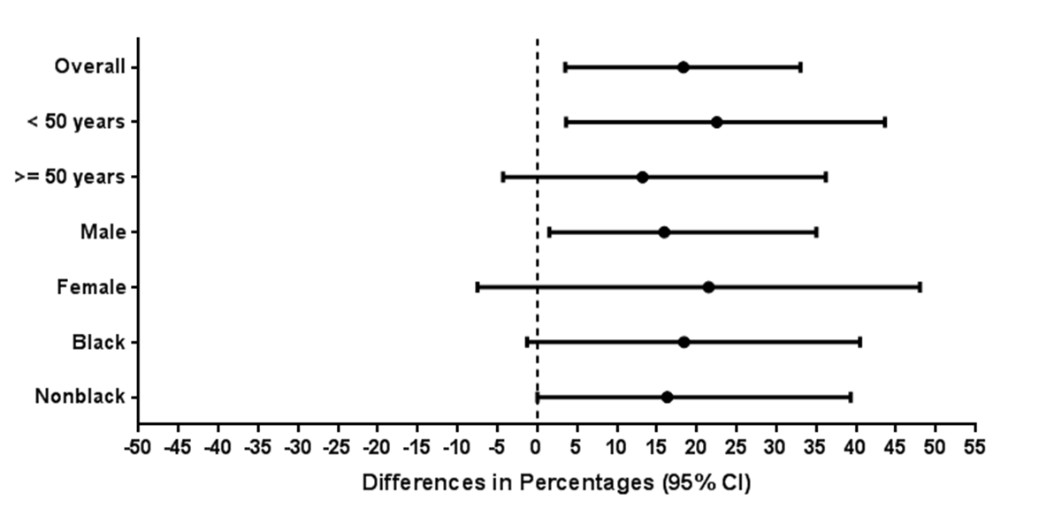

Relative to the vertical line at 0, differences on the right favor the E/C/F/TAF+DRV group and differences on the left favor the CR group.

Supplementary Table 3. Summary of Serious Adverse Events
Serious Adverse Events by Preferred Term | E/C/F/TAF + DRV  n=89 | Baseline Regimens  n=46
Any Serious Adverse Event | 9 (10.1%) | 1 (2.2%)
Tachycardia, alcohol abuse, alcohol withdrawal syndrome, urinary tract infection | 1 (1.1%) | 0
Hemorrhoidal hemorrhage | 1 (1.1%) | 0
Small intestinal obstruction | 1 (1.1%) | 0
Non-cardiac chest pain, bronchitis | 1 (1.1%) | 0
Cellulitis | 1 (1.1%) | 0
Clostridium difficile colitis, clostridial gastroenteritis | 1 (1.1%) | 0
Sepsis | 1 (1.1%) | 0
Splenic rupture, retroperitoneal hemorrhage | 1 (1.1%) | 0
Vascular pseudoaneurysm | 0 | 1 (2.2%)
Syncope, chest pain, chronic obstructive pulmonary disease | 1 ( 1.1%) | 0

Adverse events were coded using MedDRA 18.0.
DRV = darunavir; E/C/F/TAF = elvitegravir/cobicistat/emtricitabine/tenofovir alafenamide

