Supplementary data
Detailed Methodology
General antibody-subtypes quantification
96 well MicroWell™ MaxiSorp™ flat bottom plates (Nunc) were coated with polyclonal affinipure goat anti-human IgA antibody α-Chain Specific (Jackson Immunoresearch), mouse anti-human IgM antibody (clone G20-127 ) (BD Pharmingen™), mouse anti-human IgG1 antibody (clone HP6069 ) (Life technology,) mouse anti-human IgG2 antibody (clone G18-21 ) (BD Pharmingen™), mouse anti-human IgG3 Hinge (clone HP6050 ) (SouthernBiotech), mouse anti-human IgG4 antibody (clone G17-4 ) (BD Pharmingen™) or polyclonal affinipure F(ab')₂ fragment goat anti-human IgG, Fcγ Fragment Specific. 0.05% Tween®20 (Sigma Aldrich) 1% BSA (Sigma Aldrich) in PBS was used as blocking solution. Standard was prepared from N-Prot Standard Serum (Siemens, Healthcare Diagnostics). HRP-Goat anti human Ig Fc-specific (Jackson-Immunoresearch) was used as detection antibody, citrate diluted-OPD (Sigma Aldrich) as substrate and 4N H₂SO₄ as stop solution. Optimal density was measured at 492 and 620nm.
Specific HIV antibody-subtypes quantification
p31 was amplified from RNA isolated from a plasma sample of a HIV-1 subtype C infected patient using the following primers: NcoI integC sense: 5´ TATATCCATGGCTTTTTTAGATGGGATAGAT-3´ and XhoI Integrase as: 5´ TTTACTCGAGATCCTCATCCTGTCTACCTG-3´. A Gp41 subtype C fragment containing the HR1, HR2 and MPER domains was amplified from the plasmid p97ZA012.1 (NIH AIDS Reagent Program, Division of AIDS, NIAID, NIH) using the following primers: gp41-s 5´-AAAAACCATGGCAGCACTAGGAGCTTTGTTC-3´ and gp41-as 5´- TTTATCTCGAGTATTTTTATATACCACAGCC-3´ Both p31 and gp41 amplimers were cloned into the pET21 d(+) vector (Novagen). Recombinant proteins was produced in BL21 DE3 cells (Invitrogen) and purified by immobilized metal ion affinity chromatography by using Ni Sepharose 6 Fast flow (GE Healthcare). p24 ( isolate 92BR025) was purchased from Sino Biological Inc. Proteins were coupled to MagPlex Microspheres (Luminex) following the manufacturer instructions. BSA and a F(ab)2 Goat anti-human IgG Fc specific (Jackson-Immunoresearch) were included as negative and positive controls, respectively. Bound antibodies was detected using the following biotin conjugated monoclonal antibodies and Streptavidin-PE (Jackson Immunoresearch): anti-huIgG1 (clone HP6069, Thermo Scientific), anti-huIgG2 (clone G18-21, BD Biosciences), anti-humanIgG3 (clone HP6050, SouthernBiotech), anti-human IgG4 (clone JDC-14, BD Biosciences) and Goat anti-human IgA (Jackson Immunoresearch).
Cytokines quantification
Detection of IL-1RA, FGF-Basic, MCP-1, G-CSF, IFN-γ, IL-12, IL-13, IL-7, VEGF, MIG, RANTES, Eotaxin, MIP-1β, IP-10, IL-2R, IFN-α, IL-15, GM-CSF, TNF-α, IL-1β, IL-2, IL-4, IL-5, IL-6, IL-10, MIP-1α, IL-17, IL-8, EGF and HGF were determined by using Human Cytokine Magnetic 30-Plex panel (Invitrogen) according to manufacturer’s instructions. Detection of CD40L, IL-21, IL-22 and IL-23 was performed by using the Bio-Plex Pro Human Th17 cytokine assay (Biorad) according to manufacturer’s instructions. Detection of BAFF, CD27 and TNFR2 was performed by using a Human Magnetic Luminex Screening Assay (R&D ) according to manufacturer’s instructions. Detection of sCD14, LBP, FABP2, CRP, CD163, CXCL16, CD23, B7H1, PD-L2, TRAIL, FasL, TGF-b1 (R&D); ASCA IgG and ASCA IgA (Orgentec); EndoCab IgG and EndoCab IgA(Hycult biotech) and Zonulin (Immundiagnostik) was assessed by ELISA according to manufacturer’s instructions. Overflow and under limit of detection values were validated for every analyte as the double and the half of the detection limit respectively.

Supplementary table 1. Biomarker assessed grouped by main pathway involved and technique employed. Note that those biomarkers in italics were not quantifiable in more than 75% of the samples and were therefore excluded from the analysis
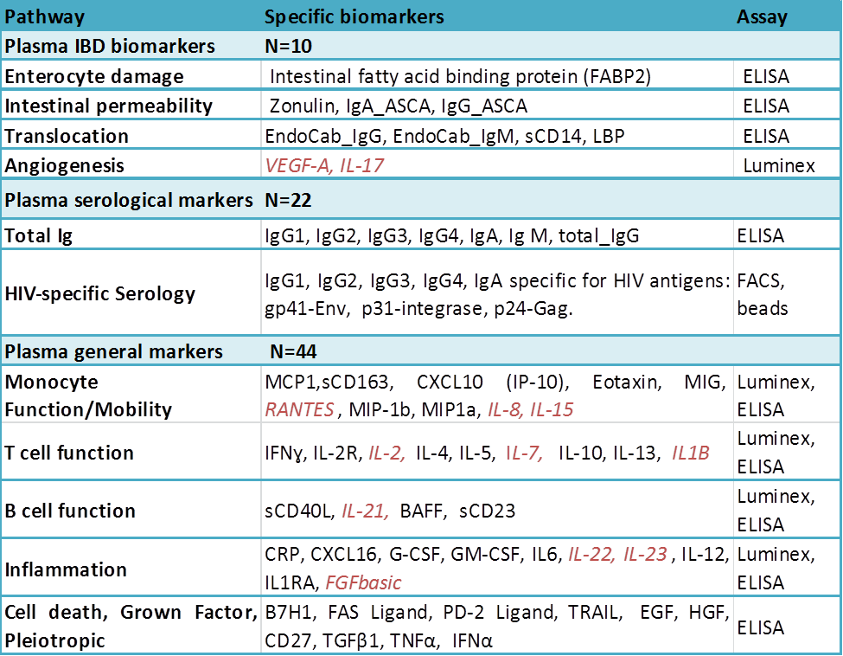

Supplementary table 2. Age, gender and viral load comparison between PHI cases continuing follow-up and those lost to follow-up. There was no significant difference in age, gender balance or viral load between acute HIV patients who returned for enrolment and those who were lost to follow-up. (1) Mann-Whitney U Test, (2) Chi-Square Test and (3) Independent Samples T Test.

 | PHI enrolled  n (%) or median (IQR) | PHI LTFU  n(%) or median (IQR) | p-value
Total (n) | 44 | 13
Age (years)  Median (IQR))  17-30  31-40  41-50  50+ | 26 (11.0)  33 (75.0)  7 (16.1)  3 (7.1)  1 (1.8) | 25 (10.0)  10 (80.0)  2 (10.0)  1 (6.7)  0 (3.3) | 0.939(1)
Gender  Female  Male | 27 (61.4)  17 (38.6) | 5 (38.5)  8 (61.5) | 0.144(2)
Viral load  Median (IQR) | 6.19 (2.15) | 6.80 (2.80) | 0.332(3)

