Online Methods Supplement

Barriers to Universal Prescribing of Antiretroviral Therapy by HIV Care Providers in the United States, 2013-2014

Contents
Page
Appendix 1. Sample Design 2
Appendix 2. Disposition Flowchart 4
Appendix 3. Survey Questionnaire 5
Appendix 4. Response Rate Calculation 21

Appendix 1. Sample Design

Sampling Overview
The sampling strategy for the Medical Monitoring Project (MMP) Provider Survey used a census of all providers on the sampling frame. The sample population included providers at eligible outpatient HIV healthcare facilities in 23 project areas. Eligible facilities were those where HIV care was provided, defined as monitoring care with CD4+ T-lymphocyte cell (CD4) count and HIV viral load tests or the prescribing of antiretroviral medications. Facilities sampled for inclusion were identified according to the larger Medical Monitoring Project (MMP) HIV patient survey methodology.

Sample Population

From 2009-2014, MMP used a 3-stage sampling design resulting in annual cross-sectional probability samples of adults receiving outpatient care for HIV infection in the U.S. During the first stage of sampling, 16 states and one territory were selected using probability proportional to size (PPS) sampling based on AIDS prevalence at the end of 2002. In addition, six separately funded cities within these states agreed to participate in MMP, resulting in 23 project areas: California (including the separately funded jurisdictions of Los Angeles County and San Francisco), Delaware, Florida, Georgia, Illinois (including Chicago), Indiana, Maryland, Massachusetts, Michigan, Mississippi, New Jersey, New York (including New York City), North Carolina, Oregon, Pennsylvania (including Philadelphia), Puerto Rico, South Carolina, Texas (including Houston), Virginia, and Washington). In the second stage of MMP sampling, representative samples of medical facilities providing care for HIV-infected patients within project areas were selected using PPS sampling. During the third stage of MMP sampling, patients were selected with equal probability sampling methods from among all eligible patients seen for medical care at sampled facilities between January 1st and April 31st of the current data collection cycle. In the second stage of MMP sampling during the 2012 data collection cycle, all medical providers meeting eligibility criteria at each sampled facility were eligible to be included in the provider survey.

Eligibility and Inclusion Criteria
Inclusion for the MMP Provider Survey required that all providers meet the following criteria:
- Completed professional school and all postgraduate training programs (i.e., not an intern, resident, or fellow)
- Practiced as a physician (MD or DO), physician assistant or nurse practitioner
- Provided care to HIV-infected patients age ≥ 18 years old at an eligible facility between January and April 2012
- Ordered CD4 count or HIV viral load testing and/or prescribe antiretroviral medications in the context of managing a patient’s HIV disease (providers who obtained CD4 counts and HIV viral load tests only for referral purposes or provided antiretroviral refill prescriptions – but did not play a more active role in managing their patients’ HIV infection – were not eligible for participation).

Sampling Frame Construction
The provider frame for the sample was comprised of individual frames created by each of the 23 project health departments. CDC prompted all 23 project areas to collect information about each eligible facility within the project area including the name and email address of a contact at the facility as well as the number of physicians (MDs and DOs), nurse practitioners and physician assistants practicing at the facility. Within each facility, information was collected about all eligible providers including name, profession, address, phone number and email address (when available).
These individual files were transferred through a secure data network to the CDC contractor (Altarum Institute, Ann Arbor, MI). Upon receipt of these files, staff cleaned all data and built a log of relevant counts and errors, ensuring that mailing addresses were valid. Staff solicited information from project areas to correct errors when necessary. Email formats were also verified. After all project area provider frames were edited and standardized, the 23 separate files were combined into a unified file. The entire file was then checked against the National Change of Address (NCOA) database to correct and update addresses. A de-identified version of the provider frame was sent to CDC.

Final Sample
All providers in the sampling frame were included in the sample. Because of the census nature of the sample, no further sampling process was required to construct the list of providers to be surveyed. However, identifying information for the provider, facility, and project area was preserved for use in application of multistage weighting of the collected provider case-level data.

____________________________________________
Frankel MR, McNaghten AD, Shapiro MF, Sullivan PS, Berry SH, Johnson CH, Flagg EW, Morton S, Bozzette SA. A Probability Sample for Monitoring the HIV-infected Population in Care in the U.S. and in Selected States. The Open AIDS Journal. 2012, 6 (Suppl 1: M2): 67-76.

Appendix 2. Disposition Flowchart
Figure 1. Disposition of sample of 2228 providers for the 2013 Medical Monitoring Project HIV care Provider Survey including 2208 providers at eligible outpatient HIV healthcare facilities and 1234 survey responses from eligible providers.

Appendix 3. Survey Questionnaire

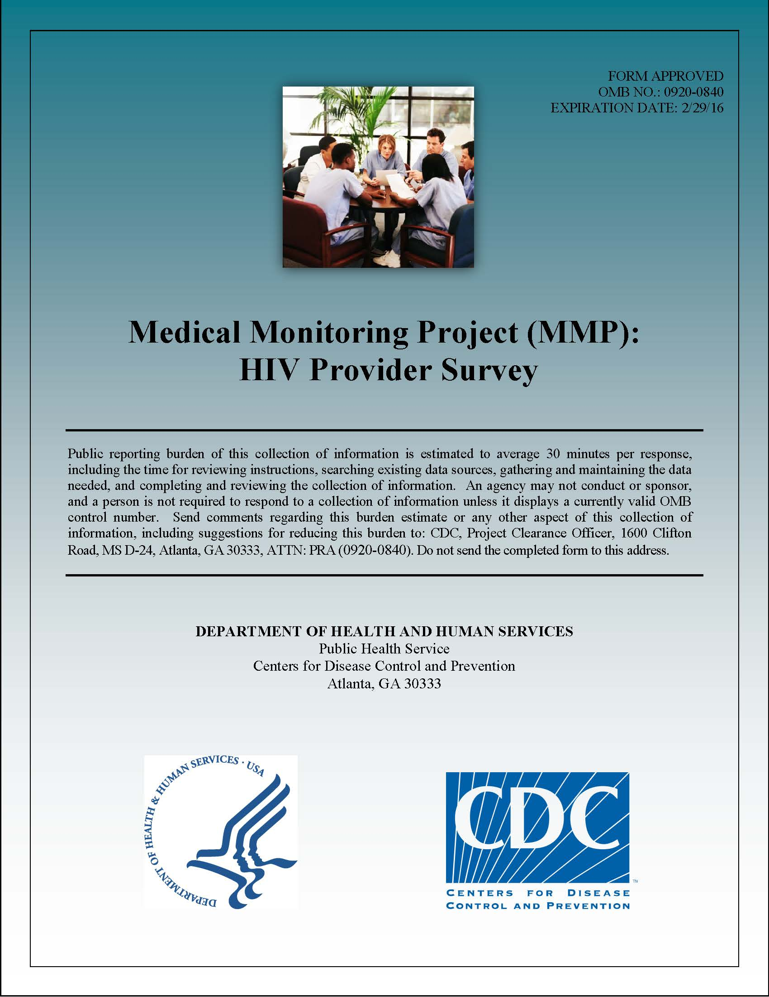
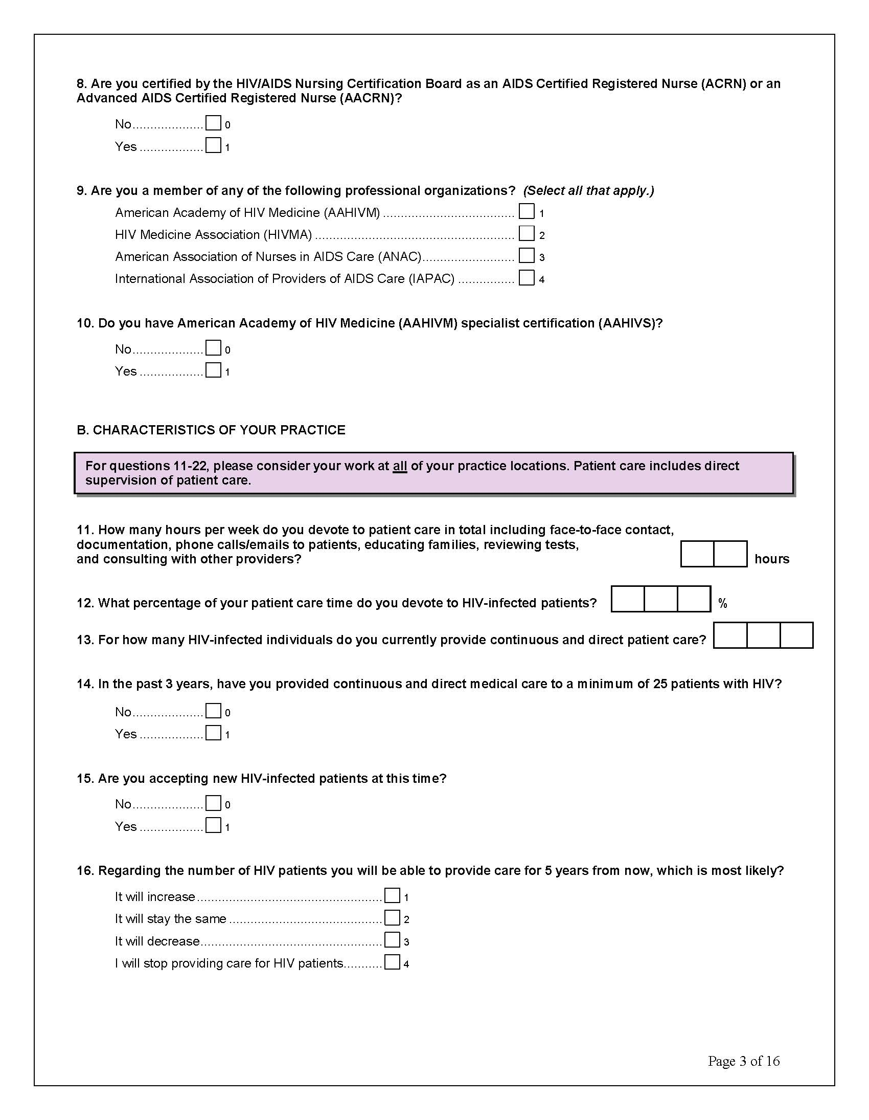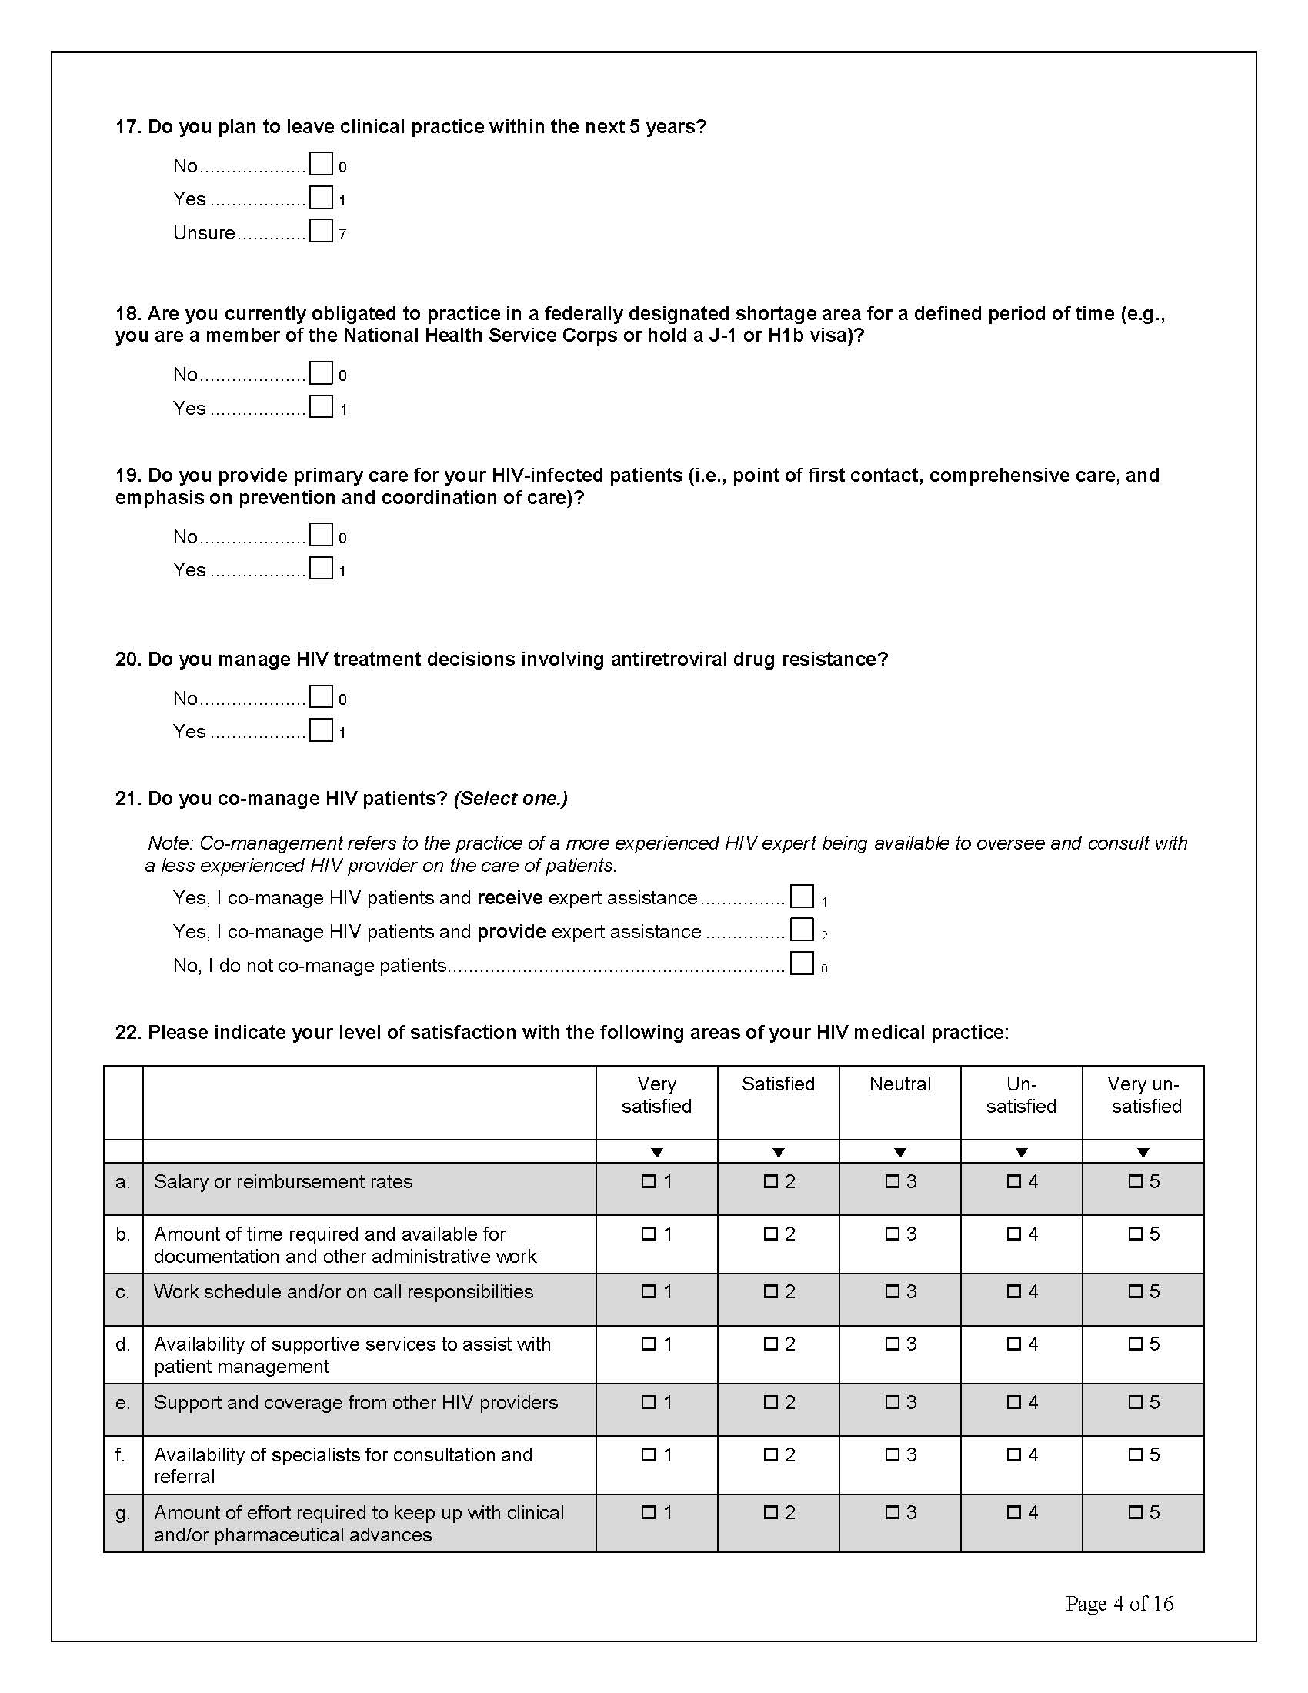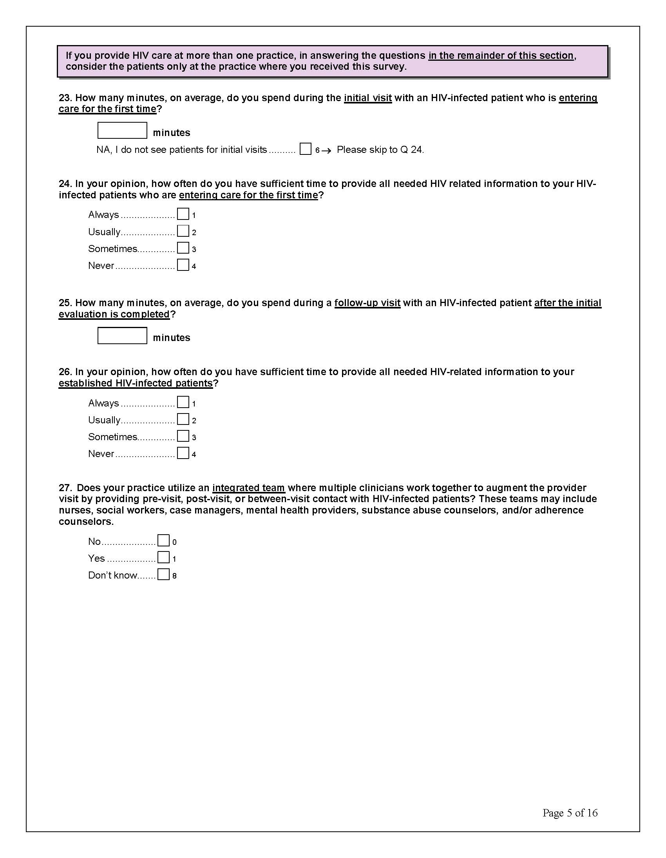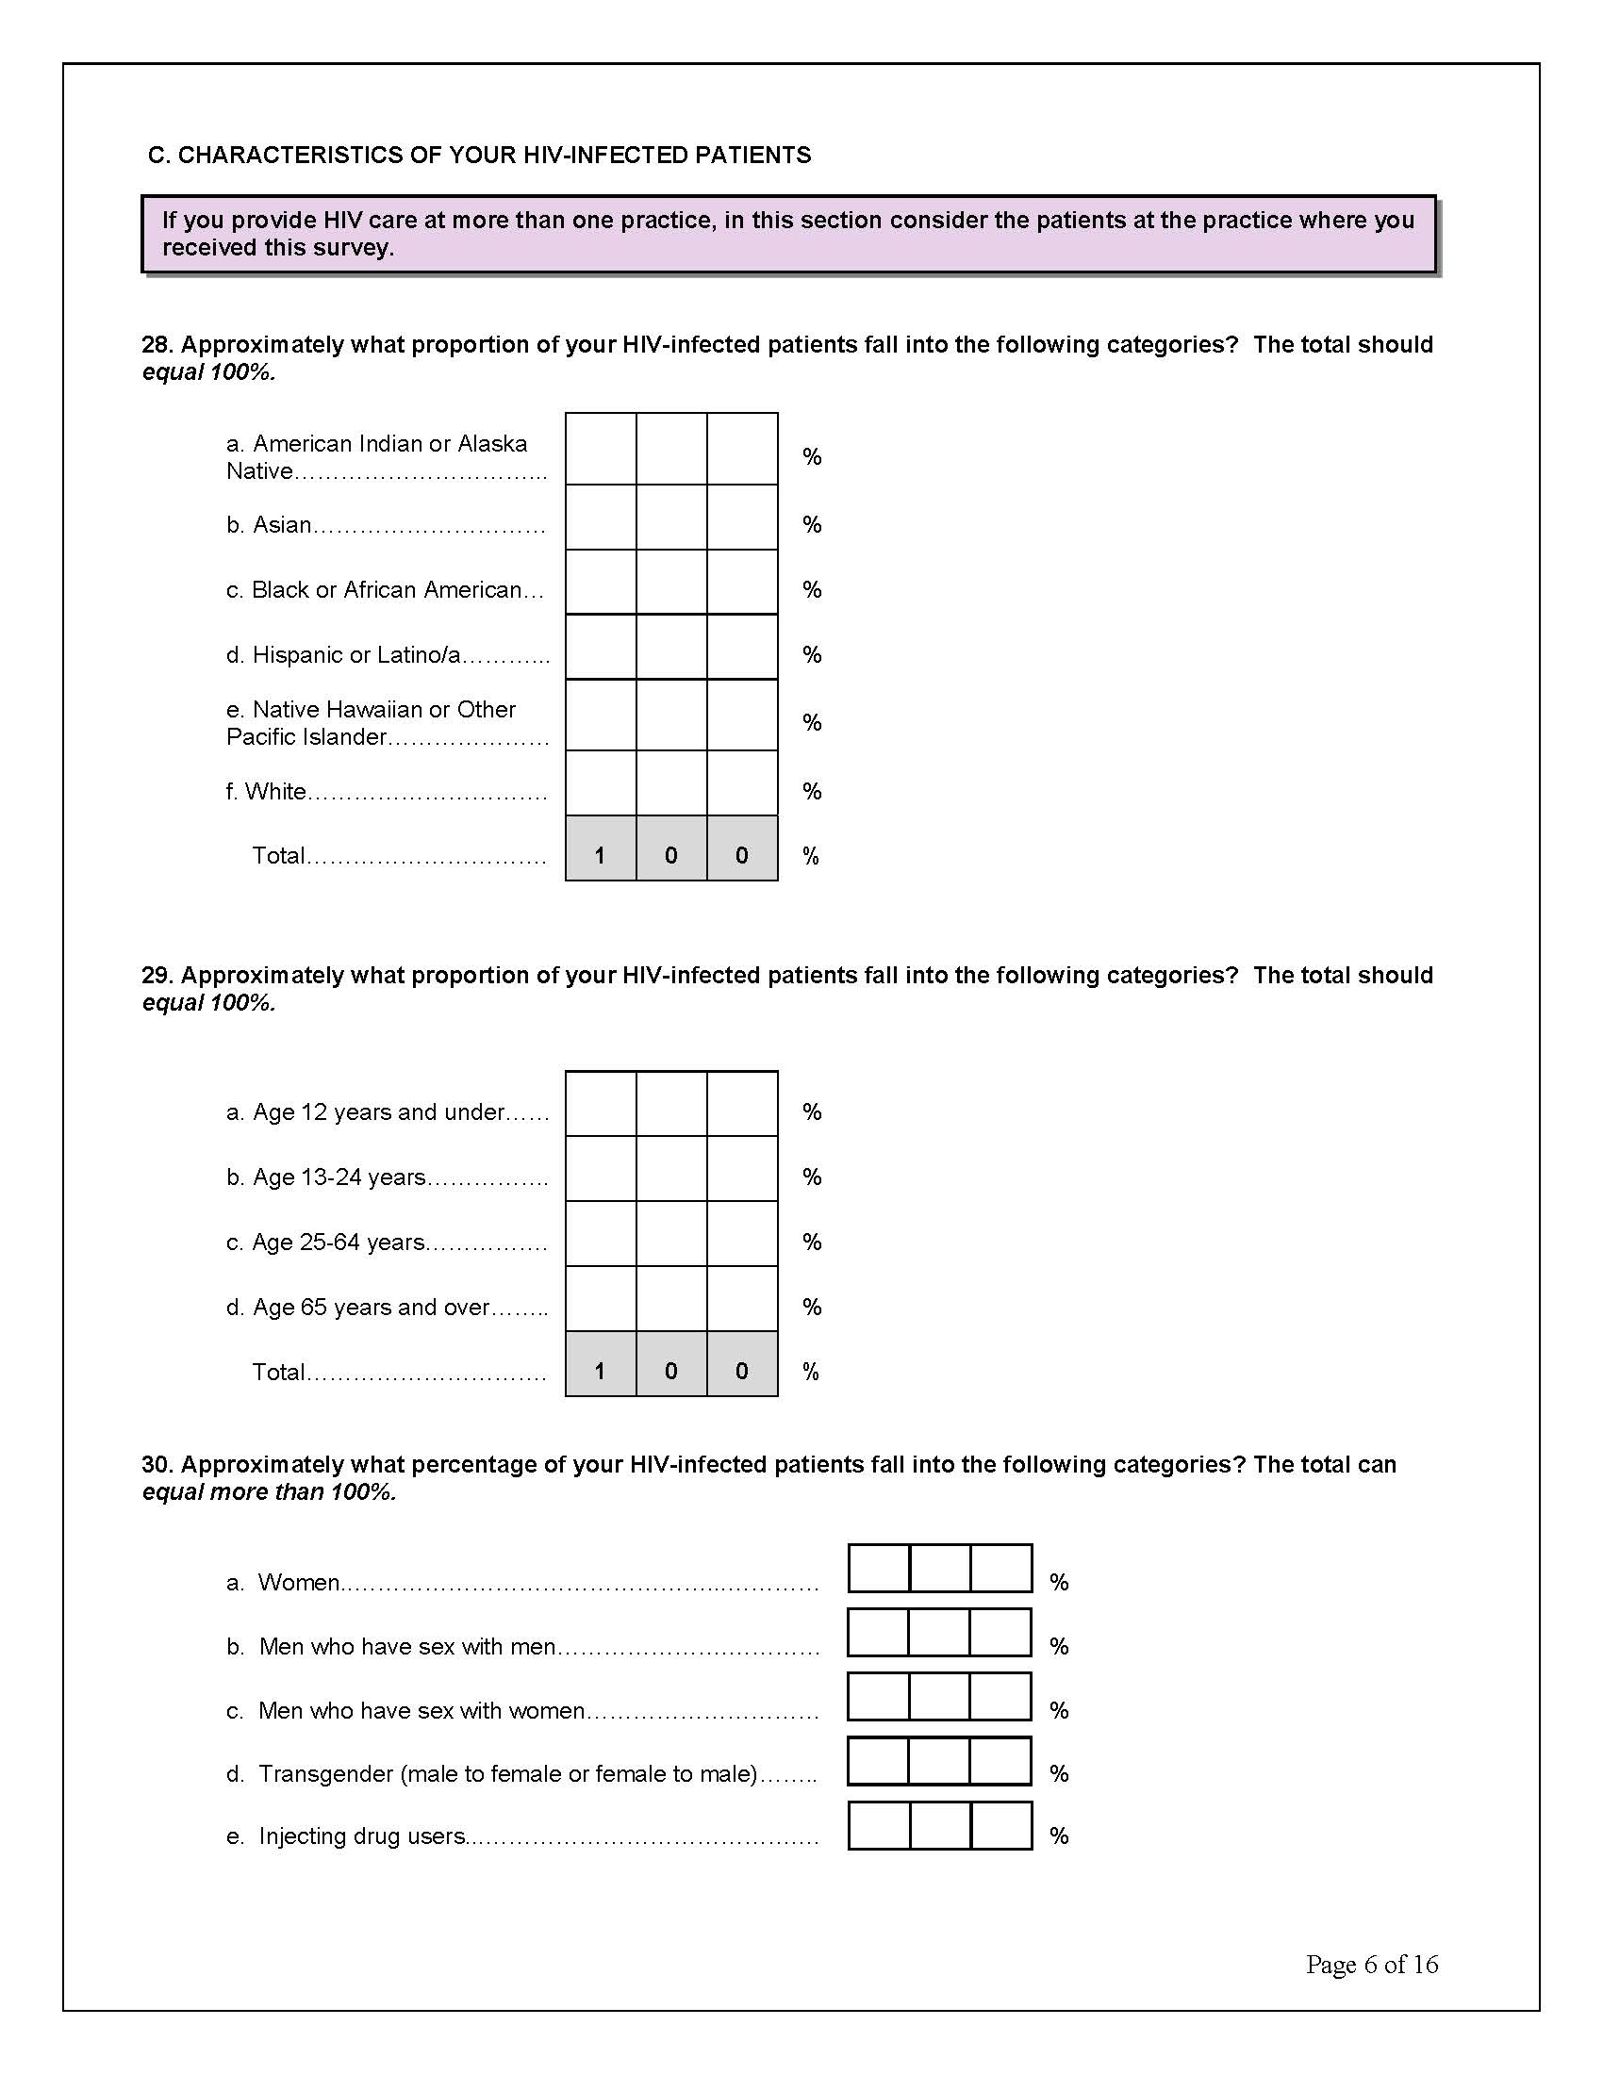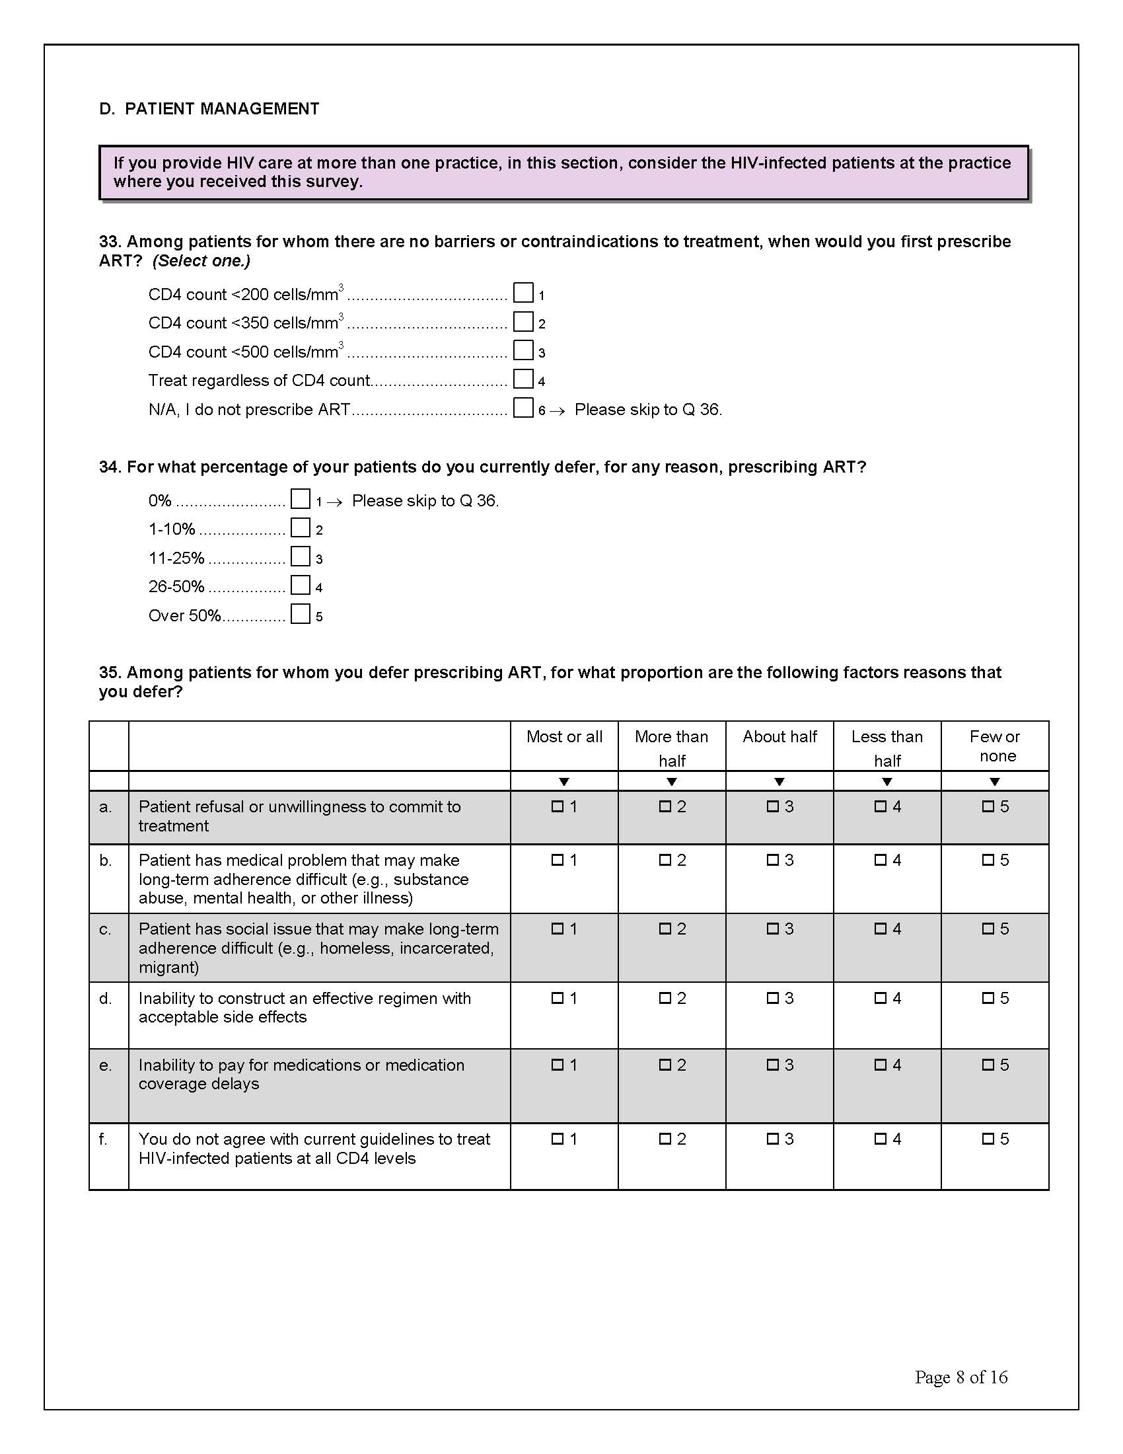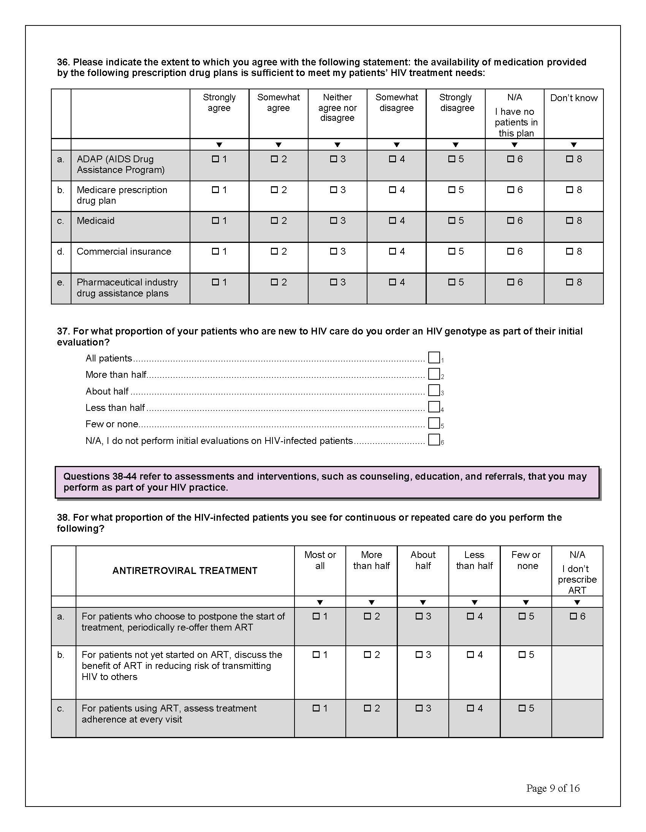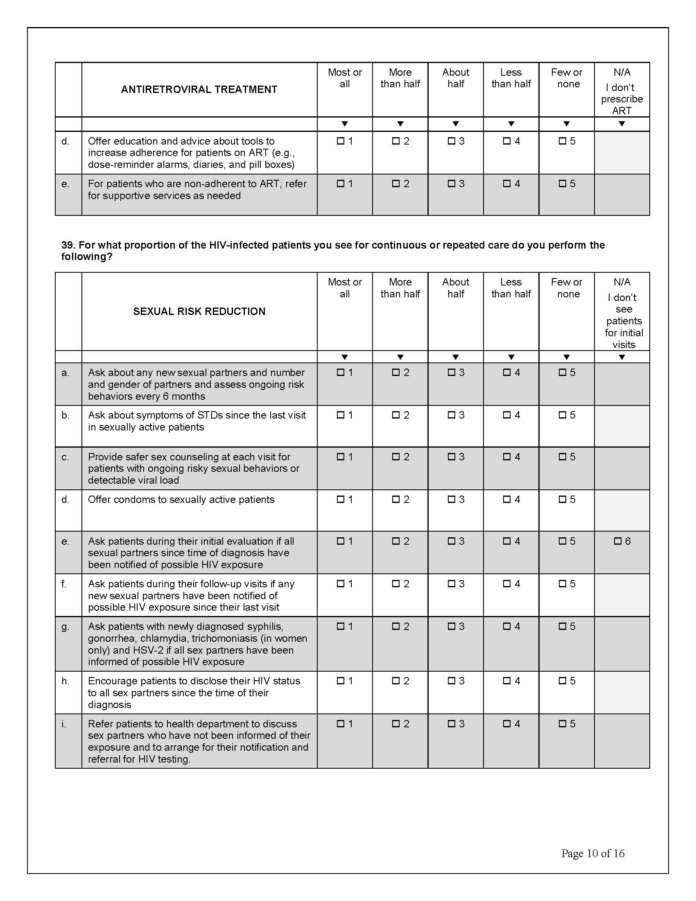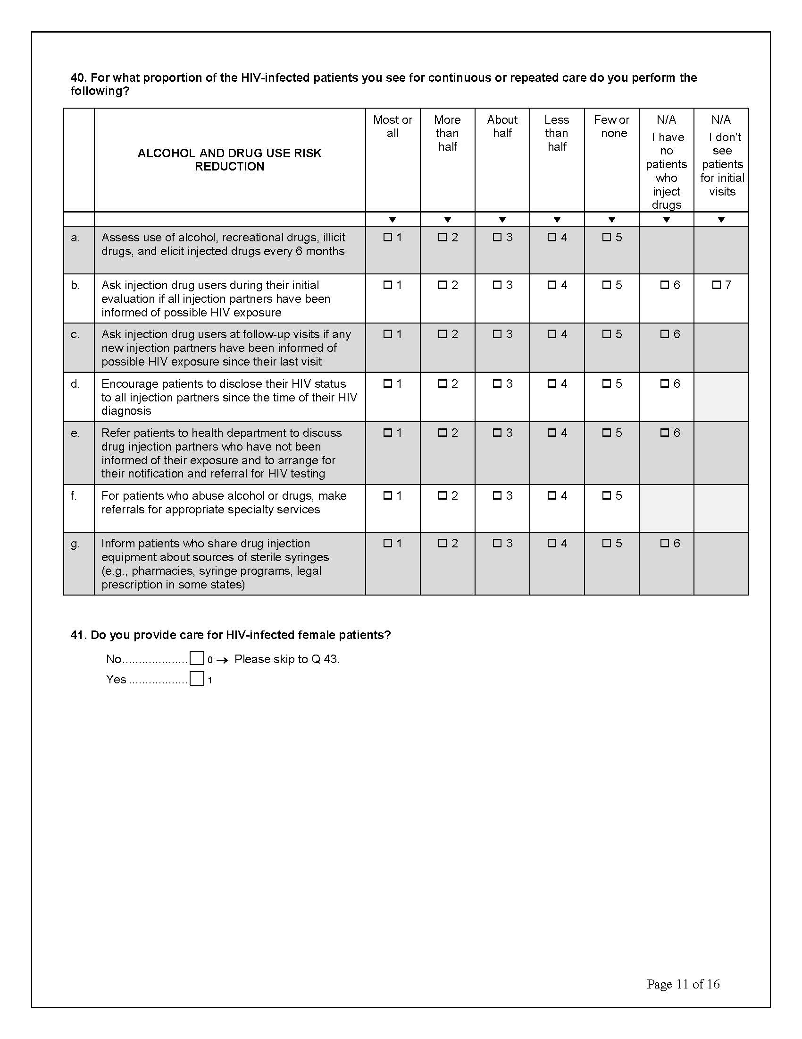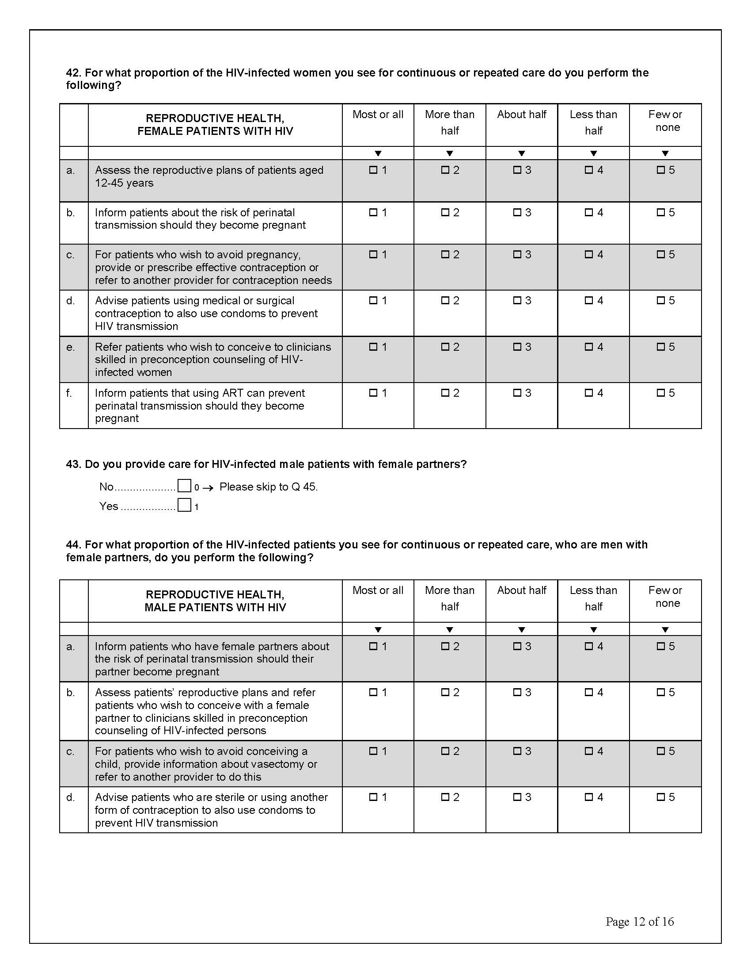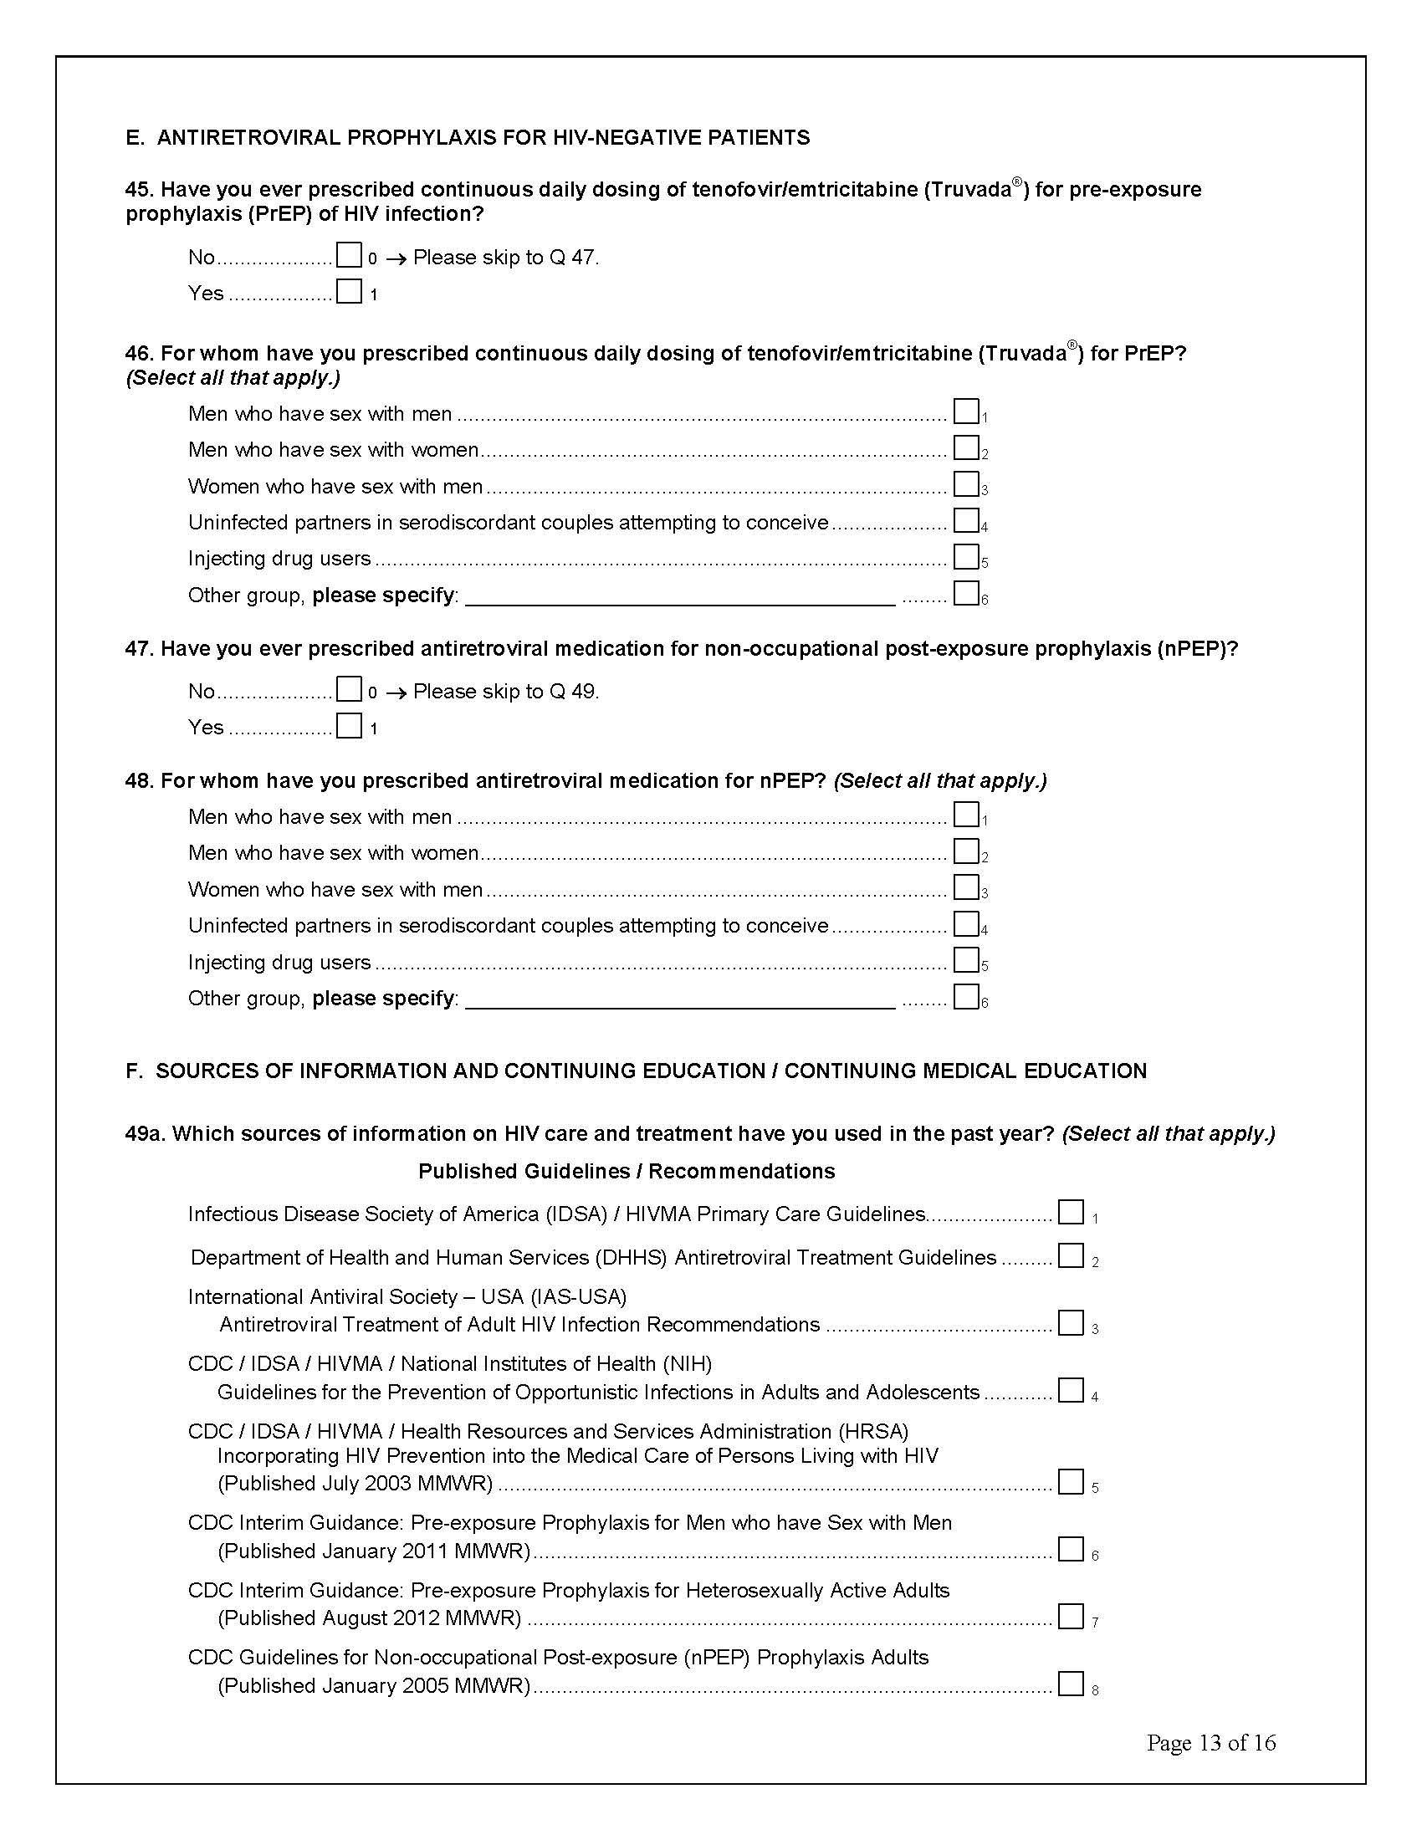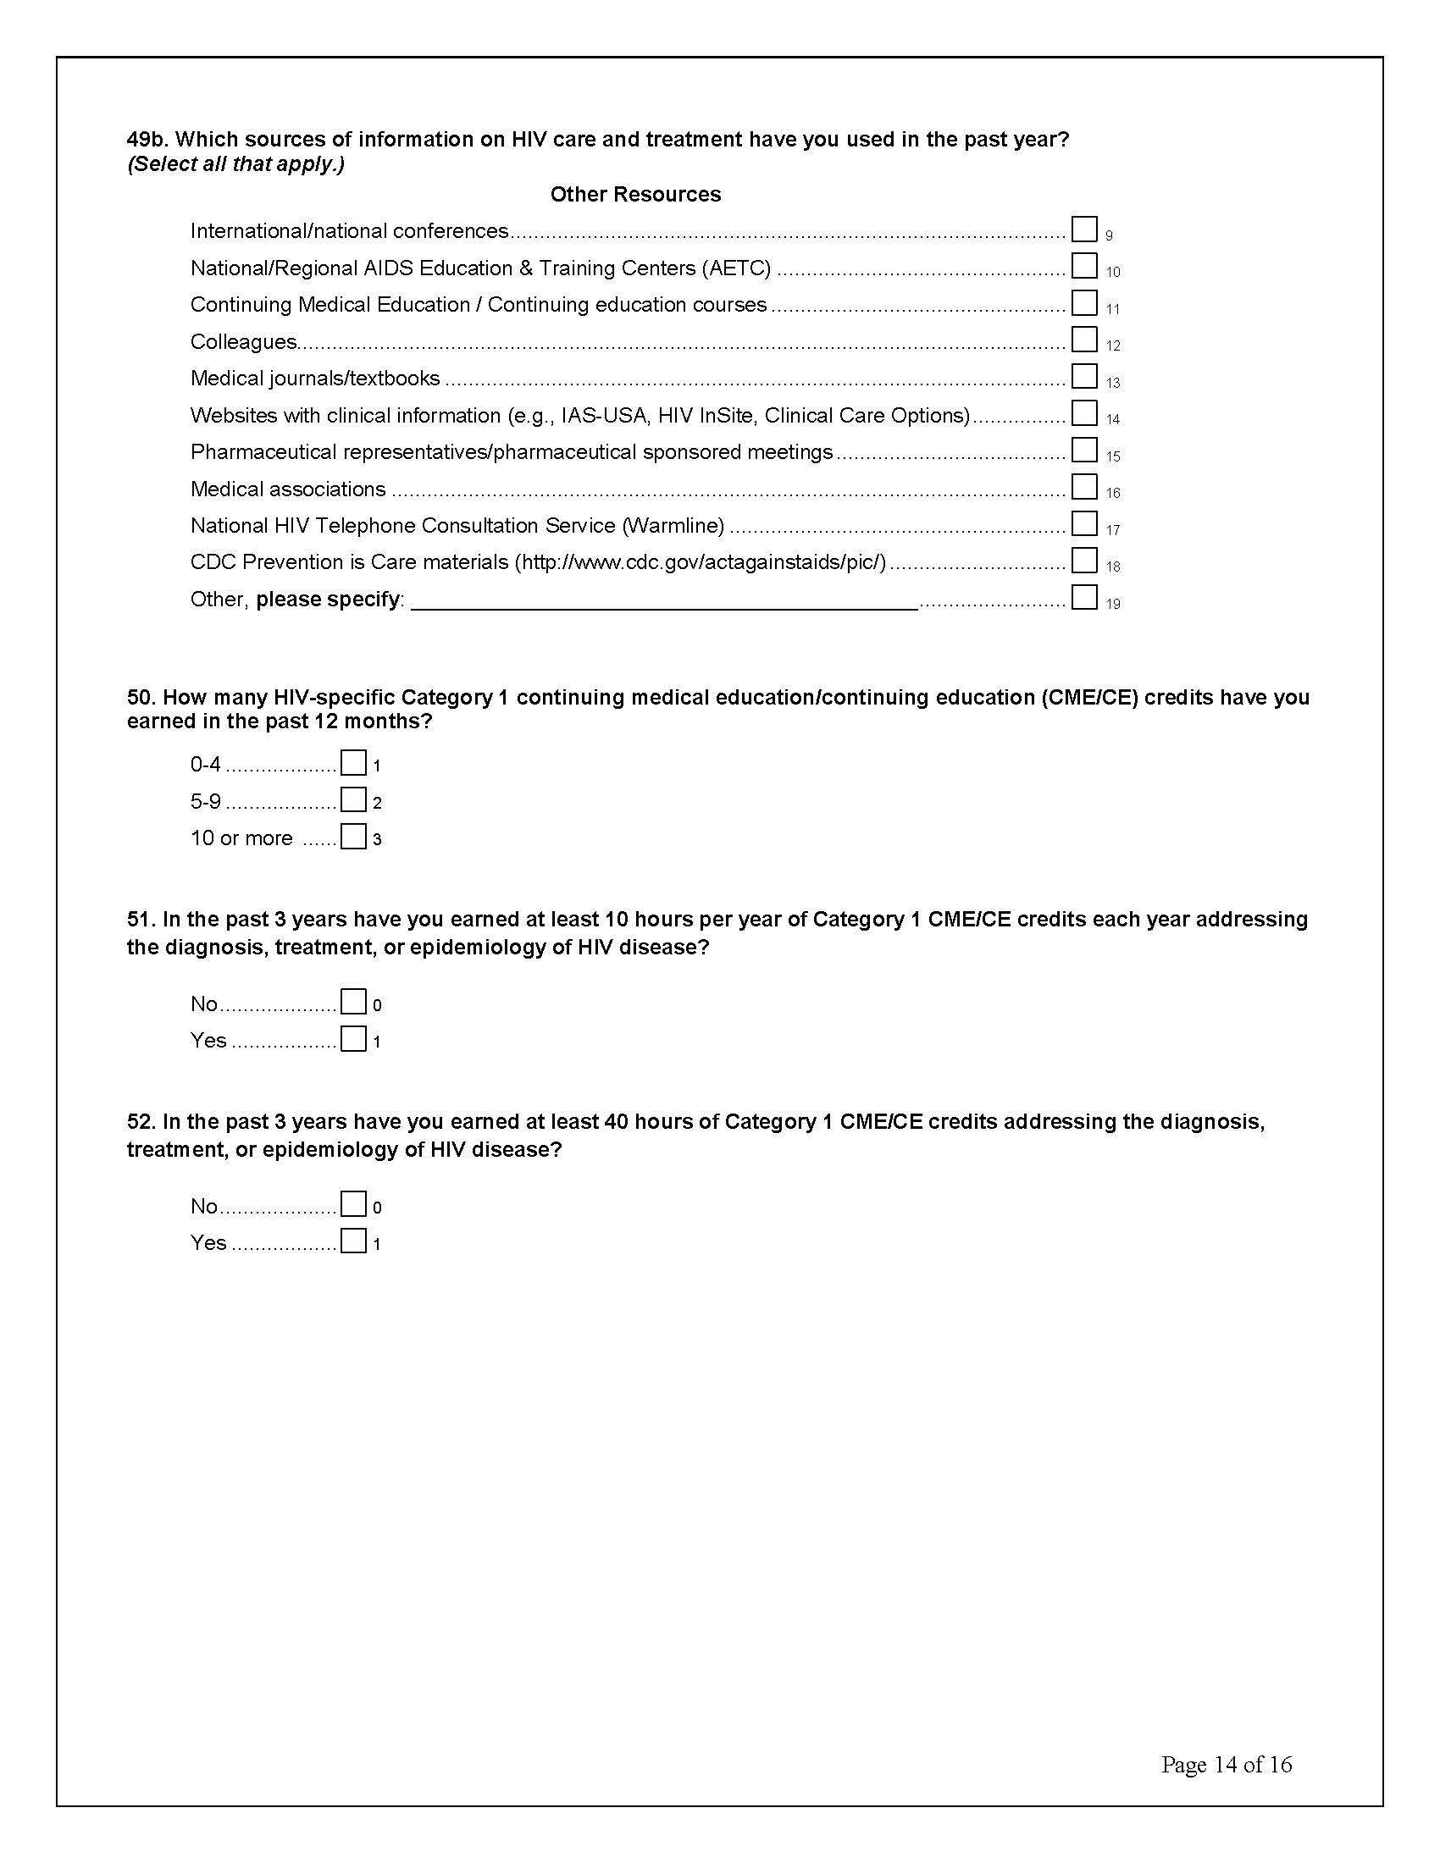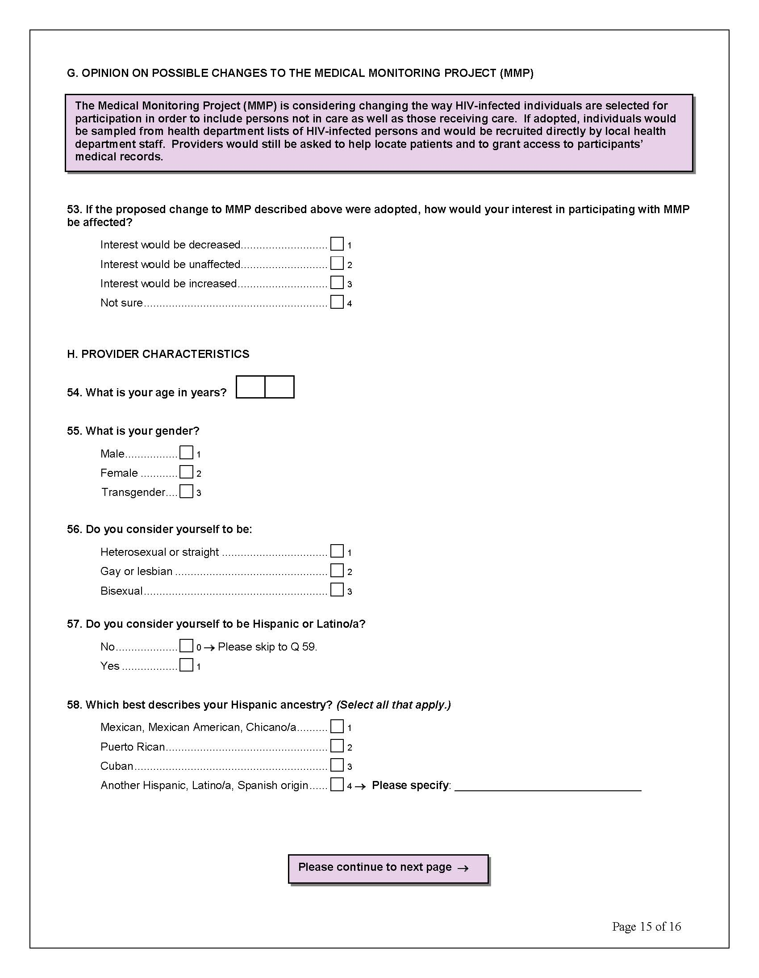

Appendix 4. Response Rate Calculation

CDC MMP Provider Survey Response Rate Report
Altarum Institute

Formulas for response rate are based both on the formulas used for CDC’s prior patient HIV MMP response rate report and formal recommendations from the American Academy of Public Opinion Research (AAPOR.) All three rates will be calculated and reported.

Formula 1 represents a raw response rate, which includes participants of unknown eligibility in the denominator, representing a lower response rate. This is equivalent to AAPOR’s Response Rate Formula 1.

Formula 1: MMP Raw Response Rate

$$\frac{ER}{ER+EN+UE}=MMP Raw Response Rate$$

Formula 2 calculates the eligibility rate. Eligibility standards are determined by the CDC, and require that the provider have certain medical qualifications, and have a recent history treating HIV patients.

Formula 2: MMP Eligibility Rate

$$\frac{ER+EN}{ER+EN+I}=e$$

Formula 3 incorporates the eligibility rate of Formula 2, and applies it as a coefficient to the sample with unknown eligibility. This results in a modest boost to response rate. This is equivalent to AAPOR’s Response Rate Formula 3. This adjusted rate is likely to be more accurate than formula 1, as it neither assumes that all unknowns are eligible, nor that all unknowns are ineligible.

Formula 3 MMP Adjusted Response Rate

$$\frac{ER}{ER+EN+(UE*e)}=MMP Adjusted Response Rate$$

Where
- ER = Eligible respondents
- EN = Eligible non-respondents
- I = Ineligible
- UE = Unknown Eligibility
- e = Eligibility rate

Table of Responses by Disposition Code

Disposition Code | Text | AAPOR designation | Freq
0 | Nonresp | UE | 585
11 | Q1Comp (returned 1st fielding cycle) | ER | 641
12 | Q2Comp (returned 2nd fielding cycle) | ER | 114
13 | Q3Comp (returned 3rd fielding cycle) | ER | 68
14 | SpecialMailComp | ER | 29
21 | WebComp | ER | 374
22 | WebPartial | ER | 8
41 | InElig | I | 128
42 | Refusal | EN | 5
43 | Deceased | EN | 1
45 | Returned Blank | EN | 6
46 | Cover letter Refusal | EN | 9
47 | Retired/Left Medicine | EN | 22
51 | Postal Non-Deliverable | UE | 74
54 | Address Correction Mid Stream | UE | 87
55 | Inel, NR,PA,non-hiv prov | I | 39
58 | Inel,NR, Fac, non-hiv prov | I | 10
59 | Inel, NR, Fac, In training | I | 4
60 | Ineli, NR, Fac, not at fac | I | 4
TOTAL |  |  | 2208

These dispositions give an MMP raw response rate (Formula 1) of 61.00%

$$\frac{1234}{1234+715+74}=61.00\%$$

Formula 2 calculates an eligibility rate of 87.35%.

$$\frac{1234+43}{1234+43+185}=87.35\%$$

Formula 3 adjusts the response rate by applying the known eligibility rate of 87.35% to the cases of unknown eligibility, giving an adjusted response rate of 63.98%.

$$\frac{1234}{1234+43+(746*.8735)}=63.98\%$$

