Supplementary materials

Supplementary Table 1. Susceptibility of a panel of non-longitudinal virus isolates to GSK3532795, BMS MI B, LPV and ATV
Virus # | PR-resistant viruses* | PR genotype (primary PI^{R} mutations in PR) |  | Maximum signal relative to WT control, % | FC-IC₅₀
 |  | Major | Minor |  | GSK3532795 | BMS MI B | LPV | ATV
Control | Gag A364V |  |  | 97 | >1000 | >1000 | 0.84 | 0.92
1 | NIH Cat # 11801 | M64L, I54V, V82A, I84V, L90M | L10F, L33F, L35D, K43T, A71V | 40 | 0.23 | 0.28 | 307 | 235
2 | NIH Cat # 11803 | M36I, M46I, G48V, I50V, I54S, V82A | L10I, L33F, E35D, K43T, A71V | 54 | 0.16 | 0.25 | 355 | 189
3 | NIH Cat # 11804 | G48V, I54V, V82A, L90M | L10I, A71T | 43 | 0.17 | 0.14 | 27 | 79
4 | NIH Cat # 11805 | M46I, I84V, L90M | L10I, A71T | 61 | 0.4 | 0.68 | 15 | 11
5 | NIH Cat # 11806 | V32I, M36I, V82A, L90M | L10I, L33F, A71V | 50 | 0.28 | 0.27 | 442 | 17
6 | NIH Cat # 11807 | V32I, M36I, I54V, V82A, I84V, L90M | L10F, V11I, L33F, E35G, A71I, G73S | 84 | 0.29 | 0.34 | 123 | 415
7 | NIH Cat # 11808 | D30N, M36L, I84V, N88D, L90M | L10F, L33F, E35D, K43T | 62 | 0.68 | 0.49 | 24 | 140
* Multiple-cycle assay. Renilla luciferase activity was measured 4 days post-transfection. FC-IC₅₀ values >3 are bolded.
ATV, atazanavir; FC-IC₅₀, fold-change in IC₅₀; IC₅₀, drug concentration leading to 50% viral inhibition; LPV, lopinavir; MI, maturation inhibitor; PI^{R}, protease inhibitor resistance; pt, patient; WT, wild-type.

Supplementary Table 2. GSK3532795 and PI phenotypic susceptibility of Pt04 and Pt09
 | CFB, GSK3532795 |  |  | Single-cycle FC-IC₅₀ |  |  |  |  | Multiple-cycle FC-IC₅₀
Sample name | Monogram assay | Single-cycle assay (n=2 experiments) | Multiple-cycle assay | GSK3532795 | MI A | MI B | ATV | LPV | GSK3532795 | MI B | ATV | LPV
Pt04 pre-PI | 1 | 1 | 1 | 1.44  (1.72, 1.16) | 0.62 | 0.59 | 0.54 | 0.73 | 2.0 | 0.92 | 0.46 | 0.43
Pt04 PTx 1 | 0.48 | 1.15  (1.3, 0.98) | 0.35 | 1.7  (2.26, 1.13) | 0.52 | 0.83 | 34.9 | 28.7 | 0.70 | 0.87 | 17.0 | 14.5
Pt04 PTx 2 | 7.46 | 4.17  (2.3, 6.1) | 2.1 | 5.46  (3.90, 7.0) | 1.1 | 1.2 | 402 | 152 | 4.2 | 0.95 | 217 | 133
Pt09 pre-PI | 1 | 1 | 1 | 0.64  (0.70, 0.57) | 0.54 | 0.87 | 0.99 | 1.2 | 1.2 | 0.70 | 0.82 | 0.84
Pt09 PTx 1 | 27.4 | 1.53  (1.40, 1.70) | 1.5 | 0.96  (0.96, 0.95) | 0.31 | 0.56 | 14.8 | 9.6 | 1.8 | 0.94 | 4.4 | 5.1
Pt09 PTx 2 | 3.17 | 2.21  (1.90, 2.50) | 0.79 | 1.3  (1.31, 1.3) | 0.45 | 0.64 | 60.4 | 28.2 | 1.0 | 0.71 | 9.0 | 4.7
FC-IC₅₀ values >3 are bolded.
ATV, atazanavir; CFB, change from baseline; FC-IC₅₀, fold-change in IC₅₀; IC₅₀, drug concentration leading to 50% viral inhibition; LPV, lopinavir; MI, maturation inhibitor; PI, protease inhibitor; PT, post-PI treatment; pt, patient.

Supplementary Figure 1. Study strategy and data summary
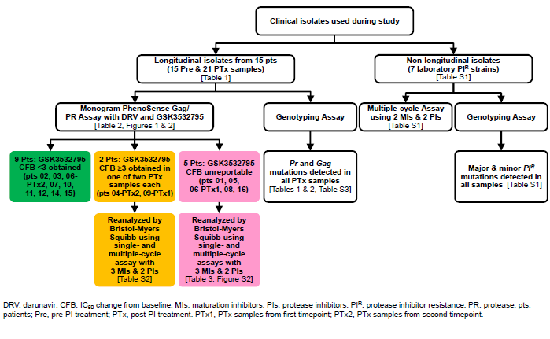
ATV, atazanavir; CFB, change from baseline; DRV, darunavir; LPV, lopinavir; PI^{R}, protease inhibitor resistance; PR, protease; PTx, post-PI treatment; PTx 1, PTx samples from first timepoint; PTx 2, PTx samples from second timepoint; pts, patients; RAM, resistance-associated mutation.

Supplementary Figure 2. Additional longitudinal isolates (single-cycle assay): susceptibility to GSK3532795, BMS MI A and B, ATV and LPV*

*Samples from pt10 were re-cloned and re-tested as a control for the single-cycle assay. All post-treatment samples contain ≥1 major PI RAM.
ATV, atazanavir; FC-IC₅₀, fold-change in IC₅₀; IC₅₀, drug concentration leading to 50% viral inhibition; LPV, lopinavir; MI, maturation inhibitor; PI, protease inhibitor; PTx, post-PI treatment; pts, patients; RAM, resistance-associated mutation.

Supplementary Figure 3. Mutations in (a) Protease (b) Gag
a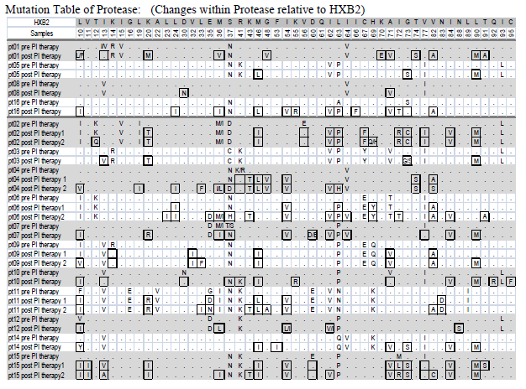
b
