Appendices:

The Impact of Pre-Exposure Prophylaxis Among Men Who Have Sex With Men: A Modeling Study

Authors:
Parastu KASAIE, Jeff PENNINGTON, Maunank S. SHAH, Stephen A. BERRY, Danielle GERMAN, Colin P. FLYNN, Chris BEYRER, and David W. DOWDY

HIV simualtion model

Model Design
Our agent-based simulation model of the HIV epidemic among MSM in Baltimore City is structured as a collection of different modules that govern various aspects of population demographics, partnerships, HIV natural history and cascade of care. Each “agent” represents a single MSM in Baltimore City, characterized by his age, race, and place of residence, and the model is evaluated in a series of one-week time steps. The natural history module characterizes the progression of HIV among infected individuals according to disease stage (acute, early, and late). Each stage is associated with a different per-act risk of HIV transmission, and progression from early to late disease can be prevented (and/or reversed) by provision of ART. The continuum of care module estimates individuals’ probabilities of HIV testing, linkage to care, disengagement/re-engagement, and ART provision/viral suppression at each time step. The sexual network and transmission module create and modify the population’s sexual networks (as a series of stable and casual partnerships) at each step, modeling HIV transmission as a per-act probability among serodiscordant partnerships according to frequency and safety of sex act, HIV stage of the infected partner, and ART/PrEP use. Sexual partnerships are modeled as assortative according to age, race, and location of residence. Finally, the demographic module accounts for aging, death, and birth processes.

Demographic Module
This module characterizes the initial population structure and governs various procedures for aging, natural death and birth processes at end of each simulated year. We model the population of MSM in Baltimore city between the ages of 15 to 75. The population is structured as a collection of population-groups corresponding to Baltimore’s Community Statistical Areas (CSA) [1]. CSAs are clusters of neighborhoods and are organized around census tract boundaries, which are consistent statistical boundaries. In some cases, CSA boundaries may cross neighborhood boundaries. There are 55 CSAs in Baltimore City. Neighborhood lines often do not fall along CSA boundaries, but CSAs are representations of the conditions occurring within those particular neighborhoods. Simulated population-groups are characterized with regard to their geographical location (CSA of residence) and racial structure (Caucasian white and African-American black). We exclude the spatial distribution of individuals within each CSA, and the geographical assignments are made via the corresponding CSAs’ center’s coordinate on the map. Initial HIV distribution across CSAs is estimated according to available data from Maryland’s department of health and mental hygiene (MDHMH) [2].
Individuals age with the simulation clock (years) and exit the model according to an age-specific natural mortality rate [3], or by reaching the age of 75, or via additional mortality rate associated with HIV infection. In order to maintain the initial population decomposition without disturbing the CSA structures, we model a natural birth process at the CSA level for replenishing the population size over time. The birth process is modeled via a non-stationary Poisson process tuned to maintain the CSA’s population at a constant mean over time. Newborns enter the MSM population at age of 15 to 20 years old, and follow the corresponding racial-structure of the CSA of residence.
Determining the population size: While U.S. census data currently allow the Centers for Disease Control and Prevention (CDC) to calculate disease rates by age, sex at birth, and racial/ethnic groups, there are no census data for the number of MSM in the United States [4]. Initial research by Kinsey and his colleagues suggested that approximately 10% of U.S. men are gay or bisexual [5], but the estimates were lowered by half in later reviews [6]. Addition of questions about same-sex household to U.S census in 1990, did not provide a national estimate of the MSM population given exclusion of those who are not partnered [7]. Lieb and his colleagues summarized a wide variety of methods that have been used to estimate the size of the MSM population in specific cities, states, or for the whole United States [8].
Using the current estimate of Baltimore city male population (~287000) who are 15 year or older in age (~232000), and estimated percentage of adult MSMs in each racial group as provide by Lieb et al (7.5% of white males and 5.8% of black males [8]), we estimate the size of Baltimore’s MSM population at approximately ~15000 men in Baltimore city.
Forming CSA-groups: To determine the CSA groupings, we first ranked the CSAs according to the median income level and racial makeup based on available information from Baltimore City census [1]. For simplicity, the levels of income and racial makeup were coded into a value of 1 to 5 (representative of various shades in Figure 1), and two values were assigned to each CSA based on available information from Figure 1. E.g., CSA “midtown” was assigned a rank of 3 for median household income, and 2 for the racial make up. We defined a CSA-group to include a number of neighboring CSAs (sharing a border) with at most one-level difference in their ranked levels of income and racial makeup. In order to determine the CSA-groups throughout the city, we implemented a random search mechanism using a branch and bound logic. The search was started from a random CSA and branched through all neighboring CSA to determine the number of those that could belong to the same CSA-group according to our definition. The search was bounded by those CSAs representing a big difference in ranked income and racial makeup, but continued for those CSAs that belonged to the same group and branched further to test their other neighbors until it was bounded in all directions. At the end of each iteration, a list of CSAs grouped by relative similarity across the whole city was generated. This search was repeated many times and the CSA groups that were most likely to form were identified. Overlapping CSA-groups were further checked for possibility of getting combined into a single group. This consequently resulted in formation of 16 CSA-groups across Baltimore city, representing geographically approximate neighborhoods with similar levels of income and racial makeup.

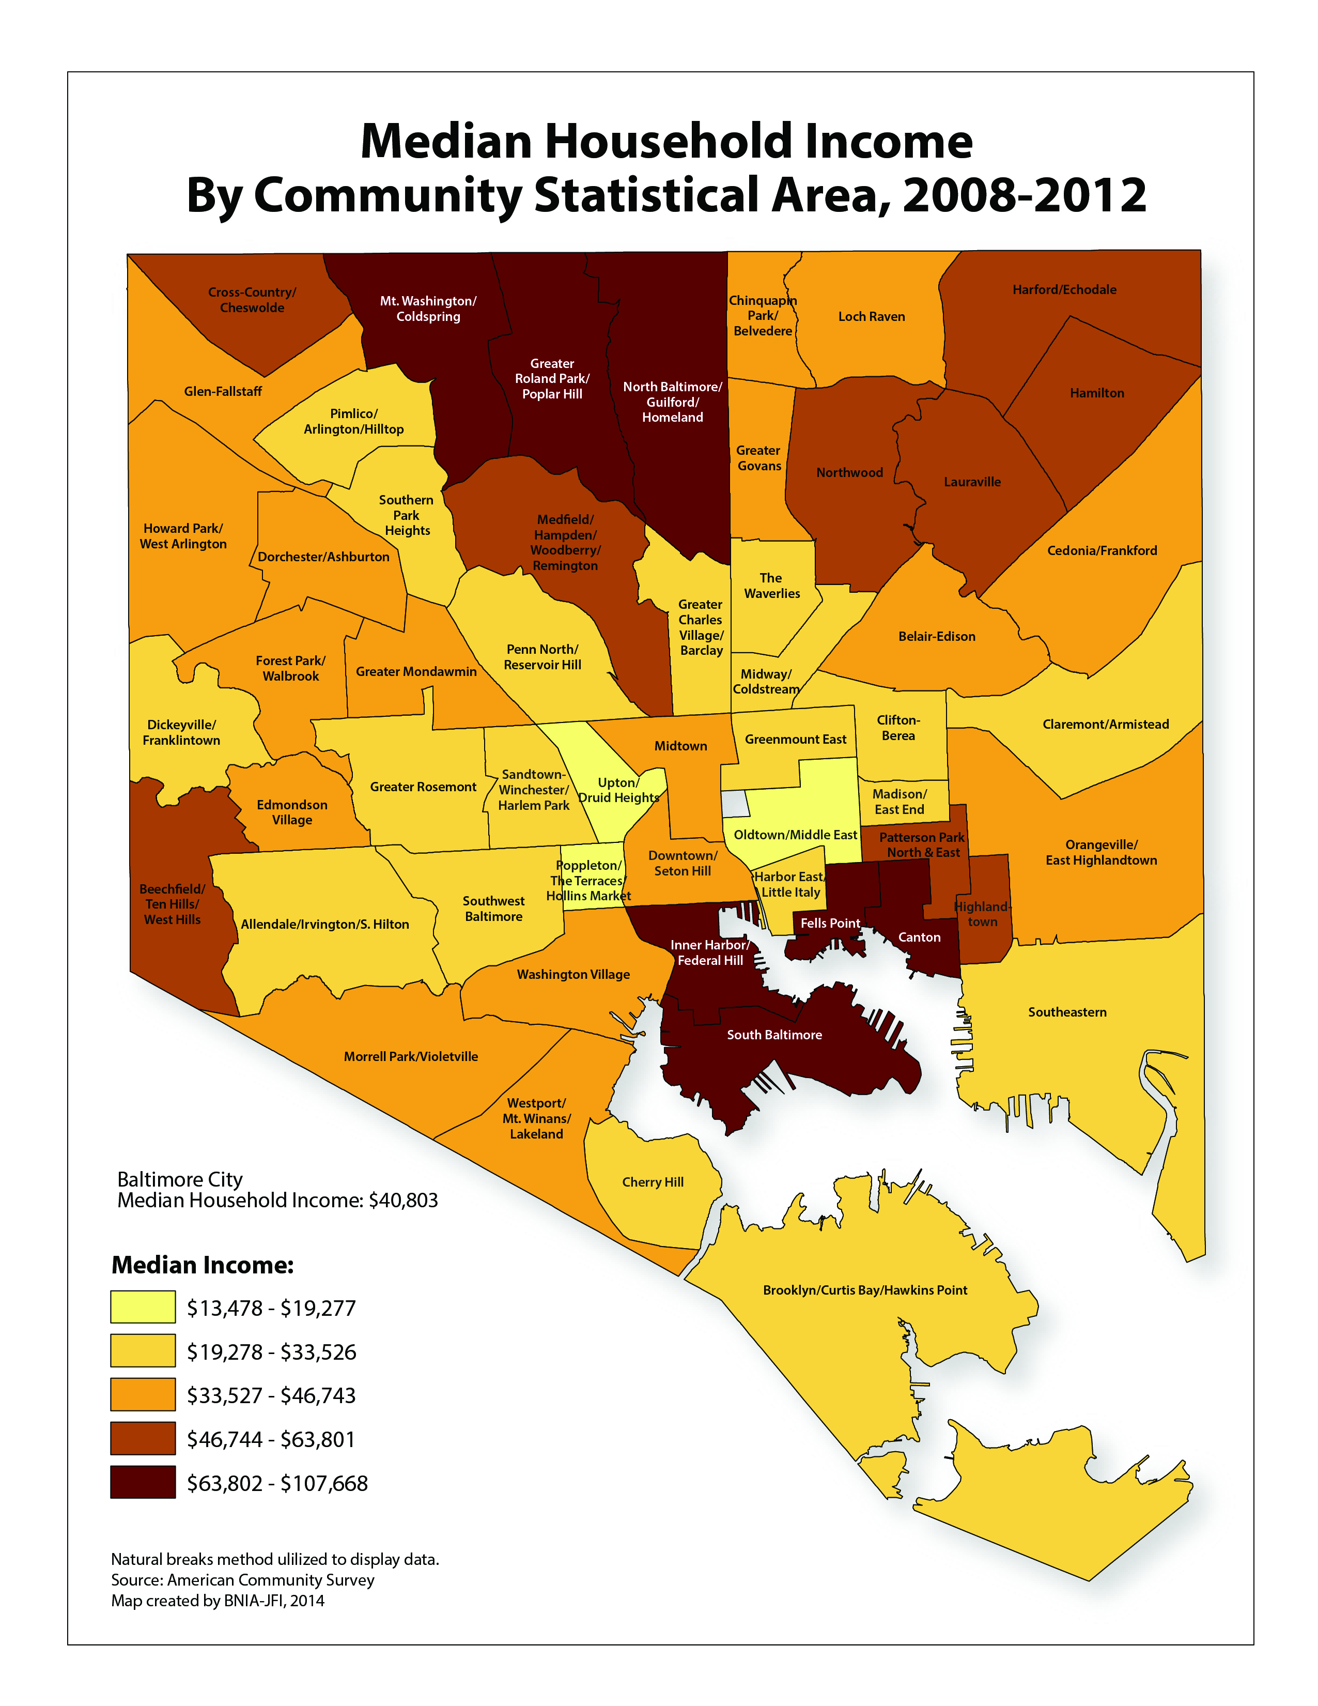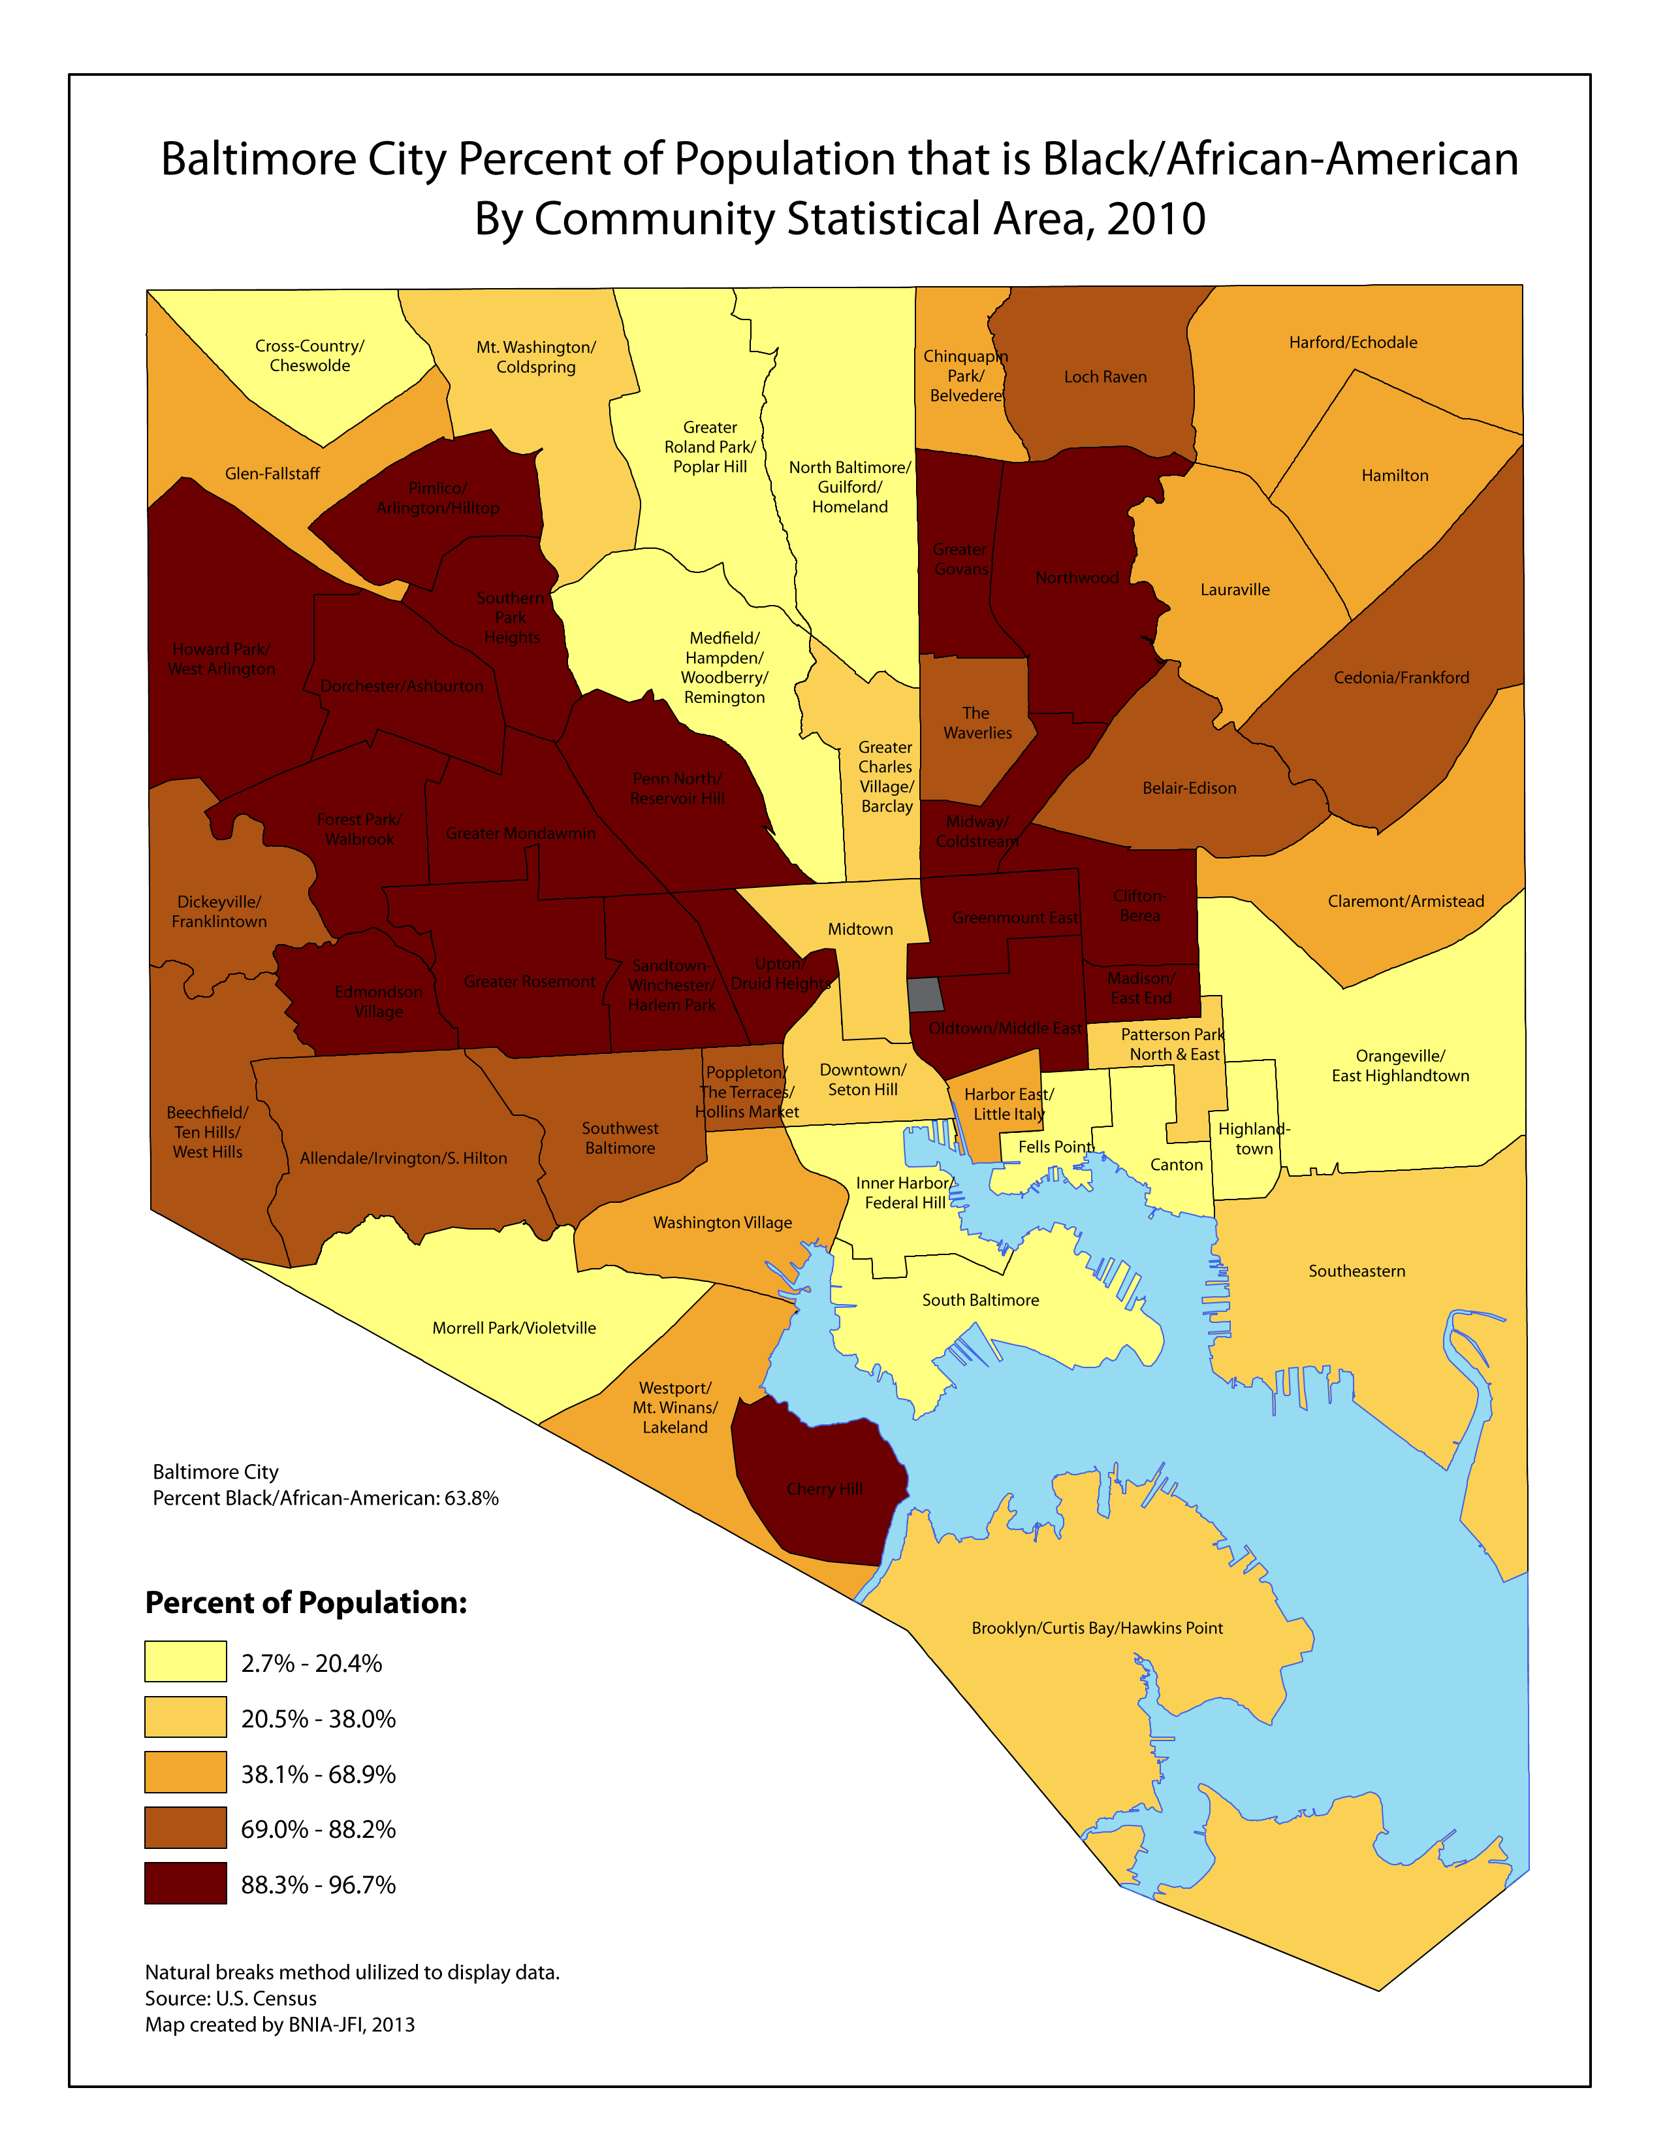
Figure 1: Baltimore city CSA ranking according to median income and racial structure.

Sexual Partnership Module
This module governs the network of sexual partnerships and runs in discrete time steps representing a week. In absence of individual-level data on MSM partnership preferences and sexual history, we rely on population-level behavioral surveillance data available from the recent round of BESURE study, the Baltimore branch of the National HIV Behavioral Surveillance Study [9]. This survey provides global information on frequency of the reported number sexual partners in the past 12 months for different age groups, as well as the type of reported partnerships. Based on this information, and existing models of MSM sexual networks [10–12], we conceptualize the partnership module at the individual-level to accommodate meeting the validation targets at the population level. To this end, we adopt several coefficients of partnerships as a function of age, race, inherent sexual activity level and current partnership status, and model simple-form dynamics for creation/dissolution of sexual partnerships over time.
Partnership types: We model two types of partnerships representing long-term “stable” partnerships with average duration of 4 years [11], and short-term “casual” partnerships with duration of 1 week (updated at each time step). Individuals can only engage in a maximum of one stable and one casual partnership at any point of time [13]. Partnerships are updated at the end of each simulation week, and those partnerships reaching their pre-specified duration are dissolved. In the next step, individuals’ tendency to engage in a new partnership is evaluated and “eligible” individuals proceed to choose the search domain for meeting their future partner based on their location of residence. Once the partnership domain is established, individuals follow a search mechanism based on a combination of race- and age-dependent mixing patterns to select their future partner from the pool of eligible people at that domain. This process is modeled in 3 steps:

Step 1. Evaluating individual’s likelihood for engaging in a new partnership
Individual’s likelihood for engaging in a new partnership is modeled as a function of individual’s current partnership status, age, and their level of sexual activity.
We assume global parameters describing individual’s tendency for engaging in a casual partnership (pCsl) and a stable partnership (pStb) at any point of time, as well as an additional coefficient modeling the relative likelihood for engaging in new casual partnerships concurrent to a stable partnership (pCsl|Stb).
In accordance with the heterogeneous distribution of number of reported partnerships by various age-groups, we adopt a partnership coefficient for likelihood of engaging in new partnerships as function of age (cPart|Age) and model it at five levels corresponding to various age-groups reflected in our validation targets (Age groups={ [15-24],[25-34], [35-44], [45-59], [60-75] years old} .
Furthermore, we model the heterogeneous pattern of sexual activities among MSM via definition of three sexual activity classes, each corresponding to a certain level of sexual engagement over lifetime of individuals. An individuals’ sexual activity level (cSA) is determined at the time of birth and remains fixed throughout their life. This attribute represents a combination of factors determining individual’s tendency for engaging in sexual partnerships, and can be considered as a general marker for various personality types (e.g., shy vs. outgoing person). We assume 3 level of social activity representing low, med, high activity levels, and assume equal likelihood of membership in each class. The levels of sexual activities are further tuned to calibrate the proportion of population reporting zero and more than 5 partners in a given year. We assume that individual’s likelihood for engaging in a stable partnership is independent of the level of their sexual activity.
With these definitions, an individual’s likelihood of engaging in a new stable or casual partnership at each time step is modeled as:
- pNew_Stab = pStb × cPart|Age
- pNew_Csl = pCSL × pCSL|Stb × cPart|Age × cSA

At each time step, individual’s likelihood for engaging in a new partnership is evaluated and eligible individuals are added to the pool of available people at their CSA of residence to find their potential partners in the next steps.

Step 2. Choosing the partnership domain
The partnership domain is determined according to a discrete mixing-structure at the CSA level (Figure 2). In order to model the spatial mixing patterns across the population and among various subgroups, we first define sets of “neighboring” CSA groups with regard to geographical proximity and similar socioeconomic status (income levels) and racial structure [1]. Upon seeking a new partnership, an individual’s search scope (for choosing the new partner) is determined according to a discrete geographical mixing likelihood (pGM ) for selecting one’s own CSA (p₀), a random neighboring CSA (p₁) or non-neighbor CSA (p₂). The geographical mixing likelihood (pGM=(p₀, p₁, p₂)) represents a measure of geographical/socioeconomic clustering in the network of partnerships, where pGM=(1,0,0) translates into an isolated mixing pattern for partnership only with individuals in one’s CSA of residence, and pGM=(0.33,0.33,0.33) translates into a homogeneous mixing structure across the entire population. In our initial analysis, we calibrate the geographical mixing likelihoods at pGM = (50%, 30%, 20%) according to available estimates from [14].

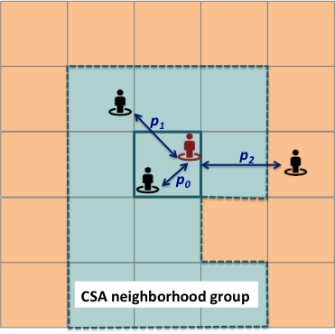
Figure 2: Partnership search domains. Individuals can choose their future partner from one’s own CSA or a random CSA within or outside their neighbor group.

Step 3. Modeling the search mechanism within the partnership domain
Once the partnership domain is established, the individual follows a search mechanism for finding their new partner from the pool of eligible members in the selected domain. The likelihood of partnership between two people is evaluated according to an age- and race-mixing structure. Assuming independent patterns of Age- and race-mixing, the age-race mixing likelihood is computed as the product of age-mixing and race-mixing probabilities for each pair of potential partners. A random search mechanism is implemented to evaluate the probability of partnership with each potential partner in the selected domain until a successful match is found or the entire domain is search. Upon a successful match, a new casual partnership is formed for both parties and they’re excluded from the pool of eligible people.
Age-mixing pattern: The age-mixing is modeled based on absolute difference in the square root (ADSR) of men’s ages [11]. The ADSR provides a closer fit to the observed age-mixing matrix than does age directly. This statistic also has several nice properties, including the fact that the same absolute difference in square root of age becomes less important with older ages. We model the age-mixing likelihood as a function of ADSR and a global coefficient ( cAgeDiff), which is used to calibrate the average level of ADSR in the simulation model. The level of ADSR is further tuned to calibrate the expected levels of HIV incidence in various age-groups. The likelihood of age mixing between person p and q is computed as

pAgeMixing = 1 - | sqrt(p_{age}) – sqrt(q_{age})) / cAgeDiff |

Race-mixing: We model the likelihood of partnership between different races via three coefficient corresponding to a partnership between two white people, two black people, and a white and black person (pRaceMixing=(p_{WW}, p_{BB}, p_{WB}) ). These coefficient are tuned to calibrate the estimated proportion of same race partnerships in Baltimore’s MSM [15,16].

Epidemiological Module
This module governs various aspects of HIV natural history and cascade of care, and is evaluated at the end of each week.

HIV Transmission
HIV transmission is evaluated for all active partnerships of HIV infected individuals with susceptible partners at the end of each week.
The likelihood of transmission is modeled as a function of the HIV-positive partner’s viral load, susceptibility of the HIV-negative partner, and a global transmission coefficient.
Infectiousness: Infectiousness is modeled as a function of viral load corresponding to their disease state and ART status as 2.45^{(log(VL)-4.5)} [17]. The average viral load is assumed to be fixed within each disease stage level according to previous estimates [18].
Susceptibility: Susceptibility to infection is modeled as a function of PrEP usage, ranging between 1 (in absence of PrEP) and 0 (full protection under PrEP).
Transmission coefficient: The transmission coefficient is a simulation variable that captures the baseline probability of HIV transmission per contact and is used to calibrate the model to disease prevalence at equilibrium.
The weekly likelihood of transmission, per contact, is estimated according to the equation:
pTrans(p,q)= CT * (1- q_{Immunity}) * p_{Infectiousness}
where
pTrans(p,q,t): Probability of transmission between person p (infected) and q (susceptible)
CT: Coefficient of transmission
q_{Immunity} : Susceptibility of the HIV-negative partner (i.e., effect of PrEP)
p_{Infectiousness} : Infectiousness of the HIV-positive partner

Table 1 gives the actual values used in the model for this calculation.

Table 1: Weekly probability of HIV transmission over active contacts in the absence of PrEP.
HIV-positive partner’s disease state: | Viral Load | Infectiousness Parameter | Coefficient of Transmission | Weekly probability of transmission per contact
 |  |  | 0.0124
- Acute | 6.5 | 0.037 |  | 0.0004588 (0.0002752)
- Chronic | 4.5 | 0.032 |  | 0.0003968  (0.0002380)
- Late (“AIDS”) | 5 | 0.033 |  | 0.0004092  (0.0002455)
- On ART, partial suppression | 3.5 | 0.029 |  | 0.0003596  (0.0002157)
- On ART, full suppression | 1.5 | 0.021 |  | 0.0002604  (0.0001562)

HIV Natural History
Upon a successful HIV transmission event, individuals experience a gradual decline in CD4 count (accompanied an increase in viral load (VL)) and move through various stages of disease. We consider three disease states in absence of ART, including acute infection lasting for 6 to 9 weeks (CD4 count > 500 cells/ µL), chronic infection lasting 8 to 10 years (CD4 count between 200-500 cells/ µL) and finally late infection lasting 1 to 3 years (CD4 count <200). We further model two disease states in presence of ART, including partial-suppression state in the first 3 to 6 months after ART initiation, and full-suppression state then after. Table 1 provides a list of HIV natural history parameters.

HIV Cascade of Care
The continuum of care for infected individuals is modeled in four levels corresponding to those unaware of their HIV infection, diagnosed HIV cases not linked to care, patients retained in care and on ART, and finally those linked to care but off ART.
Infected individuals are subject to a probability of testing for HIV at the beginning of each week. Upon diagnosis with HIV infection, individuals have the option for linking to care immediately, and those not-linked-to-care are subject to a weekly probability of linking to care in the future. Upon linking to care, individuals experience a fixed likelihood for initiating ART immediately, or staying off ART until initialing it in the future according to a fixed per week probability of reinitiating ART. These parameters are tuned to calibrate the overall proportion of HIV infected MSM on ART.
Those individuals retained in care and on ART experience partial-suppression (associated with a lower viral load) at the first few months after ART initiation before reaching full suppression (associated with a very low viral load). Without modeling the exact pattern of CD4 increase while on ART, we assume that upon achieving viral suppression on ART, individuals transition from late stage infection to the chronic state.
Individual’s adherence to ART is modeled as a step function with fixed probabilities of losing adherence by the first, second and 8th year after initiation of ART (and 50% per year after the 8th year), upon which the individual lose viral suppression immediately. Without modeling the exact level of CD4 decline over time, we assume that partially suppressed individuals will immediately return for to chronic or late disease state based on the original timing of ART (e.g., those starting ART through chronic (or acute) or late infection will return to chronic or late state accordingly). For individuals with full suppression, we assume an immediate return to chronic state. The remaining period in the chronic state is set to an additional 3-6months for those originally started ART through late infection, or alternatively set to the original remaining duration of the chronic state for those initiated ART through acute/chronic infection. These individuals are subject to a weekly probability of reinitiating ART in the future, but can not reinitiate ART for 6 months [19].

Simulation Calibration
Individual-level data (e.g., age- and race-specific probability of condom use) were incorporated as agent-level characteristics. Network-level data (e.g., assortative sexual mixing and frequency of concurrent partnerships) were incorporated as a modification to the sexual partnership module. For example, we calibrated agents’ preferences for selecting sexual partners to provide network-level estimates of assortative mixing and concurrency that were consistent with those measured in BESURE. Data on disparities in clinical care was incorporated as an expansion of the epidemiological module.
Upon collection of all data and incorporation of those data into the model as above, we recalibrated the model as a whole against population census and HIV surveillance data in Baltimore City, to ensure that the model provides realistic outputs. Calibration targets for the model included the size of the MSM population, the frequency distribution and type of reported partnerships in the past year, the number of MSM living with HIV, the proportion of MSM diagnosed and those with suppressed viral loads, and the proportion of HIV infected individuals who are black.

Table 2: List of calibration targets and data sources
Validation Measures | Validation target | Ref.
PARTNERSHHSIPS
Distribution of number of partnerships in the last 12 months | (11, 27, 16, 15, 3, 27)% for (0,1,2,3,4,5+) partners | [9]
Distribution of number of partnerships in the last 12 months for each age-group (values in %) | Number of partners: Age groups:  18-24 25-34 35-44 45-60 60+  0 3.95 7.53 8.2 16.28 18.75  1 28.95 26.71 22.95 33.72 25  2 17.11 8.22 22.95 18.6 12.5  3 17.11 13.01 16.39 8.14 18.75  4 1.32 6.85 3.28 5.81 0  5+ 3.95 15.75 6.56 4.65 6.25 | [9]
Distribution of reported partnership types in the last 12 months | 23%: stable-only  35%: casual-only  41%: stable & casual
Assortative race-mixing proportions in each race | 80%: black-black  92%: white-white | [20]
HIV MEASURES
Prevalence | 3329 infected cases with HIV | [2]
Proportion of HIV infected population diagnosed | 51% | [2]
Proportion of HIV infected population virally suppressed | 34% | [2]
Proportion of HIV infected population currently with AIDS (CD4<200) | 12% | [2]
Proportion of living HIV cases who are black | 76% | [2]
Differential cascade of care in black MSMs (relative to white MSMs) | 90%: Diagnosed  56%: On ART  47%: VL Suppressed | [21]

Burn-in period
The model starts from a randomly generated population of MSM with no active partnership at time zero. In order to create a realistic pattern of sexual partnerships with age, we allowed the original population to age and evolve for one generation (75 years) and then introduced a single HIV infection (randomly according to age, race and location of residence). The model was then run for another generation (75 years) to stabilize the dynamics of disease transmission and entry/exit through the cascade of care. Conservatively, we ran the model for another 50 extra years to ensure reaching a stable level of HIV incidence in the absence of PrEP – thus generating a full burn-in period of 200 years (a decision made on an a-priori basis).

Calculating the require number of independent simulation replications
In order to calculate the required number of independent simulation replications required to ensure appropriate precision of results, we follow the classical literature on calibration of computer simulation models [22]. Running simulation for an initial number of replications, we compute the 95% half-width confidence interval around each simulation output (e.g., prevalence) via:

$$h_{0}=t_{n0-1, α/2} {S_{0}^{2}}/{\sqrt{n_{0}}}$$

where n0 denotes the initial number of replications and S0 is the standard deviation of simulation outputs gathered from each run. Using this information, the sample size (n1) required to achieve a confidence interval with half-width equal to a pre-specified desired h1 level can approximated via in two ways:

$$n_{1}=z_{1-α/2}^{2} {S_{0}^{2}}/{h_{1}^{2}}$$
$$n_{1}=n_{0}{h_{0}^{2}}/{h_{1}^{2}}$$

Using an initial sample of 50 replications, we compute the required number of simulation runs to achieve a 1% error around mean prevalence via both approaches, and choose the maximum suggested value at n1= 85. We round up this number to 100 replications.

Reporting the uncertainty range
Any stochastic simulation model will generate a range of different outcomes over independent simulation runs. For this reason, several replications of the model are performed, and the results are usually reported in terms of the average value over all simulation runs, as well as the range of simulated values (as a representation of uncertainty). Given the highly stochastic nature of our model and the wide uncertainty intervals around simulation outcomes, we applied a resampling approximation method to report the 95% uncertainty range (95% UR) as the 95% UR not around a single simulation, but rather around the mean of 100 simulations. In this method, we initially computed the required within-group sample size to provide a precision of at worst 5% around the main simulation output (HIV incidence) and estimated that at 100 replications (above). In the next step, we ran a large sample of simulation replications (>2000) and then resampled, with replacement (i.e., bootstrapped) random samples of size 100 from the original pool of simulations. We measured the mean value of each output over those 100 simulations and repeated this process (with other groups of 100 simulations) until the distribution of these means was stable. Once we had taken enough bootstrap samples to achieve stability, we estimated the 95% UR as the 2.5th and 97.5th percentile around this outcome (i.e., the mean value of the output across bootstrapped groups of 100 simulations).

Calibrating partnerships
BESURE 2014 provides the main source of local information available on MSM network of partnerships in Baltimore. The data include aggregate information for the reported number of sexual partners (by age-group) and type of those partnerships in the last 12 months (Figure 3-orange bars). Given the aggregate scale of reporting (no data provided at the individual level) and lack of corresponding data from previous surveys, we could not estimate the margin of error around each data point – thereby precluding a precise statistical estimate of goodness-of-fit.
Assuming a fixed mixing structure over time, we use this information to calibrate the individual-level likelihood of engaging in a stable or casual partnership at each simulated time step (week). We use the coefficients of sexual-activity to calibrate the right and left tail of the partnership frequency distribution (for those MSM reporting 0 or more than 5 partners in a given year). The age-dependent coefficients of partnerships are further tuned to calibrate the reported number of partnerships by each age-group. The calibration results are summarized in Figure 3 and 4.

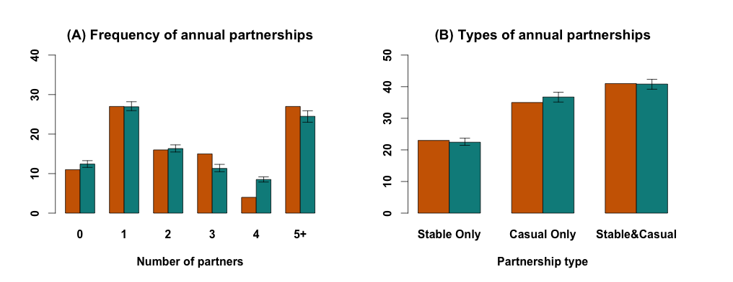
Figure 3: Model Calibration to Epidemiological Data. Shown are the mean values of 200 simulations (in green) compared against empirical data (in orange). The error bars represent the 90% uncertainty range of observations around each simulated measure.
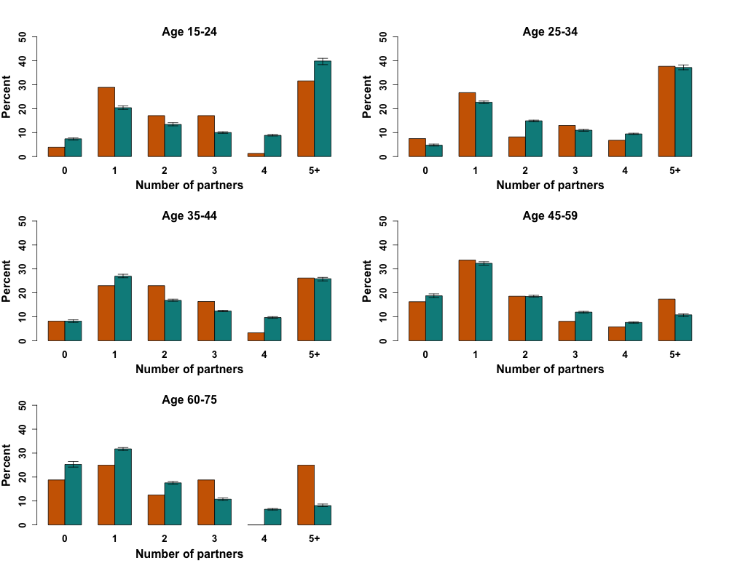
Figure 4: Simulation calibration for frequency of reported partnerships by each age-group. Shown are the mean values of 200 simulations (in green) compared against empirical data (in orange). The error bars represent the 90% uncertainty range of observations around each simulated measure.

Quality of fit:
Given the strong bimodal distribution of partnerships among young adults, we were not able to replicate these empirical distributions precisely and thus chose to minimize the estimation error at the tails of this distribution. There are also conceptual challenges with the empirical data; specifically, BESURE applies a venue-based sampling method, which is more likely to capture a representative sample of young (as opposed to older) MSM. Based on discussions with the BESURE investigators, we felt that the general population of older MSM was likely to have lower numbers of sex partners than reported in BESURE.
Ultimately, what is important from these dynamics is the ability of the model to replicate HIV incidence in these age groups at the population level. While the number of HIV diagnoses is not reported by both age and risk group in Baltimore City (due to low numbers of people reporting risk group), the age breakdown is known – and likely to track the age breakdown of HIV infections among MSM, since MSM account for over 50% of new HIV diagnoses in Baltimore. Baltimore City reports that 5% and 32.8% of all new HIV diagnoses in 2011 occurred in people ages 13-19 and 20-29 [2]; our model estimates that 10.3% [6.4-14.6] and 32.4% [26.7-37.5%] of HIV infections (which occur at an earlier age than diagnosis) occur in this age groups accordingly. Similarly, Baltimore City reports that 3.3% of all new diagnoses occur in those over age 60; our model estimates that 8.8% [5.7-12.3%] of all HIV infections occur in this age group. Thus, if anything, it is likely that our model is overestimating the amount of HIV transmission in the elderly and perhaps underestimating the amount of transmission in the younger age groups. As such, we did not want to force our model to more closely match empirical venue-based estimates of partnership by age at the expense of sacrificing our ability to match the likely dynamics of HIV incidence at the population level.

Calibrating HIV prevalence and the continuum of care
The main calibration targets (model outputs) relating to HIV epidemiology include the estimated prevalence of HIV among MSM in Baltimore City and the proportion of the HIV-positive population that actually resides at each step of the care continuum [2]. We used a repetitive search mechanism that allowed us to tune several input parameters (e.g., per-partnership transmission probability, individual-level probability of screening for HIV, linkage to care, etc.) simultaneously in order to match the calibration targets at baseline (Figure 5). The output values (calibration targets) are not set at model initialization; rather, the input parameters are calibrated in order to hit these output values at baseline (corresponding to the present day).

Figure 5: Simulation calibration for HIV prevalence and the continuum of care. Shown are the mean values of 200 simulations (in green) compared against empirical data (in red). The error bars represent the 90% uncertainty range of observations around each simulated measure.

Calibrating age- and racial-disparity in HIV infection
Regarding age, we decided to use empirical data on the number of partnerships by age, rather than calibrating to age-specific HIV prevalence. Figure 6 compares model-estimated incidence to the number of reported new HIV diagnoses, by age (even though age-specific incidence is not a model calibration target per se). This figure suggests good overall fit of the model.

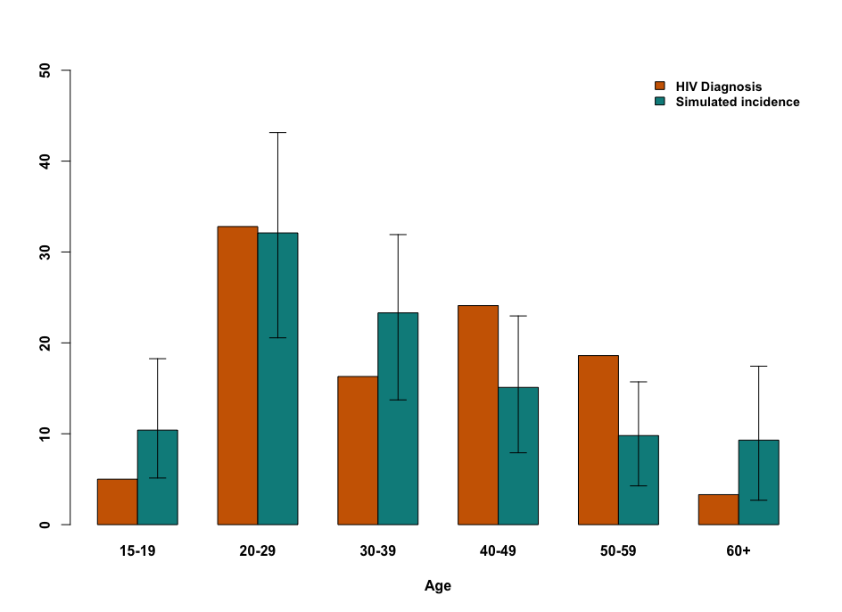
Figure 6: Distribution of simulated HIV incidence versus reported number of HIV diagnosis in each age group. Orange bars show the number of new HIV diagnoses reported in Baltimore City among MSM in 2012. Green bars show the estimated incidence of HIV in this population in the simulation model.

Despite capturing the reported levels of age- and race-assortative mixing among black and white MSM and calibrating the initial population according to the current levels of HIV infection in each age- and race-group, our preliminarily results underestimated the levels of disparity in HIV prevalence between black and white MSM over time. Despite general hypothesis, previous studies have not detected a significant difference in sexual risk behaviors by MSMs of each race, and in the absence of such difference, we assume that the disparity can partially root in differential levels of access, linkage and engagement in care by MSM of each race, as proposed by previous studies [23]. To that end, we implemented a simulation coefficient to distinguish the level of access to care (at all levels of diagnosis, linkage, and ART initiation) between black and white MSM in the model, and tuned this parameter to calibrate the reported disparity in proportion of HIV prevalence attributable to each race (i.e., ~76% infection in Black MSM and 24% in white MSM).

RESULTS

Population overview
After calibrating to an HIV prevalence of 22% among MSM [2], our model projects an HIV incidence of 208.6 cases per 100,000 person year in the absence of PrEP. Young black MSM between ages of 15 to 29 account for 18.5% of the population but 36% of incident HIV infections (Figure 7). Black MSM account for 80% of HIV incidence in this model, and they have 30-50% lower levels of being diagnosed, in care on ART, and virally suppressed, relative to white MSM (Figure 8).

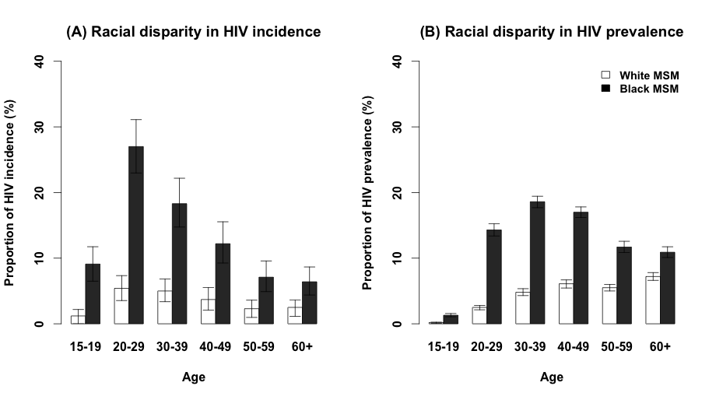
Figure 7: Simulated distribution of simulated HIV incidence and prevalence in each age/race. Shown are the mean values of 200 simulations comparing the annual incidence and prevalence of HIV by age and racial composition (black MSM are shown in dark and white MSM are shown in light bars). The error bars represent the 90% uncertainty range of observations around each simulated measure. Black MSM carry a higher burden of HIV infections (more than 80%), and young black MSM account for the highest ratio of new infections in each year.

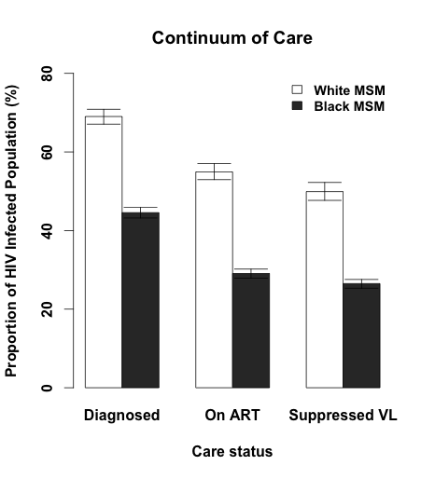
Figure 8: Simulated distribution of HIV continuum of HIV care by race. Shown are the mean values of 200 simulations comparing the HIV continuum of care by racial composition (black MSM are shown in dark and white MSM are shown in light bars). The error bars represent the 90% uncertainty range of observations around each simulated measure. Black MSM have 30-50% lower levels of being diagnosed, in care on ART, and virally suppressed, relative to white MSM.

Impact of PrEP on HIV incidence
Figure 9 to 13 show the annual impact of PrEP on HIV incidence under each PrEP scenario. Each panel represents the percent reduction in HIV incidence at various levels of population coverage (on the x-axis, with numbers of MSM on PrEP on top and percent of eligible population covered in parentheses) and individual adherence (on the y-axis, modeled as the percentage of days with immunity to HIV infection), at the end of each year during/after a five-year PrEP campaign, compared to a baseline of no PrEP delivery. The program starts at the beginning of year 1, with immediate achievement of full impact, and stops at the end of year 5, with immediate cessation of impact (as seen in the sixth panel). Contour lines are labeled with the percent reduction in HIV incidence achieved.

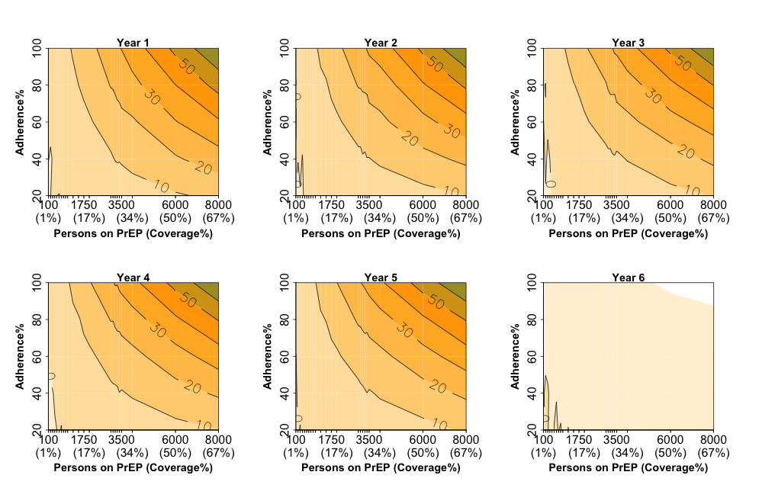
Figure 9: Annual impact of PrEP on HIV incidence under scenario 1. This scenario assumes universal administration of PrEP to all HIV-negative individuals.
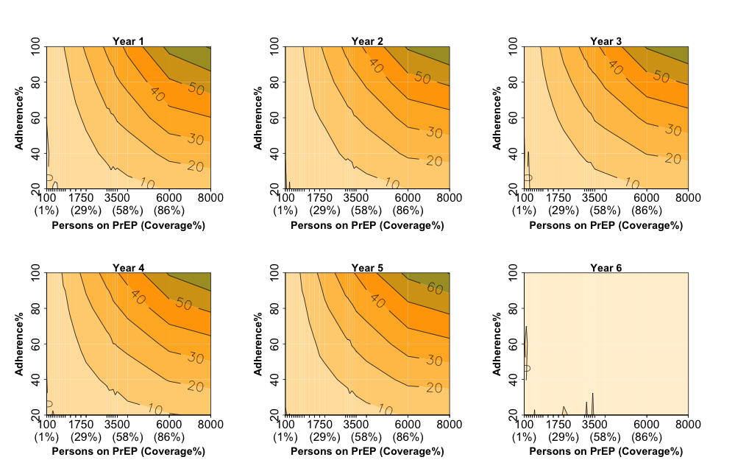
Figure 10: Annual impact of PrEP on HIV incidence under scenario 2. This scenario models administration of PrEP to all HIV-negative individuals reporting more than one sexual partner in the last 12 months.

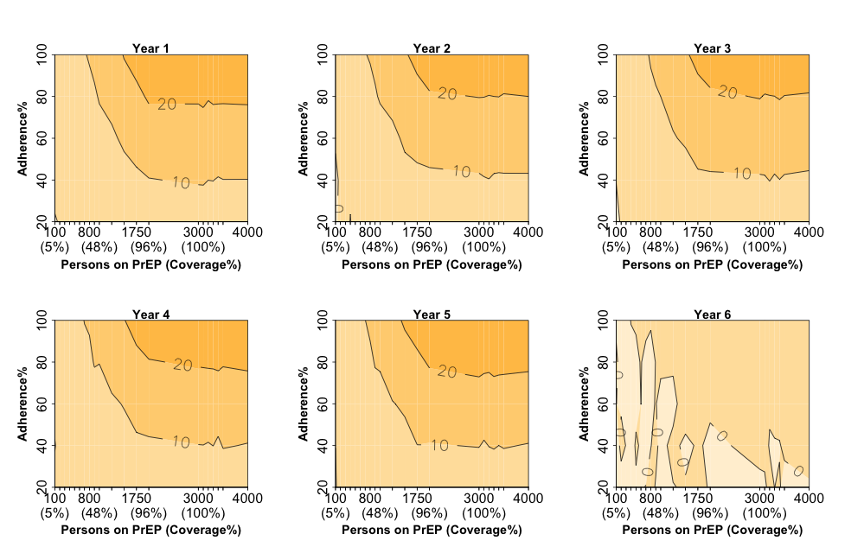
Figure 11: Annual impact of PrEP on HIV incidence under scenario 3. This scenario models administration of PrEP to all HIV-negative individuals reporting more than five sexual partner in the last 12 months

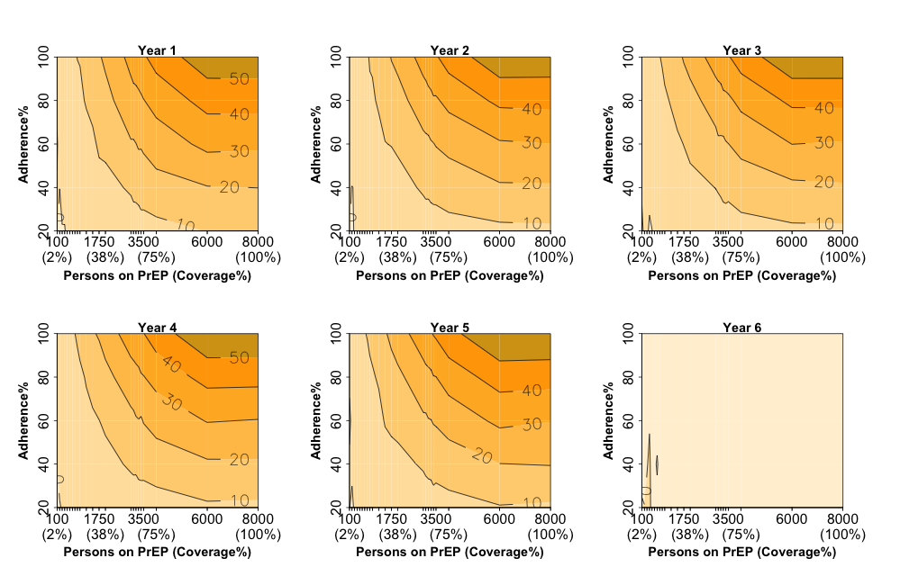
Figure 12: Annual impact of PrEP on HIV incidence under scenario 4. This scenario models administration of PrEP to all HIV-negative young MSM between the age of 15 and 29.
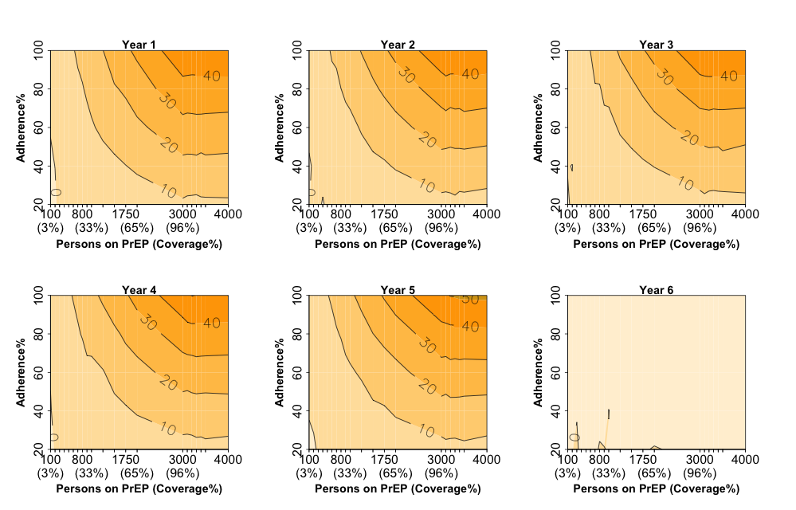
Figure 13: Annual impact of PrEP on HIV incidence under scenario 5. This scenario models administration of PrEP to all HIV-negative young black MSM between the age of 15 and 29.

Impact of PREP under various program duration
In the initial analysis, we considered a short term program for provision of PrEP in 5 consecutive years. We further increase the length of this program to assess the impact on HIV incidence and prevalence over time. For this experiment, we consider a program for provision of PrEP to high-risk MSM reporting more than one partner in the last year (according to scenario 2), assuming no capacity constraint on the number of individuals receiving PrEP in each year and 80% adherence to treatment. Figure 14, panel A, compare the annual % reduction in HIV incidence and prevalence over the 20 years of implementing PrEP according to this program. Despite fast reduction in the level of HIV incidence after the beginning of PrEP, the impact on HIV prevalence is slower to achieve and requires a long and sustained effort over time. Figure 14, panel B, shows compares the impact of program duration (e.g., set to 5, 10, 15 and 20) on sustainability of impact on HIV incidence after the end of programs when all individuals are taken off PrEP. Short-term provision of PrEP (e.g., a 5 year program) did not provide significant improvements in the level of HIV prevalence and as such, it didn’t provide a sustained improvement in the level of HIV incidence once the program is ended. In contrast, long-term programs achieving at least 20% improvement in the underlying prevalence of HIV over years continued to control the level of HIV incidence at a reduced level (relative to reduction in prevalence) after the end of PrEP (e.g., as seen for a 15 year program in Figure 14).
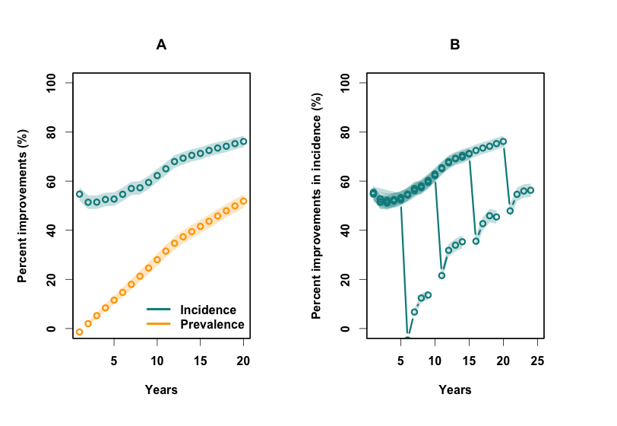
Figure 14: Annual impact of PrEP on HIV incidence and prevalence under scenario 2, assuming no capacity constrains and 80% adherence to treatment. The shaded areas represent 95% confidence interval around the mean value of 200 simulations.

Sensitivity analysis

Analysis design
One-way sensitivity analysis of simulation results was performed with regard to all model parameters (listed in Table 3), including all the fixed- (values set to the best estimate from the literature) and variable-inputs (tuned to meet the calibration targets). The main outputs of interest were a) the underlying level of HIV incidence in the absence of PrEP, and b) the percent reduction in HIV incidence after ten years of universal PrEP implementation (Scenario1). For this purpose, we started the analysis by running each model for 200 years to reach the steady state, and then changed each simulation parameter to +/- 25% of its original values while keeping all others fixed at the original value. The new model was run for another 20 years to insure that the parameter change is in effect before staring the sensitivity analysis.

Table 3: List of all (fixed and variable) model parameters. The Fixed parameters are calibrated to best available estimates from the literature. The variable parameters are tuned to calibrate simulation outputs.
ID | Name | Description | Value | Type
1 | pEngage_Casual | Individual’s likelihood for expressing interest in forming a new stable partnership if currently single | 0.02 | Variable
2 | pEngage_Stable | Individual’s likelihood for expressing interest in forming a new casual partnership | 0.09 | Variable
3 | cEngage_Casual_Based_Stable | Coefficient for adjusting the likelihood of engaging in casual partnership if currently in a stable relationship | 0.35 | Variable
4 | pCSA_Mixing | Individual’s likelihood of choosing partnership domain from (his own CSA, CSAs in the same group, any other CSA) | 0.5: Inside CSA  0.3: Among CSA group  0.2: Outside of CSA group | Fixed (Modeling Assumption)
5 | cRace_Mixing | Coefficients of partnership between any two MSM based on race ([W-W],[B-B],[W/B]) | 0.081: [WW]  1: [BB]  0.07: [WB] | Variable
6 | cAge-Diff | A fix coefficient used to calibrate the age mixing | 4 | Variable
7 | cSexualActivity | Coefficient of sexual activity influencing individual’s likelihood for engaging in a new partnership at all times | 0.2: low  1.3: med  3.0: high | Variable
8 | cPArtnership_With_Age | Coefficients of partnership influencing individual’s likelihood for engaging in a new partnership as a function of age | 1.0: age 15-24  1.0: age 25-34  0.7: age 35-44  0.4: age 45-60  0.4: age 60-75 | Variable
9 | cTransmission | Coefficient of transmission over each active partnership (used to calibrate incidence) | 0.0124 | Variable
10 | dAcute | Duration of disease state 1 | Uniform (6,9) weeks | Fixed (Literature)
11 | dChronic | Duration of disease state 2 | Uniform (416,520) weeks | Fixed (Literature)
12 | cAIDS | Duration of disease state 3 | Uniform (52,156) weeks | Fixed (Literature)
13 | dPArtialSupp | Duration of disease state 4 | Uniform (13, 27) weeks | Fixed (Literature)
14 | dChronic_after_ART | Duration of chronic HIV after losing adherence to ART for those with a history of AIDS | Uniform (12, 36) weeks | Fixed (Literature)
15 | pHIV_Mortality | Annual rate of HIV mortality | 0.005 | Fixed (Literature)
16 | pHIV_Mortality_ART_Coef | Reduced HIV mortality for those on ART | 0.58 | Fixed (Literature)
17 | cVL | Coefficients of Viral Load for individuals in each state of disease (acute, chronic, late, partial-, full suppression) | 6.5: Acute infection  4.5: Chronic infection  5.0: Late infection  3.5: Partial suppression  1.5: Full suppression | Fixed (Literature)
18 | cAccess_Care | Coefficient of access to care for black and white MSM  Influencing the likelihood of testing, linkage to care, and initiating ART at all times | 1: White MSM  0.5: Black MSM | Variable
19 | pTesting | Individual’s likelihood of taking HIV test throughout a year | 0.09 | Variable
20 | pLinkCare_Immediately | Individual’s likelihood of linking to care immediately after diagnosis | 0.8 | Variable
21 | pLinkCare_later | Individual’s likelihood of linking to care after diagnosis | 0.8 | Variable
22 | pStart_ART_Immediately | Individual’s likelihood of initiating ART after linkage to care | 0.9 | Variable
23 | pRestart_ART | Individual’s likelihood of initiating ART per year | 0.9 | Variable
24 | dGap_In_Care | Duration of gap in care after losing adherence to ART | 26 weeks | Fixed
25 | pLose_Adh_ART | Individual’s likelihood of losing adherence to ART in (1, 2, 8) years after initiation | 0.24: In the 1st year  0.5: In the 2nd year  0.9: Until the 8th year | Fixed (Literature)
26 | cLose_Adh_ART | A simulation coefficient used to adjust the adherence to ART and calibrating the cascade of care | 0.7 | Variable

Sensitivity analysis of HIV incidence in the absence of PrEP:
After implementing the parameter change and running the model for an additional burn in period (20 years), we mapped the new level of HIV incidence over 10 years of analysis and compared that with the original level of HIV incidence in the baseline model. Using a threshold of 25% to identify significant effects, HIV incidence was sensitive to variation of several model parameters pertaining to probability of transmission (e.g., Viral load levels determining HIV infectiousness), and frequency of sexual contacts (Figure 15).

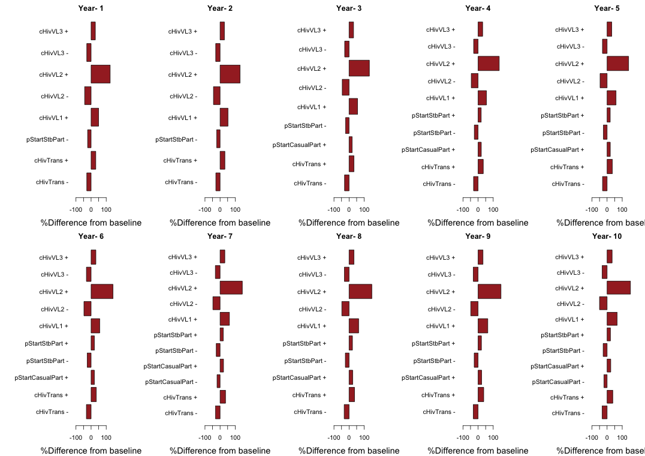
Figure 15: Sensitivity analysis of annual HIV incidence to variation of all model parameters in the absence of PrEP. The x-axis shows the percent difference in the incidence after the parameter change relative to its baseline value [ranging from -100% to +100%]. The Y-axis shows the corresponding parameter change, with +/- sign representing a 25% increase/decrease in the original value. Using a threshold of 25% to detect significant variations from baseline (highlighted in red), presented SA scenarios carry a significant impact on HIV incidence.

Sensitivity analysis of the impact of PrEP on HIV incidence:
Since our viral load and HIV transmission parameters end up being multiplied together, or even exponentiated – a 25% variation in the original parameter value often resulted in unreasonably large shifts in HIV incidence, in the absence of PrEP. For example, a 25% change in estimated viral load during the chronic phase results in an increase of more than 150% in the HIV incidence in this population – a level of variation that is not epidemiologically reasonable in Baltimore City (and indeed, the very reason that we calibrated the model to HIV prevalence, as above). As a result, reporting sensitivity of the model to a “25% change in viral load during the chronic phase” is misleading, as this is actually reporting the sensitivity of the model to a >150% change in baseline incidence.
After seeing this, we instead took each of the viral load parameters and evaluated what degree of change in those parameters would result in a roughly 25% change in HIV incidence. We found that, regardless of the parameter chosen, the sensitivity of the relative impact of PrEP scaled with the effect of the parameter on HIV incidence. For example, a 3.5% increase in viral load during the chronic phase results in a 17% increase in HIV incidence, under which the relative impact of PrEP increases by 10%. Similarly, a 15% increase in viral load during the late phase results in a 20% increase in HIV incidence, under which the relative impact of PrEP increases by 12% (Figure 16). When these parameters are varied in such a way to generate a <= 25% change in HIV incidence at baseline, the change in PrEP impact actually falls below our pre-defined threshold of +/-25% (Figure 17).

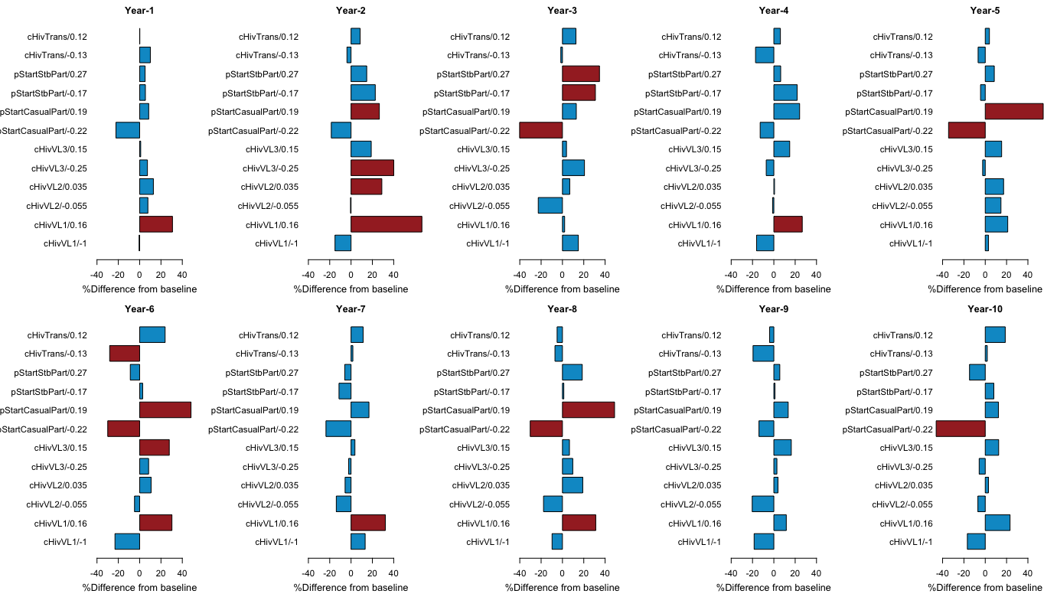
Figure 16: Sensitivity analysis of the impact of PrEP on HIV incidence to variation of selected model parameters. Panels map the relative impact of PrEP on incidence in the first 10 years of implementation according to scenario 1, assuming 60% protection. The x-axis shows the percent difference in the corresponding output after the parameter change relative to its baseline value. The Y-axis shows the corresponding parameter change, with the noted variation in the original value to provide a roughly 25% change in HIV incidence. Using a threshold of 25% to detect significant variations from baseline (bars highlighted in red), none of the SA scenarios carries a significant impact on results that persists over time.
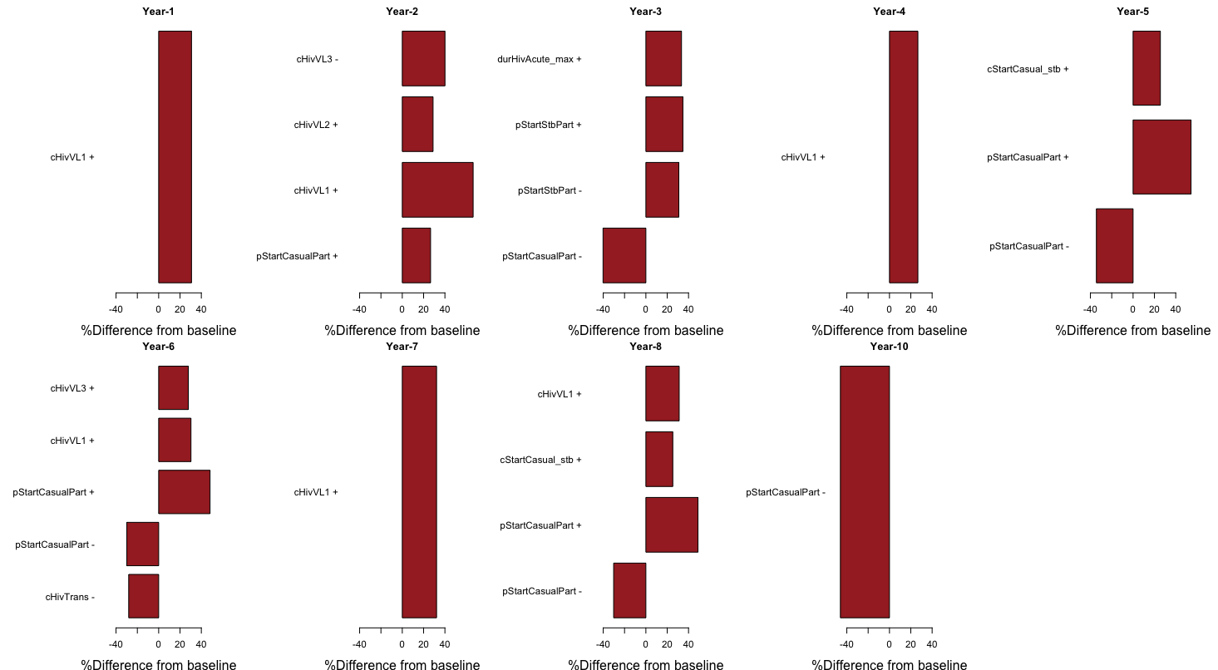
Figure 17: Sensitivity analysis of the impact of PrEP on HIV incidence to variation of all model parameters. Panels map the relative impact of PrEP on incidence in the first 10 years of implementation according to scenario 1, assuming 60% protection. The x-axis shows the percent difference in the corresponding output after the parameter change relative to its baseline value. The Y-axis shows the corresponding parameter change, with +/- sign representing variation in the original value. Using a threshold of 25% to detect significant variations from baseline (only significant values are shown), none of the SA scenarios carries a significant impact on results that persists over time.

Sexual positioning (and corresponding differences in HIV transmissibility)
Given the main aim of this study to explore the population-level impact of PrEP, we have adopted several simplifying assumption regarding the heterogeneity of susceptibility to HIV infection. We note that this approach is also taken by a number of other recently published studies in the literature [13,24,25].
Nevertheless, in order to examine the potential impact of this assumption on our results, we constructed a test model in which we have assumed that 42% of MSM are insertive-only, 26% are receptive-only and the rest are versatile in their preference for an insertive or receptive role (estimated values are based on recent and unpublished data from BESURE [26]). We further modified the sexual partnership formation to match for sexual positioning, and assumed that within each active sexual contact, those in a receptive role carry a higher probability of HIV transmission (using a similar structure as Jenness 2016 [27]). We also modeled the likelihood of condom use in each partnership type and used the corresponding data reported through BESURE to calibrate the preference for condom use among MSM:
- Proportion of MSM never using a condom in a casual partnership: 47%
- Proportion of MSM sometimes using a condom in a casual partnership: 12%
- Proportion of MSM never using a condom in a stable partnership: 45%
- Proportion of MSM sometimes using a condom in a stable partnership: 55%
Those reporting use of a condom sometimes were assumed to have a 50% probability of condom use in each active partnership, with condom use providing 80% protection against transmission for both partners. Under these new assumptions, we recalibrated the new model with regard to HIV prevalence and compared the results in terms of PrEP effectiveness for reducing HIV incidence over time. Assuming a universal PrEP campaign screening 50 random MSM each week and delivering PrEP with adherence of 60% for 5 years, the percent reduction in HIV incidence relative to the baseline (without PrEP) was 34.4% [range 29%-37%] in the original model and 33.1% [range: 27%- 39%] in the new model. Based on these results– and the theoretical argument that sexual position should not dramatically affect the relative impact of PrEP (measured in terms of % of infections averted) – we chose to use a simpler model that highlights the basic relationships that we are aiming to explore (e.g., between coverage/adherence and PrEP impact) with a minimum of additional assumptions incorporated.

References
1. Alliance BNI. Vital Signs 12 [Internet]. 2012. Available: http://bniajfi.org/vital_signs/
2. Maryland Department of Health and Mental Hygiene, MDHMH. 2012 Baltimore City Annual HIV Epidemiological Profile. Baltimore; 2012.
3. World Health Organization. Life tables by country United States of America. In: Global Health Observatory Data Repository [Internet]. 2013. Available: http://apps.who.int/gho/data/view.main.61780?lang=en
4. Purcell DW, Johnson CH, Lansky A, Prejean J, Stein R, Denning P, et al. Estimating the population size of men who have sex with men in the United States to obtain HIV and syphilis rates. Open AIDS J. 2012;6: 98–107. doi:10.2174/1874613601206010098
5. AC K, WB P, CD. M. Sexual behavior in the human male. Philadelphia: W. B. Saunders; 1948.
6. Diamond M. Homosexuality and bisexuality in different populations. Arch Sex Behav. 1993;22: 291–310.
7. Black D, Gates G, Sanders S, Taylor L. Demographics of the gay and lesbian population in the United States: Evidence from available systematic data sources.". Demography. 2000;37: 139–154.
8. Lieb S, Fallon SJ, Friedman SR, Thompson DR, Gates GJ, Liberti TM, et al. Statewide Estimation of Racial/Ethnic Populations of Men Who Have Sex with Men in the U.S. Public Health Rep. 2011;126: 60–72.
9. German D. BESURE Study: National HIV Behavioral Surveillance Study in Baltimore [Internet]. Available: http://www.jhsph.edu/faculty/research/map/US/1413/8192
10. Xiridou M, Geskus R, de Wit J, Coutinho R, Kretzschmar M. The contribution of steady and casual partnerships to the incidence of HIV infection among homosexual men in Amsterdam. AIDS. 2003;7: 1029–1038.
11. Beyrer C, Baral SD, van Griensven F, Goodreau SM, Chariyalertsak S, Wirtz AL, et al. Global epidemiology of HIV infection in men who have sex with men. Lancet. 2012;380: 367–77.
12. Hoare A, Gray RT, Wilson DP. Could implementation of Australia’s National Gay Men’s Syphilis Action Plan have an indirect effect on the HIV epidemic? Sex Health. 2012;9: 144–151.
13. Vieira IT, Senna V de, Pereira. HB de B. A small world model for the spread of HIV infection. Pesqui Operacional. 2011;31: 373–389.
14. Egan JE, Frye V, Kurtz SP, Latkin C, Chen M, Tobin K, et al. Migration, neighborhoods, and networks: approaches to understanding how urban environmental conditions affect syndemic adverse health outcomes among gay, bisexual and other men who have sex with men. AIDS Behav. 2011;15: 35–50.
15. White JM, Reisner SL, Dunham E, Mimiaga MJ. Race-Based Sexual Preferences in a Sample of Online Profiles of Urban Men Seeking Sex with Men. J Urban Heal. 2014;91: 768–775.
16. Wilson DP. Modelling based on Australian HIV notifications data suggests homosexual age mixing is primarily assortative. J Acquir Immune Defic Syndr. 2009;51: 356–360.
17. Wilson DP, Law MG, Grulich AE, Cooper DA, Kaldor JM. Relation between HIV viral load and infectiousness: a model-based analysis. Lancet. Elsevier; 2008;372: 314–20. doi:10.1016/S0140-6736(08)61115-0
18. Beyrer C, Baral SD, van Griensven F, Goodreau SM, Chariyalertsak S, Wirtz AL, et al. Global epidemiology of HIV infection in men who have sex with men. Lancet. 2012;380: 367–77. doi:10.1016/S0140-6736(12)60821-6
19. Rana AI, Liu T, Gillani FS, Reece R, Kojic EM, Zlotnick C, et al. Multiple gaps in care common among newly diagnosed HIV patients. AIDS Care. 2015;27: 697–687.
20. Maulsby C, Jain K, Sifakis F, German D, Flynn CP, Holtgrave D. Individual-Level and Partner-Level Predictors of Newly Diagnosed HIV Infection Among Black and White Men Who Have Sex with Men in Baltimore, MD. AIDS Behav. 2014; 1–9.
21. Rosenberg ES, Millett GA, Sullivan PS, Rio C del, Curran JW. Understanding the HIV disparities between black and white men who have sex with men in the USA using the HIV care continuum: a modelling study. Lancet HIV. 2014;1: e112–e118.
22. Law AM, Kelton WD. Simulation Modeling and Analysis. Third. McGraw-Hill; 2000.
23. Sullivan PS, Peterson J, Rosenberg ES, Kelley CF, Cooper H, Vaughan A, et al. Understanding racial HIV/STI disparities in black and white men who have sex with men: a multilevel approach. PLoS One. 2014;9: e90514.
24. Marshall BD, Paczkowski MM, Seemann L, Tempalski B, Pouget ER, Galea S, et al. A complex systems approach to evaluate HIV prevention in metropolitan areas: preliminary implications for combination intervention strategies. PLoS One. 2012;7: e44833.
25. Alam SJ, Meyer R, Norling E. A model for HIV spread in a South African village. Multi-Agent-Based Simul IX. 2009; 33–45.
26. Maryland Department of Health and Mental Hygiene. BESURE Study 2004-2014: Baltimore site of National HIV Behavioral Surveillance (NHBS) [Internet]. 2015.
27. Jenness S, Goodreau S. Impact of the Centers for Disease Control’s HIV preexposure prophylaxis guidelines for men who have sex with men in the United States. J Infect. 2016; Available: http://jid.oxfordjournals.org/content/early/2016/07/12/infdis.jiw223.abstract

Estimates are based on reported surveillance data from MSM and MSM/IDUs

