Supplementary Material

Epigallocatechin gallate inhibits macaque SEVI-mediated enhancement of SIV or SHIV infection
Run-Hong Zhou¹, Le Guo¹, Jin-Biao Liu¹, Hang Liu¹, Wei Hou¹, Tong-Cui Ma¹, Xu Wang², Jian-Guo Wu¹, Li Ye³, Wen-Zhe Ho^{1, 2*}, and Jie-Liang Li^{2*}
*Correspondence to: Wen-Zhe Ho wenzheho@temple.edu and Jieliang Li leejl77@temple.edu

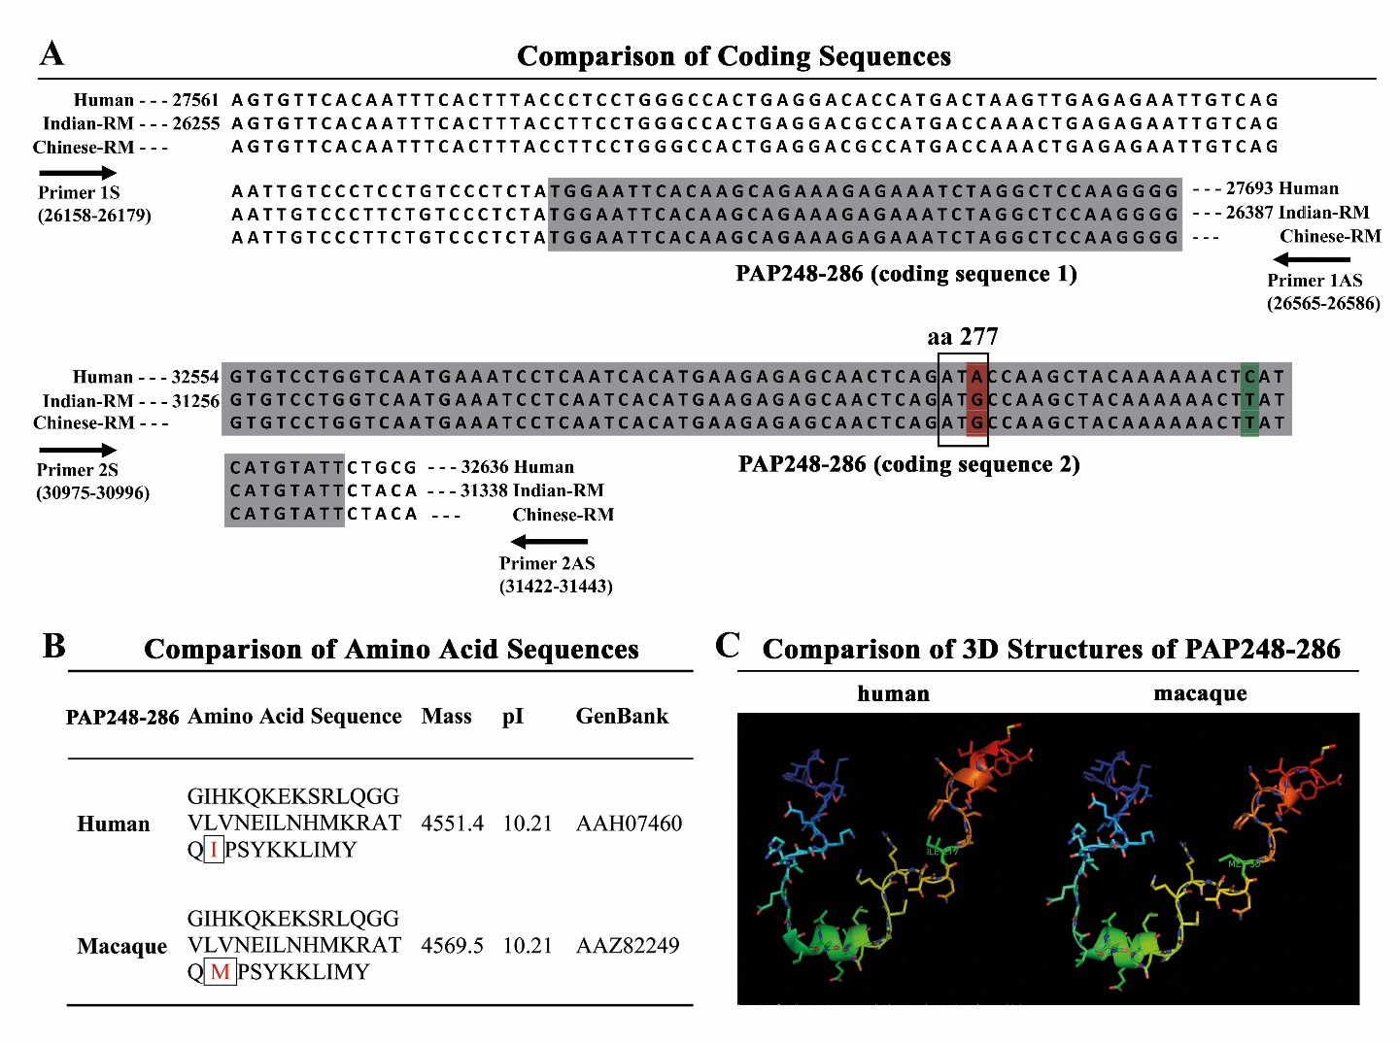 Fig. S1. Comparison of the human PAP248-286 and macaque PAP248-286 coding sequences and peptides. (A) Alignment of the coding sequences of human PAP248-286 and macaque PAP248-286. The gray color highlights the two coding sequences of PAP248-286. The nucleotide sequences that encodes the amino acid 277 of PAP248-286 are boxed in the gray frame. The red highlight was the nucleotide substitution that results in the amino acid difference between human and macaque PAP248-286. (B) Comparison of the amino acid sequences between the human and macaque PAP248-286. (C) The 3D structures of PAP248-286. The structure of human PAP248-286 (left) was download from RCSB PDB (2L3H). The structure of macaque PAP248-286 (right) was derived with the Swiss-Model structure prediction server via Expasy (www.expasy.ch) and drawn with PyMol.

Fig. S2. Cytotoxicity analysis of SEVI or EGCG. TZM-bl cells (open bar) and macaque PBMC (solid bar) were exposed to the indicated concentrations of macaque SEVI (A) or EGCG (B) for 3 h. The cells were then washed and cultured in the fresh medium without SEVI or EGCG. The cell viability was measured at day 2 (for TZM-bl cells) or day 6 (for macaque PBMC) in culture. Data were expressed as mean ± SD of three independent experiments (*P<0.05, **P<0.01, compared with no treatment control).

