Supplemental Digital Content
Supplemental Digital Content 1. Map of Uganda showing location of study sites by arm
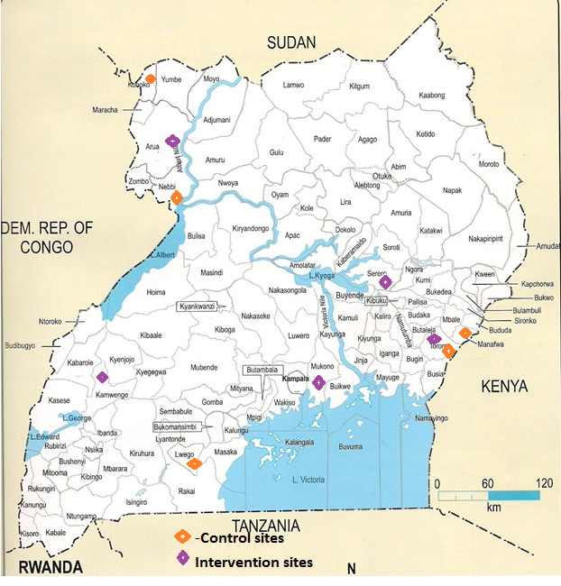

Supplemental Digital Content 2: Table of changes in case scenario scores of mid-level providers in intervention and control arms
Primary outcome | Covariates | Control Arm (N=20) |  |  |  | Intervention Arm (N=19) |  |  |  | Intervention Effect
 |  | Baseline Score | Endline Score | Mean change |  | Baseline Score | Endline Score | Mean change |  | Difference in differences
 |  | % | % | % (95% CI) |  | % | % | % (95% CI) |  | % (95% CI) | p-value
Case Scenario scores | Professional Cadre:
 | Clinical Officers | 60.3 | 58.2 | -2.1 (-8.5, 4.3) |  | 61.9 | 67.4 | 5.5 (-9.0, 20.1) |  | 7.6 (-7.3, 22.5) | 0.278
 | RN/MW* | 45.5 | 44.6 | -0.8 (-3.7, 2.1) |  | 46.2 | 63.2 | 17.0 (10.3, 23.7) |  | 17.8 (11.2, 24.4) | <0.001
 | Gender
 | Female | 48.3 | 47.1 | -1.2 (-4.3, 2.0) |  | 52.6 | 63.1 | 10.4 (4.6, 16.3) |  | 11.6 (5.3, 18.0) | 0.001
 | Male | 51.7 | 50.7 | -1.0 (-4.9, 2.9) |  | 45.5 | 69.9 | 24.4 (-1.5, 50.3) |  | 25.4 (8.1, 42.7) | 0.010
 | Years of practice:
 | Less/equal 2yrs | 47.0 | 46.5 | -0.5 (-4.9, 3.9) |  | 51.0 | 65.2 | 14.2 (-2.4, 30.8) |  | 14.7 (1.2, 28.2) | 0.035
 | Greater 2yrs | 50.9 | 49.3 | -1.6 (-4.8, 1.6) |  | 51.2 | 64.1 | 12.9 (6.7, 19.1) |  | 14.6 (7.8, 21.3) | <0.001
 | Monthly average HIV clients
 | Less than 291 | 50.0 | 49.5 | -0.5 (-2.8, 1.8) |  | 53.5 | 66.3 | 12.8 (-9.9, 35.4) |  | 13.3 (5.0, 21.5) | 0.003
 | Greater than 291 | 45.9 | 42.3 | -3.6 (-16.0, 8.8) |  | 50.5 | 64.0 | 13.5 (6.3, 20.7) |  | 17.1 (2.6, 31.7) | 0.024
*RN: registered nurse; MW: midwife.

Supplemental Digital Content 3: Table of changes in clinical observation scores of mid-level providers in intervention and control arms

Primary outcome | Covariates |  | Control (N=20) |  |  |  | Intervention (N=19) |  |  |  | Intervention Effect
 |  |  | Baseline | Endline | Mean change |  | Baseline | Endline | Mean change |  | Difference in differences
 |  |  | % | % | % (95% CI) |  | % | % | % (95% CI) |  | % (95% CI) | p-value
Clinical observation scores | Professional Cadre:
 | Clinical Officers |  | 55.6 | 58.2 | 2.6 (-12.8, 18.0) |  | 49.0 | 75.2 | 26.2 (15.6, 36.7) |  | 23.6 (8.3, 38.9) | 0.007
 | RN/MW |  | 56.5 | 56.7 | 0.2 (-4.2, 4.7) |  | 44.2 | 72.7 | 28.5 (19.0, 38.0) |  | 28.3 (18.8, 37.8) | <0.001
 | Gender
 | Female |  | 56.4 | 58.1 | 1.7 (-2.8, 6.2) |  | 46.1 | 73.6 | 27.4 (18.9, 36.0) |  | 25.7 (16.4, 35.0) | <0.001
 | Male |  | 56.1 | 54.1 | -2.0 (-16.6, 12.7) |  | 44.1 | 73.3 | 29.2 (19.6, 38.8) |  | 31.2 (15.7, 46.6) | 0.002
 | Years of practice:
 | Less/equal 2yrs |  | 51.9 | 56.4 | 4.5 (-1.3, 10.3) |  | 43.1 | 71.7 | 28.6 (21.5, 35.6) |  | 24.1 (15.9, 32.3) | <0.001
 | Greater 2yrs |  | 59.9 | 57.7 | -2.2 (-8.5, 4.0) |  | 47.2 | 74.6 | 27.3 (16.6, 38.1) |  | 29.6 (17.6, 41.6) | <0.001
 | Monthly average HIV clients
 | Less than 291 |  | 55.4 | 57.3 | 1.9 (-3.0, 6.9) |  | 54.3 | 73.2 | 18.8 (0.6, 37.0) |  | 16.9 (5.5, 28.3) | 0.006
 | Greater than 291 |  | 59.9 | 56.1 | -3.7 (-14.5, 7.0) |  | 43.4 | 73.6 | 30.2 (22.5, 37.9) |  | 33.9 (18.6, 49.3) | <0.001
*RN: registered nurse; MW: midwife.

Supplemental Digital Content 4: Table of Baseline Characteristics of patients at primary care facilities in the study (October 2013 to July 2014) 1
 | Characteristics | Control Arm | Intervention Arm | Total
OPD Section | OPD consultations by Study MLP (161,655)
 | Other staff | 53,646 (76%) | 59,734 (65%) | 113,380 (70%)
 | Study MLP | 16,586 (24%) | 31,689 (35%) | 48,275 (30%)
 | Gender of OPD patients (157,085)
 | Female | 42,118 (63%) | 57,720 (64%) | 99,838 (64%)
 | Male | 24,829 (37%) | 32,418 (36%) | 57,247 (36%)
 | Age group of OPD patients (159,532)
 | 0-5yrs | 19,342 (28%) | 24,045 (26%) | 43,387 (27%)
 | 6-14yrs | 13,840 (20%) | 17,110 (19%) | 30,950 (19%)
 | >=15yrs | 35,547 (52%) | 49,648 (55%) | 85,195 (53%)
HIV Clinic | HIV consultations managed by Study MLP (28,360)
 | Non-Study MLP | 8,022 (73%) | 8,798 (50%) | 16,820 (59%)
 | Study MLP | 2,893 (27%) | 8,647 (50%) | 11,540 (41%)
 | Gender of HIV patients (28,360)
 | Female | 7,488 (69%) | 11,193 (64%) | 18,681 (66%)
 | Male | 3,427 (31%) | 6,252 (36%) | 9,679 (34%)
 | Age group of HIV patients (28,360)
 | 0-5yrs | 451 (4%) | 416 (2%) | 867 (3%)
 | 6-14yrs | 500 (5%) | 774 (4%) | 1,274 (5%)
 | >=15yrs | 9,964 (91%) | 16,255 (93%) | 26,219 (92%)
The counts may not sum to the totals because of missing data and the percentages reported include only those persons with known values

Supplemental Digital Content 5: Table of co-efficient of trend curves for health facility performance indicators by arm; and differences with significance test between the slopes of the two arms for each health facility indicator
No. | Facility indicator | Arm | Slope | Std. Err | P-value | 95% CI | Difference in slopes coef. (Intervention arm-Control arm) | Std. Err | P-value | 95% CI | Trend line | R² | Trend P-value
1 | Proportion of outpatients with unknown HIV status who were offered or received an HIV test | Intervention(n=69195) | 2.862 | 0.780 | 0.006 | 1.062 - 4.661 | 3.204 | 0.793 | 0.001 | 1.522 - 4.885 | y = 2.862x + 27.444 | 0.627 | 0.030
 |  | Control  (n=67790) | -0.342 | 0.142 | 0.042 | (0.669) - (0.015) |  |  |  |  | y = -0.342x + 13.201 | 0.422 | 0.091
2 | Proportion of HIV patients with a recorded TB screen | Intervention  (n=17445) | 1.277 | 0.127 | <0.001 | 0.985 - 1.569 | 1.435 | 0.232 | <0.001 | 0.945 - 1.926 | y = 1.277x + 75.233 | 0.927 | 0.003
 |  | Control  (n=10915) | -0.159 | 0.194 | 0.437 | (0.606) - 0.288 |  |  |  |  | y = -0.159x + 93.370 | 0.077 | 0.373
3 | Proportion of TB suspects with an acid-fast bacilli smear ordered | Intervention  (n=1637) | 1.683 | 0.445 | 0.005 | 0.658 - 2.709 | 0.466 | 1.034 | 0.658 | -1.725 - 2.657 | y = 1.684x + 64.029 | 0.642 | 0.003
 |  | Control  (n=1100) | 1.218 | 0.933 | 0.228 | (0.934) - 3.369 |  |  |  |  | y = 1.218x + 67.707 | 0.176 | 0.373
4 | Proportion of HIV patient visits with WHO clinical stage recorded | Intervention  (n=17445) | 1.13 | 0.164 | <0.001 | 0.751 - 1.509 | 0.871 | 0.189 | <0.001 | 0.468 - 1.273 | y = 1.130x + 79.481 | 0.855 | 0.004
 |  | Control  (n=10915) | 0.259 | 0.095 | 0.026 | 0.040 - 0.479 |  |  |  |  | y = 0.259x + 93.041 | 0.482 | 0.078
5 | Proportion of HIV patient visits with prescription of daily cotrimoxazole | Intervention  (n=17445) | 0.045 | 0.066 | 0.512 | (0.107) - 0.198 | 0.234 | 0.098 | 0.029 | 0.027 - 0.441 | y = 0.045x + 97.254 | 0.056 | 0.373
 |  | Control  (n=10915) | -0.189 | 0.072 | 0.031 | (0.355) - (0.022) |  |  |  |  | y = -0.189x + 98.479 | 0.461 | 0.044
6 | Proportion of HIV patient visits with adherence to daily cotrimoxazole recorded | Intervention  (n=17445) | 1.677 | 0.493 | 0.009 | 0.539 - 2.816 | 3.909 | 0.649 | <0.001 | 2.532 - 5.287 | y = 1.677x + 46.986 | 0.591 | 0.014
 |  | Control  (n=10915) | -2.232 | 0.422 | 0.001 | (3.206) - (1.258) |  |  |  |  | y = -2.232x + 77.152 | 0.777 | 0.010
7 | Proportion of HIV patient visits with adherence to ARVs recorded | Intervention  (n=17445) | 2.053 | 0.532 | 0.005 | 0.827 - 3.279 | 2.441 | 0.685 | 0.003 | 0.989 - 3.894 | y = 2.053x + 25.561 | 0.651 | 0.021
 |  | Control  (n=10915) | -0.389 | 0.432 | 0.394 | (1.385) - 0.607 |  |  |  |  | y = -0.389x + 52.052 | 0.092 | 0.456
8 | Proportion of HIV patient visits with adherence to ARVs recorded | Intervention  (n=17445) | 0.579 | 0.437 | 0.222 | (0.429) - 1.587 | 1.326 | 0.565 | 0.032 | 0.128 - 2.524 | y = 0.579x + 76.322 | 0.180 | 0.197
 |  | Control  (n=10915) | -0.747 | 0.358 | 0.07 | (1.573) - 0.079 |  |  |  |  | y = -0.747x + 90.419 | 0.352 | 0.237

