Supplementary tables and figures

Table S1. Baseline demographic and clinical characteristics
Characteristic | E/C/F/TAF  (n=159) | ATV+RTV and FTC/TDF  (n=53)
Age (years) | 36 (30, 43) | 36 (31, 44)
Race
White | 65 (40.9%) | 16 (30.2%)
Black | 69 (43.4%) | 32 (60.4%)
Asian | 12 (7.5%) | 3 (5.7%)
Ethnicity
Hispanic or Latino | 15 (9.4%) | 3 (5.7%)
Body-mass index (kg/m²) | 25·0 (21·5, 29·4) | 24·8 (21·2, 32·1)
CD4 count (cells/μL) | 580 (477, 723) | 687 (522, 811)
Creatinine clearance by Cockcroft-Gault (CG) formula (mL/min) | 103·2 (84·0, 124·8) | 100·8 (81·9, 121·2)
Proteinuria by urinalysis (dipstick)
Grade 0 | 144 (90·6%) | 49 (92·5%)
Grade 1 | 15 (9·4%) | 3 (5·7%)
Grade 2 | 0 | 1 (1·9%)
HBV Surface Antigen Status
Positive | 5 (3·1%) | 0
Negative | 154 (96·9%) | 52 (100%)
HCV Antibody Status
Positive | 14 (8·8%) | 4 (7·5%)
Negative | 145 (91·2%) | 48 (90·6%)
Data are median (IQR) or n (%).

Table S2. Adverse events
 | E/C/F/TAF  (n=159) | ATV+RTV and FTC/TDF  (n=53)
Any adverse event | 111 (69.8%) | 31 (58.5%)
Grade 3 or 4 adverse event | 10 (6.3%) | 1 (1.9%)
Serious adverse event | 12 (7.5%) | 3 (5.7%)
Study drug-related adverse event | 18 (11.3%) | 2 (3.8%)
Study drug-related serious adverse event | 0 | 0
Any adverse event leading to study drug discontinuation* | 1 (0.6%) | 1 (1.9%)
Adverse event ≥ 5%
Upper respiratory tract infection | 19 (11.9%) | 10 (18.9%)
Headache | 15 (9.4%) | 3 (5.7%)
Influenza | 11 (6.9%) | 1 (1.9%)
Back pain | 11 (6.9%) | 1 (1.9%)
Neuropathy peripheral | 9 (5.7%) | 7 (13.2%)
Nausea | 8 (5.0%) | 2 (3.8%)
Vulvovaginal candidiasis | 4 (2.5%) | 3 (5.7%)
Abdominal pain | 3 (1.9%) | 3 (5.7%)
Data are n (%).
*Adverse event leading to study drug discontinuations were confusional state (elvitegravir, cobicistat, emtricitabine, and tenofovir alafenamide) and hepatitis (ritonavir-boosted atazanavir plus coformulated emtricitabine and tenofovir disoproxil fumarate)

Table S3. Bone and Renal Safety Parameters
 | E/C/F/TAF  (n=159) |  | ATV+RTV and FTC/TDF  (n=53) |  | P-value
Parameter | n |  | n
Spine BMD, mean (95% CI)
Baseline | 100 | 1.00 (0.96, 1.03) | 35 | 0.98 (0.92, 1.03) | 0.56*
Percentage change at week 48 | 93 | 2.82 (2.17, 3.47) | 29 | 0.00 (-1.29, 1.29) | <0.001*
Hip BMD, mean (95% CI)
Baseline | 101 | 0.95 (0.92, 0.98) | 35 | 0.93 (0.89, 0.98) | 0.57*
Percentage change at week 48 | 94 | 2.08 (1.40, 2.76) | 29 | 1.33 (0.10, 2.56) | 0.29*
eGFR, median (IQR)
Baseline | 159 | 103.2 (84.0, 124.8) | 53 | 100.8 (81.9, 121.2) | 0.51†
Change at week 48 | 153 | 4.2 (-6.0, 13.6) | 42 | -1.8 (-8.4, 7.2) | 0.060†
RBP:Cr, median (IQR)
Baseline | 159 | 108.1 (63.4, 197.3) | 53 | 99.0 (71.8, 185.3) | 0.81†
Percentage change at week 48 | 153 | -33.6 (-54.6, 1.5) | 49 | 23.4 (-6.8, 93.3) | <0.001†
β2-microglobulin:Cr, median (IQR)
Baseline | 159 | 144.9 (89.8, 315.3) | 53 | 125.6 (86.2, 300.0) | 0.94†
Percentage change at week 48 | 153 | -47.7 (-79.7, -13.6) | 48 | 20.7 (-11.1, 113.0) | <0.001†
IQR = interquartile ratio
*p-value was from the ANOVA model including treatment as a fixed effect
†p-value was from the 2-sided Wilcoxon rank sum test to compare the 2 treatment groups.

Table S4. Fasting Lipid Parameters
 | E/C/F/TAF  (n=159) |  | ATV+RTV and FTC/TDF  (n=53) |  | P-value†
Lipid Parameter | n | Median (IQR) | n | Median (IQR)
Total cholesterol (mg/dL)
Baseline | 159 | 171 (148, 203) | 53 | 180 (154, 201) | 0.55
Change at week 48 | 153 | 27 (7, 46) | 48 | 5 (-7, 24) | <0.001
Direct LDL (mg/dL)
Baseline | 159 | 105 (89, 133) | 53 | 115 (95, 133) | 0.43
Change at week 48 | 153 | 16 (1, 34) | 48 | 8 (-10, 18) | 0.002
HDL (mg/dL)
Baseline | 159 | 50 (43, 61) | 53 | 56 (44, 64) | 0.43
Change at week 48 | 153 | 5 (-1, 12) | 48 | 0 (-4, 7) | 0.009
Triglycerides (mg/dL)
Baseline | 159 | 105 (80, 141) | 53 | 105 (80, 136) | 0.60
Change at week 48 | 153 | 3 (-20, 33) | 48 | 11 (-9, 41) | 0.30
Total cholesterol to HDL ratio
Baseline | 159 | 3.3 (2.8, 4.1) | 53 | 3.2 (2.7, 4.1) | 0.72
Change at week 48 | 153 | 0.1 (-0.1, 0.5) | 48 | 0.0 (-0.3, 0.4) | 0.075
IQR = interquartile ratio
†P-values were from the 2-sided Wilcoxon rank sum test to compare the 2 treatment groups

Figure S1. Study profile
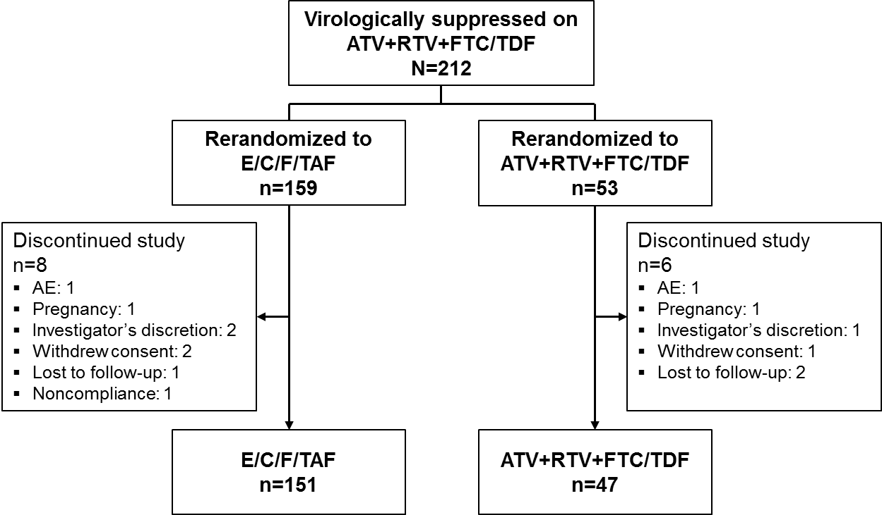

ATV=atazanavir; E/C/F/TAF= coformulated elvitegravir, cobicistat, emtricitabine, tenofovir alafenamide; FTC/TDF=coformulated emtricitabine and tenofovir disoproxil fumarate; RTV=ritonavir

Figure S2. Forest plot of treatment difference in virologic success at OLE week 48 (HIV-1 RNA <50 copies/mL, snapshot algorithm) by subgroup
