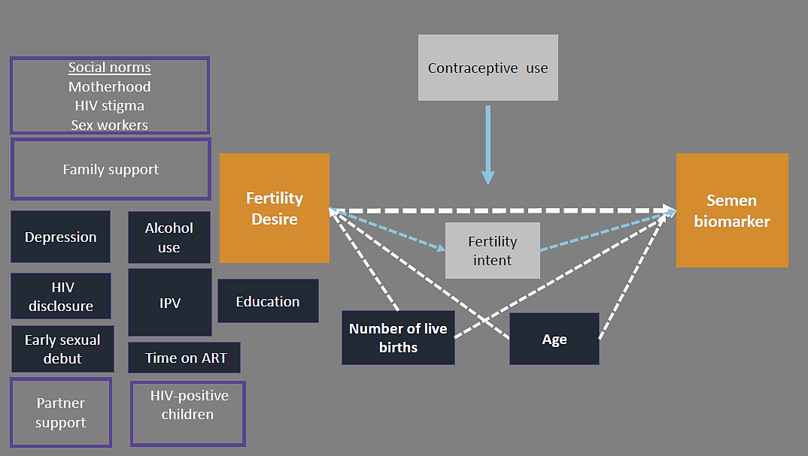
Figure 1. Conceptual diagram of fertility desire in relation to a biomarker of condomless sex in HIV-positive FSWs in Kenya
Legend: Conceptual diagram of a plausible relationship between the fertility desire and biologic evidence of unprotected sex (orange boxes). Variables that were evaluated as potential confounding factors are shown in dark blue. Number of live births and age were retained in the final adjusted model and therefore are connected to the exposure and outcome by dotted white arrows. Fertility intent (white box) is a likely mechanism linking fertility desire and unprotected sex. Social and family factors that were not measured in this analysis, but may influence the primary association, are shown in light purple boxes.

