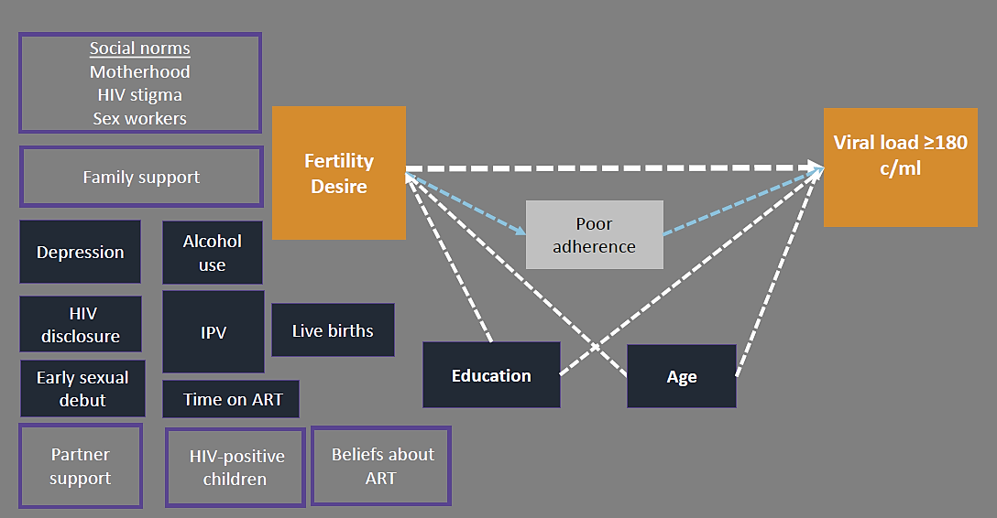
Figure 2. Conceptual diagram of fertility desire in relation to detectable plasma viral load in HIV-positive FSWs in Kenya

Legend: Conceptual diagram of a plausible relationship between the fertility desire and detectable viral load (orange boxes). Variables that were evaluated as potential confounding factors are shown in dark blue. Education level and age were retained in the final adjusted model, and are connected to the exposure and outcome by dotted white arrows. Poor adherence (white box) is a likely mechanism linking fertility desire to detectable viral load. Unmeasured individual, family, and social factors that were not measured in this analysis, but may influence the primary association, are shown in light purple boxes (e.g. partner support).

