Supplementary Table 1: Characteristics* of WIHS participants, included versus excluded
Characteristic | Included Participants (N=1662) | Excluded Eligible† Participants  (N=578) | P Value
Distensibility index, 10⁻⁶ × Newtons⁻¹ × meters² | 17.8 (12.2-25.1) | 15.8 (13.9-19.6) | 0.64
HIV positive, n (%) | 1192 (72) | 397 (69) | 0.18
Demographics
Age, years | 41 (34-47) | 43 (36-50) | <0.0001
Race/ethnicity, n (%)
Non-Hispanic black | 997 (60) | 278 (48) | <0.0001
Hispanic | 470 (28) | 131 (23) | 0.009
Non-Hispanic white | 159 (10) | 124 (21) | <0.0001
WRAT-3 Reading Score | 93 (79-105) | 95 (80-106) | 0.04
Income <$30,000 per year, n (%) | 1348 (81) | 414 (72) | <0.0001
Behavior-related
Current smoker, n (%) | 730 (44) | 272 (47) | 0.21
History of injection drug use, n (%) | 391 (24) | 157 (27) | 0.08
Current crack/cocaine, n (%) | 139 (8) | 64 (11) | 0.06
Current alcohol use >7 drinks/week, n (%) | 126 (8) | 60 (10) | 0.05
History of hepatitis C virus infection, n (%) | 436 (22) | 150 (26) | 0.89
Metabolic risk factors
Body mass index, kg/m² | 28 (24-33) | 27 (23-32) | 0.0007
Systolic blood pressure, mm Hg | 116 (108-128) | 123 (111-133) | 0.002
Mean arterial pressure, mm Hg | 86 (79-95) | 92 (84-103) | 0.0001
Heart rate, beats per minute | 70 (64-78) | 72 (69-81) | 0.06
Anti-hypertensive medication, n (%) | 305 (18) | 113 (20) | 0.52
History of hypertension, n (%) | 445 (27) | 198 (34) | 0.0006
History of diabetes, n (%) | 232 (14) | 93 (16) | 0.24
History of coronary heart disease, n (%) | 16 (3) | 57 (9) | <0.0001
Total cholesterol, mg/dL | 170 (147-200) | 176 (148-205) | 0.009
HDL cholesterol, mg/dL | 49 (39-60) | 47 (39-62) | 0.79
Lipid-lowering medication, n (%) | 97 (6) | 51 (9) | 0.02
eGFR, ml/min/1.73 m² | 101 (87-117) | 95 (80-111) | <0.0001
Post-menopausal (self-report), n (%) | 349 (21) | 156 (27) | 0.003
Framingham 10-year all-CVD risk % | 3.2 (1.7-6.2) | 4.5 (2.9-6.5) | 0.02
D:A:D 5-year all-CVD risk % | 1.0 (0.5-2.0) | 2.6 (1.1-2.2) | 0.0009
Neuropsychological
Trailmaking Test A Raw Score, seconds | 36 (29-47) | 36 (27-47) | 0.93
Trailmaking Test B Raw Score, seconds | 83 (62-115) | 78 (59-110) | 0.03
Symbol Digit Modalities Test Raw Score, total  Correct | 43 (34-50) | 43 (33-52) | 0.0002
Antipsychotic, antidepressant, sedative or  Alzheimer medication, n (%) | 360 (22) | 156 (27) | 0.009
CES-D score | 10 (4-21) | 11 (4-21) | <0.0001
HIV-specific (among HIV-infected subset)
Baseline CD4+ T cell count, cells/mm³ | 465 (294- 691) | 422 (273- 667) | 0.0001
Nadir CD4+ T cell count, cells/mm³ | 275 (164-400) | 259 (161-381) | 0.02
Undetectable baseline viral load, n (%) | 572 (48) | 181 (46) | 0.44
History of AIDS, n (%) | 442 (37) | 171 (43) | 0.04
Potent ART use in past 6 months, n (%) | 760 (64) | 261 (66) | 0.51
Cumulative exposure of potent ART, years | 3.5 (1.0-6.5) | 3.5 (0.5-7.0) | <0.0001
of PIs, years | 1.5 (0.0-5.0) | 1.5 (0.0-5.0) | <0.0001
of NNRTIs, years | 0.5 (0.0-3.0) | 0.5 (0.0-2.5) | 0.0004
of NRTIs, years | 5.0 (1.5-8.0) | 5.0 (1.5-9.0) | 0.003

*Continuous variables are presented as medians (interquartile ranges), comparisons by the Wilcoxon rank-sum test for medians or Fisher’s exact for counts
†Excluded eligible participants were those who did not have carotid ultrasound within one year of the baseline neuropsychological assessment and were free of stroke, transient ischemic attack, heart failure or other heart disease
AIDS: Acquired immunodeficiency syndrome; ART: Anti-retroviral therapy; CES-D: Center for Epidemiological Studies Depression Scale (range 0-60); WRAT-3: Wide Range Achievement Test 3 (standard average 90-109); D:A:D: Data-collection on Adverse Effects of Anti-HIV Drugs; eGFR: Estimated glomerular filtration rate; NNRTI: Non-nucleoside reverse transcriptase inhibitor; NRTI: Nucleoside reverse transcriptase inhibitor; PI: Protease inhibitor

Supplementary Table 2: Association of baseline distensibility index, HIV positivity and other adjustment factors with cross sectional neuropsychological performance at baseline
 | Baseline Symbol Digit Modalities Test Z Score |  | Baseline Trail Making Test A Z Score |  | Baseline Trail Making Test B Z Score
Adjustment Factor | β (95% CI) | P | β (95% CI) | P | β (95% CI) | P
Baseline age (per year) | -0.02  (-0.03 to -0.01) | <0.0001 | -0.008  (-0.02 to 0.003) | 0.15 | -0.02  (-0.03 to -0.009) | <0.0001
HIV positive (vs negative) | -0.16  (-0.27 to -0.06) | 0.003 | -0.19  (-0.34 to -0.03) | 0.02 | -0.09  (-0.21 to -0.03) | 0.13
Distensibility Index* | 0.005  (0.00008 to 0.01) | 0.05 | 0.006  (-0.002 to 0.01) | 0.17 | 0.07  (0.01 to 0.01) | 0.02
Hispanic ethnicity (vs non-hispanic white) | -0.38  (-0.56 to -0.21) | <0.0001 | -0.39  (-0.65 to -0.14) | 0.003 | -0.46  (-0.66 to -0.26) | <0.0001
Black Race (vs non-hispanic white) | -0.41  (-0.58 to -0.24) | <0.0001 | -0.37  (-0.61 to -0.12) | 0.004 | -0.29  (-0.48 to -0.10) | 0.003
Income >30,000 USD (vs <30,000 USD) | 0.32  (0.20 to 0.44) | <0.0001 | 0.21  (0.03 to 0.38) | 0.02 | 0.25  (0.12 to 0.39) | 0.0002
WRAT-3 score | 0.02  (0.01 to 0.02) | <0.0001 | 0.01  (0.009 to 0.02) | <0.0001 | 0.01  (0.01 to 0.02) | <0.0001
CES-D score | -0.006  (-0.01 to -0.002) | 0.001 | -0.004  (-0.009 to 0.002) | 0.23 | -0.01  (-0.01 to -0.005) | <0.0001
BMI (per kg/m²) | 0.007  (0.0005 to 0.01) | 0.04 | 0.003  (-0.006 to 0.01) | 0.51 | 0.009  (0.002 to 0.02) | 0.01
Hypertension (vs no hypertension) | -0.10  (-0.21 to 0.02) | 0.11 | -0.08  (-0.25 to 0.08) | 0.33 | -0.25  (-0.37 to -0.12) | 0.0002
Diabetes (vs no diabetes) | 0.02  (-0.12 to 0.16) | 0.78 | -0.03  (-0.23 to 0.17) | 0.78 | 0.07  (-0.09 to 0.22) | 0.39
Menopausal (vs not menopausal) | -0.14  (-0.28 to -0.007) | 0.04 | -0.43  (-0.62 to -0.23) | <0.0001 | -0.09  (-0.25 to 0.06) | 0.23
Models adjusted for baseline age, HIV serostatus, carotid distensibility index, race-ethnicity, income, Wide Range Achievement Test (WRAT)-3 reading score, Center for Epidemiologic Studies Depression Scale (CES-D), current smoking, current alcohol use, history of intravenous drug use, current crack/cocaine, history hepatitis C virus, body mass index, hypertension, diabetes, menopausal status, total cholesterol, HDL cholesterol, use of lipid-lowering medications, psychoactive medication use, history of coronary heart disease, and eGFR.
* Over an increase in a standard deviation of distensibility (9.4 × 10⁻⁶ × Newtons⁻¹ × meters²)

Supplementary Table 3: Association of baseline Young’s elastic modulus or HIV serostatus with longitudinal change in neuropsychological performance score (SD/per 10 year increase)

 | Increase in rate of decline per SD increase in Young’s elastic modulus |  | Increase in rate of decline for HIV positive women (versus HIV negative women)
Cognitive Test | Β* (95% CI) | P | β† (95% CI) | P
Symbol Digit Modalities Test Z-score | -0.001  (-0.002 to -0.0005) | 0.0005 | -0.004  (-0.01 to 0.002) | 0.20
Trail Making Test A Z-score | -0.001  (-0.002 to -0.0002) | 0.01 | -0.008  (-0.02 to 0.0002) | 0.05
Trail Making Test B Z-score | -0.001  (-0.002 to -0.0006) | 0.0002 | -0.006  (-0.01 to 0.0007) | 0.08
Models adjusted for baseline age, HIV serostatus, Young’s elastic modulus, race-ethnicity, income, Wide Range Achievement Test (WRAT)-3 reading score, Center for Epidemiologic Studies Depression Scale (CES-D), current smoking, current alcohol use, history of intravenous drug use, current crack/cocaine, history hepatitis C virus, body mass index, hypertension, diabetes, menopausal status, total cholesterol, HDL cholesterol, use of lipid-lowering medications, psychoactive medication use, history of coronary heart disease, and eGFR.
* β is the Young’s elastic modulus × age interaction term, and represents the increase in rate of cognitive decline (measured as difference in Z-score per 10-year increase in age) for one standard deviation (4.6 × 10⁵ × Newtons × meters⁻²) increase in Young’s elastic modulus
† β is the HIV serostatus × age interaction term, and represents the increase in rate of cognitive decline (measured as difference in Z-score per 10-year increase in age) for an HIV-positive woman versus an HIV-negative woman

Supplementary Table 4: Association of HIV-related factors with the longitudinal change in neuropsychological performance scores over increasing age, among HIV positive women
 | Symbol Digit Modalities Test Z Score |  | Trail Making Test A Z Score |  | Trail Making Test B Z Score
Interaction Term | Β* (95% CI) | P | Β* (95% CI) | P | Β* (95% CI) | P
CD4 count <200 × Age  (compared to CD4 count ≥200) | <0.0001  (-0.07 to 0.07) | 0.99 | -0.11  (-0.2 to 0.005) | 0.06 | -0.02  (-0.1 to 0.07) | 0.70
Nadir CD4 count <200 × Age  (compared to CD4 count ≥200) | -0.009  (-0.09 to 0.07) | 0.82 | -0.03  (-0.1 to 0.08) | 0.60 | 0.02  (-0.07 to 0.1) | 0.67
Viral Suppression  (compared to non-suppressed) | -0.01  (-0.09 to 0.06) | 0.72 | -0.005  (-0.1 to 0.1) | 0.92 | -0.02  (-0.1 to 0.06) | 0.66
Persistent viral suppression  (compared to non-suppressed) | -0.02  (-0.10 to 0.10) | 0.79 | -0.20  (-0.30 to -0.010) | 0.03 | -0.05  (-0.20 to 0.08) | 0.44
History of AIDS  (compared to without AIDS) | -0.09  (-0.20 to -0.01) | 0.03 | -0.20  (-0.30 to -0.07) | 0.002 | -0.08  (-0.20 to 0.01) | 0.08
Potent antiretrovirals  (compared to not on ART) | -0.06  (-0.10 to 0.02) | 0.17 | -0.02  (-0.10 to 0.08) | 0.71 | -0.002  (-0.09 to 0.08) | 0.96
Cumulative years of NRTI | -0.003  (-0.01 to 0.008) | 0.64 | -0.01  (-0.03 to 0.003) | 0.13 | -0.009  (-0.02 to 0.003) | 0.14
Cumulative years of NNRTI | -0.008  (-0.02 to 0.009) | 0.36 | -0.001  (-0.03 to 0.01) | 0.32 | -0.01  (-0.03 to 0.006) | 0.18
Cumulative years of PI | -0.01  (-0.02 to 0.003) | 0.12 | -0.02  (-0.04 to -0.05) | 0.009 | -0.01  (-0.03 to -0.001) | 0.03
Models adjusted for baseline age, HIV serostatus, carotid distensibility index, race-ethnicity, income, Wide Range Achievement Test (WRAT)-3 reading score, Center for Epidemiologic Studies Depression Scale (CES-D), current smoking, current alcohol use, history of intravenous drug use, current crack/cocaine, history hepatitis C virus, body mass index, hypertension, diabetes, menopausal status, total cholesterol, HDL cholesterol, use of lipid-lowering medications, psychoactive medication use, history of coronary heart disease, and eGFR
* β is the change in the Z-score of each cognitive test over a ten-year increase in age
Supplementary Figure 1: Multivariable adjusted longitudinal change in neuropsychological performance as a function of elastic modulus (tertiles)

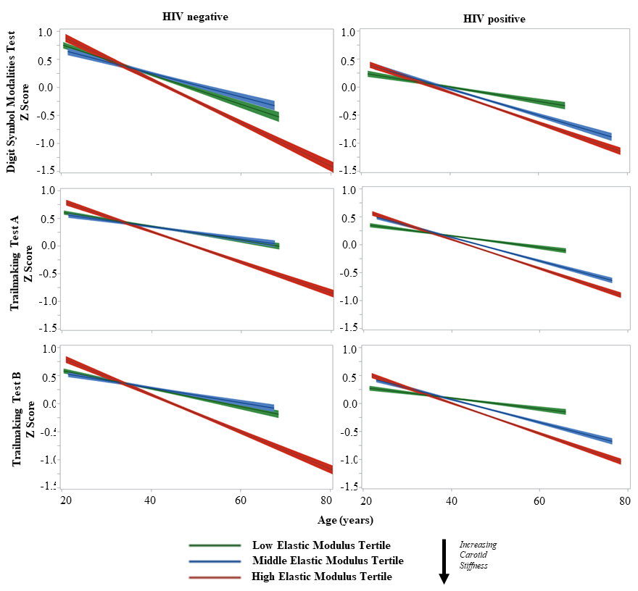
Models adjusted for baseline age, HIV serostatus, Young’s elastic modulus, race-ethnicity, income, Wide Range Achievement Test (WRAT)-3 reading score, Center for Epidemiologic Studies Depression Scale (CES-D), current smoking, current alcohol use, history of intravenous drug use, current crack/cocaine, history hepatitis C virus, body mass index, hypertension, diabetes, menopausal status, total cholesterol, HDL cholesterol, use of lipid-lowering medications, psychoactive medication use, history of coronary heart disease, and eGFR.

