Supplementary digital content
Supplementary Table 1: Neuropsychological test battery and calculation of z-scores and global deficit scores (GDS) in the study population
Cognitive domains | Individual neuropsychological measures
Executive functions | Trail Making Test B (TMT B)
Verbal generativity | Letter Fluency (S-word)  Category Fluency (Animal)
Verbal learning and memory | Rey Auditory Verbal Learning Test (RAVLT)
Speed of information processing | Trail Making Test A (TMT A)  Symbol Digit Modalities Test (SDMT)
Premorbid verbal intelligence | WAIS-III (WAIS-III) subtest  The Danish Adult Reading Test (DART)
Calculation of z-scores and global deficit scores (GDS)
Z-scores(Bloch et al., 2016; Cysique et al., 2014) | Raw scores from the neuropsychological tests were transformed into scaled z-scores to approach the normal distribution and to place all scores on the same metric. Mean and SD from HIV-uninfected controls were used as normative reference and z-scores were created for both PLWHIV and HIV-uninfected controls. PLWHIV and HIV-uninfected controls had comparable demographics. The z-score mean is 0 and the SD is 1.
GDS-scores(Blackstone et al., 2012; Carey et al., 2004; Cysique et al., 2014) | GDS-scores can be calculated with both T-scores and Z-scores. In this study, Z-scores were used and transformed into deficit scores: 0, no impairment (z score≥−1.0); 1, mild impairment (z score <−1.0 to −1.5); 2, mild to moderate impairment (z score < −1.5 to −2.0); 3, moderate impairment (z score < −2.0 to −2.5); 4, moderate to severe impairment (z score < −2.5 to −3.0); and 5, severe impairment (z score < −3.0). Individual deficit scores were then averaged to a summary score, the global deficit score (GDS).

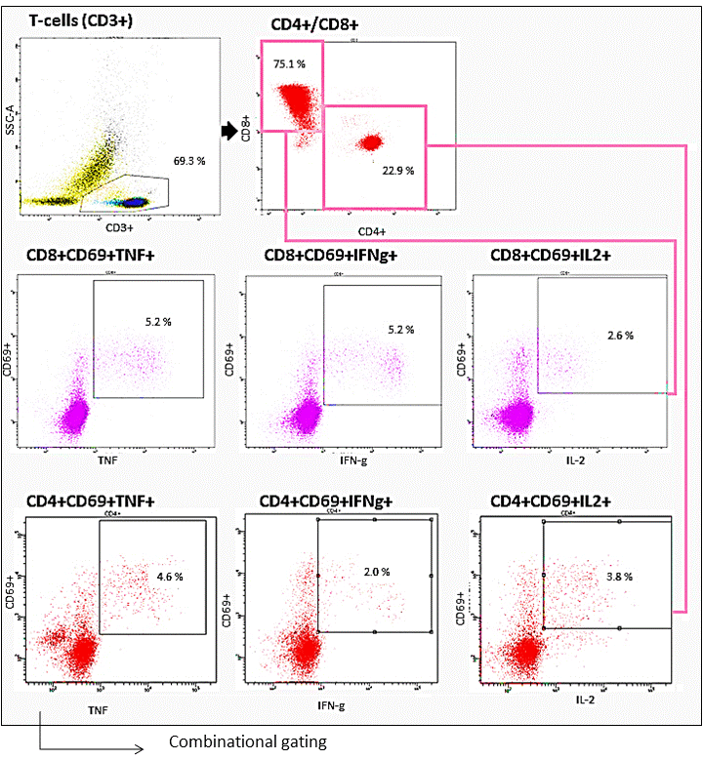
Supplementary Figure 1: Gating strategy for intracellular cytokine staining. A lymphocyte gate based on FSC/SSC, a singlet gate, and a live/dead cell gate were applied before gating on CD3+CD4+ and CD3+CD8+ cells. Activated CD69+ T-cell populations were gated from CD69+ histograms for CD4+ and CD8+ populations. Expression of IFN-γ, TNF-α and IL-2 was determined from the CD4+ and CD8+ populations. To obtain co-expression patterns a combinational gating strategy was applied to obtain all functional subsets. The figure has been modified from (Ballegaard et al., 2018).

