SUPPLEMENTAL DIGITAL CONTENT

Supplemental Digital Content 1:
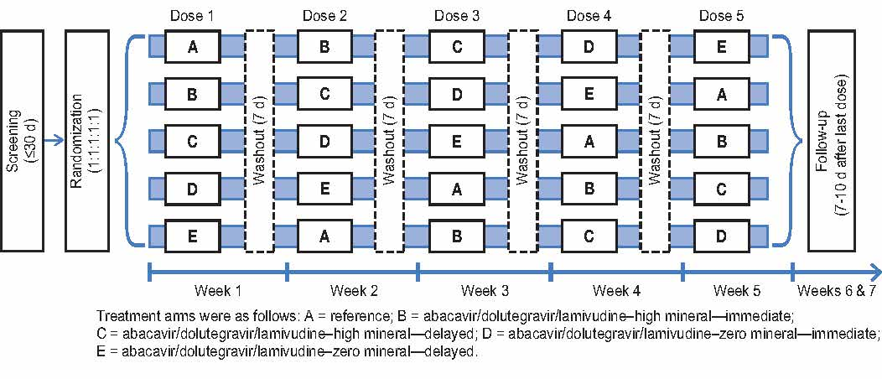

Supplemental Digital Content 2:

Supplemental Table. Summary of Participant Responses From the Palatability Questionnaire
Item, n (%)ª | Abacavir/dolutegravir/  lamivudine–high mineral  —immediate (n=20) | Abacavir/dolutegravir/  lamivudine–high mineral  —delayed (n=20) | Abacavir/dolutegravir/  lamivudine–zero mineral  —immediate (n=20) | Abacavir/dolutegravir/  lamivudine–zero mineral  —delayed (n=19)
Palatability
Mean (SD) | 1.9 (0.49) | 1.7 (0.49) | 1.8 (0.44) | 1.9 (0.32)
Unacceptable | 4 (20) | 7 (35) | 5 (25) | 2 (11)
Neutral/Acceptable | 15 (75) | 13 (65) | 15 (75) | 17 (89)
Very good | 1 (5) | 0 | 0 | 0
All descriptors associated
Bitter | 9 (45) | 11 (55) | 11 (55) | 9 (47)
Chalky | 16 (80) | 17 (85) | 16 (80) | 13 (68)
Fruity | 10 (50) | 10 (50) | 8 (40) | 12 (63)
Medicinal | 12 (60) | 14 (70) | 14 (70) | 10 (53)
Nutty | 0 | 2 (10) | 0 | 1 (5)
Sour | 5 (25) | 5 (25) | 6 (30) | 5 (26)
Sweet | 13 (65) | 13 (65) | 12 (60) | 14 (74)
Descriptors most closely associated
Bitter | 2 (10) | 2 (10) | 2 (10) | 2 (11)
Chalky | 6 (30) | 5 (25) | 3 (15) | 4 (21)
Fruity | 3 (15) | 4 (20) | 3 (15) | 3 (16)
Medicinal | 4 (20) | 7 (35) | 7 (35) | 6 (32)
Other | 2 (10) | 0 | 1 (5) | 2 (11)
Sour | 1 (5) | 0 | 2 (10) | 0
Sweet | 2 (10) | 2 (10) | 2 (10) | 2 (11)
Rate mouth feel
Mean (SD) | 1.7 (0.47) | 1.8 (0.52) | 1.8 (0.41) | 2.0 (0.47)
Unacceptable | 6 (30) | 5 (25) | 4 (20) | 2 (11)
Neutral/Acceptable | 14 (70) | 14 (70) | 16 (80) | 15 (79)
Very good | 0 | 1 (5) | 0 | 2 (11)
Rate aroma of the product
Mean (SD) | 2.1 (0.55) | 2.0 (0.39) | 2.0 (0.46) | 2.1 (0.57)
Unacceptable | 2 (10) | 2 (10) | 2 (10) | 2 (11)
Neutral/Acceptable | 14 (70) | 17 (85) | 16 (80) | 13 (68)
Pleasant/Desirable | 4 (20) | 1 (5) | 2 (10) | 4 (21)
Rate aftertaste
Mean (SD) | 1.5 (0.60) | 1.6 (0.68) | 1.5 (0.51) | 1.7 (0.58)
Unacceptable | 12 (60) | 10 (50) | 11 (55) | 7 (37)
Neutral/Acceptable | 7 (35) | 8 (40) | 9 (45) | 11 (58)
Pleasant/Desirable | 1 (5) | 2 (10) | 0 | 1 (5)
Flavor intensity perception
Mean (SD) | 3.8 (0.95) | 3.9 (0.99) | 3.7 (0.88) | 3.3 (1.05)
Mild | 0 | 0 | 0 | 0
Average | 2 (10) | 2 (10) | 6 (30) | 4 (21)
Strong | 4 (20) | 5 (25) | 3 (15) | 2 (11)
Aroma perception
Mean (SD) | 2.5 (1.32) | 3.0 (1.10) | 2.7 (1.14) | 2.3 (0.93)
Mild | 7 (35) | 3 (15) | 4 (20) | 5 (26)
Average | 9 (45) | 12 (60) | 11 (55) | 8 (42)
Strong | 2 (10) | 2 (10) | 2 (10) | 0
Sweetness perception
Mean (SD) | 3.0 (1.32) | 2.9 (0.88) | 2.9 (1.17) | 3.1 (0.94)
Not sweet | 3 (15) | 0 | 3 (15) | 1 (5)
Sweet | 5 (25) | 8 (40) | 6 (30) | 9 (47)
Very sweet | 3 (15) | 1 (5) | 1 (5) | 1 (5)
Sour/Tartness perception
Mean (SD) | 2.4 (1.53) | 2.5 (1.43) | 2.8 (1.54) | 2.4 (1.26)
Mild | 9 (45) | 7 (35) | 7 (35) | 6 (32)
Average | 3 (15) | 5 (25) | 4 (20) | 5 (26)
Strong | 3 (15) | 3 (15) | 3 (15) | 1 (5)
Consistency perception
Mean (SD) | 2.8 (0.95) | 3.1 (1.00) | 2.7 (0.93) | 2.6 (0.96)
Thin | 2 (10) | 1 (5) | 3 (15) | 4 (21)
Average | 11 (55) | 10 (50) | 10 (50) | 11 (58)
Thick | 1 (5) | 2 (10) | 0 | 0
Flavor intensity recommendation
Mean (SD) | 2.7 (1.13) | 2.7 (1.13) | 2.8 (1.28) | 2.8 (0.96)
Reduce as much as possible | 3 (15) | 3 (15) | 4 (20) | 1 (5)
Leave as is | 6 (30) | 6 (30) | 6 (30) | 8 (42)
Increase as much as possible | 1 (5) | 1 (5) | 2 (10) | 1 (5)
Aroma recommendation
Mean (SD) | 3.0 (0.56) | 2.6 (0.82) | 2.8 (0.55) | 2.8 (0.50)
Reduce as much as possible | 1 (5) | 4 (20) | 1 (5) | 1 (5)
Leave as is | 17 (85) | 16 (80) | 16 (80) | 17 (89)
Increase as much as possible | 0 | 0 | 0 | 0
Sweetness recommendation
Mean (SD) | 3.5 (1.19) | 3.0 (1.03) | 3.2 (1.18) | 3.1 (0.81)
Reduce as much as possible | 1 (5) | 2 (10) | 1 (5) | 1 (5)
Leave as is | 4 (20) | 9 (45) | 5 (25) | 13 (68)
Increase as much as possible | 4 (20) | 1 (5) | 3 (15) | 1 (5)
Sour/tartness recommendation
Mean (SD) | 2.8 (1.06) | 2.6 (1.05) | 2.6 (1.05) | 2.6 (0.90)
Reduce as much as possible | 2 (10) | 4 (20) | 3 (15) | 2 (11)
Leave as is | 7 (35) | 11 (55) | 7 (35) | 7 (37)
Increase as much as possible | 1 (5) | 1 (5) | 1 (5) | 0
Consistency recommendation
Mean (SD) | 2.8 (0.77) | 2.6 (0.82) | 3.2 (0.67) | 3.1 (0.62)
Reduce as much as possible | 2 (10) | 3 (15) | 0 | 0
Leave as is | 14 (70) | 13 (65) | 14 (70) | 15 (79)
Increase as much as possible | 0 | 0 | 1 (5) | 1 (5)
Rate color
Mean (SD) | 2.0 (0.46) | 2.1 (0.55) | 2.0 (0.32) | 2.2 (0.54)
Unpleasant | 2 (10) | 2 (10) | 1 (5) | 1 (5)
Neutral/Acceptable | 16 (80) | 14 (70) | 18 (90) | 13 (68)
Pleasant/Desirable | 2 (10) | 4 (20) | 1 (5) | 5 (26)
SD, standard deviation. ªUnless otherwise noted.

