Supplemental Digital Content
Supplemental Figure 1: Flow-chart of the study population (ANRS 12249 TasP trial)
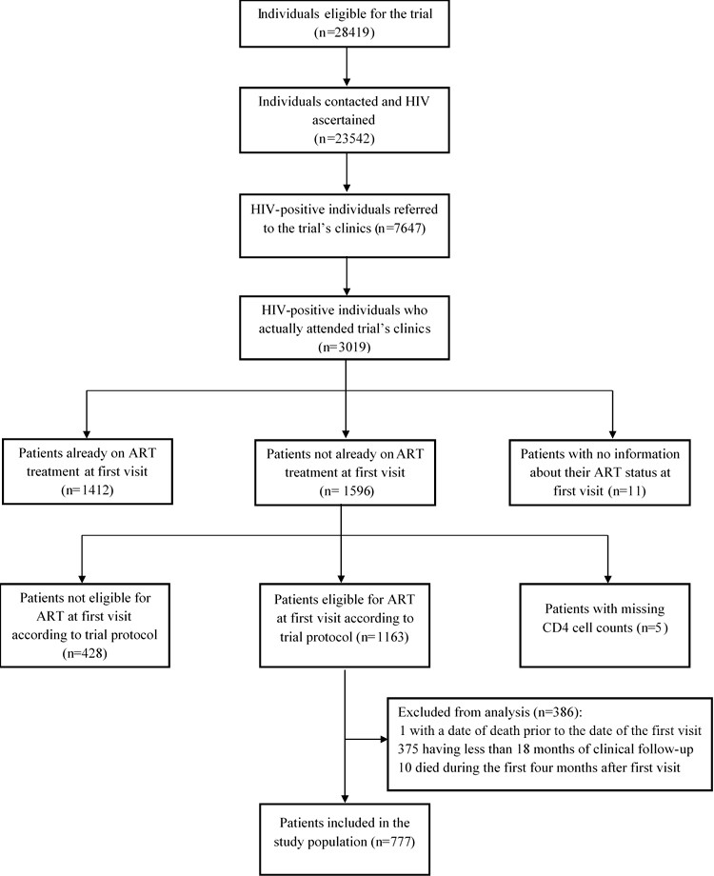

Supplemental Figure 2: Care trajectories in trial clinics over 24 months of clinical follow-up among patients eligible for ART initiation at the first visit (ANRS 12249 TasP trial, n=536)
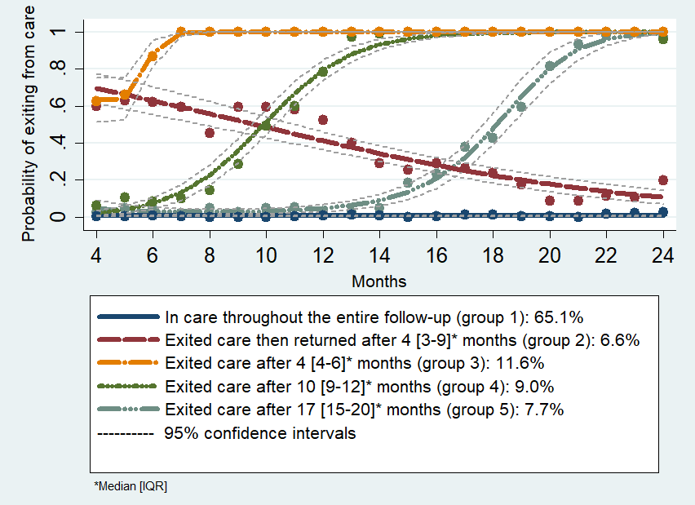
Supplemental Table 1: Sensitivity analysis of factors associated with trajectory groups (reference= Group 1 “Remained in care”) when patients who transferred out were considered as missing, multivariable analysis (ANRS 12249 TasP trial, n=725)
 | Groups
Covariates– aOR [95% CI] | Group 2: exited care then returned | Group 3: exited care rapidly | Group 4: exited care later
Gender & Social support
Female & social support | 1 | 1 | 1
Female & no social support | 1.5 [0.5,4.4] | 1.9 [0.8,4.1] | 0.6 [0.2,1.6]
Male & social support | 3.3** [1.4,7.9] | 1.8 [0.9,3.7] | 1.8 [0.9,3.4]
Male & no social support | 2.3 [0.5,9.9] | 1.9 [0.7,5.0] | 1.9 [0.7,4.7]
Age (years)
≥40 | 1 | 1 | 1
30-39 | 1.0 [0.4,3.0] | 1.0 [0.4,2.3] | 2.9** [1.3,6.4]
16-29 | 3.1* [1.3,7.7] | 3.6*** [1.8,7.2] | 4.5*** [2.1,9.6]
Having a regular partner
Yes | 1 | 1 | 1
No | 3.3* [1.3,8.1] | 1.5 [0.7,3.0] | 1.1 [0.5,2.4]
Newly diagnosed at referral
No | 1 | 1 | 1
Yes | 1.1 [0.3,4.4] | 5.5*** [2.7,11.1] | 6.0*** [3.1,11.7]
CD4 at first visit
CD4≤350 | 1 | 1 | 1
CD4 between ]350-500] | 12.1*** [3.3,45.0] | 0.5 [0.2,1.2] | 0.5 [0.2,1.1]
CD4>500 | 9.8*** [2.7,36.1] | 0.8 [0.4,1.6] | 0.9 [0.5,1.6]
On ART at M1
No | 1 | 1 | 1
Yes | 0.05*** [0.0,0.2] | 0.1*** [0.1,0.2] | 0.7 [0.4,1.2]
* p < 0.05, ** p < 0.01, *** p < 0.001; aOR: adjusted odds ratio
Supplemental Table 2: Sensitivity analysis of factors associated with trajectory groups (reference= Group 1: remained in care) when patients who transferred out were considered as retained in care, multivariable analysis (ANRS 12249 TasP trial, n=735)
 | Groups
Covariates– aOR [95% CI] | Group 2: exited care then returned | Group 3: exited care rapidly | Group 4: exited care later
Gender & Social support
Female & social support | 1.0 | 1.0 | 1.0
Female & no social support | 1.4 [0.5,4.1] | 1.7 [0.8,3.8] | 0.5 [0.2,1.4]
Male & social support | 3.2** [1.4,7.5] | 1.9 [0.9,3.8] | 1.8 [0.9,3.4]
Male & no social support | 2.8 [0.8,10.5] | 1.8 [0.7,4.9] | 1.6 [0.6,4.2]
Age (years)
≥40 | 1.0 | 1.0 | 1.0
30-39 | 0.9 [0.3,2.4] | 1.0 [0.4,2.3] | 3.2** [1.4,7.2]
16-29 | 2.5* [1.1,5.9] | 3.5*** [1.8,7.0] | 4.8*** [2.2,10.3]
Having a regular partner
Yes | 1.0 | 1.0 | 1.0
No | 3.1* [1.3,7.3] | 1.5 [0.7,3.1] | 1.2 [0.6,2.5]
Newly diagnosed at referral
No | 1.0 | 1.0 | 1.0
Yes | 1.1 [0.3,4.3] | 5.3*** [2.6,10.6] | 6.2*** [3.2,12.1]
CD4 at first visit
CD4≤350 | 1.0 | 1.0 | 1.0
CD4 between ]350-500] | 11.3*** [3.1,41.9] | 0.5 [0.2,1.1] | 0.5 [0.2,1.1]
CD4>500 | 11.1*** [3.1,40.2] | 0.8 [0.4,1.6] | 0.8 [0.4,1.5]
On ART at M1
No | 1.0 | 1.0 | 1.0
Yes | 0.1*** [0.0,0.2] | 0.1*** [0.1,0.2] | 0.7 [0.4,1.3]
* p < 0.05, ** p < 0.01, *** p < 0.001; aOR: adjusted odds ratio

