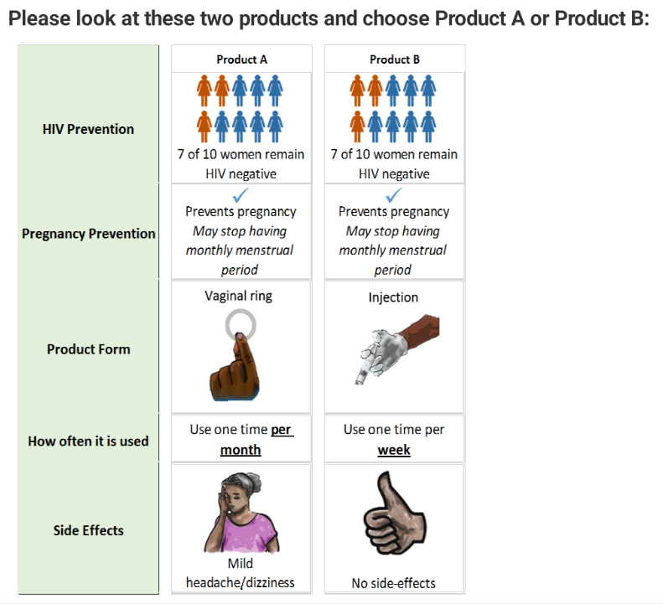
Supplemental Figure 1. Example choice task.

Supplemental Table 1. Estimated preference-weights for HIV prevention product attributes using random parameters logit models.
 |  | Kenya  Product-experienced |  |  |  | Kenya  Product-naïve |  |  |  | South Africa
 |  | Coeff. | SE | p-value |  | Coeff. | SE | p-value |  | Coeff. | SE | p-value
HIV prevention
 | 9 of 10 women remain HIV negative | 1.75 | (0.28) | <0.001 |  | 3.47 | (0.66) | <0.001 |  | 0.99 | (0.12) | <0.001
 | 7 of 10 women remain HIV negative | 0.58 | (0.09) | <0.001 |  | 1.16 | (0.22) | <0.001 |  | 0.33 | (0.04) | <0.001
 | 5 of 10 women remain HIV negative | -0.58 | (0.09) | <0.001 |  | -1.16 | (0.22) | <0.001 |  | -0.33 | (0.04) | <0.001
 | 3 of 10 women remain HIV negative | -1.75 | (0.28) | <0.001 |  | -3.47 | (0.66) | <0.001 |  | -0.99 | (0.12) | <0.001
Pregnancy prevention
 | Does not prevent pregnancy, no menstrual changes | -0.85 | (0.19) | <0.001 |  | -0.35 | (0.20) | 0.08 |  | -0.55 | (0.11) | <0.001
 | Prevents pregnancy, Menstruation light and regular | 0.52 | (0.16) | 0.001 |  | 0.62 | (0.22) | 0.004 |  | 0.53 | (0.10) | <0.001
 | Prevents pregnancy, Menstruation may be heavy | 0.08 | (0.16) | 0.63 |  | -0.21 | (0.24) | 0.37 |  | -0.20 | (0.11) | 0.07
 | Prevents pregnancy, May stop period | 0.25 | (0.14) | 0.08 |  | -0.06 | (0.19) | 0.75 |  | 0.22 | (0.10) | 0.02
Side effects
 | Mild headache/dizziness | -0.36 | (0.11) | 0.001 |  | -0.28 | (0.14) | 0.05 |  | -0.10 | (0.07) | 0.15
 | Mild nausea/upset stomach | -0.19 | (0.11) | 0.09 |  | -0.16 | (0.14) | 0.23 |  | -0.23 | (0.07) | 0.002
 | No side-effects | 0.55 | (0.13) | <0.001 |  | 0.44 | (0.16) | 0.006 |  | 0.32 | (0.08) | <0.001
Delivery form by frequency
 | Ring - Use one time per week | -0.39 | (0.33) | 0.25 |  | -1.04 | (0.41) | 0.01 |  | -0.16 | (0.19) | 0.40
 | Ring - Use one time per month | -0.62 | (0.28) | 0.03 |  | 0.03 | (0.32) | 0.92 |  | 0.22 | (0.23) | 0.33
 | Ring - Use one time per 2-3 months | -0.26 | (0.30) | 0.37 |  | 0.20 | (0.40) | 0.61 |  | 0.03 | (0.25) | 0.91
 | Tablets - Use every day | -0.41 | (0.26) | 0.11 |  | -0.26 | (0.34) | 0.45 |  | -0.97 | (0.17) | <0.001
 | Tablets - Use one time per week | -0.25 | (0.29) | 0.39 |  | 0.31 | (0.42) | 0.46 |  | -0.72 | (0.23) | 0.002
 | Tablets - Use one time per month | 0.28 | (0.28) | 0.33 |  | 0.67 | (0.37) | 0.07 |  | -0.44 | (0.18) | 0.01
 | Tablets - Use one time per 2-3 months | -0.06 | (0.34) | 0.87 |  | 0.09 | (0.43) | 0.83 |  | -0.14 | (0.26) | 0.59
 | Injections - Use one time per week | 0.09 | (0.34) | 0.80 |  | 0.77 | (0.42) | 0.07 |  | -0.10 | (0.22) | 0.63
 | Injections - Use one time per month | 1.11 | (0.36) | 0.002 |  | -0.34 | (0.41) | 0.41 |  | 0.67 | (0.20) | 0.001
 | Injections - Use one time per 2-3 months | 0.51 | (0.39) | 0.19 |  | -0.43 | (0.42) | 0.30 |  | 1.61 | (0.37) | <0.001
Models for each population analyzed separately; p-value indicates significantly different from zero

