Appendix – Tables with data from sensitivity analyses
Table A1: Association between obesity/HIV comorbidity and elevated biomarkers of inflammation, monocyte activation and altered coagulation excluding people with hepatitis C.
Logistic regression model | Obesity/HIV status | Elevated biomarker (i.e highest quartile)  Odds Ratio (95% Confidence Interval)
 |  | IL-6 (N=1338) |  | sCD14 (N=1348) |  | D-dimer (N=1349)
 |  | OR (95% CI) | P-value | OR (95% CI) | P-value | OR (95% CI) | P-value
Fully adjusted | Non-obese, uninfected | 1 (ref) | 0.04 | 1 (ref) | <0.01 | 1 (ref) | 0.06
 | Non-obese, HIV+ | 1.43 (0.98-2.08) |  | 1.28 (0.90-1.83) |  | 1.08 (0.75-1.56)
 | Obese, uninfected | 1.71 (1.13-2.61) |  | 0.77 (0.51-1.18) |  | 1.57 (1.05-2.34)
 | Obese, HIV+ | 1.89 (1.14-3.13) |  | 0.52 (0.29-0.92) |  | 0.91 (0.54-1.54)
Fully adjusted models adjusted for age, race/ethnicity, FIB4, eGFR, smoking, hypertension, LDL, HDL- cholesterol, statin use, alcohol, cocaine.

Table A2: Association between obesity/HIV comorbidity and elevated biomarkers of inflammation, monocyte activation and altered coagulation excluding those with diabetes, cardiovascular disease, and cancer.
Logistic regression model | Obesity/HIV status | Elevated biomarker (i.e highest quartile)  Odds Ratio (95% Confidence Interval)
 |  | IL-6 (N=1368) |  | sCD14 (N=1374) |  | D-dimer (N=1376)
 |  | OR (95% CI) | P-value | OR (95% CI) | P-value | OR (95% CI) | P-value
Fully adjusted | Non-obese, uninfected | 1 (ref) | 0.01 | 1 (ref) | 0.03 | 1 (ref) | 0.39
 | Non-obese, HIV+ | 1.58 (1.08-2.30) |  | 0.83 (0.59-1.17) |  | 1.26 (0.88-1.80)
 | Obese, uninfected | 1.95 (1.19-3.21) |  | 0.85 (0.52-1.38) |  | 1.48 (0.92-2.39)
 | Obese, HIV+ | 2.28 (1.33-3.92) |  | 0.39 (0.21-0.74) |  | 1.13 (0.65-1.95)
Fully adjusted models adjusted for age, race/ethnicity, FIB4, eGFR, smoking, hypertension, LDL, HDL- cholesterol, statin use, alcohol, cocaine.

Appendix Figure. Relationship between biomarkers and BMI for A. IL-6, B. sCD14, and C. D-dimer, fitted with fractional polynomial lines demonstrating the non-linear relationship between BMI and the individual biomarkers.
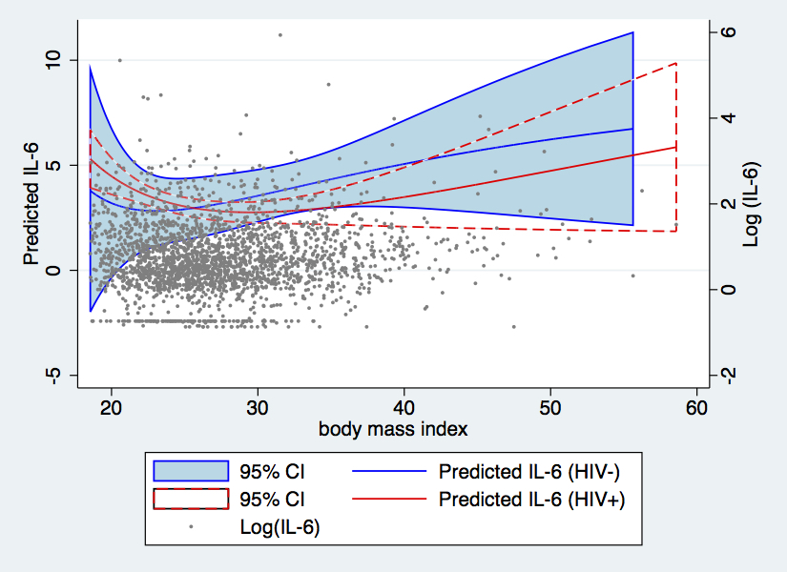
A.

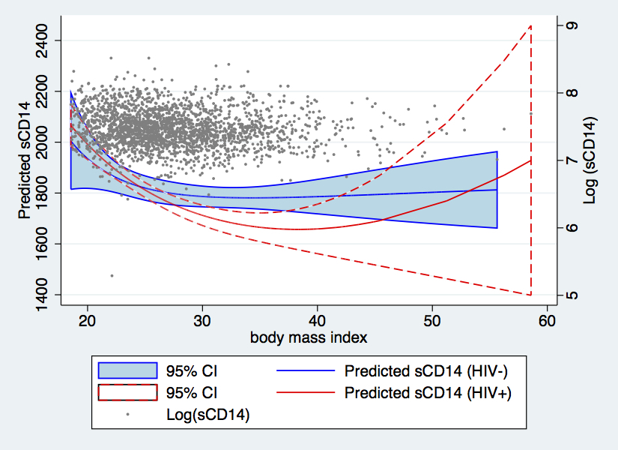
B.

C.
