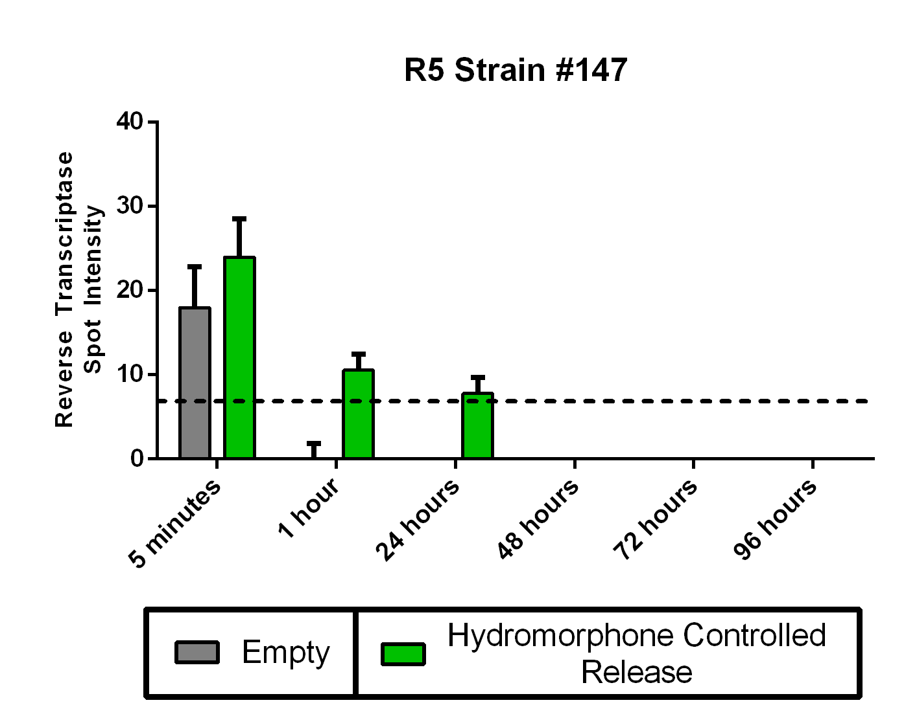
Supplementary Figure 1. R5-tropic HIV strain Reverse Transcriptase persistence in hydromorphone controlled-release. Reverse Transcriptase assay spot intensity to measure HIV persistence in injection drug preparation equipment when inoculated with a R5-tropic strain of HIV. Genotype #147 HIV was diluted 1:5 from the stock of ~2-4*10⁷ viral particles and added to IDPE. Cookers were serially washed at 5-minute, 1, 24, 48 72 and 96 hour timepoints, lysed, spotted, and quantified on a phosphorimager. Error bars represent standard error. The dotted line denotes the assay detection limit due to background signal from the phosphorimager.

