The impact of concurrent antiretroviral therapy and MDR-TB treatment on adverse events
APPENDIX
- Model Selection and Covariates
Each AE was individually evaluated for confounding and goodness-of-fit. Underlying causal structures and a priori knowledge were used to consider potential confounders, and models were critically appraised using an all-possible subset approach to determine the most parsimonious model. Wald and likelihood ratio test statistics were used to determine the presence of statistical interaction by covariates. Collinearity between covariates was assessed by comparing the condition indices (CNI) and variance decomposition proportions (VDP). Covariates with a CNI ≥30 and VDP ≥0.5 were considered to be collinear. The proportional hazards assumption was assessed for HIV and CD4 status and covariates in each model using a combination of visual log-log curves, plots of the observed verses expected values, and goodness-of-fit tests based on the Schoenfield residuals of the covariates. Potential covariates included: Age, weight, gender, history of mining, healthcare worker, history of incarceration, history of alcohol use, history of smoking, and viral load at baseline.
- Audiology
The DAIDS toxicity table has no existing criteria for hearing loss, and other hearing loss grading schemes were developed for other medications (e.g., cisplatin) which produce different patterns of ototoxicity from aminoglycosides. Aminoglycoside-induced hearing loss generally begins at higher frequencies which may not be noticed by participants, and is thus, often underreported ^{1,2}. We therefore developed a novel set of audiometry grading criteria for hearing loss severity by modifying the current Common Terminology Criteria for Adverse Events (CTCAE) classification system to more appropriately detect the earlier, high-frequency hearing loss seen in aminoglycosides ³.

- Supplementary Tables and Figures
Table S1: Novel grading criteria for severity of hearing loss
 | Criteria
Grade 1ª | Loss of 15-25dB relative to baseline at 2 or more contiguous frequencies, or a 15-25dB loss at 8000Hz, in at least one ear.
Grade 2 | Loss of 26-55dB at 2 contiguous test frequencies, or a 26-55dB shift at 8000Hz, in at least one ear.
Grade 3 | Threshold shift or loss of 56-90dB in at least 2 contiguous test frequencies in at least one ear.
Grade 4 | Absolute threshold greater than 90dB in any two frequencies in both ears.
ªMild or moderate hearing loss was defined as grade 1 or 2; severe was defined as grade 3 or 4.

Table S2: Severity of Laboratory Adverse Events and Hearing Loss, by HIV Status (n, %)
 | Grade of Adverse Event
 | Grade 1 | Grade 2 | Grade 3 | Grade 4 | p-valueª
Laboratory AEs
Hypokalaemia^{b} |  |  |  |  | 0.37
HIV-uninfected | 19 (33.9) | 3 (5.4) | 0 (0.0) | 0 (0.0)
HIV-infected | 52 (35.1) | 13 (8.8) | 7 (4.7) | 2 (1.4)
Decreased Creatinine Clearance^{c} |  |  |  |  | 0.49
HIV-uninfected | N/A | 16 (28.6) | 6 (10.7) | 2 (3.6)
HIV-infected | N/A | 40 (26.8) | 27 (18.1) | 4 (2.7)
Elevated Alkaline Phosphatase^{b} |  |  |  |  | 0.72
HIV-uninfected | 18 (32.1) | 2 (3.6) | 1 (1.8) | 0 (0.0)
HIV-infected | 60 (40.5) | 6 (4.1) | 2 (1.4) | 1 (0.7)
Elevated TSH^{d} |  |  |  |  | 0.75
HIV-uninfected | 3 (6.5) | N/A | 6 (13.0) | N/A
HIV-infected | 10 (9.4) | N/A | 18 (17.0) | N/A
Elevated ALT^{c} |  |  |  |  | <0.01
HIV-uninfected | 1 (1.8) | 5 (8.9) | 1 (1.8) | 3 (5.4)
HIV-infected | 33 (22.1) | 3 (2.0) | 1 (0.7) | 1 (0.7)
Hyperkaliemia^{b} |  |  |  |  | 0.02
HIV-uninfected | 7 (12.5) | 0 (0.0) | 3 (5.4) | 0 (0.0)
HIV-infected | 9 (6.1) | 5 (3.4) | 0 (0.0) | 2 (1.4)
Hearing Loss^{e} |  |  |  |  | 0.80
HIV-uninfected | 13 (27.1) | 20 (41.7) | 2 (4.2) | 0 (0.0)
HIV-infected | 30 (24.0) | 48 (38.4) | 7 (5.6) | 5 (4.0)
ªFisher’s Exact Test; ^{b}n=204 (n=56 HIV-uninfected, n=148 HIV-infected); ^{c}n=205 (n=56 HIV-uninfected, n=149 HIV-infected); ^{d}n=152 (n=46 HIV-uninfected, n=106 HIV-infected); ^{e}n=173 (n=48 HIV-uninfected, n=125 HIV-infected);
N/A=Not Applicable; TSH=thyroid stimulating hormone; ALT=alanine aminotransferase

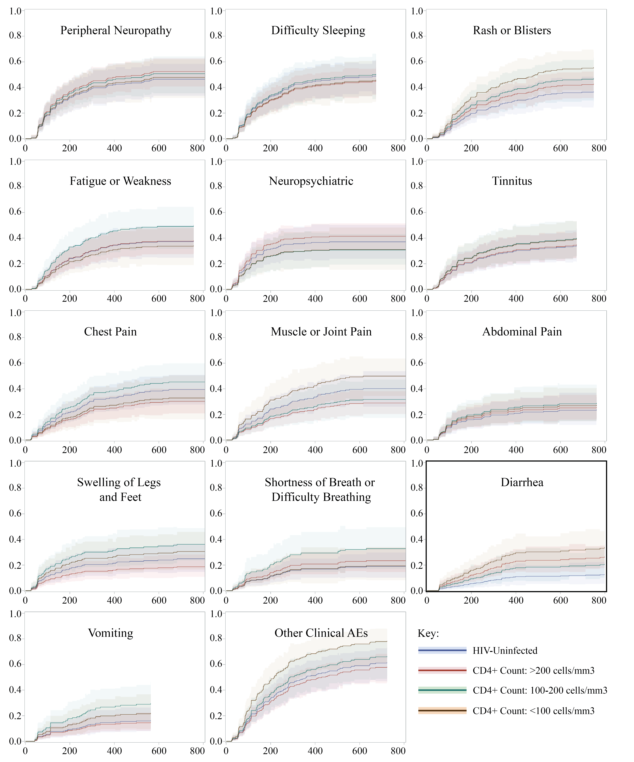
Figure S1: Cumulative incidence function (CIF) curves of time to first clinical adverse event, by CD4 status.
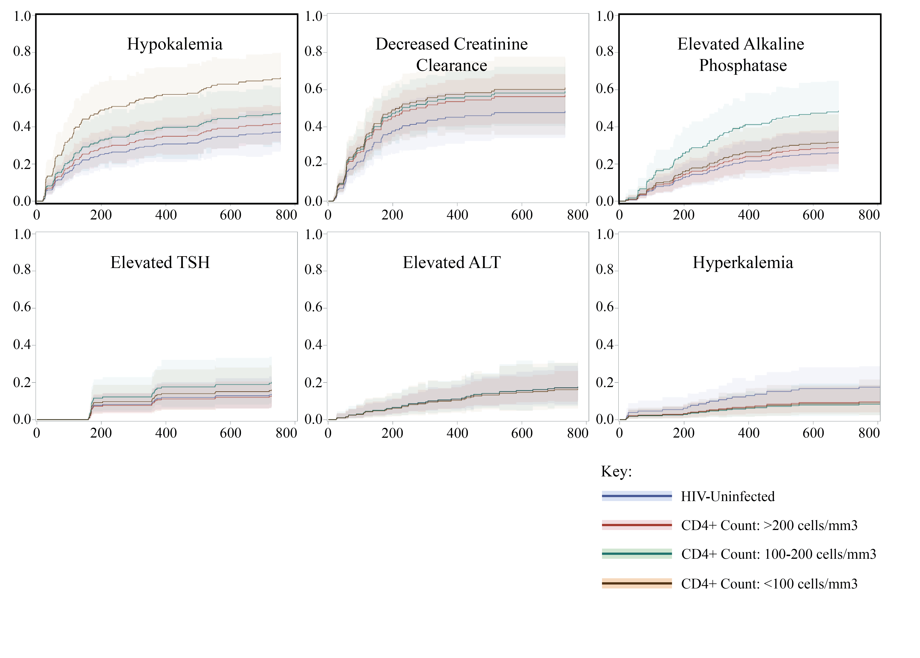
Figure S2: Cumulative incidence function (CIF) curves of time to first laboratory adverse event, by CD4 status. Bold indicates statistical significance.

Figure S3: Enrolment flowchart. Abbreviations: HIV, human immunodeficiency virus; MDR, multidrug-resistant.

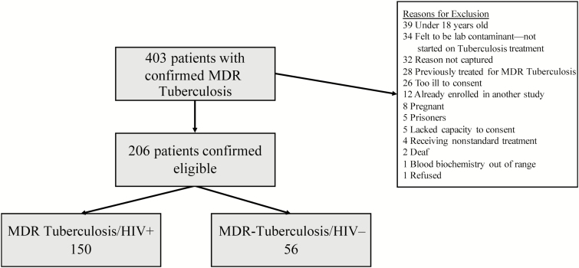

CITATIONS
1. Schacht J, Talaska AE, Rybak LP. Cisplatin and Aminoglycoside Antibiotics: Hearing Loss and Its Prevention. Anatomical record (Hoboken, NJ : 2007). 2012;295(11):1837-1850.
2. Fausti SA, Henry JA, Schaffer HI, Olson DJ, Frey RH, McDonald WJ. High-frequency audiometric monitoring for early detection of aminoglycoside ototoxicity. J Infect Dis. 1992;165(6):1026-1032.
3. Common Terminology Criteria for Adverse Events (CTCAE) Version 5.0. In: Services UDoHaH, Health NIo, Institute NC, eds. Bethesda: National Institutes of Health; 2009.

