SUPPLEMENTAL DIGITAL CONTENT

Tables S1-S3: Systematic review search terms. Search was conducted on May 23, 2019.

Table S1. PubMed search strategy.
HIV/AIDS terms | ("Anti-HIV Agents"[Mesh] OR ”HIV Infections/drug therapy"[Mesh] OR "HIV Infections/economics"[Majr] OR "antiretroviral therapy"[tiab] OR "anti retroviral therapy"[tiab] OR ((art[tiab] OR antiretroviral[tiab] OR "anti retroviral"[tiab]) AND hiv[ti]) OR "antiretroviral treatment"[tiab] OR "anti retroviral treatment"[tiab])
AND
Differentiated ART delivery terms | ("Patient-Centered Care"[Mesh] OR "Community Health Nursing"[Mesh] OR "Community Participation"[Mesh] OR "Community Networks"[Mesh] OR "Community Health Workers"[Mesh] OR "Self-Help Groups"[Mesh] OR "Cooperative Behavior"[Mesh] OR "Delegation, Professional"[Mesh] OR "adherence club"[tw] OR "adherence clubs"[tw] OR "adherence group"[tw] OR "adherence groups"[tw] OR (adherence[ti] AND (club[ti] OR clubs[ti] OR group[ti] OR groups[ti])) OR "alternative health care"[tw] OR "alternative healthcare"[tw] OR "alternative treatment system"[tw] OR "adherence support"[tw] OR "appointment scheduling"[tw] OR "appointment spacing"[tw] OR "visit scheduling"[tw] OR "visit spacing"[tw] OR "dispensing interval"[tw] OR "dispensing intervals"[tw] OR "visit interval"[tw] OR "visit intervals"[tw] OR "appointment interval"[tw] OR "appointment intervals"[tw] OR "appointment system"[tw] OR "appointment systems"[tw] OR "client centered"[tw] OR "client centred"[tw] OR "patient centered"[tw] OR "patient centred"[tw] OR "client managed"[tw] OR "patient managed"[tw] OR "return interval"[tw] OR "return intervals"[tw] OR ((club[tw] OR clubs[tw]) AND refill*[tw]) OR "home based"[tw] OR community[ti] OR "community art"[tw] OR "ART group"[tw] OR "ART groups"[tw] OR "ART club"[tw] OR "ART clubs"[tw] OR (community[tw] AND ("therapy group"[tw] OR "therapy groups"[tw] OR "therapy support"[tw] OR "group therapy"[tw]) AND (antiretroviral*[tw] OR "anti retroviral"[tw] OR "art"[tw])) OR "community care"[tw] OR "community based"[tw] OR "group model"[tw] OR "group models"[tw] OR ((ART[tw] OR antiretroviral*[tw] OR "anti retroviral"[tw]) AND ("support group"[tw] OR "support groups"[tw])) OR "ART support"[tw] OR "antiretroviral therapy support"[tw] OR "anti retroviral therapy support"[tw] OR "company-level"[tw] OR "delivery model"[tw] OR "delivery models"[tw] OR "chronic care model"[tw] OR ("antiretroviral treatment services"[tw] AND "delivery"[tw]) OR "distribution center"[tw] OR "distribution centers"[tw] OR (community[tw] AND (drug[tw] OR drugs[tw] OR prescription*[tw] OR medication*[tw]) AND (pickup*[tw] OR "pick up"[tw])) OR "community health worker"[tw] OR "community health workers"[tw] OR "community health"[tw] OR "health worker"[tw] OR "health workers"[tw] OR "community worker"[tw] OR "community workers"[tw] OR "community supported"[tw] OR decentralized[tw] OR decentralised[tw] OR decentralization[tw] OR delegat*[tw] OR differentiated[tw] OR "down refer"[tw] OR "down referral"[tw] OR "down referrals"[tw] OR "down referred"[tw] OR "down referring"[tw] OR "refill extension"[tw] OR "extended refills"[tw] OR "extending refills"[tw] OR "expedited encounter"[tw] OR "expedited encounters"[tw] OR "treatment club"[tw] OR "treatment clubs"[tw] OR "facility based"[tw] OR "distribution group"[tw] OR "distribution groups"[tw] OR "fast track"[tw] OR "fast tracked"[tw] OR "fast tracking"[tw] OR "lay people"[tw] OR "lay person"[tw] OR "lay health"[tw] OR "lay healthcare"[tw] OR "lay counsellors"[tw] OR "lay counselors"[tw] OR "multi-month"[tw] OR "multiple month"[tw] OR "managed groups"[tw] OR "managed group"[tw] OR "nurse managed"[tw] OR "nurse led"[tw] OR "non specialist"[tw] OR "non specialists"[tw] OR "optimised care"[tw] OR "optimized care"[tw] OR "out of facility"[tw] OR "outreach service"[tw] OR "outreach services"[tw] OR "home visit"[tw] OR "home visits"[tw] OR "home delivery"[tw] OR "home deliveries"[tw] OR "point-of-care system"[tw] OR "point of care systems"[tw] OR "refill program"[tw] OR "refill programs"[tw] OR "service delivery model"[tw] OR "service delivery models"[tw] OR "targeted adherence"[tw] OR "stable client"[tw] OR "stable clients"[tw] OR streamline*[tw] OR "support group"[tw] OR "support groups"[tw] OR "task shifting"[tw] OR "task sharing"[tw] OR "shift tasks"[tw] OR "skill mix"[tw] OR "ART delivery"[tw] OR "patient-centered"[tw] OR "tiered care"[tw] OR "refills model"[tw] OR "pharmacy refill"[tw] OR "pharmacy refills"[tw] OR "refill program"[tw] OR "refill programs"[tw] OR "public sector facilities"[tw] OR "public sector facility"[tw] OR "community care"[tw] OR "community support"[tw] OR "peer counseling"[tw] OR "peer counselling"[tw])
AND
Cost terms | ("Costs and Cost Analysis"[Mesh] OR efficient[tw] OR efficacy[tw] OR financial*[tw] OR economic*[tw] OR economics[sh] OR budget*[tw] OR affordab*[tw] OR Cost[tw] OR costs[tw] OR costing[tw] OR costly[tw] OR expensive[tw] OR inexpensive[tw] OR expenditure*[tw] OR spending[tw] OR expense*[tw] OR savings[tw])
AND
Filter for sub-Saharan Africa | (Angola[tw] OR Benin[tw] Burkina Faso[tw] OR Burkina Fasso[tw] OR Burundi[tw] OR Urundi[tw] OR Cameroon[tw] OR Cameroons[tw] OR Cameron[tw] OR Cape Verde[tw] OR Central African Republic[tw] OR Chad[tw] Comoros[tw] OR Comoro Islands[tw] OR Comores[tw] OR Mayotte[tw] OR Congo[tw] OR Zaire[tw] OR Cote d'Ivoire[tw] OR Ivory Coast[tw] OR Djibouti[tw] OR French Somaliland[tw] OR Eritrea[tw] OR Ethiopia[tw] OR Gabon[tw] OR Gabonese Republic[tw] OR Gambia[tw] OR Ghana[tw] OR Gold Coast[tw] Guinea[tw] OR Guam[tw] OR Guiana[tw] OR Kenya[tw] OR Lesotho[tw] OR Basutoland[tw] OR Liberia[tw] OR Madagascar[tw] OR Malagasy Republic[tw] OR Malawi[tw] OR Nyasaland[tw] OR Mali[tw] OR Mauritania[tw] OR Mauritius[tw] OR Mozambique[tw] OR Namibia[tw] OR Niger[tw] OR Nigeria[tw] OR Rwanda[tw] OR Ruanda[tw] OR Senegal[tw] OR Seychelles[tw] OR Sierra Leone[tw] OR Somalia[tw] OR South Africa[tw] OR Sudan[tw] OR Suriname[tw] OR Surinam[tw] OR Swaziland[tw] OR eSwatini[tw] OR Tanzania[tw] OR Togo[tw] OR Togolese Republic[tw] OR Uganda[tw] OR Zambia[tw] OR Zimbabwe[tw] OR Rhodesia[tw] OR ("africa south of the sahara"[MeSH Terms] OR ("africa"[All Fields] AND "south"[All Fields] AND "sahara"[All Fields]) OR "africa south of the sahara"[All Fields] OR ("sub"[All Fields] AND "saharan"[All Fields] AND "africa"[All Fields]) OR "sub Saharan africa"[All Fields]))
AND
Filter for publication year | 2005:2019[pdat]

Table S2. Embase search strategy.
HIV/AIDS terms | ('anti human immunodeficiency virus agent'/exp OR 'human immunodeficiency virus infection'/exp/dm_dt OR 'antiretroviral therapy'/exp OR 'antiretroviral therapy':ti,ab,kw OR ‘anti retroviral therapy’:ti,ab,kw OR ‘antiretroviral treatment’:ti,ab,kw OR ‘anti retroviral treatment’:ti,ab,kw OR ((art:ti,ab,kw OR antiretroviral:ti,ab,kw OR ‘anti retroviral’:ti,ab,kw) AND hiv:ti))
AND
Differentiated ART delivery terms | ('community health nursing'/exp OR 'community participation'/exp OR 'community care'/exp OR 'health auxiliary'/exp OR 'self help'/exp OR 'cooperation'/exp OR 'professional delegation'/exp OR “adherence club” OR “adherence clubs” OR “adherence group” OR “adherence groups” OR (adherence:ti AND (club:ti OR clubs:ti OR group:ti OR groups:ti)) OR “alternative health care” OR “alternative healthcare” OR “alternative treatment system” OR “adherence support” OR “appointment scheduling” OR “appointment spacing” OR “visit scheduling” OR “visit spacing” OR “dispensing interval” OR "dispensing intervals" OR "visit interval" OR "visit intervals" OR "appointment interval" OR "appointment intervals" OR "appointment system" OR "appointment systems" OR "client centered" OR "client centred" OR "patient centered" OR "patient centred" OR "client managed" OR "patient managed" OR "return interval" OR "return intervals" OR ((club OR clubs) AND refill*) OR "home based" OR community:ti OR "community art" OR "ART group" OR "ART groups" OR "ART club" OR "ART clubs" OR (community AND ("therapy group" OR "therapy groups" OR "therapy support" OR "group therapy") AND (antiretroviral* OR "anti retroviral" OR "art")) OR "community care" OR "community based" OR "group model" OR "group models" OR ((ART OR antiretroviral* OR "anti retroviral") AND ("support group" OR "support groups")) OR "ART support" OR "antiretroviral therapy support" OR "anti retroviral therapy support" OR "company-level" OR "delivery model" OR "delivery models" OR "chronic care model" OR ("antiretroviral treatment services" AND "delivery") OR "distribution center" OR "distribution centers" OR (community AND (drug OR drugs OR prescription* OR medication*) AND (pickup* OR "pick up")) OR "community health worker" OR "community health workers" OR "community health" OR "health worker" OR "health workers" OR "community worker" OR "community workers" OR "community supported" OR decentralized OR decentralised OR decentralization OR delegat* OR differentiated OR "down refer" OR "down referral" OR "down referrals" OR "down referred" OR "down referring" OR "refill extension" OR "extended refills" OR "extending refills" OR "expedited encounter" OR "expedited encounters" OR "treatment club" OR "treatment clubs" OR "facility based" OR "distribution group" OR "distribution groups" OR "fast track" OR "fast tracked" OR "fast tracking" OR "lay people" OR "lay person" OR "lay health" OR "lay healthcare" OR "lay counsellors" OR "lay counselors" OR "multi-month" OR "multiple month" OR "managed groups" OR "managed group" OR "nurse managed" OR "nurse led" OR "non specialist" OR "non specialists" OR "optimised care" OR "optimized care" OR "out of facility" OR "outreach service" OR "outreach services" OR "home visit" OR "home visits" OR "home delivery" OR "home deliveries" OR "point-of-care system" OR "point of care systems" OR "refill program" OR "refill programs" OR "service delivery model" OR "service delivery models" OR "targeted adherence" OR "stable client" OR "stable clients" OR streamline* OR "support group" OR "support groups" OR "task shifting" OR "task sharing" OR "shift tasks" OR "skill mix" OR "ART delivery" OR "patient-centered" OR "tiered care" OR "refills model" OR "pharmacy refill" OR "pharmacy refills" OR "refill program" OR "refill programs" OR "public sector facilities" OR "public sector facility" OR "community care" OR "community support" OR "peer counseling" OR "peer counselling")
AND
Cost terms | ('cost'/exp OR 'health economics'/exp OR efficient OR efficacy OR financial* OR economic* OR economics/lnk OR budget* OR affordab* OR Cost OR costs OR costing OR costly OR expensive OR inexpensive OR expenditure* OR spending OR expense* OR savings)
AND
Filter for sub-Saharan Africa | (Africa OR Angola OR Benin OR Botswana OR “Burkina Faso” OR “Burkina Fasso” OR Burundi OR Urundi OR Cameroon OR Cameroons OR Cameron OR “Cape Verde” OR “Central African Republic” OR Chad OR Comoros OR “Comoro Islands” OR Comores OR Mayotte OR Congo OR “Cote dIvoire” OR “Cote d Ivoire” OR “Ivory Coast” OR Djibouti OR “French Somaliland” OR Eritrea OR Ethiopia OR Gabon OR “Gabonese Republic” OR Gambia OR Ghana OR “Gold Coast” OR Kenya OR Lesotho OR Basutoland OR Liberia OR Madagascar OR “Malagasy Republic” OR Malawi OR Nyasaland OR Mali OR Mauritania OR Mozambique OR Namibia OR Niger OR Nigeria OR Rwanda OR Ruanda OR Senegal OR Seychelles OR “Sierra Leone” OR Somalia OR South Africa OR Sudan OR Suriname OR Surinam OR Swaziland OR eSwatini OR Uganda OR Zambia OR Zimbabwe OR Rhodesia OR “sub-Saharan Africa” OR “sub Saharan Africa”)
AND
Filter for publication year | [2005-2019]/py

Table S3. EconLit search strategy.
HIV/AIDS terms | (antiretroviral OR “anti retroviral” OR “anti hiv” OR (hiv AND art))
AND
Differentiated ART delivery terms | (“patient centered” OR “community health” OR “community participation” OR “community networks” OR “community network” OR “community care” OR “self help” OR cooperative OR delegat* OR “adherence club” OR “adherence clubs” OR “adherence group” OR “adherence groups” OR (adherence AND (club OR clubs OR group OR groups)) OR “alternative health care” OR “alternative healthcare” OR “alternative treatment system” OR “adherence support” OR “appointment scheduling” OR “appointment spacing” OR “visit scheduling” OR “visit spacing” OR “dispensing interval” OR "dispensing intervals" OR "visit interval" OR "visit intervals" OR "appointment interval" OR "appointment intervals" OR "appointment system" OR "appointment systems" OR "client centered" OR "client centred" OR "patient centered" OR "patient centred" OR "client managed" OR "patient managed" OR "return interval" OR "return intervals" OR ((club OR clubs) AND refill*) OR "home based" OR TI community OR "community art" OR "ART group" OR "ART groups" OR "ART club" OR "ART clubs" OR (community AND ("therapy group" OR "therapy groups" OR "therapy support" OR "group therapy") AND (antiretroviral* OR "anti retroviral" OR "art")) OR "community care" OR "community based" OR "group model" OR "group models" OR ((ART OR antiretroviral* OR "anti retroviral") AND ("support group" OR "support groups")) OR "ART support" OR "antiretroviral therapy support" OR "anti retroviral therapy support" OR "company-level" OR "delivery model" OR "delivery models" OR "chronic care model" OR ("antiretroviral treatment services" AND "delivery") OR "distribution center" OR "distribution centers" OR (community AND (drug OR drugs OR prescription* OR medication*) AND (pickup* OR "pick up")) OR "community health worker" OR "community health workers" OR "community health" OR "health worker" OR "health workers" OR "community worker" OR "community workers" OR "community supported" OR decentralized OR decentralised OR decentralization OR delegat* OR differentiated OR "down refer" OR "down referral" OR "down referrals" OR "down referred" OR "down referring" OR "refill extension" OR "extended refills" OR "extending refills" OR "expedited encounter" OR "expedited encounters" OR "treatment club" OR "treatment clubs" OR "facility based" OR "distribution group" OR "distribution groups" OR "fast track" OR "fast tracked" OR "fast tracking" OR "lay people" OR "lay person" OR "lay health" OR "lay healthcare" OR "lay counsellors" OR "lay counselors" OR "multi-month" OR "multiple month" OR "managed groups" OR "managed group" OR "nurse managed" OR "nurse led" OR "non specialist" OR "non specialists" OR "optimised care" OR "optimized care" OR "out of facility" OR "outreach service" OR "outreach services" OR "home visit" OR "home visits" OR "home delivery" OR "home deliveries" OR "point-of-care system" OR "point of care systems" OR "refill program" OR "refill programs" OR "service delivery model" OR "service delivery models" OR "targeted adherence" OR "stable client" OR "stable clients" OR streamline* OR "support group" OR "support groups" OR "task shifting" OR "task sharing" OR "shift tasks" OR "skill mix" OR "ART delivery" OR "patient-centered" OR "tiered care" OR "refills model" OR "pharmacy refill" OR "pharmacy refills" OR "refill program" OR "refill programs" OR "public sector facilities" OR "public sector facility" OR "community care" OR "community support" OR "peer counseling" OR "peer counselling")
AND
Filter for sub-Saharan Africa | (Africa OR Angola OR Benin OR Botswana OR “Burkina Faso” OR “Burkina Fasso” OR Burundi OR Urundi OR Cameroon OR Cameroons OR Cameron OR “Cape Verde” OR “Central African Republic” OR Chad OR Comoros OR “Comoro Islands” OR Comores OR Mayotte OR Congo OR “Cote dIvoire” OR “Cote d Ivoire” OR “Ivory Coast” OR Djibouti OR “French Somaliland” OR Eritrea OR Ethiopia OR Gabon OR “Gabonese Republic” OR Gambia OR Ghana OR “Gold Coast” OR Kenya OR Lesotho OR Basutoland OR Liberia OR Madagascar OR “Malagasy Republic” OR Malawi OR Nyasaland OR Mali OR Mauritania OR Mozambique OR Namibia OR Niger OR Nigeria OR Rwanda OR Ruanda OR Senegal OR Seychelles OR “Sierra Leone” OR Somalia OR South Africa OR Sudan OR Suriname OR Surinam OR Swaziland OR eSwatini OR Uganda OR Zambia OR Zimbabwe OR Rhodesia OR “sub-Saharan Africa” OR “sub Saharan Africa”)
Filter for publication year | Limiters - Published Date: 20050101-20191231

Table S4. Global Health search strategy.
HIV/AIDS terms | (“antiretroviral therapy” OR “antiretroviral treatment” OR ((art OR antiretroviral OR “anti retroviral”)
AND
Differentiated ART delivery terms | ("community involvement" OR "social participation" OR "community action" OR "community health" OR "community programmes" OR “community program” OR "self help" OR "self care" OR "cooperation" OR “community participation” OR “adherence club” OR “adherence group” OR (title:(adherence) AND title:(club OR group)) OR “adherence support” OR “appointment scheduling” OR “appointment spacing” OR “visit scheduling” OR “visit spacing” OR “dispensing interval” OR "visit interval" OR "appointment interval" OR "appointment system" OR "client centered" OR "client centred" OR "patient centered" OR "patient centred" OR "client managed" OR "patient managed" OR "return interval" OR (club AND refill*) OR "home based" OR title:(community) OR "community art" OR "ART group" OR "ART club" OR “therapy group" OR "therapy support" OR "group therapy" OR "community care" OR "community based" OR "group model" OR "support group" OR "ART support" OR "company-level" OR "delivery model" OR "chronic care model" OR ("antiretroviral treatment services" AND "delivery") OR "distribution center" OR (community AND (pickup* OR "pick up")) OR "health worker" OR "community worker" OR "community supported" OR decentralized OR decentralised OR decentralization OR delegat* OR differentiated OR "down refer" OR "refill extension" OR "extended refills" OR "extending refills" OR "expedited encounter" OR "treatment club" OR "facility based" OR "distribution group" OR "fast track" OR "lay people" OR "lay person" OR "lay health" OR "lay counsellors" OR "lay counselors" OR "multi-month" OR "multiple month" OR "managed group" OR "nurse managed" OR "nurse led" OR "non specialist" OR "optimised care" OR "optimized care" OR "out of facility" OR "outreach service" OR "home visit" OR "home delivery" OR "home deliveries" OR "point-of-care system" OR "refill program" OR "service delivery model" OR "targeted adherence" OR "stable client" OR streamline* OR "task shifting" OR "task sharing" OR "shift tasks" OR "skill mix" OR "ART delivery" OR "patient-centered" OR "tiered care" OR refill* OR "public sector" OR "community support" OR peer)
AND
Cost terms | (economic* OR cost OR efficient OR efficacy OR financial* OR budget* OR affordab* OR costing OR costly OR expensive OR inexpensive OR expenditure* OR spending OR expense* OR savings)
AND
Filter for publication year | yr:[2005 TO 2019]

Figure S1: Annual per-patient cost of antiretroviral drugs (ARVs) reported by differentiated ART delivery models in nominal US dollars. Costs are from the provider perspective. 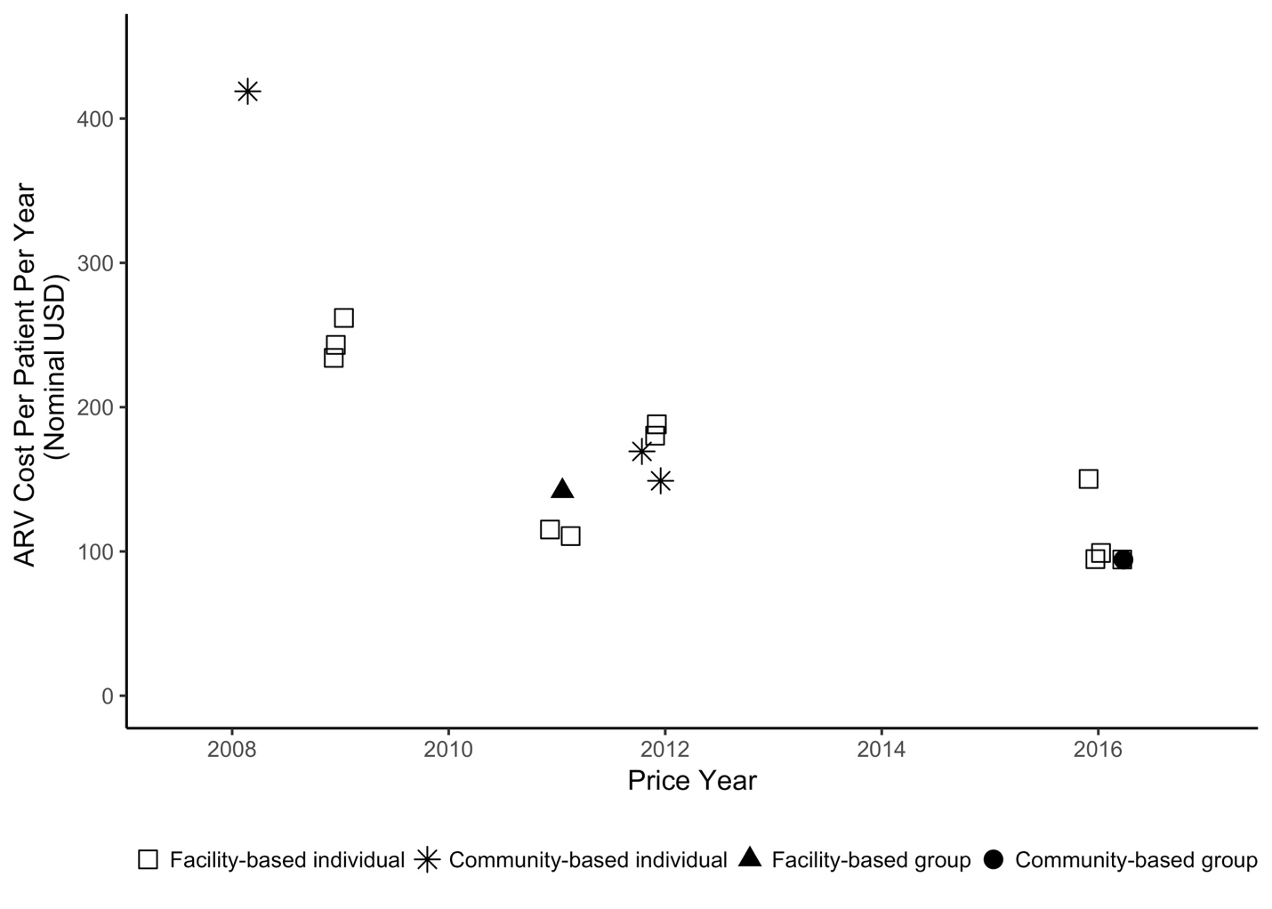

Figure S2: Annual non-ARV cost per patient of differentiated ART delivery models identified in review (2018 USD). Costs are from the provider perspective. Multiple estimates from the same model implemented in the same country but at different sites are averaged. TS = task shifting; HBC = home-based care; AC = adherence club; CDDP = community drug-distribution point; MMS = multi-month scripting; FTR = fast-track refills; CAG = community adherence group
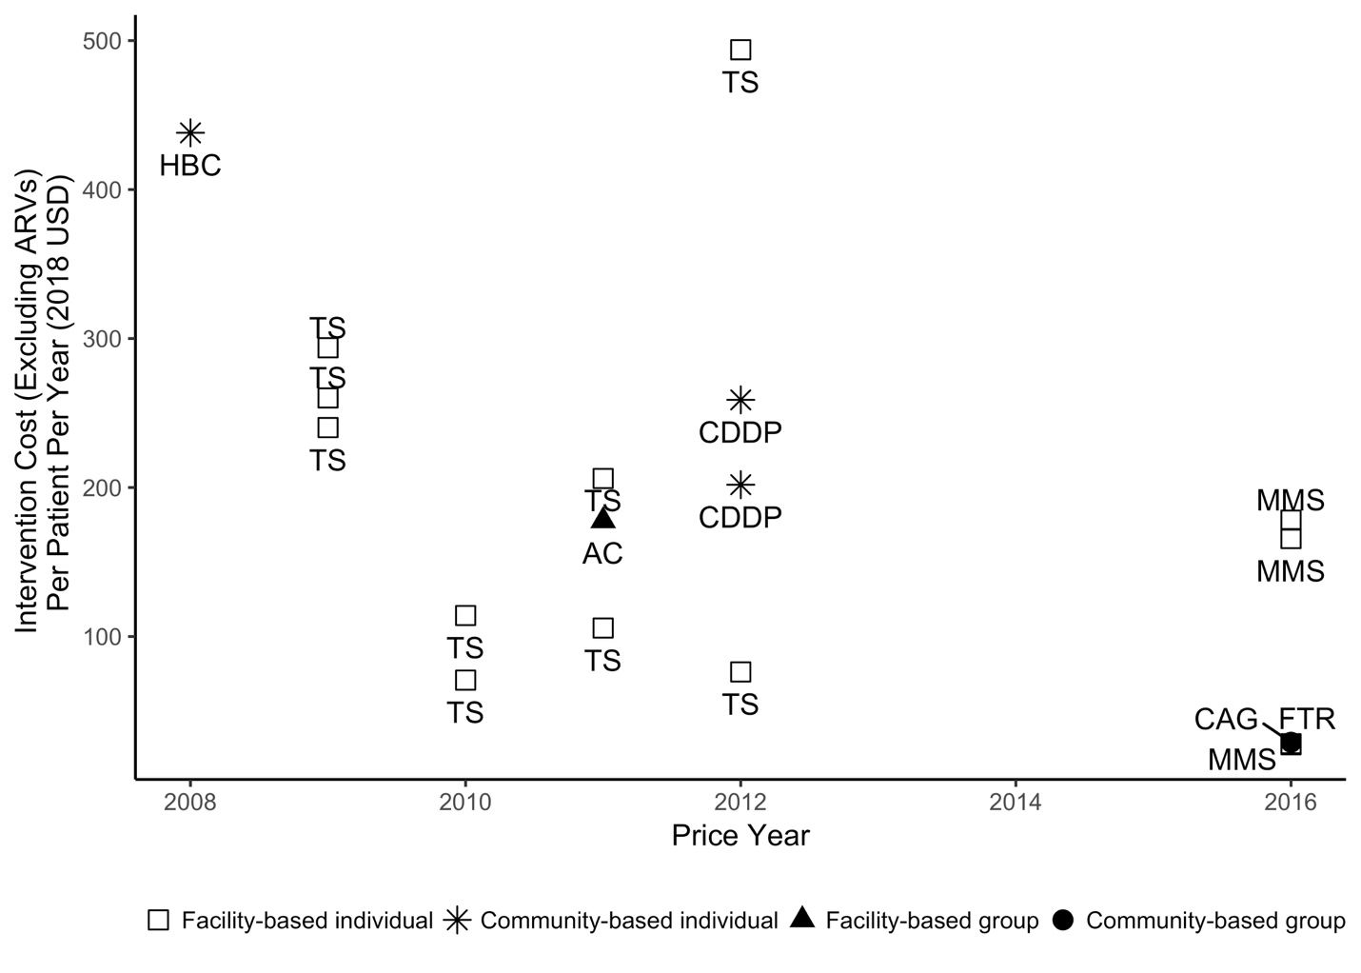

Figure S3: Annual non-ARV cost per patient of standard of care models identified in review (2018 USD). Costs are from the provider perspective. Multiple estimates from the same model implemented in the same country but at different sites are averaged. TS = task shifting; HBC = home-based care; AC = adherence club; CDDP = community drug-distribution point; MMS = multi-month scripting; FTR = fast-track refills; CAG = community adherence group

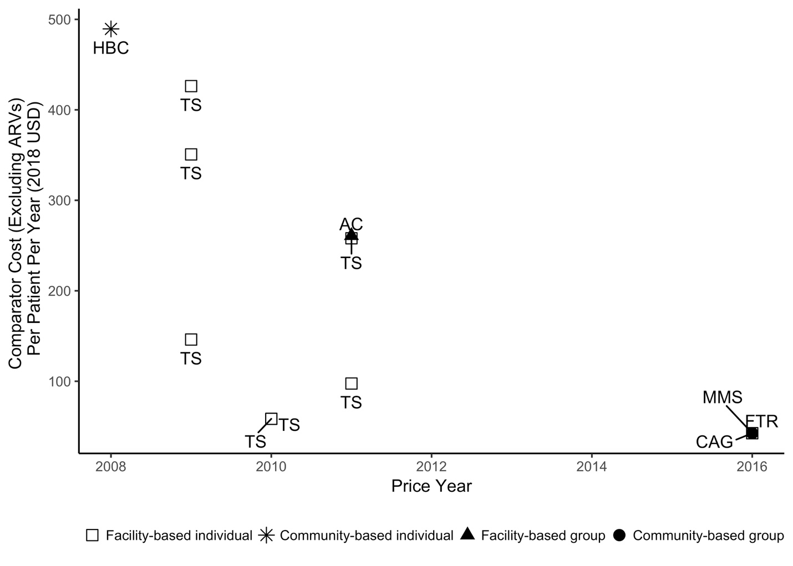
Figure S4: Annual per-patient incremental cost of differentiated ART delivery models. Costs are from the provider perspective. Multiple estimates from the same model implemented in the same country but at different sites are averaged. TS = task shifting; HBC = home-based care; AC = adherence club; CDDP = community drug-distribution point; MMS = multi-month scripting; FTR = fast-track refills; CAG = community adherence group

