Supplemental Table 1. Description of the 2wT cohort at enrolment, by study arm.

Characteristic |  | Routine care  N=359 (%) | Intervention  N=362 (%) | Full sample  N=721
Age (years)
Median |  | 23 | 24 | 24
IQR* |  | (18-31) | (19-32) | (19,31)
Site
 | Seke South | 294 (81.9) | 300 (82.9) | 594 (82.4)
 | Norton | 65 (18.1) | 62 (17.1) | 127 (17.6)
Language
 | English | 127 (35.4) | 154 (42.5) | 281 (39.0)
 | Shona | 232 (64.6) | 208 (57.5) | 440 (61.0)
Cell company
 | Econet | 315 (87.7) | 321 (88.7) | 636 (88.2)
 | Other | 44 (12.2) | 41 (11.3) | 85 (11.8)
Daily wage ($)
 | Median | 4.75 | 4.50 | 4.50
 | IQR* | 0-15 | 0-15 | 0-15
*Interquartile range

Supplemental Table 2: Type, timing, and severity of AEs
Severity |  | Post-operative day | Type | Study Arm
 |  |  |  | Texting | Routine
1 | Severe | 0 | Bleeding |  | X
2 | Severe | 0 | Bleeding | X
3 | Severe | 0 | Bleeding | X
4 | Moderate | 0 | Bleeding |  | X
5 | Moderate | 2 | Bleeding | X
6 | Moderate | 4 | Infection | X
7 | Moderate | 7 | Infection | X
8 | Moderate | 11 | Infection | X
9 | Moderate | 16 | Infection |  | X
10 | Mild | 2 | Bleeding |  | X
11 | Mild | 2 | Swelling |  | X
12 | Mild | 3 | Bleeding | X
13 | Mild | 4 | Swelling | X
14 | Mild | 4 | Swelling | X
15 | Mild | 4 | Swelling | X
16 | Mild | 7 | Infection | X
17 | Mild | 7 | Swelling | X
18 | Mild | 14 | Swelling | X

Supplemental Digital Content, Figure 1: Community Health Toolkit app example for 2wT
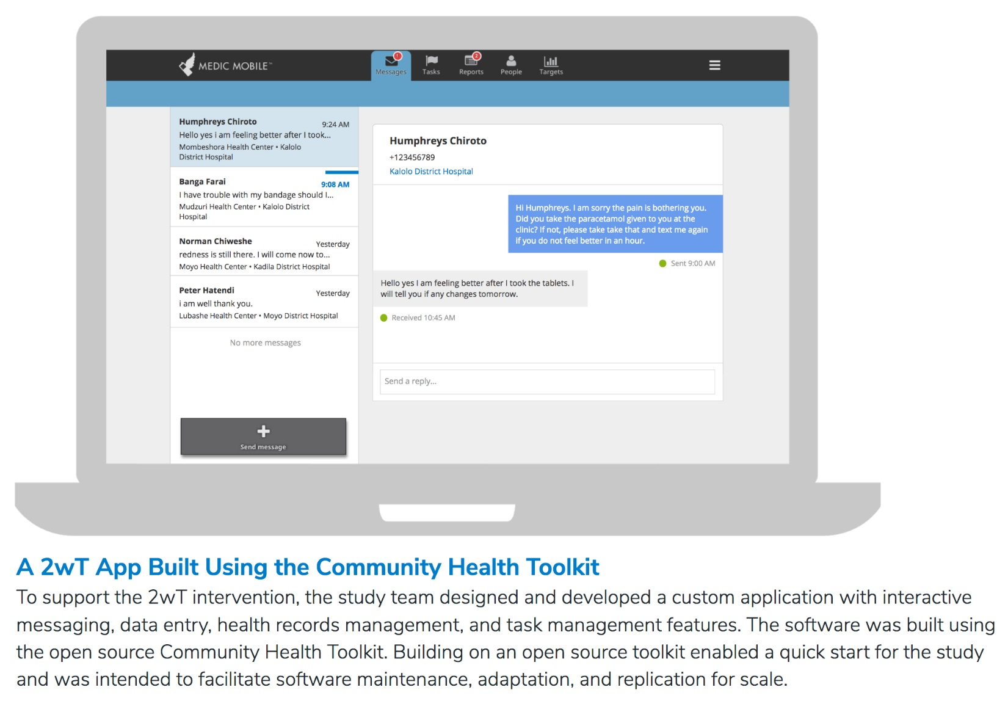

Supplemental Digital Content, Figure 2: 2wT daily response rates over time 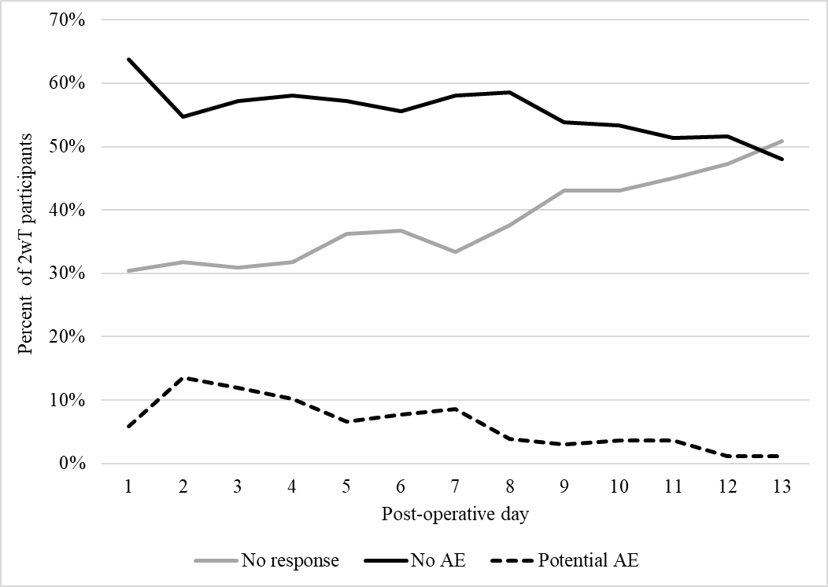

Supplemental Digital Content, Figure 3: Summary of daily text flow
4706 daily texts sent

Reasons for lack of PAE forms:
- 37 men sent both “No AE” and “Potential AE” texts same day. Form filled only if most recent text was PAE
- Some men sent PAE texts erroneously
- Some PAE sent to ask logistical questions (transport, visit timing, etc.)
- Some PAE may be missed

292 PAE texts received (6.2%)

252 (86.3%) PAE reports filled by 2wT nurse

83/252 (32.9%) nurse did not believe client described an AE
- 51/82 (62.2%) asked to return as a precaution

165 (65.4%) referred to in-person visit

100 (62%) texted the next day:
“No AE”
46 (29%) came back for an in-person visit
14 (9%) did not return as requested
5 (0.03%) missing form

