Appendix 1
Updated Embase search strategy
Supplementary Table 1. Characteristics of studies investigating the prevalence of vertebral fracture in patients living with HIV
Study | Population | Time period | Design | Fracture evaluation | PLHIV (n) | % men PLHIV | Age PLHIV | Prevalence of VF (%) | Evidence level
Atteritano 2018 ¹ | Messina University Hospital | 2012-2015 | Cross-sectional | Lateral spine X-ray | 100 | 16% | 44 | 16% | III
Borderi 2014 ² | Infectious Diseases unit of Bologna | 2011-2012 | Cross-sectional | Lateral spine X-ray | 202 |  | 51 | 23% | III
Ciulini 2017 ³ | Sant Andrea Hospital | 2013 | Cross-sectional | Lateral spine X-ray | 143 | 87% | 43 | 14% | III
Gazzola 2015 ⁴ | San Paolo Hospital, Milan | 2007-2011 | Cross-sectional | Lateral spine X-ray | 194 | 73% | 49 | 21% | III
Llop 2018 ⁵ | HIV/AIDS unit | 2014-2016 | Cross-sectional | Lateral spine X-ray | 128 | 73% | 57 | 20% | III
Mata-Marin 2018 ⁶ | Outpatient clinic | 2015-2016 | Cross-sectional | Lateral spine X-ray | 104 | 87% | 49 | 25% | III
Pietogrande 2012 (abstract) ⁷ | Milano | N/A | Cross-sectional | MorphoXpress | 133 | N/A | 47 | 21% | III
Porcelli 2014 ⁸ | Clinic of Infectious and Tropical Diseases of Brescia | 2009-2012 | Cross-sectional | Lateral spine X-ray | 131 | 71% | 51 | 27% | III
Stephens 2014 ⁹ | VA Medical Center, Atlanta | 2007-2010 | Cross-sectional | Lateral spine X-ray | 232 |  | 49.1 | 47% | III
Thouvinen 2014 ¹⁰ | ANRS EP48 HIV CHEST cohort | 2011-2012 | Cross-sectional | Chest Low dose CT | 397 | 83% | 49.5 | 12% | III
Torti 2012 ¹¹ | Department of Infectious Diseases, Brescia | 1998-2010 | Cross-sectional | Lateral Chest X-ray | 160 | 100% | 53 | 27% | III
Yin 2010 ¹² | CUMC and BLHC | 2002-2007 | Cross-sectional | Spine radiographs | 92 | 0% | 55.9 | 4·1% | III

Age (years) and BMI (kg/m²) are presented as means. Level of evidence based on level of evidence for prognostic studies.
Body mass index (BMI),patients living with HIV (PLHIV), vertebral fracture (VF)
Supplementary Table 2. Characteristics of studies investigating fracture risk in patients living with HIV
Study | Population | Time period | Design | Fracture evaluation | PLHIV (n) | % men PLHIV | Age of PLHIV |  | BMI of PLHIV |  | Evidence level
Arnsten 2007 ¹³ | CHAMPS study | 2000-2006 | Cohort | Incident fractures | 328 | 100% | 54.7 |  |  |  |  | II
Battalora 2016 ¹⁴ | HOPS-DIDX and SUN study, site Denver | 2004-2012 | Cohort | Incident fractures | 1,006 | 83% | 43 |  | 25 |  |  | II
Bedimo 2012 ¹⁵ | VHA Clinical Case registry | 1988-2009 | Cohort | Incident fractures | 56,600 |  | 44-46 |  |  |  |  | I
Byrne 2015 ¹⁶ | Medicaid | 1999-2007 | Cohort | Incident-hip fracture | 96,253 | 62% | 41 |  |  |  |  | I
Collin 2009 ¹⁷ | ANRS CO APROCO COPILOTE cohort | 1997-2007 | Cohort | Incident fractures - grade 3 or 4 fractures | 1,281 | 77% | 36.2 |  | 22 |  |  | II
Gedmintas 2014 ¹⁸ | Research Patient Data Registry | 2001-2012 | Cohort | Incident fracture | 3,161 | 73% | 41-44 |  |  |  |  | II
Gedmintas 2017 ¹⁹ | Research Patient Data Registry | 2001-2012 | Cohort | Incident fracture | 2,663 | 72% | 43 |  |  | 26 |  | II
Gonciulea 2017 ²⁰ | MACS | 1984-2015 | Cohort | Incident fracture (self-report) | 1,221 | 100% | 40 |  |  | 25 |  | II
Guerri-Fernandez 2013 ²¹ | SIDIAP | 2007-2009 | Cohort | Incident fracture | 2,489 | 75% | 50 |  |  | 25 |  | I
Hansen 2012 ²² | DHCS and DNHR | 1995-2010 | Cohort | Incident fracture | 5,306 | 76% | 36.7 |  |  |  |  | I
Komatsu 2018 ²³ | HRD survey | 2004-2013 | Cohort | Incident fracture | 3,251 | 94 | 40-41.2 |  |  |  |  | I
LaFleur 2018 ²⁴ | VHA | 2003-2015 | Cohort | Incident fracture | 7,161 | 94-97% | 47-50 |  |  | 25-27 |  | I
Mundy 2012 ²⁵ | INBD | 1997-2008 | Case-control | Incident fracture | 2,477 (C) 9,144 (CO) | 67-72% |  |  |  |  |  | III
Nkhoma 2016 ²⁶ | Truven Health MarketScan Databases | 2008-2014 | Cohort | Incident fracture | 9,876 | 84-89% |  | 42- 44 |  |  |  | II
Peters 2013 ²⁷ | Guy's and St Thomas Hospital, London | 2009-2010 | Cross-sectional | Previous fracture | 222 | 60% |  | 44-46 |  | 24-28 |  | III
Prieto-Alhambre 2014 ²⁸ | DNHR | 2000 | Case-control | Incident | 102 |  |  |  |  |  |  | III
Prior 2007 ²⁹ | CWHS and CaMOS | 2001-2003 | Case-control | Life-time fragility fractures | 138 | 0% |  | 38 |  | 25 |  | III
Reyes 2014 ³⁰ | SIDIAP | 2007-2009 | Cohort | Incident | - | - |  | - |  | - |  | II
Sharma 2015 ³¹ | WIHS | 2002-2013 | Cohort | Incident | 1,713 | 0% |  | 40 |  | 29 |  | II
Short 2013 ³² | UK Teaching Hospital | 2008 | Cross-sectional | Prevalent/previous | 168 | 100% |  | 45 |  | 25 |  | III
Triant 2008 ³³ | RPDR | 1996-2008 | Cross-sectional | Prevalence | 8525 | 65% |  |  |  |  |  | III
Warriner 2010 (abstract) ³⁴ | Medical claims | 1999-2010 | Cohort | Incident | 13,221 |  |  |  |  |  |  | II
Womack 2011 ³⁵ | VACS-VC | 1997-2009 | Cohort | Incident | 40,115 | 100% |  |  |  | 25 |  | I
Womack 2013 ³⁶ | VACS-VC | 1997-2009 | Cohort | Incident | 40,115 |  |  | 46 |  | 25 |  | I
Yin 2010 ³⁷ | WIHS | 2002-2008 | Cohort | Incident | 1,728 | 0% |  | 40 |  | 29 |  | II
Yin 2012 ³⁸ | ALLRT Database | -2009 | Cohort | Incident | 4,640 | 83% |  | 39 |  | 25 |  | II
Yin 2016 ³⁹ | VACS-VC | 2000-2010 | Cohort | Incident | 7,067 | 100% |  | 56 |  | 25 |  | II
Yong 2011 ⁴⁰ | The Alfred Hospital, Melbourne | 1998-2009 | Case-control | Incident | 2,424 | 89% |  | 50 |  | 23 (C) 25(CO) |  | II
Young 2011⁴¹ | HOPS and NHAMCS | 2000-2008 | Cohort | Incident | 5,826 | 79% |  | 40 |  | 24 |  | II

Age (years) and BMI (kg/m²) are presented as means. Level of evidence based on level of evidence for prognostic studies.
Body mass index (BMI), cases (C), controls (CO), patients living with HIV (PLHIV)

Supplementary Table 3. Characteristics of studies reporting bone mineral density in patients living with HIV and controls
Study | Design | ART | PLHIV (n) | CO (n) | PLHIV (%men) | CO (%men) | Age PLHIV | Age CO | BMI PLHIV | BMI CO | Evidence level
Amiel 2004 ⁴² | Cross-sectional | Mixed | 148 | 81 | 100% | 100% | 40 | 39 | 23 | 24 | III
Anastos 2007 ⁴³ | Cross-sectional | ART naive | 74 | 152 | 0% | 0% | 43 | 36 | 29 | 30 | III
Anastos 2007 ⁴³ | Cross-sectional | Non-PI ART | 98 | 152 | 0% | 0% | 42 | 36 | 27 | 28 | III
Anastos 2007 ⁴³ | Cross-sectional | PI ART | 93 | 152 | 0% | 0% | 44 | 36 | 28 | 28 | III
Arnsten 2006 ⁴⁴ | Cross-sectional | Mixed | 263 | 232 | 0% | 0% | 44 | 45 |  |  | III
Arnsten 2007 ¹³ | Cohort | Mixed | 328 | 231 | Mix | Mix | 55 | 56 |  |  | III
Badie 2013 ⁴⁵ | Cross-sectional | Naive | 44 | 40 | 84% | 78% | 35 | 37 | 23 | 23 | III
Badie 2013 ⁴⁵ | Cross-sectional | ART | 36 | 40 | 75% | 78% | 39 | 37 | 23 | 23 | III
Bedimo 2016 ⁴⁶ | Cross-sectional | ART | 81 | 107 | 100% | 100% | 56 | 53 | 28 | 30 | III
Biver 2014 ⁴⁷ | Cross-sectional | ART | 28 | 112 | 100% | 100% | 64 | 65 | 25 | 26 | III
Bolland 2007 ⁴⁸ | Cohort | ART | 23 | 26 | 100% | 100% | 47 | 45 | 24 | 25 | III
Bolland 2012 ⁴⁹ | Cohort | ART | 32 | 33 | 100% | 100% | 49 | 46 | 25 | 26 | III
Brown 2004 ⁵⁰ | Cross-sectional | ART | 51 | 22 | 86% | 82% | 40 | 39 | 25 | 26 | III
Bruera 2003 ⁵¹ | Cross-sectional | Naive | 33 | 31 | 91% | 77% | 31 | 31 | 24 | 25 | III
Bruera 2003 ⁵¹ | Cross-sectional | Non-PI ART | 35 | 31 | 69% | 77% | 35 | 31 | 24 | 25 | III
Bruera 2003 ⁵¹ | Cross-sectional | PI + ART | 42 | 31 | 81% | 77% | 36 | 31 | 24 | 25 | III
Calmy 2013 ⁵² | Cross-sectional | ART | 22 | 44 | 0% | 0% | 44 | 44 | 22 | 22 | III
Dolan 2007 ⁵³ | Cross-sectional | Mixed | 28 | 100 | 0% | 0% | 39 | 41 | 19 | 27 | III
Dolan 2007 ⁵³ | Cross-sectional | Mixed | 124 | 100 | 0% | 0% | 41 | 41 | 26 | 27 | III
Guerri-Fernandez 2016 ⁵⁴ | Cross-sectional | Naive | 50 | 35 | 70% | 69% | 37 | 34 | 24 | 23 | III
Hamill 2013 ⁵⁵ | Cross-sectional | Non ART | 74 | 98 | 0% | 0% | 34 | 30 | 28 | 27 | III
Hamill 2013 ⁵⁵ | Cross-sectional | Pre ART | 75 | 98 | 0% | 0% | 33 | 30 | 24 | 27 | III
Hamill 2017 ⁵⁶ | Cohort | Naive | 120 | 67 | 0% | 0% | 33-35 | 31 | 26-28. | 29 | III
Hileman 2014 ⁵⁷ | Cohort | Naive | 47 | 41 | 70% | 6% | 40 | 37 | 26 | 27 | III
Jones 2008 ⁵⁸ | Cross-sectional | Mixed | 57 | 47 | 60% | 30% | 61 | 62 | 26 | 29 | III
Kalyan 2018 ⁵⁹ | Cross-sectional | Mixed | 73 | 280 | 0% | 0% | 43 | 50 | 25 | 26 | III
Loiseau-Peres 2002 ⁶⁰ | Cross-sectional | Mixed | 31 | 31 | 100% | 100% | 43 |  |  |  | III
Loiseau-Peres 2002 ⁶⁰ | Cross-sectional | Mixed | 16 | 16 | 0% | 0% | 38 |  |  |  | III
Madeddu 2004 ⁶¹ | Cross-sectional | ART +PI | 98 | 64 | 65% |  | 38 |  |  |  | III
Madeddu 2004 ⁶¹ | Cross-sectional | ART | 60 | 64 | 63% |  | 38 |  |  |  | III
Mulligan 2012 ⁶² | Cross-sectional | ART +PI | 105 | 53 | 100% | 100% | 21 | 21 |  |  | III
Mulligan 2012 ⁶² | Cross-sectional | ART | 42 | 53 | 100% | 100% | 21 | 21 |  |  | III
Mulligan 2012 ⁶² | Cross-sectional | Naive | 52 | 53 | 100% | 100% | 21 | 21 |  |  | III
Negredo 2014 ⁶³ | Cross-sectional | Mixed | 232 | 75 | 79% | 73% | 28 | 26 |  |  | III
Paul 2010 ⁶⁴ | Cross-sectional | Naive | 35 | 35 | 100% | 100% | 39 | 39 |  |  | III
Paul 2010 ⁶⁴ | Cross-sectional | ART | 35 | 35 | 100% | 100% | 38 | 39 |  |  | III
Peters 2013 ²⁷ | Cross-sectional | Mixed | 222 | 222 | 60% | 80% | 45-46 | 45-47 | 24-28 | 25-27 | III
Prior 2007 ²⁹ | Case-control | Mixed | 138 | 402 | 0% | 0% | 38 | 38 | 25 | 26 | III
Sharma 2015 ⁶⁵ | Cohort | Mixed | 246 | 219 | 0% | 0% | 47 | 48 | 28 | 32 | III
Teichmann 2009 ⁶⁶ | Cross-sectional | Naive | 32 | 20 | 100% | 100% | 39 | 35 | 24 | 26 | III
Teichmann 2009 ⁶⁶ | Cross-sectional | Naive | 48 | 20 | 100% | 100% | 35 | 35 | 25 | 26 | III
Unsal 2017 ⁶⁷ | Cross-sectional | Mixed | 65 | 23 | 39% | 48% | 24 | 25 | 24 | 25 | III
Yin 2010 ⁶⁸ | Cross-sectional | Mixed | 92 | 95 | 0% | 0% | 56 | 60 | 28 | 30 | III
Yin 2014 ⁶⁹ | Cross-sectional | ART | 30 | 14 | 100% | 100% | 23 | 22 | 26 | 25 | III
Yin 2005 ⁷⁰ | Cross-sectional | Mixed | 31 | 186 | 0% | 0% | 56 | 57 | 26 | 28 | III
Zhang 2013 ⁷¹ | Prospective cohort | Naive | 40 | 40 | 88% | 88% | 37 | 37 | 22 | 23 | III
Age (years) and BMI (kg/m²) are presented as means. Level of evidence based on level of evidence for prognostic studies. The same study may be present several times as it may report on different PLHIV populations (e.g. naïve vs. ART experienced).
Antiretroviral theraphy (ART), Body mass index (BMI), control (CO), patients living with HIV (PLHIV) protease inhibitor (PI)

Supplementary Table 4. RCTs and cohort studies investigating longitudinal changes of BMD in PLHIV
Study | Population | Time period | Design | ART | PLHIV (n) | PLHIV (%men) | Age PLHIV | PLHIV BMI | Evidence level
RCTs investigating TAF and TDF
Arribas 2017⁷²* | 2 phase 3 trails | - | RCT | Naive randomized to TAF or TDF | 1,733 | 85% | 33-35 | 24-25 | Ib
Eron 2018 ⁷³ | AMBER | - | RCT | Naive randomized to TAF or TDF | 113 | 88% | 34 | - | Ib
Mills 2015 ⁷⁴ | Multicenter phase 2 study | 2012-2014 | RCT | Naive randomized to TAF or TDF, both with DRV/C/FTC. Single tablet regimen | 153 | 93% | 33 | - | Ib
Mills 2016 ⁷⁵ | GS-US-292-0109 (phase 3 non-inferiority trial) | 2013-2015 | RCT | Virologically suppressed randomized to switch from TDF to TAF or stay on one of four TDF-based regimen | 1,436 | 89-90% | 40-41 | 26 | Ib
Post 2017b⁷⁶ | - | - | RCT | Virologically suppressed randomized to switch from FTC/TDF to FTC/TAF back-bone evaluated by third agent (boosted PI vs unboosted third agent) | 633 | 85% | 49 | - | Ib
Raffi 2017 ⁷⁷ | GS-US-311-108 Double-blind phase 3 trial | 2014-2016 | RCT | Switch to TAF or stay on TDF | 663 | 84-86% | 49 | 26 | Ib
Sax 2014 ⁷⁸* | GS-US-292-0102 (phase 2 multicenter study) | 2011-2013 | RCT | Naive randomized to TDF vs TAF | 1,733 | 96-98% | 34-38 | - | Ib
Wohl 2016 ⁷⁹* | GS-US-292-0104/0111 | - | RCT | Naive randomized to TAF vs TDF | 1,733 | 85% | 33-35 | 24-25 | Ib
RCTs investigating abacavir and TDF
Erlandson 2013 ⁸⁰ | A5224s, sub-study of A5202 | 2005-2008 | RCT | Naive randomized to ABC or TDF | 269 | 85% | 38 | 26 | Ib
Grant 2015 ⁸¹ | ACTG A5224s and ASSERT | 2005-2008 | Post-hoc of RCT | Naive randomized to TDF or ABC | 652 | 83% | 38 | 25 | Ib
Gupta 2017 ⁸² | ACTG A5224s | 2005-2008 | RCT | Naive randomized to TDF or ABC | 269 | 85% | 38 | - | Ib
McComsey 2011 ⁸³ | A5224s, sub-study of A5202 | 2005-2008 | RCT | Naive randomized to ABC/3TC or TDF/FTC with open-label EFV or ATV/ r | 269 | 85% | 38 | - | Ib
Moyle 2013⁸⁴ | ASSERT study | 2007-2009 | RCT | Naive randomized to ABC/3TC vs TDF/FTC, + EFV | 385 | 81% | 37 | - | Ib
Negredo 2014 ⁸⁵ | OsteoTDF study | 2010-2012 | RCT | Virologically suppressed randomized to stay on TDF or switch to ABC | 48 | 79-89% | 49 | 22-24 | Ib
Rasmussen 2012 ⁸⁶ | SWAP study | 2008-2010 | RCT | Switch from ZDV to ABC or TDF | 40 | 55-70% | 46-50 | 25 | Ib
Stellbrink 2010 ⁸⁷ | ASSERT study | 2007-2009 | RCT | Naive randomized to ABC or TDF | 385 | 81% | 37 | - | Ib
Other RCTs and cohort studies
Assoumou 2013 ⁸⁸ | ANRS 120 Fosivir trial | - | Cohort | ART | 94 | 100% | 46 | 22 | II
Bernadino 2015 ⁸⁹ | NEAT001/ANRS143 | 2010-2011 | RCT | Naive randomized to RAL or TDF | 152 | 89-95% | 39-40 | 23 | Ib
Bloch 2014 ⁹⁰ | Hospital | - | Cohort | TDF switched to RAL | 37 | 97% | 49 | 26 | II
Bolland 2007 ⁴⁸ | Infectious disease clinics | - | Cohort | ART | 23 | 100% | 47 | 24 | II
Bolland 2012 | Infectious disease clinics ⁴⁹ | - | Cohort | ART | 32 | 100% | 49 | 25 | II
Bonjoch 2010 ⁹¹ | HIV unit | 2000-2009 | Cohort | ART (1% naive) | 391 | 72% | 42 | 23 | II
Briot 2011 ⁹² | Monark | 2003-2005 | RCT | Naive randomized to LPV/r or LPV+ZDV | 68 | 64-70% | 26-38 | 23-24 | Ib
Brown 2015 ⁹³ | A5260s, substudy of AIDS Clinical Trial Group A5257 | 2009-2013 | RCT | Naive randomized to TDF or RAL | 328 | 89-91% | 36-37 | 24-26 | Ib
Calza 2017 ⁹⁴ | Infectious disease clinic | 2011-2015 | Cohort | ART | 38 | 71% | 46 | - | II
Casado 2016 ⁹⁵ | Hospital | 2012-2014 | Cohort | TDF switched to RAL | 90 | 80% | 48 | 24 | II
Cook 2016 ⁹⁶ | Single HIV clinic | 2011-2015 | RCT | Naive randomized to TDF or RAL | 20 | 60-80% | 30-37 | 24-27 | Ib
Cotter 2013 ⁹⁷ | Substudy of PREPARE study | 2006-2008 | RCT | Switch to TDF or remain on ZDV | 53 | 75-93% | 45-47 | 23-24 | Ib
Duviver 2009 ⁹⁸ | ANRS 121 substudy | 2003-2005 | RCT | ART | 71 | 77% | 40 | 23 | Ib
Gallant 2004 ⁹⁹ | Multicenter study | 2000-2004 | RCT | Naive randomized to TDF or stavudine | 600 | 74-75% | 36 | - | Ib
Galli 2016 ¹⁰⁰ | MODAt | 2010-2014 | RCT | ATV/r monotherapy vs ATV/r triple therapy | 69 | 82-86% | 41 | 23-24 | Ib
Grund 2009 ¹⁰¹ | SMART study | 2002-2006 | RCT | Mixed | 214 | 81% | 44 | 26 | Ib
Guerri-Fernandez 2018 ¹⁰² | Consecutively recruited | - | Cohort | Naive starting on TDF | 40 | 83% | 38 | 24 | II
Hamill 2017 ⁵⁶ | Single center study | 2010-2011 | RCT | Naive initiating ART (>85% TDF) | 120 | 0% | 33-35 | 26-28 | Ib
Hansen 2011¹⁰³ | SPAR trial substudy | 2006-? | RCT | Naive randomized to ZDV + EFV or LPV/r + EFV | 59 | 90% | 43 | 22 | Ib
Haskelberg 2014 ¹⁰⁴ | The Second-Line study (phase IV multicenter study) | 2010-2013 | RCT | Randomized to RAL+LPV/r or 2-3 NRTI + LPV/r | 210 | 48% | 39 | 23 | Ib
Hileman 2014 ⁵⁷ | Single Immunology Unit | 2010-2013 | Cohort | Naive | 47 | 70% | 40 | 26 | II
Hoy 2017 ¹⁰⁵ | START Bone Mineral Density Substudy | 2011-2015 | RCT | Naive randomized to initiating treatment vs deferring ART (to CD4 < 350) | 399 | 74% | 32 | 24 | Ib
Koga 2016 ¹⁰⁶ | Hospital | 2010-2015 | Cohort | ART | 54 | 100% | 42 | 23 | II
Madeddu 2014 ¹⁰⁷ | HIV University Care Center | - | Cohort | ART | 51 | 53% | 40 | - | II
Martin 2013 ¹⁰⁸ | The Second-Line study | 2010-2013 | RCT | Adults virologically failing standard first-line therapy randomized to RAL and LPV/r vs standard second line therapy (LPV/r + 2-3 N(t)RTIs) | 210 | 48% | 39 | - | Ib
Mondi 2015 ¹⁰⁹ | ATLAS study | - | Cohort | Virologically suppressed simplification trial from three-drug ATV/r + 2 NRTIs based regimen to dual regimen of ATV/r + 3TC | 40 | 58% | 45 | - | II
Post 2017 ¹¹⁰ | Multicenter phase 3 study (GS-US-292-0112) | 2013-2016 | Cohort | Virologically suppressed switched from baseline treatment (65% including TDF) to E/C/FTC/TAF | 242 | - | 58 | - | II
Pozniak 2017 ¹¹¹ | GS-US-292-0112 (open-label phase 3 study) | 2013-2014 | Cohort | Switch to TAF | 242 | 79% | 58 | -
Rey 2015 ¹¹² | Single center study | 2003-2010 | Cohort | Naive commencing a first ARV treatment (76,2% TDF) | 50 | 100% | 39-40 | 22-23 | II
Rivas 2008 ¹¹³ | Single center study | 2002-2005 | Cohort | Naive initiating ZDV/3TC + ABC or LPV/r | 32 | 100% | 39-44 | 23 | II
Rockstroh 2013¹¹⁴ | GS-US-236-0103 (phase 3 study) | - | RCT | Naive randomized to E/C/FTC/TDF vs ATV/r + FTC/TDF | 708 | - | - | - | Ib
Saitz 2018 ¹¹⁵ | Boston ARCH prospective cohort study | 2012-2014 | Cohort | Mixed | 234 | 64% | 50 | 26 | II
Sharma 2012 ¹¹⁶ | Metabolic substudy of WIHS (Women's Interagency HIV Study) | 2001-2009 | Cohort | Mixed | 318 | 0% | 44 | 27 | II
Sharma 2010 ¹¹⁷ | CHAMPS study | 2002 | Cohort | Mixed | 230 | 100% | 55 | 26 | II
Sharma 2015 ⁶⁵ | Menopause Study | 2001-2005 | Cohort | Mixed | 246 | 0% | 47 | 28 | II
Tinago 2017 ¹¹⁸ | HIV UPBEAT Study group | 2012-2015 | Cohort | Mixed | 176 | 61% | 39 | - | II
Van Vonderen 2009 ¹¹⁹ | MEDICLAS study | 2003-2007 | RCT | Naive randomized to LPV/r with ZDV/3TC or NVP | 48 | 100% | 38-43 | 23 | Ib
Yin 2012 ¹²⁰ | Single center study | 2002-2008 | Cohort | Mixed | 73 | 0% | 56 | 28 | II
Zhang 2013 ⁷¹ | Single center study | 2007-2012 | Cohort | Naive initiating ART | 40 | 88% | 37 | 22 | II
Age (years) and BMI (kg/m²) are presented as means. Level of evidence based on level of evidence for prognostic studies
Abacavir (ABC), atazanavir (ATV), atazanavir/ritonavir (ATV/r), antiretroviral theraphy (ART), body mass index (BMI), cobicistat (C), darunavir (DRV), efavirenz (EFV), elvitegravir (E), emtricitabine (FTC), lamivudine (3TC), lopinavir (LPV), lopinavir/ritonavir (LPV/r), nevirapine (NPV), nucleoside/nucleotide reverse transcriptase inhibitors (NRTI), patients living with HIV (PLHIV), protease inhibitor (PI), raltegravir (RAL) randomized controlled trial (RCT), tenofovir alafenamide (TAF), tenofovir disoproxil fumarate (TDF), Zidovudine (ZDV),
* These three studies report on the same population and only one study is included in the meta-analysis.
Supplementary Table 5. Characteristics of studies investigating antiosteoporotic treatment in patients living with HIV.
Study | Design | BMD /osteoporosis status at baseline | Antiosteoporotic treatment | PLHIV (n) | PLHIV (%men) | Age PLHIV | Result | Evidence level
Alendronate
McComsey 2007 ¹²¹ | RCT | T-score < -1.4 | 70 mg alendronate weekly vs placebo both + calcium and vitamin D for 48 weeks. | 82 | 71% | 48 | Alendronate significantly improved BMD at the lumbar spine and total hip. | Ib
Mondy 2005 ¹²² | RCT | Osteopenia or osteoporosis | 70 mg alendronate weekly vs no study drug both + calcium and vitamin D for 48 weeks. | 31 | 87% | 44 | Alendronate significantly improved BMD at the lumbar spine no difference at total hip | Ib
Rozenberg 2012 ¹²³ | RCT | Osteoporosis | 70 mg alendronate weekly vs placebo both + calcium and vitamin D for 96 weeks. | 44 | 45% | 43-47 | Alendronate significantly improved BMD at the lumbar spine but not total hip | Ib
Zoledronate
Bolland 2007 ¹²⁴ | RCT | T-score < -0.5 | Annual iv zoledronate(two doses) or placebo + calcium and vitamin D for 2 years. | 43 | 100% | 49-50 | Zoledronate significantly increased BMD at the lumbar spine and hip. | Ib
Bolland 2008 ¹²⁵ | Cohort | T-score < -0.5 | Follow up of Bolland 2007. No treatment in follow up period. | 33 | 100% | 50 | Zoledronate significantly increased BMD at the lumbar spine and hip after 36 months. | II
Bolland 2012 ¹²⁶ | Cohort | T-score < -0.5 | Four year extension of Bolland 2007. No treatment in follow up period. | 43 | 100% | 49-50 | The effect of zoledronate persists after five years. | II
Hoy 2018 ¹²⁷ | RCT | T-score < -1.0 | Continue TDF and start zoledronate or switch from TDF to another active antiretroviral therapy for 24 months. | 87 | 93-100% | 49-51 | Zoledronate and TDF significantly increased BMD at the total hip and lumbar spine compared to switch after 12- and 24 months. | Ib
Negredo 2014 ¹²⁸ | RCT | T-score < -1.0 | Randomized to 1 or 2 doses of zoledronate or control. | 21 | 78-91% | 46-49 | Zoledronate significantly improved BMD at lumbar spine. No difference between 1 and 2 doses. | Ib
Ofotokun 2016 ¹²⁹ | RCT | Non-osteoporotic | ART initiation (TDF containing) randomized to zoledronate or placebo for 48 weeks. | 63 (ART naïve) | 79% | 39-40 | Zoledronate significantly improved BMD at lumbar spine. | Ib
Risedronate
Pepe 2014 ¹³⁰ | Cohort | Two groups 1) osteoporosis and osteopenia with fractures 2) normal or osteopenia without fractures | Risedronate twice monthly 12 months in group 1. Both groups with calcium and vitamin D. | 41 | 100% | 44-53 | Risedronate significantly increased lumbar spine BMD in group 1. Better response in eugonadal men compared to hypogonadal men. | II
Age (years) is presented as a mean. Level of evidence based on level of evidence for prognostic studies
Bone mineral density (BMD), patients living with HIV (PLHIV), randomized controlled trial (RCT)

Supplementary Table 6. Guidelines identified for the management of osteoporosis in patients living with HIV.
Source | Whom to screen | Repeat screening | Whom to treat | Treatment | Dose | Duration of treatment
Osteo Renal Exchange Program,  ¹³¹ | Individuals 40-50 year old with FRAX score >10%, all ≥ 50 year old, all using glucocorticoids or history of fragility fracture or high risk of falls | 1) T-score -1·01 to -1·99 in 5 years.  2) T-score -2·00 to -2·49 or started on bisphosphonates 1-2 years. | 1) Hip or vertebral fracture 2) T-score between -1·0 and -2·5 and FRAX score ≥ 20 % or 3 ≥ at the hip 3) T-score≤-2·5 at FN, TH or LS | Consider bisphosphonate therapy. Ensure calcium and vitamin D intake. Lifestyle advice.  If on TDF recommended switching to abacavir or raltegravir. | 70 mg alendronate once weekly or 5 mg zoledronate yearly. | Reassess indication for bisphosphonates in 3-5 years.
McComsey 2010 ¹³² | ≥ 50 years males and postmenopausal women and/or history of fracture. | 1) T-score >-1 and no fragility fracture in 2-5 years. 2) T-score -1·01 to -2·49 and no fragility fracture 1-2 years. 3) T-score ≤-2·5 or fragility fracture 1-2 years. | T-score ≤-2·5 or fragility fracture. | Consider bisposphonate or other treatment.
Bolland 2015 ¹³³ | On stable ART: Age >65-70 years or strong risk factors for fracture. | Periodically reassess fracture risk decided by baseline risk.
BHIVA 2016 ¹³⁴ | Screening by FRAX in ≥ 50 years males and postmenopausal women or in the presence of other risk factors.
European AIDS Clinical Society guidelines 9.0 2017 ¹³⁵ | ≥ 50 years males and postmenopausal women and/or history of fracture. Clinical hypogonadism, high risk of falls, oral corticosteroid use. Also consider classic risk factors. Lateral spine X-rays if low BMD in the spine (osteoporosis) or height loss/kyphosis. |  | By national/geographical guidelines. Consider bisphosphonate in postmenopausal women and men >50 years with T-score ≤-2·5 and history of fragility fracture. | TAF should be considered as first choice over TDF in case of osteoporosis / progressive osteopenia or risk factor |  | Reassess indication for bisphosphonates in 3-5 years.
Negredo 2016 ¹³⁶ | ≥ 50 years males and postmenopausal women and/or history of fracture. Clinical hypogonadism, high risk of falls, oral corticosteroid use. Persons aged 40-50 years and FRAX >10 %. | Osteoporosis: Every 2 years. Osteopenia every 5 years. | 1) T-score between -1·0 and -2·5 and FRAX score ≥ 20 % or 3 ≥ at the hip 2) T-score≤-2·5 at FN, TH or LS | Alendronate or zoledronate. Avoiding or switching from TDF or protease inhibitors to others such as abacavir or integrase inhibitors. | 70 mg alendronate once weekly or 5 mg zoledronate yearly.
HIV Medicine Association/  Infectious Diseases Society  of America 2013 ¹³⁷ | ≥ 50 years males and postmenopausal women.
Antiretroviral treatment (ART), bone mineral density (BMD), femoral neck (FN), lumbar spine (LS), tenofovir alafenamide (TAF), tenofovir disoproxil fumarate (TDF), the fracture risk assessment tool (FRAX), total hip (TH)

Supplementary Figure 1. Prevalence of vertebral fracture, by the mean age of patients living with HIV.

Supplementary Figure 2. Bone mineral density (g/cm²) at the lumbar spine compared between patients living with HIV and controls.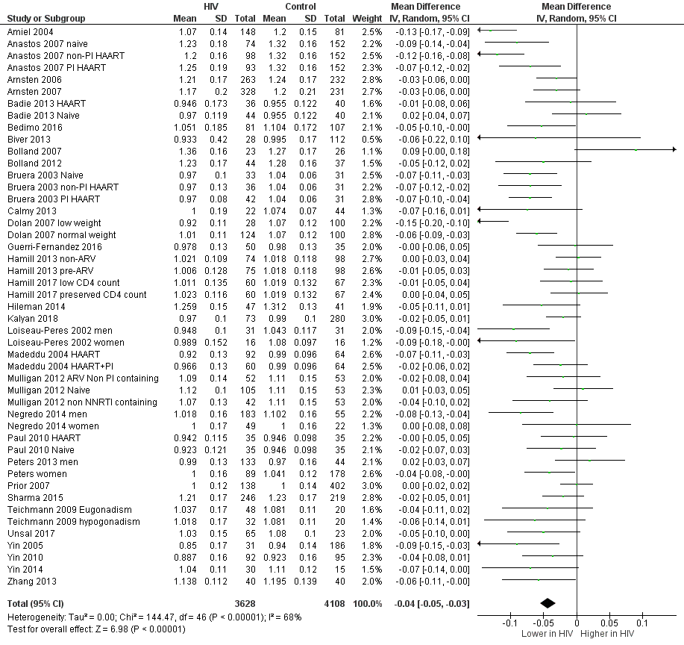

Supplementary Figure 3. Bone mineral density (g/cm²) at the hip compared between patients living with HIV and controls.
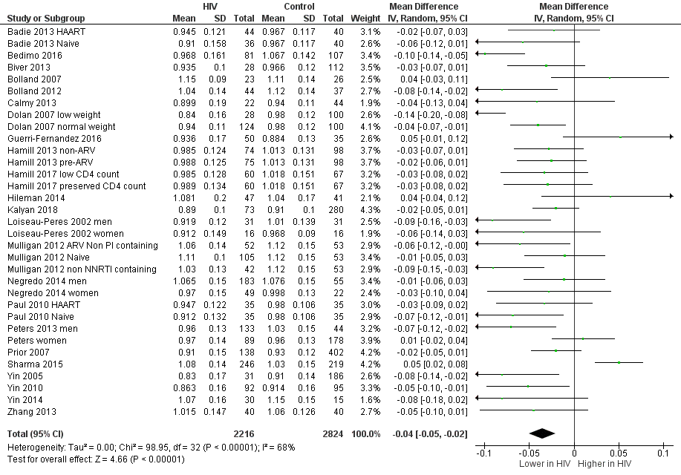
Supplementary Figure 4. Longitudinal changes in BMD (% change) within one year compared to baseline in patients living with HIV naive to ART treatment and initiating treatment. Lumbar spine (A), total hip (B).
A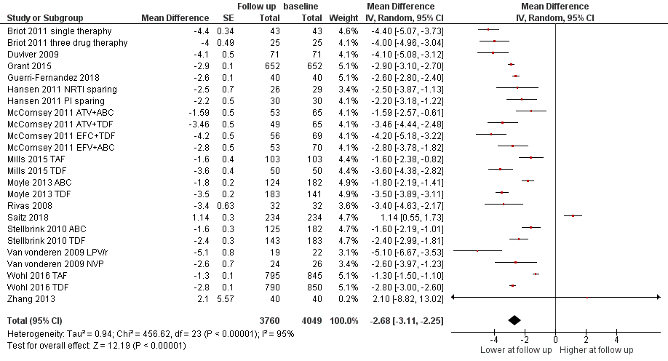 B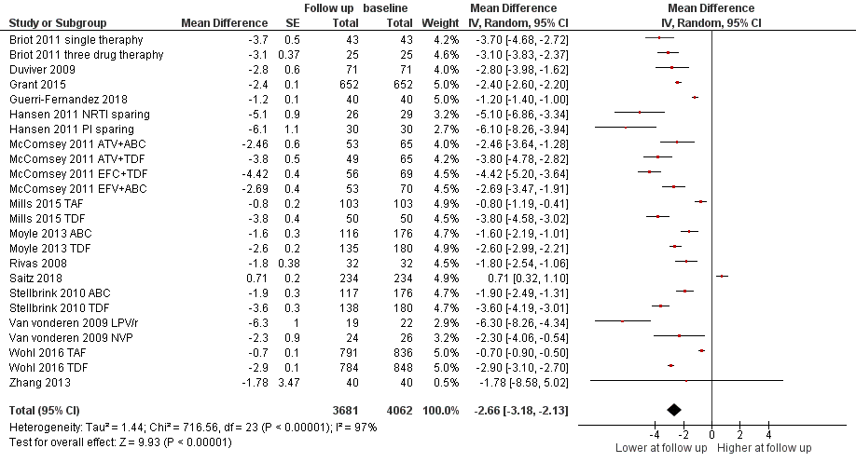
Supplementary Figure 5. Longitudinal changes in BMD (% change) within one year compared to baseline in patients living with HIV on stable ART treatment. Lumbar spine (A), total hip (B).
A
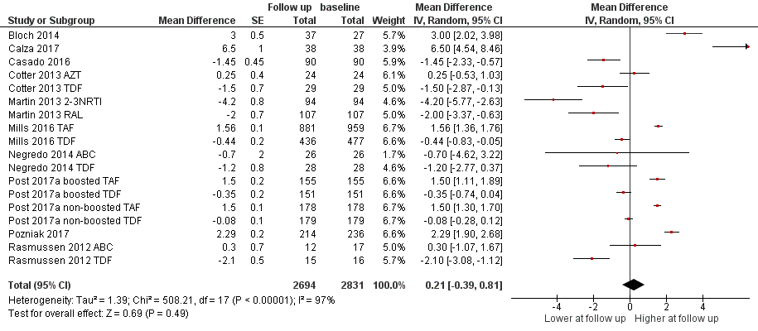
B
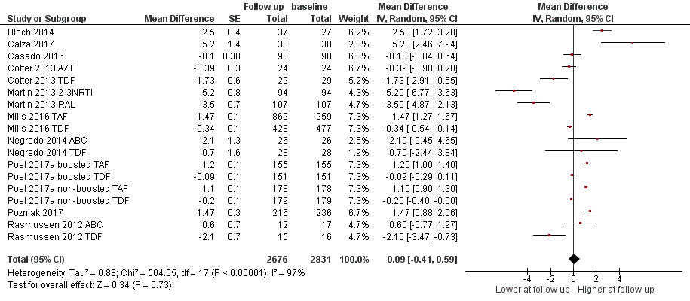
Supplementary Figure 6. RCTs assessing the different impact of abacavir and TDF on BMD (% change) after 48 weeks in persons living with HIV. Lumbar spine (A), total hip (B).
A
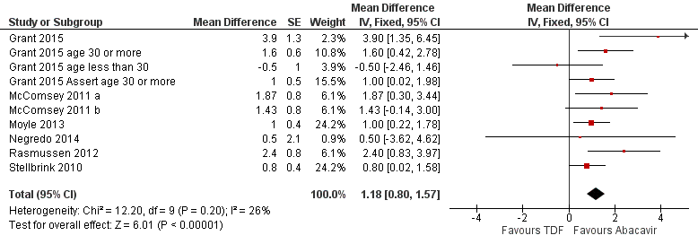
B
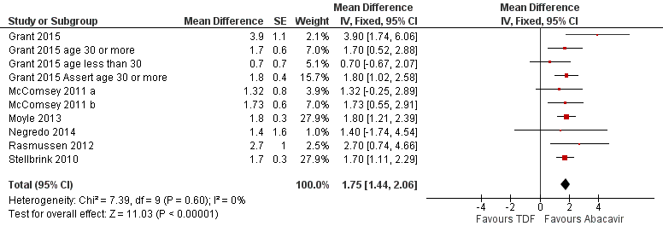

Supplementary Figure 7. RCTs assessing the different impact of TAF and TDF on BMD (% change) after 48 weeks in persons living with HIV. Lumbar spine (A), total hip (B).
A
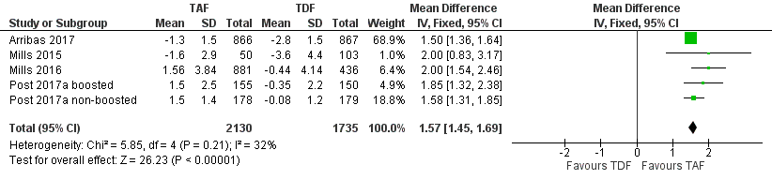
B
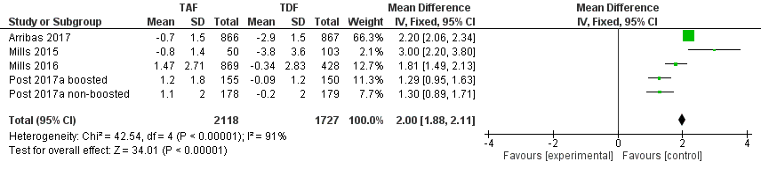

Supplementary Figure 8. RCTs assessing the effect of alendronate on BMD (% change) after 48 weeks at lumbar spine in persons living with HIV.
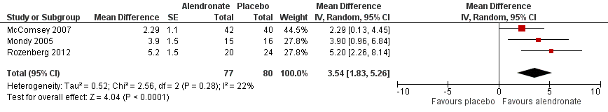

References to Supplementary Tables 1-6
1. Atteritano M, Mirarchi L, Venanzi-Rullo E, et al. Vitamin D Status and the Relationship with Bone Fragility Fractures in HIV-Infected Patients: A Case Control Study. Int J Mol Sci 2018;19:10.3390/ijms19010119.
2. Borderi M, Calza L, Colangeli V, et al. Prevalence of sub-clinical vertebral fractures in HIV-infected patients. New Microbiol 2014;37:25-32.
3. Ciullini L, Pennica A, Argento G, et al. Trabecular bone score (TBS) is associated with sub-clinical vertebral fractures in HIV-infected patients. J Bone Miner Metab 2017.
4. Gazzola L, Savoldi A, Bai F, et al. Assessment of radiological vertebral fractures in HIV-infected patients: clinical implications and predictive factors. HIV Med 2015;16:563-71.
5. Llop M, Sifuentes WA, Banon S, et al. Increased prevalence of asymptomatic vertebral fractures in HIV-infected patients over 50 years of age. Arch Osteoporos 2018;13:56,018-0464-2.
6. Mata-Marin JA, Arroyo-Anduiza CI, Berrospe-Silva MLA, et al. Mexican patients with HIV have a high prevalence of vertebral fractures. Infect Dis Rep 2018;10:7409.
7. Pietrogrande L, Dziubak M, Raimondo E, et al. Vertebral morphometric evaluation of a population of HIV positive patients. Bone 2012;50:S140.
8. Porcelli T, Gotti D, Cristiano A, et al. Role of bone mineral density in predicting morphometric vertebral fractures in patients with HIV infection. Osteoporos Int 2014;25:2263-9.
9. Stephens KI, Rubinsztain L, Payan J, et al. DUAL-ENERGY X-RAY ABSORPTIOMETRY AND CALCULATED FRAX RISK SCORES MAY UNDERESTIMATE OSTEOPOROTIC FRACTURE RISK IN VITAMIN D-DEFICIENT VETERANS WITH HIV INFECTION. Endocr Pract 2016;22:440-6.
10. Thouvenin Y, Makinson A, Cournil A, et al. Chest Low-Dose Computed Tomography for Early Lung Cancer Diagnosis as an Opportunity to Diagnose Vertebral Fractures in HIV-Infected Smokers, an ANRS EP48 HIV CHEST Substudy. J Acquir Immune Defic Syndr 2015;69:299-305.
11. Torti C, Mazziotti G, Soldini PA, et al. High prevalence of radiological vertebral fractures in HIV-infected males. Endocrine 2012;41:512-7.
12. Yin MT, McMahon DJ, Ferris DC, et al. Low bone mass and high bone turnover in postmenopausal human immunodeficiency virus-infected women. J Clin Endocrinol Metab 2010;95:620-9.
13. Arnsten JH, Freeman R, Howard AA, et al. Decreased bone mineral density and increased fracture risk in aging men with or at risk for HIV infection. AIDS 2007;21:617-23.
14. Battalora L, Armon C, Buchacz K, et al. Frax-tool fracture-risk comparison: Have a little backbone! Top Antiviral Med 2017;25:289s.
15. Bedimo R, Maalouf NM, Zhang S, et al. Osteoporotic fracture risk associated with cumulative exposure to tenofovir and other antiretroviral agents. AIDS 2012;26:825-31.
16. Byrne DD, Newcomb CW, Carbonari DM, et al. Increased risk of hip fracture associated with dually treated HIV/hepatitis B virus coinfection. J Viral Hepat 2015;22:936-47.
17. Collin F, Duval X, Le Moing V, et al. Ten-year incidence and risk factors of bone fractures in a cohort of treated HIV1-infected adults. AIDS 2009;23:1021-4.
18. Gedmintas L, Wright EA, Losina E, et al. Comparative risk of fracture in men and women with HIV. J Clin Endocrinol Metab 2014;99:486-90.
19. Gedmintas L, Wright EA, Dong Y, et al. Factors associated with fractures in HIV-infected persons: which factors matter? Osteoporos Int 2017;28:239-44.
20. Gonciulea A, Wang R, Althoff KN, et al. An increased rate of fracture occurs a decade earlier in HIV+ compared with HIV-men. AIDS 2017;31:1435-43.
21. Guerri-Fernandez R, Vestergaard P, Carbonell C, et al. HIV infection is strongly associated with hip fracture risk, independently of age, gender, and comorbidities: a population-based cohort study. J Bone Miner Res 2013;28:1259-63.
22. Hansen AB, Gerstoft J, Kronborg G, et al. Incidence of low and high-energy fractures in persons with and without HIV infection: a Danish population-based cohort study. AIDS 2012;26:285-93.
23. Komatsu A, Ikeda A, Kikuchi A, et al. Osteoporosis-Related Fractures in HIV-Infected Patients Receiving Long-Term Tenofovir Disoproxil Fumarate: An Observational Cohort Study. Drug Saf 2018.
24. LaFleur J, Bress AP, Myers J, et al. Tenofovir-Associated Bone Adverse Outcomes among a US National Historical Cohort of HIV-Infected Veterans: Risk Modification by Concomitant Antiretrovirals. Infect Dis Ther 2018;7:293-308.
25. Mundy LM, Youk AO, McComsey GA, et al. Overall benefit of antiretroviral treatment on the risk of fracture in HIV: nested case-control analysis in a health-insured population. AIDS 2012;26:1073-82.
26. Nkhoma ET, Rosenblatt L, Myers J, et al. Real-World Assessment of Renal and Bone Safety among Patients with HIV Infection Exposed to Tenofovir Disoproxil Fumarate-Containing Single-Tablet Regimens. PLoS One 2016;11:e0166982.
27. Peters BS, Perry M, Wierzbicki AS, et al. A cross-sectional randomised study of fracture risk in people with HIV infection in the probono 1 study. PLoS One 2013;8:e78048.
28. Prieto-Alhambra D, Guerri-Fernandez R, De Vries F, et al. HIV infection and its association with an excess risk of clinical fractures: a nationwide case-control study. J Acquir Immune Defic Syndr 2014;66:90-5.
29. Prior J, Burdge D, Maan E, et al. Fragility fractures and bone mineral density in HIV positive women: a case-control population-based study. Osteoporos Int 2007;18:1345-53.
30. Reyes C, Estrada P, Nogues X, et al. The impact of common co-morbidities (as measured using the Charlson index) on hip fracture risk in elderly men: a population-based cohort study. Osteoporos Int 2014;25:1751-8.
31. Sharma A, Shi Q, Hoover DR, et al. Increased fracture incidence in middle-aged HIV-infected and HIV-uninfected women: Updated results from the women's interagency HIV study. J Acquired Immune Defic Syndr 2015;70:54-61.
32. Short CE, Shaw SG, Fisher MJ, et al. Prevalence of and risk factors for osteoporosis and fracture among a male HIV-infected population in the UK. Int J STD AIDS 2014;25:113-21.
33. Triant VA, Brown TT, Lee H, et al. Fracture prevalence among human immunodeficiency virus (HIV)-infected versus non-HIV-infected patients in a large U.S. healthcare system. J Clin Endocrinol Metab 2008;93:3499-504.
34. Warriner AH, Smith W, Curtis JR, et al. Fracture among older and younger HIV+ medicare beneficiaries. Endocr Rev 2013;34. Available at: http://press.endocrine.org.ez.statsbiblioteket.dk:2048/doi/abs/10.1210/endo-meetings.2013.BCHVD.8.OR10-2.
35. Womack JA, Goulet JL, Gibert C, et al. Increased risk of fragility fractures among HIV infected compared to uninfected male veterans. PLoS One 2011;6:e17217.
36. Womack JA, Goulet JL, Gibert C, et al. Physiologic frailty and fragility fracture in HIV-infected male veterans. Clin Infect Dis 2013;56:1498-504.
37. Yin MT, Shi Q, Hoover DR, et al. Fracture incidence in HIV-infected women: results from the Women's Interagency HIV Study. AIDS 2010;24:2679-86.
38. Yin MT, Kendall MA, Wu X, et al. Fractures after antiretroviral initiation. AIDS 2012;26:2175-84.
39. Yin MT, Shiau S, Rimland D, et al. Fracture Prediction With Modified-FRAX in Older HIV-Infected and Uninfected Men. J Acquir Immune Defic Syndr 2016;72:513-20.
40. Yong MK, Elliott JH, Woolley IJ, et al. Low CD4 count is associated with an increased risk of fragility fracture in HIV-infected patients. J Acquir Immune Defic Syndr 2011;57:205-10.
41. Young B, Dao CN, Buchacz K, et al. Increased rates of bone fracture among HIV-infected persons in the HIV Outpatient Study (HOPS) compared with the US general population, 2000-2006. Clin Infect Dis 2011;52:1061-8.
42. Amiel C, Ostertag A, Slama L, et al. BMD is reduced in HIV-infected men irrespective of treatment. J Bone Miner Res 2004;19:402-9.
43. Anastos K, Lu D, Shi O, et al. The association of bone mineral density with HIV infection and antiretroviral treatment in women. Antivir Ther 2007;12:1049-58.
44. Arnsten JH, Freeman R, Howard AA, et al. HIV infection and bone mineral density in middle-aged women. Clin Infect Dis 2006;42:1014-20.
45. Badie BM, Soori T, Kheirandish P, et al. Evaluation of bone mineral density in Iranian HIV/AIDS patients. Acta Med Iran 2011;49:460-7.
46. Bedimo R, Cutrell J, Zhang S, et al. Mechanisms of bone disease in HIV and hepatitis C virus: impact of bone turnover, tenofovir exposure, sex steroids and severity of liver disease. AIDS 2016;30:601-8.
47. Biver E, Calmy A, Delhumeau C, et al. Microstructural alterations of trabecular and cortical bone in long-term HIV-infected elderly men on successful antiretroviral therapy. AIDS 2014;28:2417-27.
48. Bolland MJ, Grey AB, Horne AM, et al. Bone mineral density remains stable in HAART-treated HIV-infected men over 2 years. Clin Endocrinol (Oxf) 2007;67:270-5.
49. Bolland MJ, Grey A, Horne AM, et al. Stable bone mineral density over 6 years in HIV-infected men treated with highly active antiretroviral therapy (HAART). Clin Endocrinol (Oxf) 2012;76:643-8.
50. Brown TT, Ruppe MD, Kassner R, et al. Reduced bone mineral density in human immunodeficiency virus-infected patients and its association with increased central adiposity and postload hyperglycemia. J Clin Endocrinol Metab 2004;89:1200-6.
51. Bruera D, Luna N, David DO, et al. Decreased bone mineral density in HIV-infected patients is independent of antiretroviral therapy. AIDS 2003;17:1917-23.
52. Calmy A, Chevalley T, Delhumeau C, et al. Long-term HIV infection and antiretroviral therapy are associated with bone microstructure alterations in premenopausal women. Osteoporosis Int 2013;24:1843-52.
53. Dolan SE, Carpenter S, Grinspoon S. Effects of weight, body composition, and testosterone on bone mineral density in HIV-infected women. J Acquir Immune Defic Syndr 2007;45:161-7.
54. GÃ¼erri-FernÃ¡ndez R, Molina D, Villar-GarcÃa J, et al. Brief Report: HIV Infection Is Associated with Worse Bone Material Properties, Independently of Bone Mineral Density. J Acquired Immune Defic Syndr 2016;72:314-8.
55. Hamill MM, Ward KA, Pettifor JM, et al. Bone mass, body composition and vitamin D status of ARV-naive, urban, black South African women with HIV infection, stratified by CD(4) count. Osteoporos Int 2013;24:2855-61.
56. Hamill MM, Pettifor JM, Ward KA, et al. Changes in Bone Mineral Density, Body Composition, Vitamin D Status, and Mineral Metabolism in Urban HIV-Positive South African Women Over 12 Months. J Bone Miner Res 2017.
57. Hileman CO, Labbato DE, Storer NJ, et al. Is bone loss linked to chronic inflammation in antiretroviral-naive HIV-infected adults? A 48-week matched cohort study. AIDS 2014;28:1759-67.
58. Jones S, Restrepo D, Kasowitz A, et al. Risk factors for decreased bone density and effects of HIV on bone in the elderly. Osteoporos Int 2008;19:913-8.
59. Kalyan S, Pick N, Mai A, et al. Premature Spinal Bone Loss in Women Living with HIV is Associated with Shorter Leukocyte Telomere Length. Int J Environ Res Public Health 2018;15:10.3390/ijerph15051018.
60. Loiseau-Peres S, Delaunay C, Poupon S, et al. Osteopenia in patients infected by the human immunodeficiency virus. A case control study. Joint Bone Spine 2002;69:482-5.
61. Madeddu G, Spanu A, Solinas P, et al. Bone mass loss and vitamin D metabolism impairment in HIV patients receiving highly active antiretroviral therapy. Q J Nucl Med Mol Imaging 2004;48:39-48.
62. Mulligan K, Harris DR, Emmanuel P, et al. Low bone mass in behaviorally HIV-infected young men on antiretroviral therapy: Adolescent Trials Network Study 021B. Clin Infect Dis 2012;55:461-8.
63. Negredo E, Domingo P, Ferrer E, et al. Peak bone mass in young HIV-infected patients compared with healthy controls. J Acquir Immune Defic Syndr 2014;65:207-12.
64. Paul TV, Asha HS, Thomas N, et al. Hypovitaminosis D and bone mineral density in human immunodeficiency virus-infected men from India, with or without antiretroviral therapy. Endocr Pract 2010;16:547-53.
65. Sharma A, Flom PL, Rosen CJ, et al. Racial differences in bone loss and relation to menopause among HIV-infected and uninfected women. Bone 2015;77:24-30.
66. Teichmann J, Lange U, Discher T, et al. Bone mineral density in human immunodeficiency virus-1 infected men with hypogonadism prior to highly-active-antiretroviral-therapy (HAART). Eur J Med Res 2009;14:59-64.
67. Unsal AB, Mattingly AS, Jones SE, et al. Effect of Antiretroviral Therapy on Bone and Renal Health in Young Adults Infected with HIV in Early Life. J Clin Endocrinol Metab 2017.
68. Yin MT, Lu D, Cremers S, et al. Short-term bone loss in HIV-infected premenopausal women. J Acquir Immune Defic Syndr 2010;53:202-8.
69. Yin MT, Lund E, Shah J, et al. Lower peak bone mass and abnormal trabecular and cortical microarchitecture in young men infected with HIV early in life. AIDS 2014;28:345-53.
70. Yin M, Dobkin J, Brudney K, et al. Bone mass and mineral metabolism in HIV+ postmenopausal women. Osteoporos Int 2005;16:1345-52.
71. Zhang L, Su Y, Hsieh E, et al. Bone turnover and bone mineral density in HIV-1 infected Chinese taking highly active antiretroviral therapy -a prospective observational study. BMC Musculoskelet Disord 2013;14:224,2474-14-224.
72. Arribas JR, Thompson M, Sax PE, et al. Brief Report: Randomized, Double-Blind Comparison of Tenofovir Alafenamide (TAF) vs Tenofovir Disoproxil Fumarate (TDF), Each Coformulated with Elvitegravir, Cobicistat, and Emtricitabine (E/C/F) for Initial HIV-1 Treatment: Week 144 Results. J Acquired Immune Defic Syndr 2017;75:211-8.
73. Eron JJ, Orkin C, Gallant J, et al. A week 48 randomized phase 3 trial of darunavir/cobicistat/emtricitabine/tenofovir alafenamide in treatment-naive HIV-1 patients. AIDS 2018.
74. Mills A, Crofoot G,Jr, McDonald C, et al. Tenofovir Alafenamide Versus Tenofovir Disoproxil Fumarate in the First Protease Inhibitor-Based Single-Tablet Regimen for Initial HIV-1 Therapy: A Randomized Phase 2 Study. J Acquir Immune Defic Syndr 2015;69:439-45.
75. Mills A, Arribas JR, Andrade-Villanueva J, et al. Switching from tenofovir disoproxil fumarate to tenofovir alafenamide in antiretroviral regimens for virologically suppressed adults with HIV-1 infection: a randomised, active-controlled, multicentre, open-label, phase 3, non-inferiority study. Lancet Infect Dis 2016;16:43-52.
76. Post FA, Yazdanpanah Y, Schembri G, et al. Efficacy and safety of emtricitabine/tenofovir alafenamide (FTC/TAF) vs. emtricitabine/tenofovir disoproxil fumarate (FTC/TDF) as a backbone for treatment of HIV-1 infection in virologically suppressed adults: subgroup analysis by third agent of a randomized, double-blind, active-controlled phase 3 trial. HIV Clin Trials 2017;18:135-40.
77. Raffi F, Orkin C, Clarke A, et al. Brief Report: Long-Term (96-Week) Efficacy and Safety After Switching From Tenofovir Disoproxil Fumarate to Tenofovir Alafenamide in HIV-Infected, Virologically Suppressed Adults. J Acquir Immune Defic Syndr 2017;75:226-31.
78. Sax PE, Zolopa A, Brar I, et al. Tenofovir alafenamide vs. tenofovir disoproxil fumarate in single tablet regimens for initial HIV-1 therapy: a randomized phase 2 study. J Acquir Immune Defic Syndr 2014;67:52-8.
79. Wohl D, Oka S, Clumeck N, et al. A randomized, double-blind comparison of tenofovir alafenamide versus tenofovir disoproxil fumarate, each coformulated with elvitegravir, cobicistat, and emtricitabine for initial HIV-1 treatment: Week 96 results. J Acquired Immune Defic Syndr 2016;72:58-64.
80. Erlandson KM, Kitch D, Tierney C, et al. Weight and lean body mass change with antiretroviral initiation and impact on bone mineral density. AIDS 2013;27:2069-79.
81. Grant PM, Kitch D, McComsey GA, et al. Differential skeletal impact of tenofovir disoproxil fumarate in young versus old hiv-infected adults. HIV Clin Trials 2015;16:66-71.
82. Gupta SK, Yeh E, Kitch DW, et al. Bone mineral density reductions after tenofovir disoproxil fumarate initiation and changes in phosphaturia: a secondary analysis of ACTG A5224s. J Antimicrob Chemother 2017.
83. McComsey GA, Kitch D, Daar ES, et al. Bone mineral density and fractures in antiretroviral-naive persons randomized to receive abacavir-lamivudine or tenofovir disoproxil fumarate-emtricitabine along with efavirenz or atazanavir-ritonavir: Aids Clinical Trials Group A5224s, a substudy of ACTG A5202. J Infect Dis 2011;203:1791-801.
84. Moyle GJ, Stellbrink HJ, Compston J, et al. 96-Week results of abacavir/lamivudine versus tenofovir/emtricitabine, plus efavirenz, in antiretroviral-naive, HIV-1-infected adults: ASSERT study. Antivir Ther 2013;18:905-13.
85. Negredo E, Domingo P, Perez-Alvarez N, et al. Improvement in bone mineral density after switching from tenofovir to abacavir in HIV-1-infected patients with low bone mineral density: two-centre randomized pilot study (OsteoTDF study). J Antimicrob Chemother 2014;69:3368-71.
86. Rasmussen TA, Jensen D, Tolstrup M, et al. Comparison of bone and renal effects in HIV-infected adults switching to abacavir or tenofovir based therapy in a randomized trial. PLoS One 2012;7:e32445.
87. Stellbrink HJ, Orkin C, Arribas JR, et al. Comparison of changes in bone density and turnover with abacavir-lamivudine versus tenofovir-emtricitabine in HIV-infected adults: 48-week results from the ASSERT study. Clin Infect Dis 2010;51:963-72.
88. Assoumou L, Katlama C, Viard JP, et al. Changes in bone mineral density over a 2-year period in HIV-1-infected men under combined antiretroviral therapy with osteopenia. AIDS 2013;27:2425-30.
89. Bernardino JI, Mocroft A, Richert L, et al. Bone turnover on DRV/R+ either RAL or TDF/FTC as first-line ART: Neat 001/anrs 143. Top Antiviral Med 2015;23:344. Available at: http://www.iasusa.org.ez.statsbiblioteket.dk:2048/sites/default/files/tam/23-e1-5.pdf.
90. Bloch M, Tong W, Hoy J, et al. Switch from tenofovir to raltegravir increases low bone mineral density and decreases markers of bone turnover over 48 weeks. HIV Med 2014;15:373-80.
91. Bonjoch A, Figueras M, Estany C, et al. High prevalence of and progression to low bone mineral density in HIV-infected patients: a longitudinal cohort study. AIDS 2010;24:2827-33.
92. Briot K, Kolta S, Flandre P, et al. Prospective one-year bone loss in treatment-naive HIV+ men and women on single or multiple drug HIV therapies. Bone 2011;48:1133-9.
93. Brown TT, Moser C, Currier JS, et al. Changes in Bone Mineral Density After Initiation of Antiretroviral Treatment With Tenofovir Disoproxil Fumarate/Emtricitabine Plus Atazanavir/Ritonavir, Darunavir/Ritonavir, or Raltegravir. J Infect Dis 2015;212:1241-9.
94. Calza L, Magistrelli E, Colangeli V, et al. Dual Raltegravir-Etravirine Combination as Maintenance Regimen in Virologically Suppressed HIV-1-Infected Patients. AIDS Res Hum Retroviruses 2017.
95. Casado JL, Santiuste C, Vazquez M, et al. Bone mineral density decline according to renal tubular dysfunction and phosphaturia in tenofovir-exposed HIV-infected patients. AIDS 2016;30:1423-31.
96. Cook PP, Stang AT, Walker LR, et al. Bone Mineral Density and Vitamin D Levels in HIV Treatment-Naive African American Individuals Randomized to Receive HIV Drug Regimens. South Med J 2016;109:712-7.
97. Cotter AG, Vrouenraets SME, Brady JJ, et al. Impact of switching from zidovudine to tenofovir disoproxil fumarate on bone mineral density and markers of bone metabolism in virologically suppressed HIV-1 infected patients; A substudy of the PREPARE study. J Clin Endocrinol Metab 2013;98:1659-66. Available at: http://jcem.endojournals.org.ez.statsbiblioteket.dk:2048/content/98/4/1659.full.pdf+html.
98. Duvivier C, Kolta S, Assoumou L, et al. Greater decrease in bone mineral density with protease inhibitor regimens compared with nonnucleoside reverse transcriptase inhibitor regimens in HIV-1 infected naive patients. AIDS 2009;23:817-24.
99. Gallant JE, Staszewski S, Pozniak AL, et al. Efficacy and safety of tenofovir DF vs stavudine in combination therapy in antiretroviral-naive patients: A 3-year randomized trial. J Am Med Assoc 2004;292:191-201.
100. Galli L, Spagnuolo V, Bigoloni A, et al. Atazanavir/ritonavir monotherapy: 96 week efficacy, safety and bone mineral density from the MODAt randomized trial. J Antimicrob Chemother 2016;71:1637-42.
101. Grund B, Peng G, Gibert CL, et al. Continuous antiretroviral therapy decreases bone mineral density. AIDS 2009;23:1519-29.
102. Guerri-Fernandez R, Lerma-Chippirraz E, Fernandez Marron A, et al. Bone density, microarchitecture, and tissue quality after 1 year of treatment with tenofovir disoproxil fumarate. AIDS 2018;32:913-20.
103. Hansen AB, Obel N, Nielsen H, et al. Bone mineral density changes in protease inhibitor-sparing vs. nucleoside reverse transcriptase inhibitor-sparing highly active antiretroviral therapy: data from a randomized trial. HIV Med 2011;12:157-65.
104. Haskelberg H, Mallon PWG, Hoy J, et al. Bone mineral density over 96 weeks in adults failing first-line therapy randomised to raltegravir/lopinavir/ritonavir compared to standard second-line therapy. J Acquired Immune Defic Syndr 2014.
105. Hoy JF, Grund B, Roediger M, et al. Immediate Initiation of Antiretroviral Therapy for HIV Infection Accelerates Bone Loss Relative to Deferring Therapy: Findings from the START Bone Mineral Density Substudy, a Randomized Trial. J Bone Miner Res 2017.
106. Koga I, Seo K, Yoshino Y, et al. Decreased serum bone specific alkaline phosphatase and increased urinary N-terminal telopeptide of type I collagen as prognostic markers for bone mineral density loss in HIV patients on cART. J Infect Chemother 2016;22:543-7.
107. Madeddu G, Spanu A, Babudieri S, et al. A longitudinal study on body composition changes in HIV-infected patients receiving HAART. Eur J Nucl Med Mol Imaging 2014;41:S557.
108. Martin A, Moore C, Mallon PW, et al. Bone mineral density in HIV participants randomized to raltegravir and lopinavir/ritonavir compared with standard second line therapy. AIDS 2013;27:2403-11.
109. Mondi A, Fabbiani M, Ciccarelli N, et al. Efficacy and safety of treatment simplification to atazanavir/ritonavir + lamivudine in HIV-infected patients with virological suppression: 144 week follow-up of the AtLaS pilot study. J Antimicrob Chemother 2015;70:1843-9.
110. Post FA, Tebas P, Clarke A, et al. Switching to tenofovir alafenamide, coformulated with elvitegravir, cobicistat, and emtricitabine, in HIV-infected adults with renal impairment: 96-week results from a single-arm, multicenter, open-label phase 3 study. J Acquired Immune Defic Syndr 2017;74:180-4.
111. Pozniak A, Arribas JR, Gathe J, et al. Switching to Tenofovir Alafenamide, Coformulated With Elvitegravir, Cobicistat, and Emtricitabine, in HIV-Infected Patients With Renal Impairment: 48-Week Results From a Single-Arm, Multicenter, Open-Label Phase 3 Study. J Acquir Immune Defic Syndr 2016;71:530-7.
112. Rey D, Treger M, Sibilia J, et al. Bone mineral density changes after 2 years of ARV treatment, compared to naive HIV-1-infected patients not on HAART. Infect Dis 2015;47:88-95.
113. Rivas P, Gorgolas M, Garcia-Delgado R, et al. Evolution of bone mineral density in AIDS patients on treatment with zidovudine/lamivudine plus abacavir or lopinavir/ritonavir. HIV Med 2008;9:89-95.
114. Rockstroh JK, DeJesus E, Henry K, et al. A randomized, double-blind comparison of coformulated elvitegravir/cobicistat/emtricitabine/tenofovir DF vs ritonavir-boosted atazanavir plus coformulated emtricitabine and tenofovir DF for initial treatment of HIV-1 infection: analysis of week 96 results. J Acquir Immune Defic Syndr 2013;62:483-6.
115. Saitz R, Mesic A, Ventura AS, et al. Alcohol consumption and bone mineral density in people with HIV and substance use disorder: A prospective cohort study. Alcohol Clin Exp Res 2018.
116. Sharma A, Tian F, Yin MT, et al. Association of regional body composition with bone mineral density in HIV-infected and HIV-uninfected women: women's interagency HIV study. J Acquir Immune Defic Syndr 2012;61:469-76.
117. Sharma A, Flom PL, Weedon J, et al. Prospective study of bone mineral density changes in aging men with or at risk for HIV infection. AIDS 2010;24:2337-45.
118. Tinago W, Cotter AG, Sabin CA, et al. Predictors of longitudinal change in bone mineral density in a cohort of HIV-positive and negative patients. AIDS 2017;31:643-52.
119. van Vonderen MG, Lips P, van Agtmael MA, et al. First line zidovudine/lamivudine/lopinavir/ritonavir leads to greater bone loss compared to nevirapine/lopinavir/ritonavir. AIDS 2009;23:1367-76.
120. Yin MT, Zhang CA, McMahon DJ, et al. Higher rates of bone loss in postmenopausal HIV-infected women: a longitudinal study. J Clin Endocrinol Metab 2012;97:554-62.
121. McComsey GA, Kendall MA, Tebas P, et al. Alendronate with calcium and vitamin D supplementation is safe and effective for the treatment of decreased bone mineral density in HIV. AIDS 2007;21:2473-82.
122. Mondy K, Powderly WG, Claxton SA, et al. Alendronate, vitamin D, and calcium for the treatment of osteopenia/osteoporosis associated with HIV infection. J Acquir Immune Defic Syndr 2005;38:426-31.
123. Rozenberg S, Lanoy E, Bentata M, et al. Effect of alendronate on HIV-associated osteoporosis: a randomized, double-blind, placebo-controlled, 96-week trial (ANRS 120). AIDS Res Hum Retroviruses 2012;28:972-80.
124. Bolland MJ, Grey AB, Horne AM, et al. Annual zoledronate increases bone density in highly active antiretroviral therapy-treated human immunodeficiency virus-infected men: a randomized controlled trial. J Clin Endocrinol Metab 2007;92:1283-8.
125. Bolland MJ, Grey AB, Horne AM, et al. Effects of intravenous zoledronate on bone turnover and BMD persist for at least 24 months. J Bone Miner Res 2008;23:1304-8.
126. Bolland MJ, Grey A, Horne AM, et al. Effects of intravenous zoledronate on bone turnover and bone density persist for at least five years in HIV-infected men. J Clin Endocrinol Metab 2012;97:1922-8.
127. Hoy JF, Richardson R, Ebeling PR, et al. Zoledronic acid is superior to tenofovir DF-switching for low bone mineral density in adults with HIV: a randomised trial. AIDS 2018.
128. Negredo E, Bonjoch A, PÃ©rez-Ãlvarez N, et al. A randomized open label study for comparing two doses of zoledronic acid in HIV infected patients. Top Antiviral Med 2014;22:402. Available at: https://www-iasusa-org.ez.statsbiblioteket.dk:12048/sites/default/files/tam/22-e1-4.pdf.
129. Ofotokun I, Titanji K, Lahiri CD, et al. A Single-dose Zoledronic Acid Infusion Prevents Antiretroviral Therapy-induced Bone Loss in Treatment-naive HIV-infected Patients: A Phase IIb Trial. Clin Infect Dis 2016;63:663-71.
130. Pepe J, Isidori AM, Falciano M, et al. Effect of risedronate in osteoporotic HIV males, according to gonadal status: a pilot study. Endocrine 2014;47:456-62.
131. Brown TT, Hoy J, Borderi M, et al. Recommendations for evaluation and management of bone disease in HIV. Clin Infect Dis 2015;60:1242-51.
132. McComsey GA, Tebas P, Shane E, et al. Bone disease in HIV infection: a practical review and recommendations for HIV care providers. Clin Infect Dis 2010;51:937-46.
133. Bolland MJ, Grey A, Reid IR. Skeletal health in adults with HIV infection. Lancet Diabetes Endocrinol 2015;3:63-74.
134. BHIVA. British HIV Association guidelines for the routine investigation and monitoring of adult HIV-1-positive individuals 2016. , 2016. Available at: http://www.bhiva.org/documents/Guidelines/Monitoring/2016-BHIVA-Monitoring-Guidelines.pdf.
135. EACS. GUIDELINES Version 9.0. , 2017. Available at: http://www.eacsociety.org/files/guidelines_9.0-english.pdf.
136. Negredo E, Bonjoch A, Clotet B. Management of bone mineral density in HIV-infected patients. Expert Opin Pharmacother 2016;17:845-52.
137. Aberg JA, Gallant JE, Ghanem KG, et al. Primary care guidelines for the management of persons infected with HIV: 2013 update by the HIV medicine association of the Infectious Diseases Society of America. Clin Infect Dis 2014;58:e1-34.

