Clinical and economic impact of ibalizumab for people with multidrug-resistant HIV in the United States
Supplementary material

Lucia R.I. MILLHAM
Justine A. SCOTT, MPH
Paul E. SAX, MD
Fatma SHEBL, MD, PhD
Krishna REDDY, MD
Elena LOSINA, PhD
Rochelle P. WALENSKY, MD, MPH
Kenneth A. FREEDBERG, MD, MSc

METHODS
Input parameters
HIV transmissions
In order to calculate transmission rates over five years, we use estimates of community viral load, produced by the model, along with viral-load specific monthly transmission rates.¹ Viral load-specific transmission rates ranged from 0.16-9.03 transmissions/100 person-years (PY) and are based on a meta-analysis on transmission rates from unprotected intercourse (Supplementary Table 1)¹. Based on data regarding the frequency and effectiveness of condom use in the US, we reduced transmission rates by 40% for the whole population (Supplementary Table 1).^{2–5}

RESULTS
HIV transmissions
Transmission rates decreased from 4.81/100PY with OBR to 3.51/100PY with IBA+OBR over five years. The population in the TMB-202 analysis had more people with high viral load setpoints; because of this, transmissions in this scenario were higher in both strategies compared to the base case, decreasing from 5.33/100PY with OBR to 3.96/100PY with IBA+OBR over five years.

REFERENCES
1. Attia S, Egger M, Müller M, Zwahlen M, Low N. Sexual transmission of HIV according to viral load and antiretroviral therapy: systematic review and meta-analysis. AIDS. 2009;23(11):1397-1404.
2. Borre ED, Hyle EP, Paltiel AD, et al. The clinical and economic impact of attaining national HIV/AIDS strategy treatment targets in the United States. J Infect Dis. 2017;216(7):798-807.
3. Landovitz RJ, Tran TTT, Cohn SE, et al. HIV transmission risk behavior in a cohort of HIV-infected treatment-naïve men and women in the United States. AIDS Behav. 2016;20(12):2983-2995.
4. Holmes KK, Levine R, Weaver M. Effectiveness of condoms in preventing sexually transmitted infections. Bull World Health Organ. 2004;82(6):454-461.
5. Smith DK, Herbst JH, Zhang X, Rose CE. Condom effectiveness for HIV prevention by consistency of use among men who have sex with men in the United States. J Acquir Immune Defic Syndr 1999. 2015;68(3):337-344.
6. Khanlou H, Gathe J, Schrader S, Towner W, Weinheimer S, Lewis S. Safety, efficacy, and pharmacokinetics of ibalizumab in treatment-experienced HIV-1 infected patients: a phase 2b study. Presented at: 51st Interscience Conference on Antimicrobial Agents and Chemotherapy; 2011; Chicago, Illinois.
7. Schackman BR, Goldie SJ, Freedberg KA, et al. Comparison of Health State Utilities Using Community and Patient Preference Weights Derived from a Survey of Patients with HIV/AIDS. Med Decis Making, 2002;22:27-38.
8. Paltiel, AD, Scharfstein, JA, Seage, GR, et al. A Monte Carlo Simulation of Advanced HIV Disease: Application to Prevention of CMV Infection. Med Decis Making, 1998;18(2 Suppl):S93-105.

Supplementary Table 1. Additional base case input parameters for a modeling analysis of IBA+OBR compared to OBR for people with MDR HIV in the US
Parameter | Base Case Value |  | Reference
Cohort characteristics
HIV transmission rates by viral load/100 PY  (HIV RNA copies/mL) |  |  | 1
>100,000 | 9.03
10,001-100,000 | 8.12
3,001-10,000 | 4.17
501-3,000 | 2.06
<500 | 0.16
HIV transmission reduction by condom use, % | 40 |  | 2
Quality of life (utility weights)ª | IBA+OBR | OBR
Routine care, by CD4 |  |  | 7
>500/µL | 0.87 | 0.87
201 – 500/µL | 0.86 | 0.86
51 – 200/µL | 0.85 | 0.85
≤50/µL | 0.83 | 0.83
Acute opportunistic infections |  |  | 8
Pneumocystis pneumonia | 0.74 | 0.74
Mycobacterium avium complex | 0.69 | 0.69
Toxoplasmosis | 0.69 | 0.69
Cytomegalovirus | 0.78 | 0.78
Severe fungal infection | 0.78 | 0.78
Other opportunistic infection | 0.69 | 0.69
IBA+OBR: ibalizumab and optimized background regimen treatment strategy. OBR: optimized background regimen only strategy. MDR: multidrug-resistant. PY: person-year.
ªQuality of life weights were derived from AIDS Clinical Trials Group studies.

Supplementary Table 2. Clinical impact and cost-effectiveness of IBA+OBR compared with OBR for people with MDR HIV in the US
 | Cohort | 5-yr survival  (% alive) | Lifetime QALE (y) | Total lifetime cost (USD)ª | ICER (USD/QALY)ª | Transmissions/  100 PY over 5y^{b}
Base case | OBR | 38 | 3.74 | $301,700 | -- | 4.81
 | IBA+OBR | 47 | 5.12 | $661,800 | $260,900 | 3.51
Scenario analyses
TMB-202 trial^{c} | OBR | 33 | 3.21 | $276,100 | -- | 5.33
 | IBA+OBR | 44 | 4.64 | $637,100 | $250,900 | 3.96
Late failure: virologic failure after 48 weeks on ibalizumab regimen. IBA+OBR: ibalizumab treatment strategy. OBR: optimized background regimen only strategy. MDR: multidrug-resistant. QALE: quality-adjusted life expectancy. QALY: quality-adjusted life year. USD: 2018 US dollars. ICER: incremental cost-effectiveness ratio. PY: person-year.
ª Discounted 3% annually.
^{b} Transmission rates include first-order transmissions from the initial cohort only.
^{c} The TMB-202 trial is a phase-2b trial of ibalizumab (n = 113) and we use cohort characteristics from this trial in a scenario analysis.⁶

FIGURE LEGENDS

Supplementary Figure 1. Probabilistic sensitivity analysis examining the cost-effectiveness of IBA+OBR compared to OBR.
This shows the probability of each regimen being preferred, in terms of net monetary benefit ([quality-adjusted life-years]*[willingness-to-pay] – [lifetime costs]) when varying four parameters: CD4 decline multiplier on failed ART, IBA efficacy, time between experiencing toxicity and discontinuing IBA, and quality of life decrement due to IBA toxicity. OBR is always the preferred strategy from the cost-effectiveness point below a willingness-to-pay (WTP) threshold of $250,000/QALY, and they are equally preferred at a WTP threshold of $263,000/QALY.
Supplementary Figure 1. Probabilistic sensitivity analysis examining the cost-effectiveness of IBA+OBR compared to OBR.
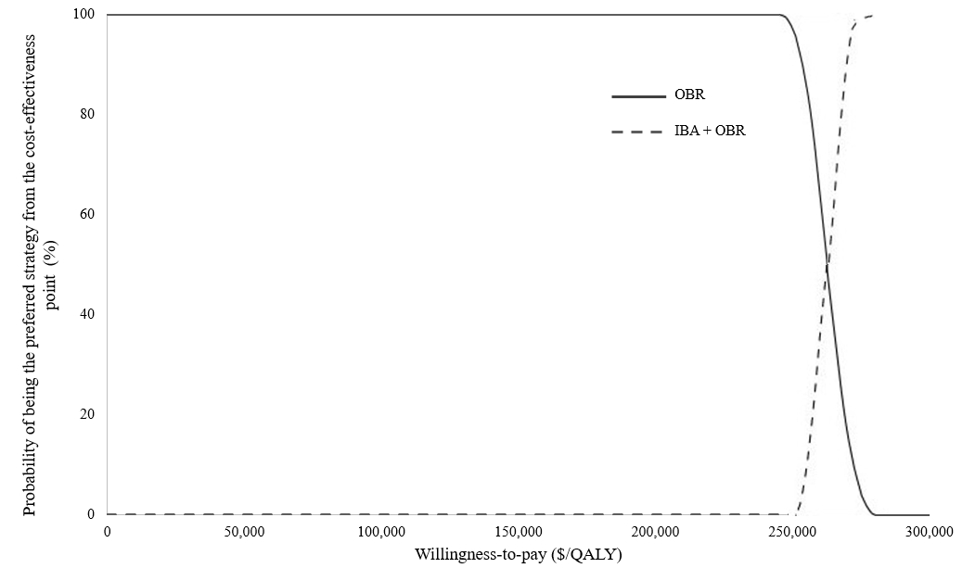
OBR: optimized background regimen only strategy. IBA+OBR: ibalizumab and optimized background regimen treatment strategy. QALY: quality-adjusted life year

