Supplementary Materials
Prediction of Serum HIV-1 Neutralization Titers After Passive Administration of VRC01
by Huang et al.
Table S1: Neutralization titers of the VRC01 clinical lot against the 2 tier 1 Env-pseudotyped viruses (MN.3 and MW965.26), and the 11 tier 2 Env-pseudotyped global panel viruses¹
 | Virus | Tier | Clade | IC50 (mcg/mL) | IC80 (mcg/mL)
1 | MN.3 | 1 | B | 0.04 | 0.12
2 | MW965.26 | 1 | C | 0.10 | 0.26
3 | X2278 | 2 | B | 0.24 | 0.68
4 | X1632 | 2 | G | 0.24 | 1.55
5 | X398F1 | 2 | A | 0.56 | 1.65
6 | X246.F3 | 2 | AC | 0.56 | 1.63
7 | CNE55 | 2 | CRF01 | 0.57 | 2.54
8 | CE0217 | 2 | C | 0.76 | 2.08
9 | TRO.11 | 2 | B | 1.02 | 2.55
10 | PVO.4 | 2 | B | 1.04 | 3.17
11 | X25710 | 2 | C | 1.1 | 3.13
12 | CNE8 | 2 | CRF01 | 1.26 | 4.27
13 | CH119 | 2 | CRF07 | 1.45 | 4.45

Table S2: Frequency of undetectable (i.e., negative response) and detectable (i.e., positive) serum concentration and serum neutralization ID₅₀ and ID₈₀ titers against MN.3, MW965.26, and PVO.4 Env-pseudotyped viruses among the 1079 serum samples.
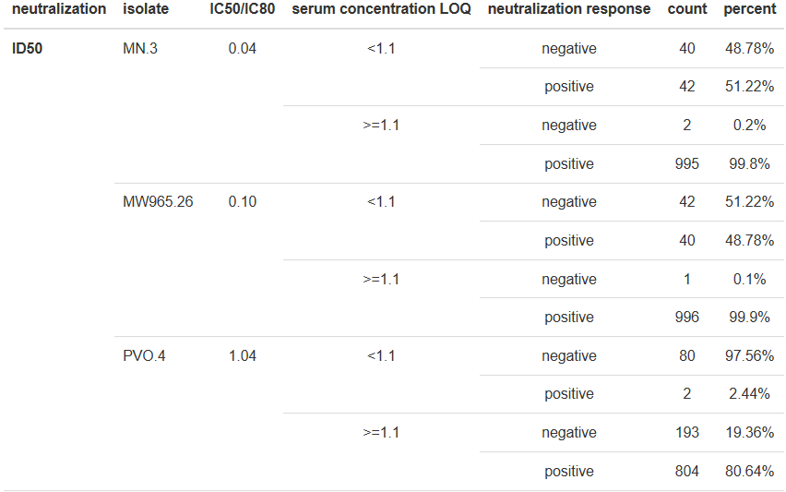
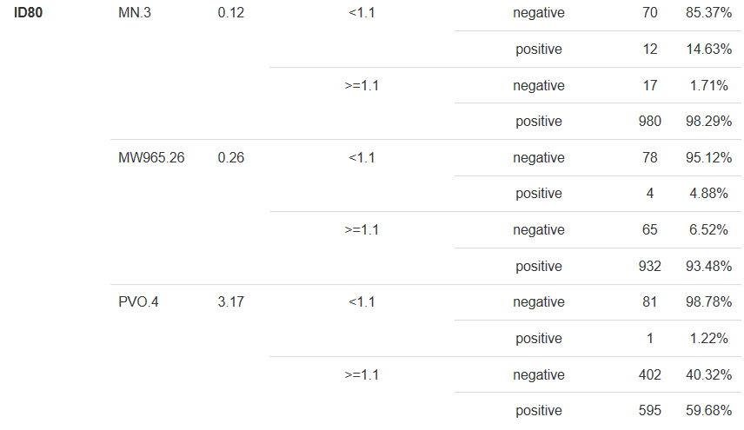
Table S3: Frequency of undetectable (i.e., negative response) and detectable (i.e., positive) serum concentration and serum neutralization ID₅₀ and ID₈₀ titers among the 30 serum samples for which TZM-bl assays were run against the global panel of 11 Env-pseudotyped viruses.

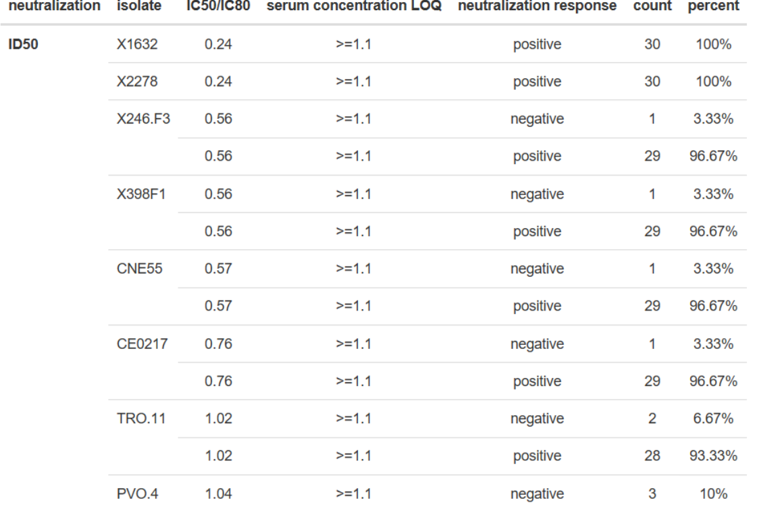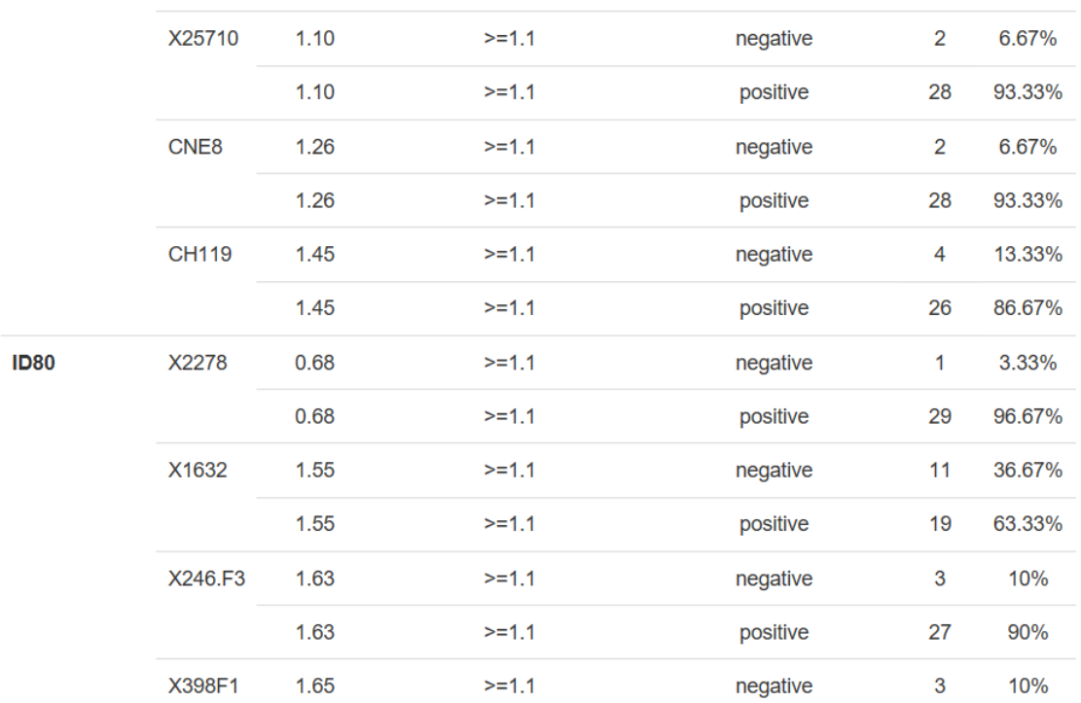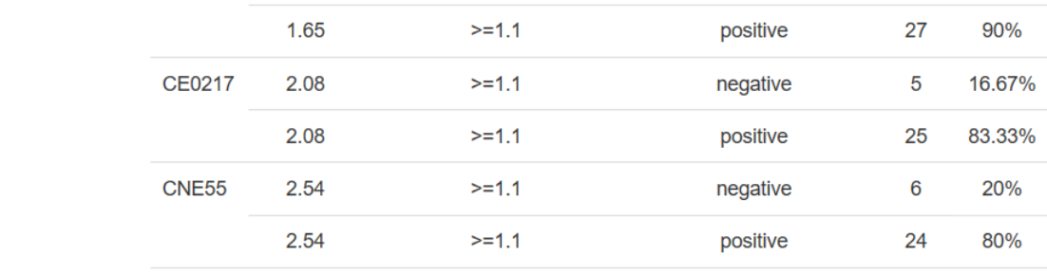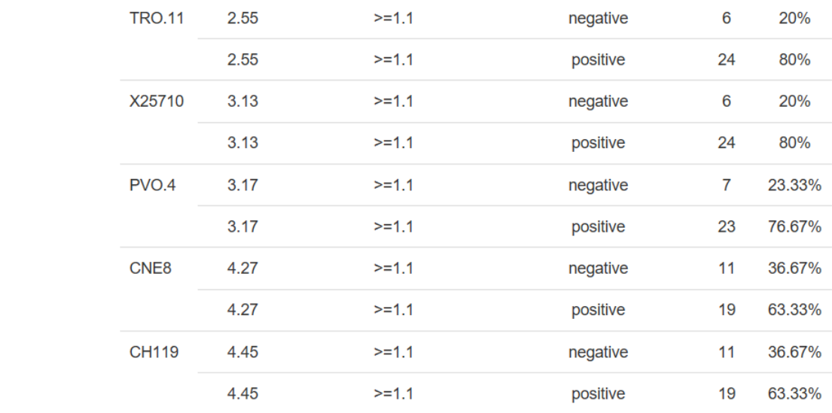

Figure S1: Summaries of fold difference, relative fold difference, and relative mean squared prediction error of predicted vs. observed ID₅₀ and ID₈₀ titers against the 11 global panel Env-pseudotyped viruses based on prediction Approaches 1 & 2. The fold difference is calculated as the ratio of predicted over observed titers; the relative fold difference is calculated as the difference of the log-transformed predicted and observed titers over the log-transformed observed titers; the relative mean prediction error is calculated as the average of the squared difference between the predicted and observed titers based on log-transformed titers relative to Approach 1.

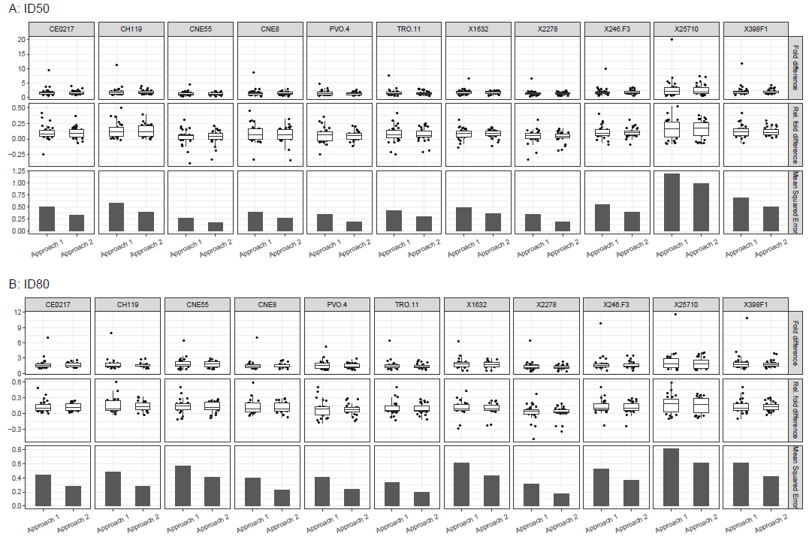

Figure S2: Observed vs. predicted serum neutralization ID₅₀ (Panel A) and ID₈₀ (Panel B) titers against 11 tier 2 Env-pseudotyped viruses as obtained using Approaches 1 and 2. Data were generated for HVTN104 participants who received 10 mg/kg (Group 4) or 30 mg/kg (Group 5) IV of VRC01.^{2,3}
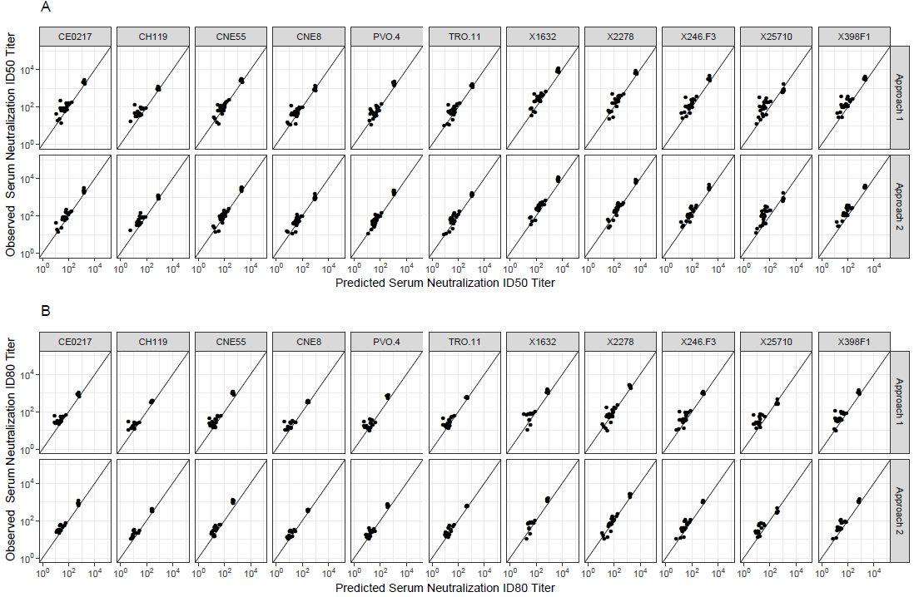

Supplementary References

1. deCamp A, Hraber P, Bailer RT, et al. Global panel of HIV-1 Env reference strains for standardized assessments of vaccine-elicited neutralizing antibodies. J Virol. 2014;88(5):2489-2507.
2. Huang Y, Zhang L, Ledgerwood J, et al. Population pharmacokinetics analysis of VRC01, an HIV-1 broadly neutralizing monoclonal antibody, in healthy adults. MAbs. 2017;9(5):792-800.
3. Mayer KH, Seaton KE, Huang Y, et al. Safety, pharmacokinetics, and immunological activities of multiple intravenous or subcutaneous doses of an anti-HIV monoclonal antibody, VRC01, administered to HIV-uninfected adults: Results of a phase 1 randomized trial. PLoS Med. 2017;14(11):e1002435.

