Methods used for calculating the confidence intervals for the diagnostic characteristics
The estimates and confidence intervals were calculated using MedCalc for Windows, version 18.5 (MedCalc Software, Ostend, Belgium; https://www.medcalc.org; 2018). They stipulate the methods used as follows:
- “Confidence intervals for sensitivity, specificity and accuracy are "exact" Clopper-Pearson confidence intervals.”
- “Confidence intervals for the likelihood ratios are calculated using the "Log method" as given on page 109 of Altman et al. 2000.” [Altman DG, Machin D, Bryant TN, Gardner MJ (Eds) (2000) Statistics with confidence, 2nd ed. BMJ Books.]
- “Confidence intervals for the predictive values are the standard logit confidence intervals given by Mercaldo et al. 2007.” [Mercaldo ND, Lau KF, Zhou XH (2007) Confidence intervals for predictive values with an emphasis to case-control studies. Statistics in Medicine 26:2170-2183.]
- “The odds ratio (OR), its standard error and 95% confidence interval are calculated according to Altman, 1991.” [Altman DG (1991) Practical statistics for medical research. London: Chapman and Hall.]
The above can be accessed at https://www.medcalc.org/calc/diagnostic_test.php and https://www.medcalc.org/calc/odds_ratio.php.

Table. Total clinical samples sent for mycobacterial testing (includes ‘research’ and ‘routine’ samples)
Sample | Samples obtained within 24 hours |  |  |  |  |  | Total samples obtained during admission
 | No. (%) patients producing ≥ 1 sample | Total no. samples | Total no. Xpert tests done | Total no. cultures done | No. positive culture and Xpert tests (%) | No. (%) TB patients with ≥1 positive culture or Xpert test | No. (%) patients producing ≥ 1 sample | Total no. samples | Total no. Xpert tests done | Total no. cultures done | No. positive culture and Xpert tests (%) | No. (%) TB patients with ≥1 positive culture or Xpert test
Urine | 266 (69.5) | 278 | 277 | 1 | 57 (20.5) | 55 (37.2) | 312 (75.4) | 328 | 322 | 6 | 64 (19.5) | 62 (36.0)
Sputumª | 227 (59.3) | 349 | 289 | 232 | 202 (38.8) | 88 (59.5) | 291 (70.3) | 581 | 466 | 441 | 291 (32.2) | 112 (65.1)
Blood | 312 (81.5) | 343 | 0 | 343 | 66 (19.2) | 61 (41.2) | 345 (83.3) | 404 | 0 | 404 | 72 (17.8) | 64 (37.2)
Fine needle aspirate (FNA) | 4 (1.0) | 4 | 2 | 4 | 5 (83.3) | 3 (2.0) | 10 (2.4) | 12 | 5 | 6 | 9 (81.8) | 5 (2.9)
Cerebrospinal fluid (CSF) | 13 (3.4) | 13 | 12 | 4 | 0 (0.0) | 0 (0.0) | 31 (7.5) | 32 | 27 | 13 | 0 (0.0) | 0 (0.0)
Pleural fluid | 15 (3.9) | 16 | 3 | 14 | 8 (47.1) | 8 (5.4) | 24 (5.8) | 27 | 4 | 26 | 13 (44.8) | 12 7.0)
Pericardial fluid | 0 (0) | 0 | 0 | 0 | 0 (0.0) | 0 (0.0) | 2 (0.5) | 2 | 0 | 2 | 2 (100) | 2 (1.2)
Ascitic fluid | 1 (0.3) | 1 | 0 | 1 | 1 (100) | 1 (0.7) | 2 (0.5) | 2 | 0 | 2 | 1 (50.0) | 1 (0.6)
Other (swab, tracheal aspirate) | 1 (0.3) | 1 | 1 | 1 | 0 (0.0) | 0 (0.0) | 2 (0.5) | 2 | 1 | 2 | 0 (0.0) | 0 (0.0)
 | 383 (92.5) | 1005 | 584 | 600 | 339 (28.6) | 148 (86.0) | 414 (100) | 1390 | 825 | 902 | 452 (26.2) | 172 (100)
ªCulture and Xpert MTB/RIF done on sputum taken on the same day were counted as two samples

Table. Distribution of alternative diagnoses in participants without microbiologically confirmed tuberculosis
Alternative diagnoses (alphabetically) | n (%)
Appendicitis | 2 (0.8)
Bronchiectasis | 6 (2.5)
Bronchitis | 1 (0.4)
Congestive cardiac failure | 2 (0.8)
Gastro-enteritis (acute & chronic) | 13 (5.4)
Clinical diagnoses of tuberculosis | 63 (26.0)
Chronic Lymphocytic Leukaemia (CLL) | 1 (0.4)
Colon carcinoma | 1 (0.4)
Constipation | 1 (0.4)
Chronic Obstructive Pulmonary Disease (COPD) exacerbation | 1 (0.4)
Lower Respiratory Tract Infection / Pneumonia | 96 (39.7)
Cor Pulmonale | 1 (0.4)
Delirium | 2 (0.8)
Duodenitis | 1 (0.4)
Dysentery | 3 (1.2)
E. Coli bacteraemia | 1 (0.4)
Empyema | 2 (0.8)
Gallstones | 2 (0.8)
Human Immunodeficiency Virus (HIV) wasting syndrome | 3 (1.2)
Interstitial lung disease | 1 (0.4)
Kaposi sarcoma | 2 (0.8)
Liver carcinoma | 1 (0.4)
Lung abscess | 1 (0.4)
Meningitis | 1 (0.4)
Non-tuberculous mycobacterial infection (disseminated) | 1 (0.4)
Pneumocystis pneumonia | 11 (4.5)
Pelvic inflammatory disease | 1 (0.4)
Progressive multifocal leukoencephalopathy | 1 (0.4)
Scleroderma | 1 (0.4)
Renal failure (acute & chronic) | 7 (2.9)
Thrombotic thrombocytopenic purpura | 1 (0.4)
Undifferentiated abdominal pain | 3 (1.2)
Unknown diagnosis | 5 (2.1)
Urosepsis | 2 (0.8)
Vitamin B12 deficiency | 1 (0.4)
 | 242 (100)

Table. Reason for clinical diagnosis of tuberculosis without microbiological confirmation
Diagnostic test | n
Suggestive formal abdominal ultrasound done in radiology department | 19
Suggestive chest X-ray | 9
Positive urine lipoarabinomannan (LAM) | 7
Suggestive formal abdominal ultrasound and suggestive chest X-ray | 6
Not improving on empiric antibiotics | 4
Raised adenosine deaminase (ADA) in effusion fluid (pleural or ascitic) | 4
Cerebrospinal fluid suggestive of tuberculous meningitis (TBM) | 4
Suggestive chest X-ray and positive urine LAM | 3
Suggestive formal abdominal ultrasound and positive urine LAM | 2
Psoas abscess on formal ultrasound | 2
Caseous necrosis on biopsy (histology) | 1
Suggestive computer tomography (CT) scan of abdomen | 1
Suggestive chest X-ray and raised ADA in effusion fluid | 1
Total | 63

Table. Number of true positives, false positives, true negatives, and false negatives for each individual point-of-care ultrasound feature
 | Sub-optimal views included as negative |  |  |  |  |  |  |  | Sub-optimal views excluded
All participants (N=414)
Ultrasound feature | TP | FN | TN | FP | N | Sn | Sp |  | TP | FN | TN | FP | N | Sn | Sp
Pericardial effusion (any) | 80 | 92 | 181 | 61 | 414 | 47% | 75% |  | 80 | 91 | 179 | 61 | 411 | 47% | 75%
Pericardial effusion (≥ 5mm) | 63 | 109 | 199 | 43 | 414 | 37% | 82% |  | 63 | 108 | 197 | 43 | 411 | 37% | 82%
Splenic lesions (hypoechoic) | 63 | 109 | 211 | 31 | 414 | 37% | 87% |  | 63 | 107 | 205 | 31 | 406 | 37% | 87%
Splenic lesions (any) | 64 | 108 | 202 | 40 | 414 | 37% | 83% |  | 64 | 106 | 196 | 40 | 406 | 38% | 83%
Intra-abdominal nodes (any size) | 51 | 121 | 223 | 19 | 414 | 30% | 92% |  | 51 | 101 | 197 | 19 | 368 | 34% | 91%
Intra-abdominal nodes (≥ 5mm) | 50 | 122 | 223 | 19 | 414 | 29% | 92% |  | 50 | 102 | 197 | 19 | 368 | 33% | 91%
Intra-abdominal nodes (≥ 10mm) | 28 | 144 | 231 | 11 | 414 | 16% | 95% |  | 28 | 124 | 205 | 11 | 368 | 18% | 95%
Intra-abdominal nodes (≥ 15mm) | 5 | 167 | 239 | 3 | 414 | 3% | 99% |  | 5 | 147 | 213 | 3 | 368 | 3% | 99%
Pleural effusion | 36 | 136 | 206 | 36 | 414 | 21% | 85% |  | 36 | 136 | 206 | 36 | 414 | 21% | 85%
Ascites | 38 | 134 | 226 | 16 | 414 | 22% | 93% |  | 38 | 134 | 226 | 16 | 414 | 22% | 93%
Hepatic lesions (any) | 0 | 172 | 241 | 1 | 414 | 0% | 100% |  | 0 | 172 | 241 | 1 | 414 | 0% | 100%
≥ 1 positive feature | 125 | 47 | 130 | 112 | 414 | 73% | 54% |  | 125 | 47 | 130 | 112 | 414 | 73% | 54%
≥ 2 positive features | 81 | 91 | 200 | 42 | 414 | 47% | 83% |  | 81 | 91 | 200 | 42 | 414 | 47% | 83%
≥ 3 positive features | 42 | 130 | 226 | 16 | 414 | 24% | 93% |  | 42 | 130 | 226 | 16 | 414 | 24% | 93%
≥ 4 positive features | 16 | 156 | 239 | 3 | 414 | 9% | 99% |  | 16 | 156 | 239 | 3 | 414 | 9% | 99%
Participants with CD4 cell count ≤ 100mm³ (n=220)
 | TP | FN | TN | FP | N | Sn | Sp |  | TP | FN | TN | FP | N | Sn | Sp
Pericardial effusion | 52 | 56 | 84 | 28 | 220 | 48% | 75% |  | 52 | 55 | 82 | 28 | 217 | 49% | 75%
Pericardial effusion (≥ 5mm) | 43 | 65 | 94 | 18 | 220 | 40% | 84% |  | 43 | 64 | 92 | 18 | 217 | 40% | 84%
Splenic lesions (hypoechoic) | 55 | 53 | 92 | 20 | 220 | 51% | 82% |  | 55 | 53 | 89 | 20 | 217 | 51% | 82%
Splenic lesions (any) | 56 | 52 | 89 | 23 | 220 | 52% | 79% |  | 56 | 52 | 86 | 23 | 217 | 52% | 79%
Intra-abdominal nodes (any size) | 43 | 65 | 100 | 12 | 220 | 40% | 89% |  | 43 | 56 | 86 | 12 | 197 | 43% | 88%
Intra-abdominal nodes (≥ 5mm) | 42 | 66 | 100 | 12 | 220 | 39% | 89% |  | 42 | 57 | 86 | 12 | 197 | 42% | 88%
Intra-abdominal nodes (≥ 10mm) | 27 | 81 | 107 | 5 | 220 | 25% | 96% |  | 27 | 72 | 93 | 5 | 197 | 27% | 95%
Intra-abdominal nodes (≥ 15mm) | 5 | 103 | 111 | 1 | 220 | 5% | 99% |  | 5 | 94 | 97 | 1 | 197 | 5% | 99%
Pleural effusions | 21 | 87 | 101 | 11 | 220 | 19% | 90% |  | 21 | 87 | 101 | 11 | 220 | 19% | 90%
Ascites | 29 | 79 | 103 | 9 | 220 | 27% | 92% |  | 29 | 79 | 103 | 9 | 220 | 27% | 92%
Hepatic lesions (any) | 0 | 108 | 112 | 0 | 220 | 0% | 100% |  | 0 | 108 | 112 | 0 | 220 | 0% | 100%
≥ 1 positive feature | 89 | 19 | 62 | 50 | 220 | 82% | 55% |  | 89 | 19 | 62 | 50 | 220 | 82% | 55%
≥ 2 positive features | 60 | 48 | 90 | 22 | 220 | 56% | 80% |  | 60 | 48 | 90 | 22 | 220 | 56% | 80%
≥ 3 positive features | 33 | 75 | 103 | 9 | 220 | 31% | 92% |  | 33 | 75 | 103 | 9 | 220 | 31% | 92%
≥ 4 positive features | 14 | 94 | 110 | 2 | 220 | 13% | 98% |  | 14 | 94 | 110 | 2 | 220 | 13% | 98%
Abbreviations: TP, True positives; FP, False positives; TN, True negatives; FN, False negatives; N, Total; Sn, Sensitivity; Sp, Specificity

Table. Diagnostic accuracy of individual point-of-care ultrasound features for diagnosing tuberculosis in HIV-positive participants with CD4 cell count ≤100/mm³ (n=220)
 | n | DOR  (95%CI) | Sensitivity  (95%CI) | Specificity  (95%CI) | PPV  (95%CI) | NPV  (95%CI) | LR (+)  (95%CI) | LR (-)  (95%CI)
Individual ultrasound feature
Intra-abdominal nodes (any location; ≥ 10mm) | 32ª | 7.0  (2.6 - 19.0) | 27%  (19% - 37%) | 95%  (88% - 98%) | 84%  (68% - 93%) | 56%  (53% - 60%) | 5.4  (2.2 - 13.3) | 0.8  (0.7 - 0.9)
Intra-abdominal nodes (any location; any size) | 55ª | 5.5  (2.7 - 11.3) | 40%  (31% - 50%) | 89%  (82% - 94%) | 78%  (67% - 87%) | 61%  (57% - 65%) | 3.7  (2.1 - 6.7) | 0.7  (0.6 - 0.8)
Intra-abdominal nodes (any location; ≥ 15mm) | 6ª | 5.4  (0.6 – 46.9) | 5%  (2%- 10%) | 99%  (95% - 100%) | 83%  (37% - 98%) | 52%  (51% - 53%) | 5.2  (0.6 – 43.7) | 1.0  (0.9 – 1.0)
Intra-abdominal nodes (any location; ≥ 5mm) | 54ª | 5.3  (2.6 – 10.8) | 39%  (30% - 49%) | 89%  (82% - 94%) | 78%  (66% - 86%) | 60%  (56% - 64%) | 3.6  (2.0 – 6.5) | 0.7  (0.6 - 0.8)
Splenic lesions (hypoechoic; any size) | 75^{b} | 4.6  (2.5 - 8.5) | 51%  (41% - 61%) | 82%  (73% - 88%) | 73%  (64% - 81%) | 63%  (58% - 67%) | 2.8  (1.8 - 4.3) | 0.6  (0.5 - 0.7)
Ascites | 38 | 4.2  (1.9 - 9.4) | 27%  (19% - 36%) | 92%  (85% - 96%) | 76%  (62% - 87%) | 57%  (53% - 60%) | 3.3  (1.7 - 6.7) | 0.8  (0.7 - 0.9)
Splenic lesions (any) | 79^{b} | 4.0  (2.2 - 7.3) | 49%  (39% - 58%) | 75%  (65% - 82%) | 65%  (56% - 73%) | 60%  (55% - 65%) | 1.9  (1.3 - 2.8) | 0.7  (0.6 - 0.9)
Pericardial effusion  (≥ 5mm) | 61^{c} | 3.4  (1.8 - 6.5) | 40%  (31% - 50%) | 84%  (76% - 90%) | 71%  (60% - 80%) | 59%  (55% - 63%) | 2.5  (1.5 - 4.0) | 0.7  (0.6 - 0.9)
Pericardial effusion (any) | 80^{c} | 2.8  (1.6 - 4.9) | 52%  (42% - 62%) | 79%  (70% - 86%) | 71%  (62% - 79%) | 62%  (57% - 67%) | 2.5  (1.6 - 3.7) | 0.6  (0.5 - 0.8)
Pleural effusion (any) | 32 | 2.2  (1.0 – 4.9) | 19%  (12% - 28%) | 90%  (83%- 95%) | 66%  (49% - 79%) | 54%  (51% - 56%) | 2.0  (1.0 – 3.9) | 0.9  (0.8 - 1.0)
Hepatic lesions (any) | 0 | - | - | - | - | - | - | -
Combination of individual ultrasound features^{d}
≥ 1 positive feature | 139 | 5.8  (3.1 - 10.8) | 82%  (74% - 89%) | 55%  (46% - 65%) | 64%  (59% - 69%) | 77%  (68% - 84%) | 1.9  (1.5 - 2.3) | 0.3  (0.2 - 0.5)
≥ 2 positive features | 82 | 5.1  (2.8 - 9.3) | 56%  (46% - 65%) | 80%  (72% - 87%) | 73  (64% - 80%) | 65%  (60% - 70%) | 2.8  (1.9 - 4.3) | 0.6  (0.4 - 0.7)
≥ 3 positive features | 42 | 5.0  2.3 - 11.1) | 31%  (22% - 40%) | 92%  (85% - 96%) | 78  (65% - 88%) | 58%  (55% - 61%) | 3.8  (1.9 - 7.6) | 0.8  (0.7 - 0.9)
≥ 4 positive features | 16 | 8.2  (1.8 – 37.0) | 13%  (7% - 21%) | 98%  (94% - 100%) | 88  (62% - 97%) | 54%  (52% - 56%) | 7.3  (1.7 - 31.2) | 0.9  (0.8 - 1.0)

Abbreviations: DOR, Diagnostic Odds Ratio (ultrasound feature present versus absent); CI, Confidence interval; PPV, Positive predictive value; NPV, Negative predictive value; LR(+), Likelihood ratio for positive test; LR(-), Likelihood ratio for negative test;
ªNumber of sub-optimal views included as negative feature = 23
^{b}Number of sub-optimal views included as negative feature = 3
^{c}Number of sub-optimal views included as negative feature = 3
^{d}Any one of intra-abdominal lymph nodes (any location, any size), ascites, any splenic lesion, pericardial effusion (any size), any pleural effusion, any hepatic lesion

Table. Diagnostic accuracy of independent point-of-care ultrasound predictors for the diagnosis of HIV-associated tuberculosis
Number of independent ultrasound predictorsª | DOR  (95% CI) | Sensitivity  (95% CI) | Specificity  (95% CI) | PPV  (95% CI) | NPV  (95% CI) | LR (+)  (95% CI) | LR (-)  (95% CI)
One or more | 2.9  (1.9 - 4.4) | 67%  (60% - 74%) | 58%  (52% – 64%) | 53%  (49% – 58%) | 71%  (66% - 76%) | 1.6  (1.4 - 1.9) | 0.6  (0.4 – 0.7)
Two or more | 5.1  (3.0 – 8.7) | 33%  (27% – 41%) | 91%  (86% – 94%) | 72%  (63% – 80%) | 66%  (63% – 68%) | 3.7  (2.4 – 5.8) | 0.7  (0.7 – 0.8)
Three or more | 54.6  (3.3 – 914) | 10%  (6% - 15%) | 100%  (98% – 100%) | --- | 61%  (60% – 62%) | --- | 0.9  (0.9 – 1.0)
Abbreviations: DOR, Diagnostic Odds Ratio (ultrasound feature present versus absent); CI, Confidence interval; PPV, Positive predictive value; NPV, Negative predictive value; LR(+), Likelihood ratio for positive test; LR(-), Likelihood ratio for negative test;
ªAscites, Intra-abdominal lymph-nodes (any size); Pericardial effusion (any)

Figure. Validation plots for the assessment of variables included in a multivariable logistic regression model for the diagnosis of HIV-associated tuberculosis.
Upper, Calibration curve between observed and predicted probabilities. Parametric (solid black line) and non-parametric (dotted black line) lines were created by regression analysis. Grouped observations are indicated by black triangles and the ideal line (solid grey line) indicate agreement between observed and predicted probabilities.
Middle, Discrimination curve (solid black line) with 95% confidence bounds (black dotted lines). The diagonal line (grey dashed) represents the line of no discrimination (c-statistics = 0.50). The area under the receiver operating characteristic curve is 0.680 (95% Confidence Interval 0.631 to 0.729)
Lower, Bootstrap calibration curve using a smooth nonparametric calibration estimator (LOESS), with superimposed logistic calibration curve estimated by bootstrapping (2000 repetitions) an intercept and slope correction. The intercept of the calibration curve is - 0.0174, when the slope is fixed at 1. The ideal line (dashed line) indicate agreement between observed and predicted probabilities.
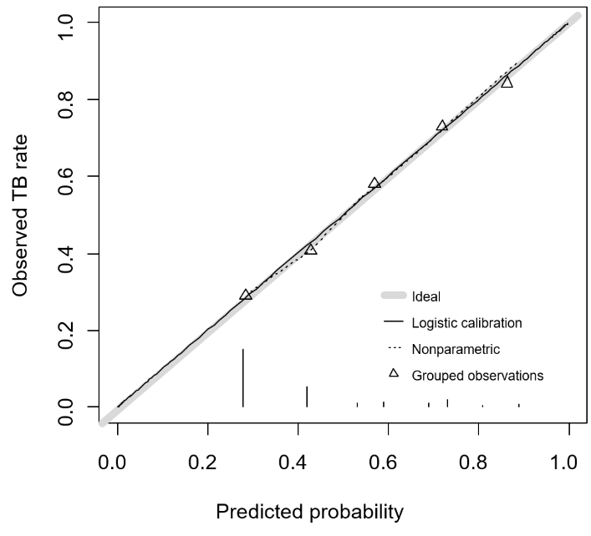
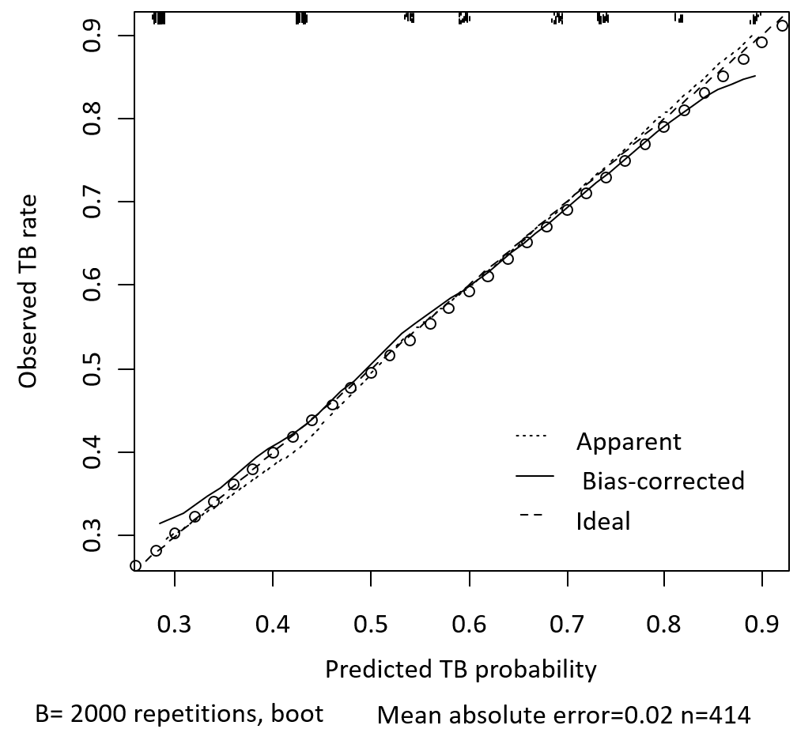
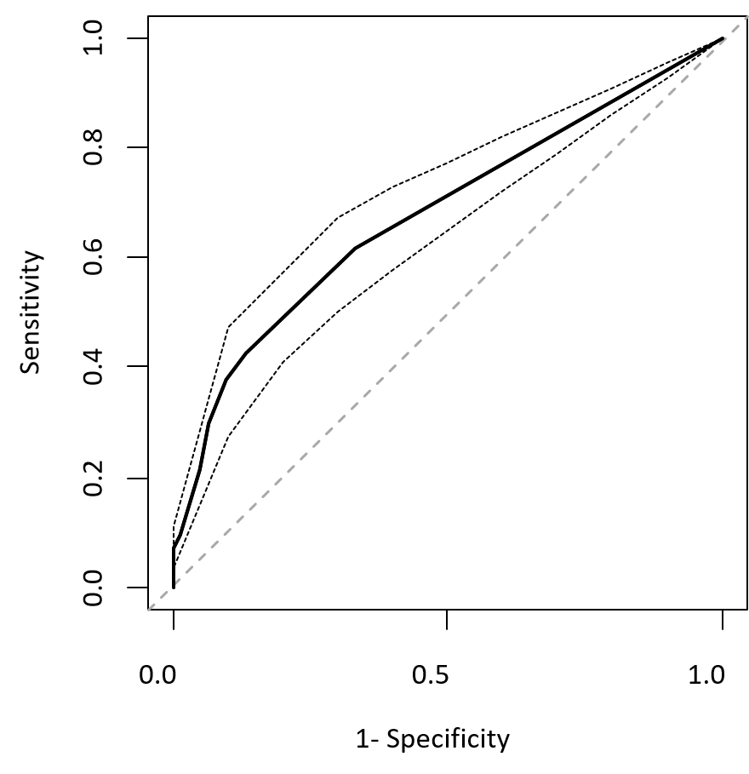
Abbreviations: TB, tuberculosis

