SUPPLEMENTAL APPENDIX

Higher acuity resource utilization with older age and poorer HIV control in adolescents and young adults in the HIV Research Network

Anne M. Neilan, MD, MPH; Frances Lu, MPH; Kelly A. Gebo, MD, MPH; Rebeca Diaz-Reyes, MSPH; Mingshu Huang, MA; Robert A. Parker ScD; Brad Karalius, MPH; Kunjal Patel, DSc, MPH; Cindy Voss, MA; Andrea L. Ciaranello, MD, MPH; Allison L. Agwu, MD, ScM

TABLE OF CONTENTS
eTable 1. Co-occurring diagnoses with first instance eliminated from AIDS-defining conditions resource utilization analysis

eTable 2. Co-occurring diagnoses included in AIDS-defining conditions resource utilization analysis

eTable 3. Definition of duration for individual AIDS-defining conditions

eTable 4. Rates of overall outpatient visits per person-year by mode of transmission, CD4 count, viral load and antiretroviral status and age

eTable 5. Rates of primary care outpatient visits per person-year by mode of acquisition, CD4 count, viral load and antiretroviral status and age

eTable 6. Rates of social work outpatient visits per person-year by mode of acquisition CD4 count, viral load and antiretroviral status and age

eTable 7. Rates of nurse outpatient visits per person-year by mode of transmission, CD4 count, viral load and antiretroviral status and age

eTable 8. Rates of emergency department visits per person-year by mode of acquisition, CD4 count, viral load and antiretroviral status and age

eTable 9. Rates of inpatient days per person-year by mode of acquisition, CD4 count, viral load and antiretroviral status and age

eFigure 1. Primary care outpatient visits per person-year

eFigure 2. Social work outpatient visits per person-year

eFigure 3. Nurse outpatient visits per person-year

eFigure 4. Primary care outpatient visits, emergency department visits and inpatient days per AIDS-defining condition among females

eFigure 5. Primary care outpatient visits, emergency department visits and inpatient days per AIDS-defining condition among males

eFigure 6. Primary care outpatient visits, emergency department visits and inpatient days per AIDS-defining condition among transgender individuals

eTable 1. Co-occurring diagnoses with first instance eliminated from AIDS-defining conditions resource utilization analysis
Primary diagnosis | Removed co-primary diagnosis
Candidal esophagitis, Cryptococcal meningitis, Dementia in conditions classified elsewhere, Disseminated MAC, Herpes simplex with other specified complications, Histoplasmosis, Kaposi’s Sarcoma, Mycobacterial Disease, Pneumococcal pneumonia, Pneumocystosis, Progressive multifocal leukoencephalopathy, Pulmonary tuberculosis, Pulmonary tuberculosis, Toxoplasmosis | Cytomegalovirus disease
Cryptosporidiosis, Other bacterial pneumonia, Primary tuberculosis infection | Herpes simplex with other specified complications
Candidal esophagitis, Cryptosporidiosis, Cytomegalovirus disease, Dementia in conditions classified elsewhere, Disseminated MAC, Herpes simplex with other specified complications, Kaposi’s Sarcoma, Other bacterial pneumonia, Pneumocystosis, Primary tuberculosis infection, Pulmonary tuberculosis, Toxoplasmosis | Cachexia
Cryptosporidiosis, Dementia in conditions classified elsewhere, Disseminated MAC, Kaposi’s Sarcoma, Mycobacterial disease, Other bacterial pneumonia, Pneumococcal pneumonia, Pneumocystosis, Pulmonary disease due to mycobacteria, Pulmonary tuberculosis | Candidal esophagitis
Pneumococcal pneumonia | Cryptosporidiosis
Other bacterial pneumonia | Encephalopathy unspecified
Pulmonary disease due to mycobacteria | Mycobacterial disease
Pulmonary tuberculosis | Primary tuberculosis infection
Cryptococcal meningitis | Cryptococcosis
Pneumococcal pneumonia | Other bacterial pneumonia
Mycobacterial disease | Pulmonary disease due to mycobacteria
Mycobacterial disease | Disseminated MAC
Mycobacterium Avium-intra Cellulare Complex, MAC
The first instance of co-occurring diagnoses were eliminated for two reasons. First: To avoid double-counting of hospital inpatient days for specific AIDS-defining conditions, the first instance of a co-primary diagnosis was removed if the co-occurring diagnoses was assumed to be of lesser severity. This was determined by physician adjudication as follows: Cachexia<Cytomegalovirus disease <Candida esophagitis and Herpes simplex with other specified complications<Cryptosporidiosis. It was not possible to review individual charts to determine illness severity. Second: If one co-occurring diagnosis could encapsulate another then the first instance was eliminated; for example, pulmonary disease due to mycobacteria and mycobacterial disease.
eTable 2. Co-occurring diagnoses included in AIDS-defining conditions resource utilization analysis
Primary diagnosis | Co-occurring diagnosis
Cryptococcal meningitis | Toxoplasmosis
Burkitt’s tumor or lymphoma | Toxoplasmosis
Cryptococcosis | Pneumocystis
Cryptococcosis | Other bacterial pneumonia
Disseminated MAC | Histoplasmosis
Disseminated MAC | Other bacterial pneumonia
Disseminated MAC | Pneumocystis
Disseminated MAC | Pulmonary tuberculosis
Disseminated MAC | Dementia in conditions classified elsewhere
Other bacterial pneumonia | Pneumocystis
Other bacterial pneumonia | Pneumococcal pneumonia
Other bacterial pneumonia | Pulmonary disease due to mycobacteria
Other bacterial pneumonia | Pulmonary tuberculosis
Pneumocystosis | Toxoplasmosis
Pneumocystosis | Pneumococcal pneumonia
Pneumocystosis | Dementia in conditions classified elsewhere
Primary tuberculosis infection | Histoplasmosis
Mycobacterium Avium-intra Cellulare Complex, MAC
For co-occurring ADCs of determined to be of similar severity by physician adjudication, we retained both diagnoses if it was likely that both would impact length of stay. It was not possible to review individual charts to determine illness severity.

eTable 3. Definition of duration for individual AIDS-defining conditions
Duration | Diagnosis
Unlimited | Burkitt’s tumor or lymphoma; Dementia in conditions classified elsewhere; Encephalopathy, unspecified; Kaposi’s sarcoma; Malignant neoplasm of cervix uteri; Progressive multifocal leukoencephalopathy
2 years | Cachexia; Coccidioidomycosis; Disseminated mycobacterium avium-intra cellulare complex; Histoplasmosis; Other specified mycobacterial disease; Primary tuberculosis infection; Pulmonary disease due to mycobacteria; Pulmonary tuberculosis, Salmonella septicemia, Toxoplasmosis; Tuberculosis of other organs; Unspecified diseases due to mycobacteria; Other respiratory tuberculosis; Large cell lymphoma; Mycobacterial disease
3 months | Candidal esophagitis; Candidal pneumonia; Cryptosporidiosis; Cytomegaloviral disease; Herpes simplex with other specified complications; Herpetic meningoencephalitis; Other bacterial pneumonia; Pneumococcal pneumonia; Pneumocystis
If the same diagnosis occurred during the specified “duration” it was not considered a new diagnosis, but rather a continuation of a prior diagnosis.

eTable 4. Rates of outpatient visits per person-year by mode of acquisition, CD4 count, viral load and antiretroviral status and age

 |  | PHIVY |  |  | NPHIVY
VL/ARV status | CD4 cell count | 13 to 17 years | 18 to 23 years | 24 to 30 years | 13 to 17 years | 18 to 23 years | 24 to 30 years
Suppressive ARV Therapy | ≥500/µL | 0.90 (0.88, 0.92) | 0.95 (0.93, 0.98) | 0.66 (0.62, 0.70) | 0.77 (0.69, 0.85) | 0.60 (0.59, 0.61) | 0.43 (0.43, 0.44)
 | 200-499/µL | 1.03 (0.98, 1.08) | 1.14 (1.10, 1.19) | 1.21 (1.13, 1.30) | 0.79 (0.67, 0.94) | 0.61 (0.60, 0.63) | 0.43 (0.42, 0.45)
 | <200/µL | 1.25 (1.09, 1.44) | 1.98 (1.83, 2.14) | 1.87 (1.68, 2.08) | 2.35 (1.60, 3.46) | 0.69 (0.64, 0.74) | 0.54 (0.50, 0.58)
Nonsuppressive cART | ≥500/µL | 1.01 (0.95, 1.06) | 1.59 (1.52, 1.66) | 1.32 (1.16, 1.50) | 0.84 (0.62, 1.14) | 0.66 (0.62, 0.69) | 0.40 (0.38, 0.42)
 | 200-499/µL | 1.04 (0.98, 1.10) | 1.12 (1.08, 1.16) | 0.86 (0.79, 0.93) | 0.83 (0.71, 0.97) | 0.60 (0.59, 0.62) | 0.40 (0.38, 0.41)
 | <200/µL | 0.97 (0.87, 1.09) | 1.18 (1.13, 1.23) | 0.75 (0.69, 0.81) | 0.95 (0.59, 1.53) | 0.72 (0.69, 0.75) | 0.47 (0.45, 0.49)
No ARV Therapy | ≥500/µL | 0.22 (0.13, 0.37) | 0.32 (0.14, 0.71) | - | 0.44 (0.36, 0.54) | 0.44 (0.41, 0.46) | 0.27 (0.25, 0.30)
 | 200-499/µL | 0.32 (0.22, 0.46) | 0.22 (0.15, 0.31) | 0.00 (-,-) | 0.55 (0.41, 0.72) | 0.43 (0.40, 0.46) | 0.26 (0.23, 0.28)
 | <200/µL | 0.23 (0.14, 0.40) | 0.48 (0.37, 0.62) | 0.00 (-,-) | 60.83 (15.21, 243.24) | 0.42 (0.33, 0.53) | 0.12 (0.08, 0.17)
Crude rates and 95% CIs are presented. Blank strata (-) contained no person-time. “0” strata (0.00 (-,-)) contained person-time, but no events.
PHIV: perinatally-acquired HIV-infection; NPHIV: non-perinatally acquired HIV; VL: viral load; ARV: antiretroviral; ART

eTable 5. Rates of primary care outpatient visits per person-year by mode of acquisition, CD4 count, viral load and antiretroviral status and age
 |  | PHIVY |  |  | NPHIVY
VL/ARV status | CD4 cell count | 13 to 17 years | 18 to 23 years | 24 to 30 years | 13 to 17 years | 18 to 23 years | 24 to 30 years
Suppressive ARV Therapy | ≥500/µL | 0.43 (0.42, 0.45) | 0.41 (0.39, 0.42) | 0.36 (0.33, 0.39) | 0.40 (0.35, 0.46) | 0.43 (0.42, 0.44) | 0.34 (0.33, 0.34)
 | 200-499/µL | 0.56 (0.52, 0.59) | 0.44 (0.42, 0.47) | 0.44 (0.39, 0.49) | 0.67 (0.56, 0.81) | 0.47 (0.45, 0.48) | 0.34 (0.33, 0.35)
 | <200/µL | 0.77 (0.65, 0.92) | 0.78 (0.68, 0.88) | 0.72 (0.60, 0.85) | 1.18 (0.68, 2.03) | 0.56 (0.51, 0.61) | 0.48 (0.45, 0.52)
Nonsuppressive cART | ≥500/µL | 0.54 (0.50,0.58) | 0.51 (0.48, 0.55) | 0.43 (0.34, 0.54) | 0.70 (0.50, 0.97) | 0.50 (0.47, 0.53) | 0.33 (0.31, 0.35)
 | 200-499/µL | 0.66 (0.62, 0.71) | 0.51 (0.48, 0.54) | 0.38 (0.34, 0.44) | 0.73 (0.62, 0.86) | 0.50 (0.48, 0.52) | 0.32 (0.31, 0.34)
 | <200/µL | 0.79 (0.69, 0.89) | 0.66 (0.62, 0.69) | 0.47 (0.42, 0.52) | 0.78 (0.46, 1.32) | 0.59 (0.56, 0.62) | 0.40 (0.38, 0.42)
No ARV Therapy | ≥500/µL | 0.17 (0.09, 0.31) | 0.32 (0.14, 0.71) | - | 0.42 (0.34, 0.52) | 0.38 (0.36, 0.40) | 0.23 (0.21, 0.26)
 | 200-499/µL | 0.31 (0.21, 0.45) | 0.16 (0.10, 0.24) | 0.00 (-,-) | 0.53 (0.40, 0.71) | 0.39 (0.36, 0.42) | 0.21 (0.19, 0.24)
 | <200/µL | 0.23 (0.14, 0.40) | 0.46 (0.36, 0.60) | 0.00 (-,-) | 30.42 (4.28, 215.93) | 0.36 (0.27, 0.47) | 0.09 (0.06, 0.14)
Crude rates and 95% CIs are presented. Blank strata (-) contained no person-time. “0” strata (0.00 (-,-)) contained person-time, but no events.
PHIV: perinatally-acquired HIV-infection; NPHIV: non-perinatally acquired HIV; VL: viral load; ARV: antiretroviral; ART

eTable 6. Rates of social work outpatient visits per person-year by mode of acquisition, CD4 count, viral load and antiretroviral status and age
 |  | PHIVY |  |  | NPHIVY
VL/ARV status | CD4 cell count | 13 to 17 years | 18 to 23 years | 24 to 30 years | 13 to 17 years | 18 to 23 years | 24 to 30 years
Suppressive ARV Therapy | ≥500/µL | 0.30 (0.29, 0.31) | 0.39 (0.37, 0.40) | 0.17 (0.15, 0.19) | 0.28 (0.23, 0.33) | 0.13 (0.12, 0.13) | 0.05 (0.05, 0.06)
 | 200-499/µL | 0.35 (0.32, 0.37) | 0.47 (0.44, 0.50) | 0.28 (0.24, 0.32) | 0.09 (0.05, 0.15) | 0.11 (0.10, 0.12) | 0.06 (0.05, 0.06)
 | <200/µL | 0.33 (0.25, 0.43) | 0.88 (0.78, 0.99) | 0.95 (0.82, 1.10) | 0.72 (0.36, 1.45) | 0.08 (0.06, 0.10) | 0.03 (0.02, 0.04)
Nonsuppressive cART | ≥500/µL | 0.28 (0.25, 0.31) | 0.78 (0.73, 0.83) | 0.71 (0.59, 0.84) | 0.10 (0.04, 0.24) | 0.12 (0.11, 0.14) | 0.04 (0.03, 0.05)
 | 200-499/µL | 0.19 (0.16, 0.22) | 0.45 (0.42, 0.48) | 0.32 (0.28, 0.37) | 0.09 (0.06, 0.15) | 0.08 (0.07, 0.09) | 0.04 (0.04, 0.05)
 | <200/µL | 0.11 (0.07, 0.15) | 0.40 (0.37, 0.43) | 0.14 (0.12, 0.17) | 0.11 (0.03, 0.45) | 0.10 (0.09, 0.11) | 0.04 (0.04, 0.05)
No ARV Therapy | ≥500/µL | 0.03 (0.01, 0.12) | 0.00 (-,-) | - | 0.00 (0.00, 0.03) | 0.04 (0.03, 0.05) | 0.02 (0.02, 0.03)
 | 200-499/µL | 0.00 (-,-) | 0.02 (0.00, 0.06) | 0.00 (-,-) | 0.01 (0.00, 0.08) | 0.03 (0.02, 0.04) | 0.03 (0.02, 0.04)
 | <200/µL | 0.00 (-,-) | 0.01 (0.00, 0.06) | 0.00 (-,-) | 30.42 (4.28, 215.93) | 0.05 (0.02, 0.10) | 0.01 (0.00, 0.04)
Crude rates and 95% CIs are presented. Blank strata (-) contained no person-time. “0” strata (0.00 (-,-)) contained person-time, but no events.
PHIV: perinatally-acquired HIV-infection; NPHIV: non-perinatally acquired HIV; VL: viral load; ARV: antiretroviral; ART

eTable 7. Rates of nurse outpatient visits per person-year by mode of acquisition, CD4 count, viral load and antiretroviral status and age

 |  | PHIVY |  |  | NPHIVY
VL/ARV status | CD4 cell count | 13 to 17 years | 18 to 23 years | 24 to 30 years | 13 to 17 years | 18 to 23 years | 24 to 30 years
Suppressive ARV Therapy | ≥500/µL | 0.17 (0.16, 0.17) | 0.16 (0.15, 0.17) | 0.13 (0.11, 0.15) | 0.09 (0.07, 0.12) | 0.04 (0.04, 0.04) | 0.04 (0.04, 0.05)
 | 200-499/µL | 0.13 (0.11, 0.14) | 0.23 (0.21, 0.25) | 0.50 (0.44, 0.55) | 0.03 (0.01, 0.07) | 0.04 (0.03, 0.04) | 0.04 (0.04, 0.04)
 | <200/µL | 0.15 (0.10, 0.22) | 0.32 (0.27, 0.39) | 0.20 (0.15, 0.28) | 0.45 (0.19, 1.09) | 0.05 (0.03, 0.06) | 0.03 (0.02, 0.04)
Nonsuppressive cART | ≥500/µL | 0.19 (0.17, 0.22) | 0.29 (0.26, 0.32) | 0.19 (0.13, 0.26) | 0.04 (0.01, 0.16) | 0.03 (0.03, 0.04) | 0.03 (0.02, 0.04)
 | 200-499/µL | 0.19 (0.17, 0.22) | 0.16 (0.15, 0.18) | 0.15 (0.12, 0.18) | 0.01 (0.00, 0.04) | 0.02 (0.02, 0.03) | 0.03 (0.03, 0.03)
 | <200/µL | 0.08 (0.05, 0.12) | 0.12 (0.11, 0.14) | 0.14 (0.11, 0.17) | 0.06 (0.01, 0.40) | 0.03 (0.03, 0.04) | 0.03 (0.03, 0.04)
No ARV Therapy | ≥500/µL | 0.02 (0.00, 0.11) | 0.00 (-,-) | - | 0.01 (0.00, 0.04) | 0.02 (0.01, 0.02) | 0.01 (0.01, 0.02)
 | 200-499/µL | 0.01 (0.00, 0.08) | 0.05 (0.02, 0.10) | 0.00 (-,-) | 0.00 (-,-) | 0.01 (0.01, 0.02) | 0.01 (0.01, 0.02)
 | <200/µL | 0.00 (-,-) | 0.01 (0.00, 0.06) | 0.00 (-,-) | 0.00 (-,-) | 0.01 (0.00, 0.05) | 0.01 (0.00, 0.04)
Crude rates and 95% CIs are presented. Blank strata (-) contained no person-time. “0” strata (0.00 (-,-)) contained person-time, but no events.
PHIV: perinatally-acquired HIV-infection; NPHIV: non-perinatally acquired HIV; VL: viral load; ARV: antiretroviral; ART

eTable 8. Rates of emergency department visits per person-year by mode of acquisition, CD4 count, viral load and antiretroviral status and age
 |  | PHIVY |  |  | NPHIVY
VL/ARV status | CD4 cell count | 13 to 17 years | 18 to 23 years | 24 to 30 years | 13 to 17 years | 18 to 23 years | 24 to 30 years
Suppressive ARV Therapy | ≥500/µL | 0.02 (0.01, 0.02) | 0.02 (0.01, 0.02) | 0.03 (0.02, 0.04) | 0.01 (0.00, 0.03) | 0.02 (0.02, 0.02) | 0.02 (0.02, 0.02)
 | 200-499/µL | 0.01 (0.01, 0.02) | 0.03 (0.03, 0.04) | 0.07 (0.06, 0.10) | 0.01 (0.00, 0.05) | 0.02 (0.02, 0.03) | 0.02 (0.02, 0.03)
 | <200/µL | 0.04 (0.02, 0.08) | 0.09 (0.06, 0.13) | 0.03 (0.02, 0.08) | 0.00 (-,-) | 0.03 (0.02, 0.04) | 0.04 (0.03, 0.05)
Nonsuppressive cART | ≥500/µL | 0.02 (0.01, 0.03) | 0.05 (0.04, 0.06) | 0.01 (0.00, 0.05) | 0.02 (0.00, 0.14) | 0.03 (0.02, 0.03) | 0.05 (0.04, 0.05)
 | 200-499/µL | 0.03 (0.02, 0.04) | 0.04 (0.03, 0.05) | 0.05 (0.04, 0.07) | 0.01 (0.00, 0.04) | 0.04 (0.03, 0.04) | 0.04 (0.04, 0.05)
 | <200/µL | 0.06 (0.03, 0.09) | 0.10 (0.09, 0.12) | 0.15 (0.12, 0.18) | 0.11 (0.03, 0.45) | 0.05 (0.05, 0.07) | 0.08 (0.07, 0.09)
No ARV Therapy | ≥500/µL | 0.00 (-,-) | 0.00 (-,-) | - | 0.00 (0.00, 0.03) | 0.02 (0.01, 0.02) | 0.04 (0.03, 0.05)
 | 200-499/µL | 0.00 (-,-) | 0.00 (-,-) | 1.84 (0.88, 3.85) | 0.01 (0.00, 0.08) | 0.03 (0.02, 0.03) | 0.04 (0.03, 0.05)
 | <200/µL | 0.02 (0.00, 0.12) | 0.03 (0.01, 0.08) | 0.88 (0.33, 2.35) | 0.00 (-,-) | 0.13 (0.08, 0.20) | 0.11 (0.07, 0.16)
Crude rates and 95% CIs are presented. Blank strata (-) contained no person-time. “0” strata (0.00 (-,-)) contained person-time, but no events.
PHIV: perinatally-acquired HIV-infection; NPHIV: non-perinatally acquired HIV; VL: viral load; ARV: antiretroviral; ART

eTable 9. Rates of inpatient days per person-year by mode of acquisition, viral load and antiretroviral status and age
 |  | PHIVY |  |  | NPHIVY
VL/ARV status | CD4 cell count | 13 to 17 years | 18 to 23 years | 24 to 30 years | 13 to 17 years | 18 to 23 years | 24 to 30 years
Suppressive ARV Therapy | ≥500/µL | 0.03 (0.03, 0.03) | 0.04 (0.03, 0.04) | 0.11 (0.09, 0.13) | 0.00 (0.00, 0.02) | 0.02 (0.02, 0.03) | 0.02 (0.02, 0.03)
 | 200-499/µL | 0.04 (0.03, 0.05) | 0.10 (0.09, 0.12) | 0.19 (0.16, 0.23) | 0.01 (0.00, 0.05) | 0.04 (0.04, 0.05) | 0.05 (0.05, 0.05)
 | <200/µL | 0.63 (0.52, 0.76) | 0.68 (0.59, 0.77) | 0.27 (0.20, 0.36) | 0.91 (0.49, 1.68) | 0.22 (0.19, 0.25) | 0.56 (0.52, 0.60)
Nonsuppressive cART | ≥500/µL | 0.04 (0.03, 0.05) | 0.08 (0.07, 0.10) | 0.02 (0.01, 0.06) | 0.00 (-,-) | 0.04 (0.04, 0.05) | 0.04 (0.03, 0.05)
 | 200-499/µL | 0.15 (0.13, 0.18) | 0.08 (0.07, 0.10) | 0.11 (0.09, 0.14) | 0.06 (0.03, 0.11) | 0.04 (0.03, 0.04) | 0.07 (0.06, 0.08)
 | <200/µL | 0.59 (0.51, 0.69) | 0.72 (0.68, 0.76) | 0.63 (0.58, 0.69) | 0.00 (-,-) | 0.35 (0.33, 0.38) | 0.45 (0.43, 0.48)
No ARV Therapy | ≥500/µL | 0.57 (0.41, 0.79) | 0.00 (-,-) | - | 0.00 (-,-) | 0.01 (0.01, 0.02) | 0.07 (0.06, 0.09)
 | 200-499/µL | 0.41 (0.30, 0.58) | 0.00 (-,-) | 4.20 (2.57, 6.85) | 0.00 (-,-) | 0.03 (0.02, 0.04) | 0.15 (0.13, 0.17)
 | <200/µL | 0.34 (0.22, 0.52) | 0.22 (0.15, 0.32) | 2.20 (1.19, 4.10) | 0.00 (-,-) | 0.38 (0.30, 0.50) | 0.82 (0.71, 0.96)
Crude rates and 95% CIs are presented. Blank strata (-) contained no person-time. “0” strata (0.00 (-,-)) contained person-time, but no events.
PHIV: perinatally-acquired HIV-infection; NPHIV: non-perinatally acquired HIV; VL: viral load; ARV: antiretroviral; ART

FIGURE LEGENDS
eFigure 1. Primary care outpatient visits per person-year
ARV: antiretroviral
Error bars indicate Poisson 95% confidence intervals.

eFigure 2. Social work outpatient visits per person-year
ARV: antiretroviral
Error bars indicate Poisson 95% confidence intervals.

eFigure 3. Nurse outpatient visits per person-year
ARV: antiretroviral
Error bars indicate Poisson 95% confidence intervals.

eFigure 4. Primary care outpatient visits, emergency department visits and inpatient days per AIDS-defining condition among females
For the category Total for all ADCs, all AIDS-defining conditions (ADCs) are averaged. For the category Total infections all individual infections are averaged. Total bacterial infections, total viral infections, total fungal infections and total mycobacterial infections are comprised of individal bacterial, viral, fungal and mycobacterial infections, respectively. Mycobacterial disease may comprise either tuberculosis or non-tuberculous mycobacteria and thus is distinguished from, for example, disseminated Mycobacterium avium complex (MAC).

AIDS: Acquired Immunodeficiency Syndrome; CMV: Cytomegalovirus; HSV: Herpes simplex virus; PML: Progressive multifocal leukoencephalopathy; MAC: Mycobacterium avium complex, TB: Tuberculosis

eFigure 5. Primary care outpatient visits, emergency department visits and inpatient days per AIDS-defining condition among males
For the category Total for all ADCs, all AIDS-defining conditions (ADCs) are averaged. For the category Total infections all individual infections are averaged. Total bacterial infections, total viral infections, total fungal infections and total mycobacterial infections are comprised of individal bacterial, viral, fungal and mycobacterial infections, respectively. Mycobacterial disease may comprise either tuberculosis or non-tuberculous mycobacteria and thus is distinguished from, for example, disseminated Mycobacterium avium complex (MAC).

AIDS: Acquired Immunodeficiency Syndrome; CMV: Cytomegalovirus; HSV: Herpes simplex virus; PML: Progressive multifocal leukoencephalopathy; MAC: Mycobacterium avium complex, TB: Tuberculosis
eFigure 6. Primary care outpatient visits, emergency department visits and inpatient days per AIDS-defining condition among transgender individuals
For the category Total for all ADCs, all AIDS-defining conditions (ADCs) are averaged. Mycobacterial disease may comprise either tuberculosis or non-tuberculous mycobacteria and thus is distinguished from, for example, disseminated Mycobacterium avium complex (MAC).
All inpatient days for Disseminated MAC are not shown; 1 distinct episode of Dissmenated MAC (defined as 2 years duration) resulted in 2 inpatient events and a total of 132 hospital days.

AIDS: Acquired Immunodeficiency Syndrome; CMV: Cytomegalovirus; MAC: Mycobacterium avium complex, TB: Tuberculosis

eFigure 1. Primary care outpatient visits per person-year
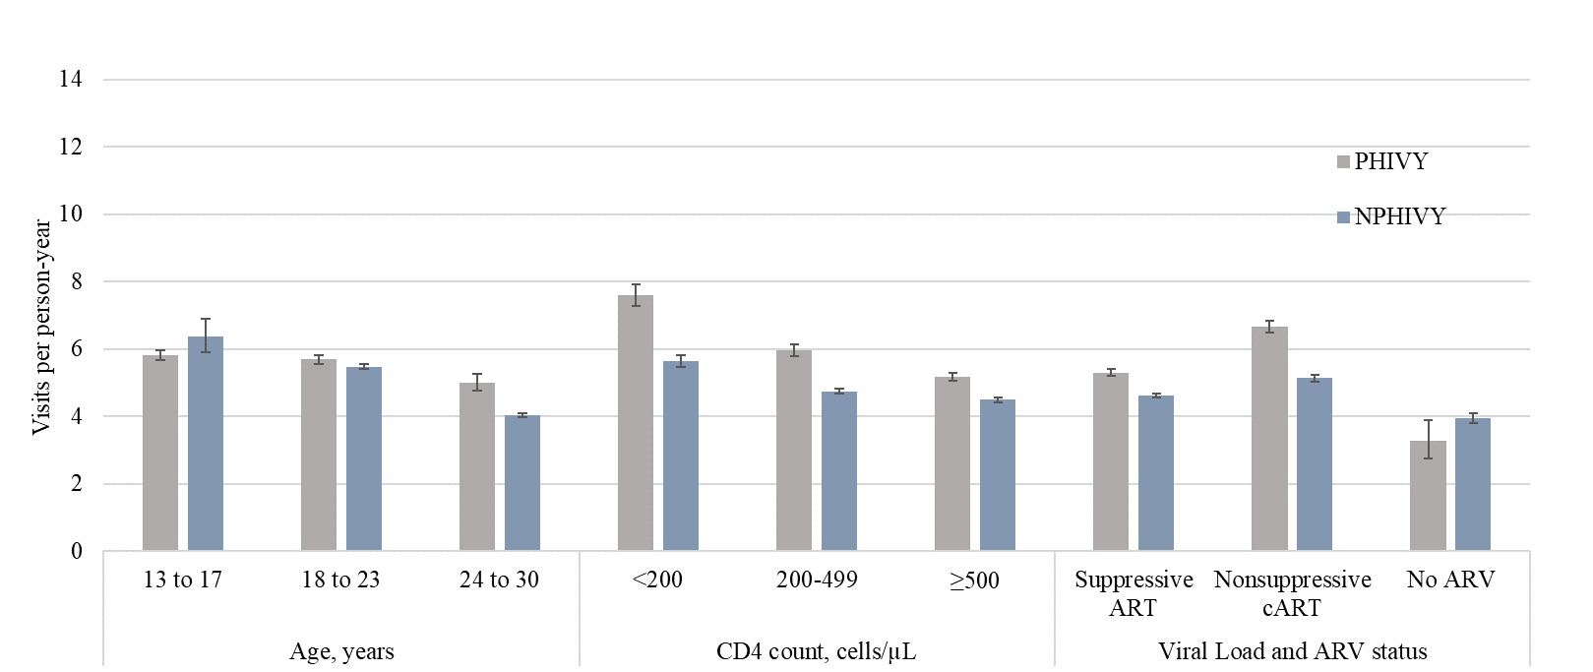
eFigure 2. Social work outpatient visits per person-year
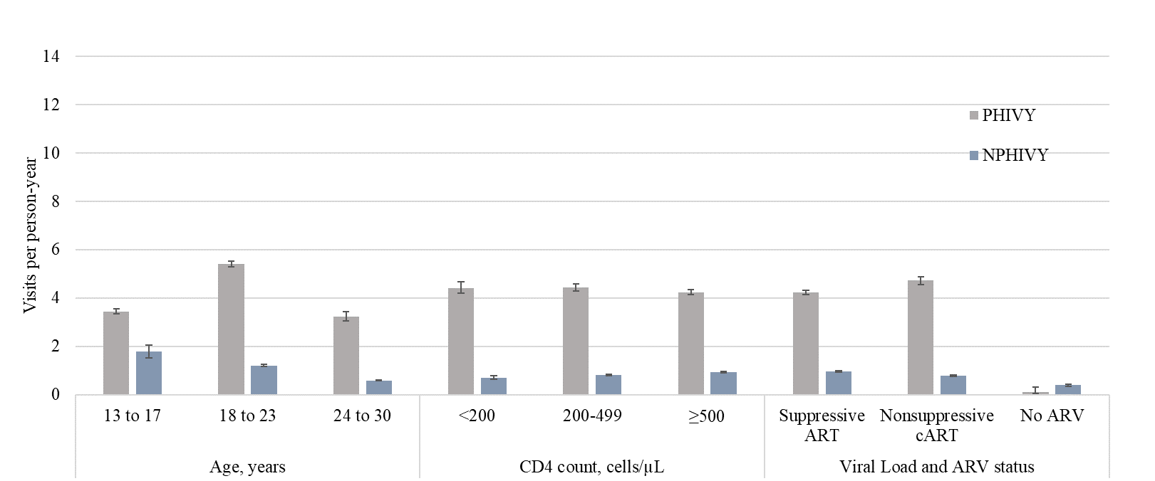

eFigure 3. Nurse outpatient visits per person-year
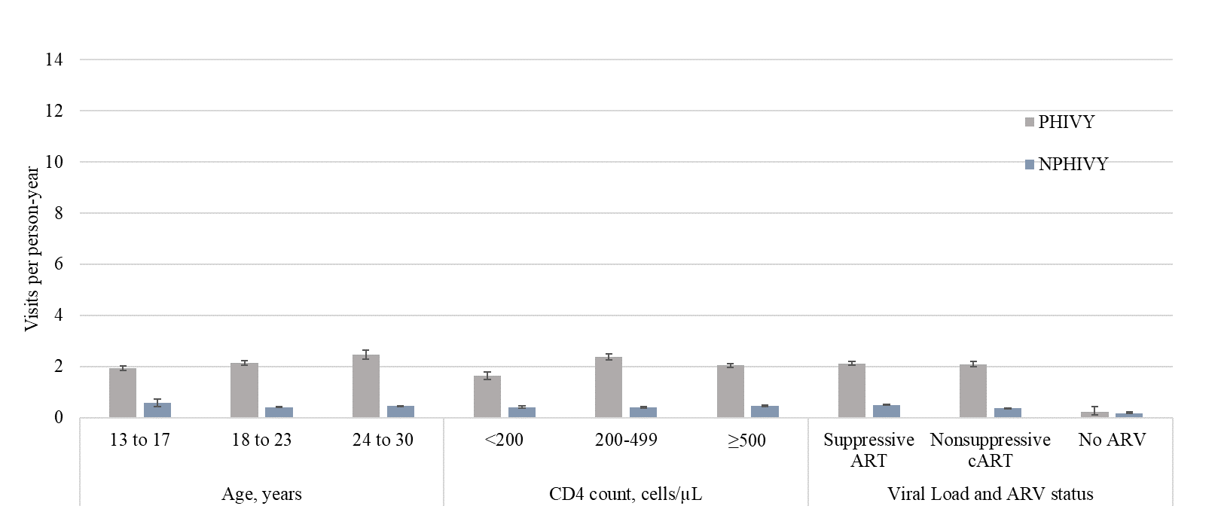

eFigure 4. Primary care outpatient visits, emergency department visits and inpatient days per AIDS-defining condition among females
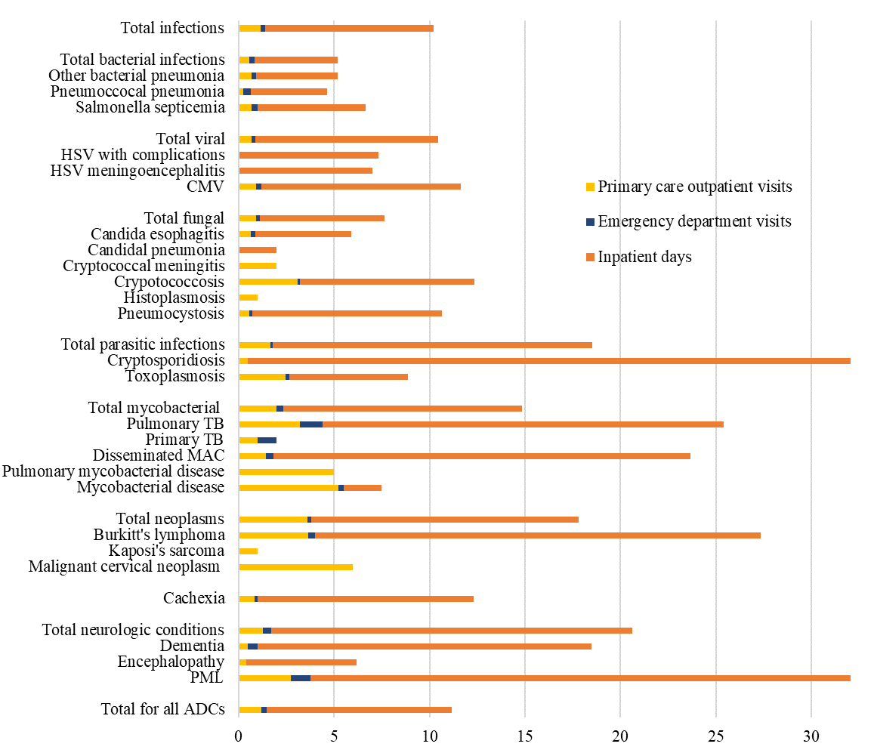

eFigure 5. Primary care outpatient visits, emergency department visits and inpatient days per AIDS-defining condition among males
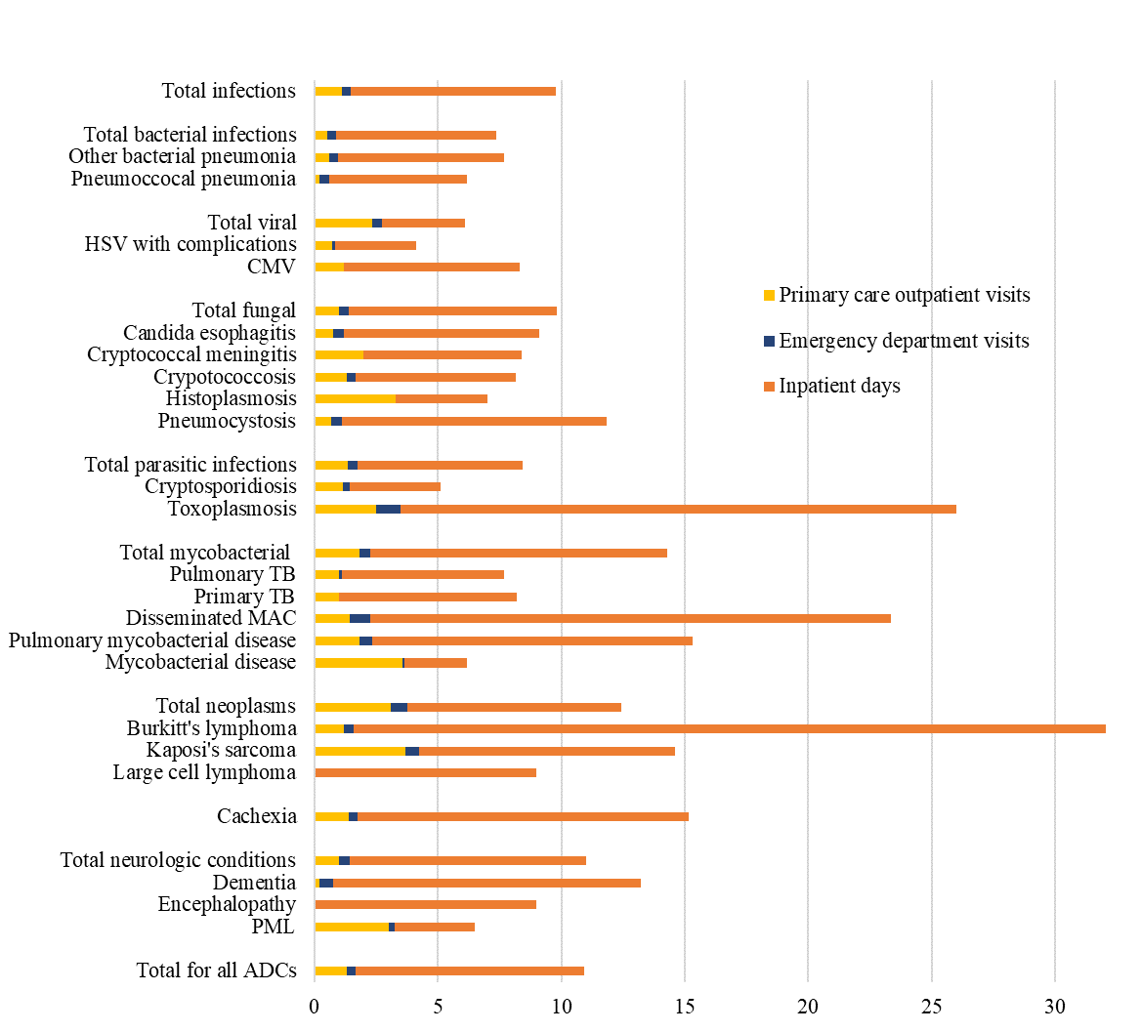

eFigure 6. Primary care outpatient visits, emergency department visits and inpatient days per AIDS-defining condition among transgender individuals
