 | Subject Level (N=52)
 | N (%)
Gender:
Female | 24 (46.2%)
Male | 28 (53.8%)
Race:
AFRICAN AMERICAN | 33 (63.5%)
CAUCASIAN | 11 (21.2%)
Other | 8 (15.4%)
Number of Visits:
6 | 12 (23.1%)
7 | 40 (76.9%)
 | Mean (Range)
Age | 33.0 [21.0;45.0]
CD4 Count (cells/ul) | 812 [343;1781]
CD4 Percentage (%) | 46.5 [32.0;62.0]
Hematocrit Ratio (%) | 39.3 [32.9;48.0]
Hemoglobin Concentration (g/dl) | 13.0 [10.2;16.0]
Platelet Count (cells/ul) | 259000 [177000;703000]
Red Blood Cell Count (million cells/ul) | 4.53 [3.68;5.98]
White Blood Cell Count (thousand cells/ul) | 6.20 [3.10;11.0]
Supplementary Table 1: Descriptive statistics for participants at the final visit week (Week 48). Mean and range displayed for continuous factor and frequencies and percentages for categorical factors.

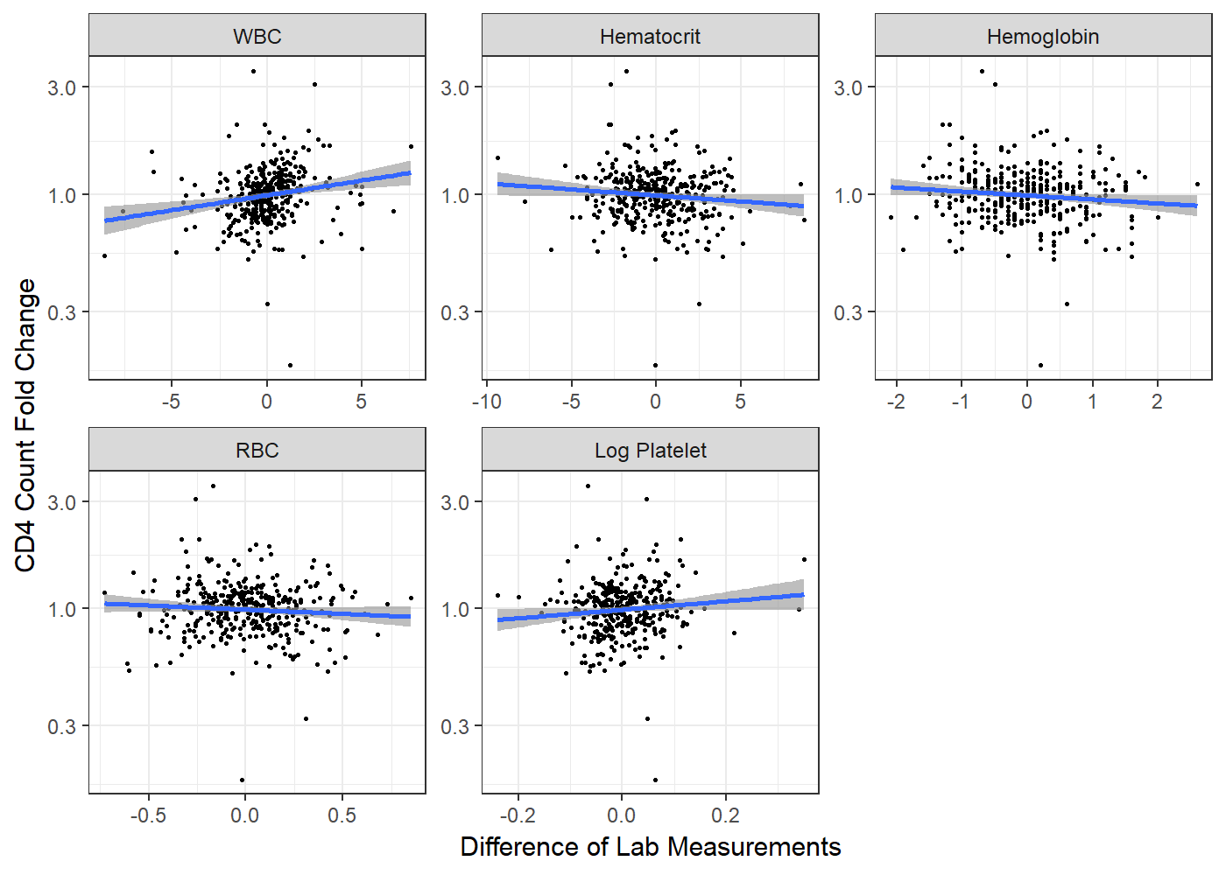
Supplementary Figure 1: Fold-changes in participant measurements of CD4 count versus differences in various laboratory measurements (white blood cell count (WBC), hematocrit levels, hemoglobin levels, red blood cell (RBC) counts, and log platelet levels) between consecutive visits. Each point represents a participant’s simultaneous change in both measurements between common consecutive visits. Trend line with 95% confidence interval was fit using linear regression.

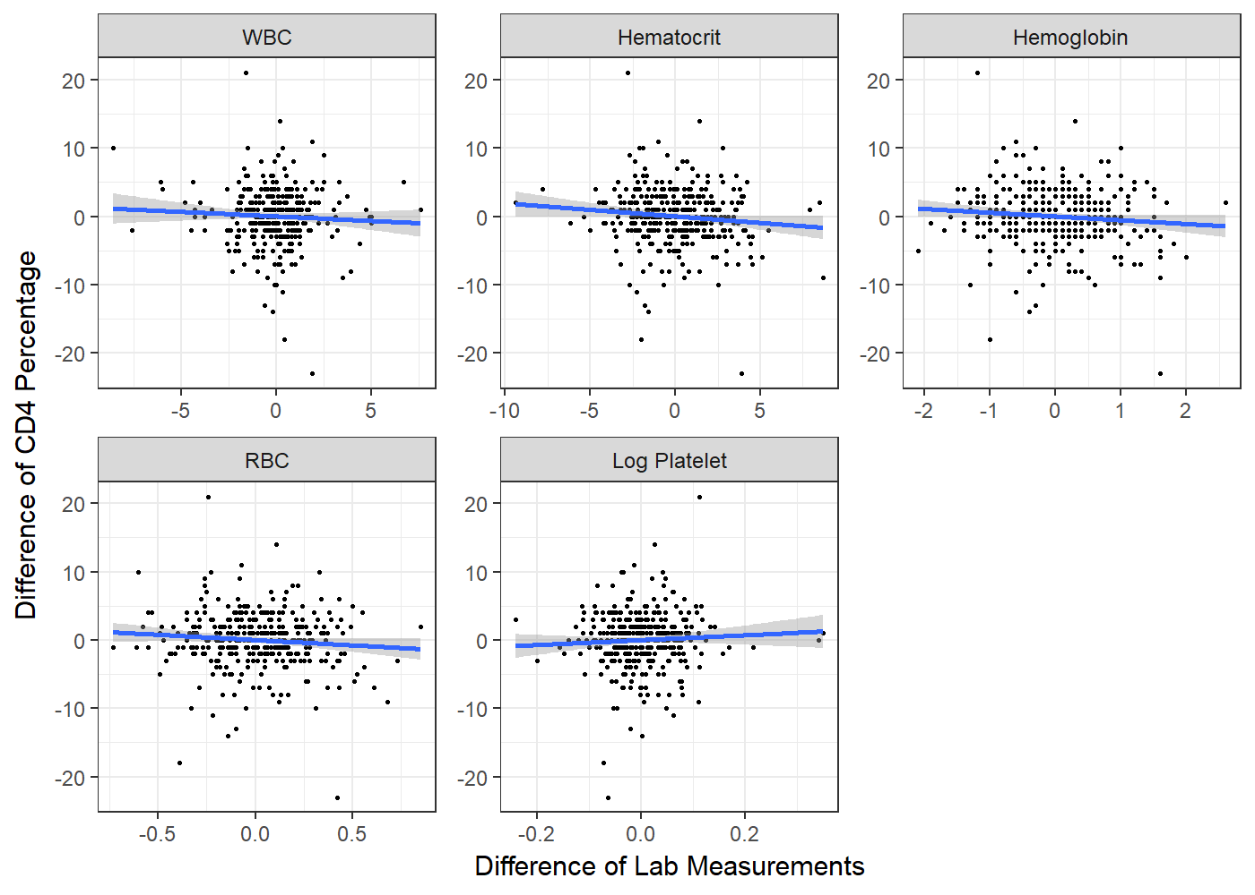
Supplementary Figure 2: Differences in participant measurements of CD4 percent versus differences in various laboratory measurements (white blood cell count (WBC), hematocrit levels, hemoglobin levels, red blood cell (RBC) counts, and log platelet levels) between consecutive visits. Each point represents a participant’s simultaneous change in both measurements between common consecutive visits. Trend line with 95% confidence interval was fit using linear regression.

