Supplemental Table 1. Detailed IPT cascade outcomes of HIV-positive female sex workers initially eligible for IPT evaluation
 | N= 646
Outcomes | N | % of outcome | % of total N
Success | 249 | 100 | 39
Cascade loss | 236 | 100 | 37
Lost to follow-up | 208 | 88
Unknown | 28 | 12
Appropriate exit | 157 | 100 | 24
Patient declined | 49 | 31
Active TB | 35* | 23
Irregular clinic attendance | 24 | 15
IPT intolerance** | 16 | 10
Became ART eligible | 19 | 12
Pregnant | 8 | 5
Died | 3 | 2
Relocated | 2 | 1
Previous INH | 1 | 1
* 1 women developed TB after initiating IPT
**Medication intolerance included: nausea/vomiting 4, peripheral neuropathy 3, rash/itching 5, unknown 4

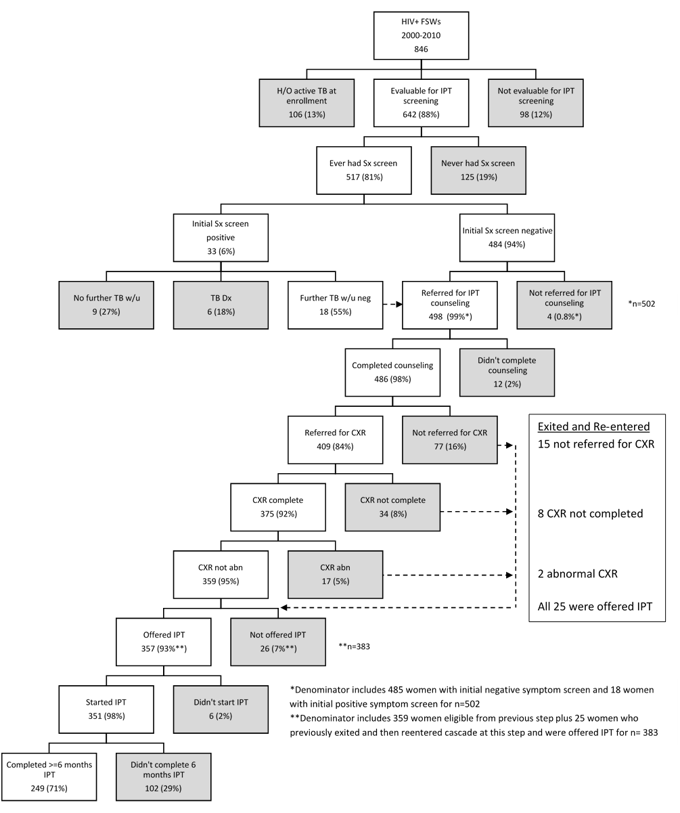
Supplemental Figure 1. Detailed ascertainment of stepwise progression of women through IPT care cascade. Women exiting cascade are shown in gray.

