Supplemental Figure 1: Hormonal contraceptive type by injection visit among cisgender women in HIV Prevention Trials Network study 077
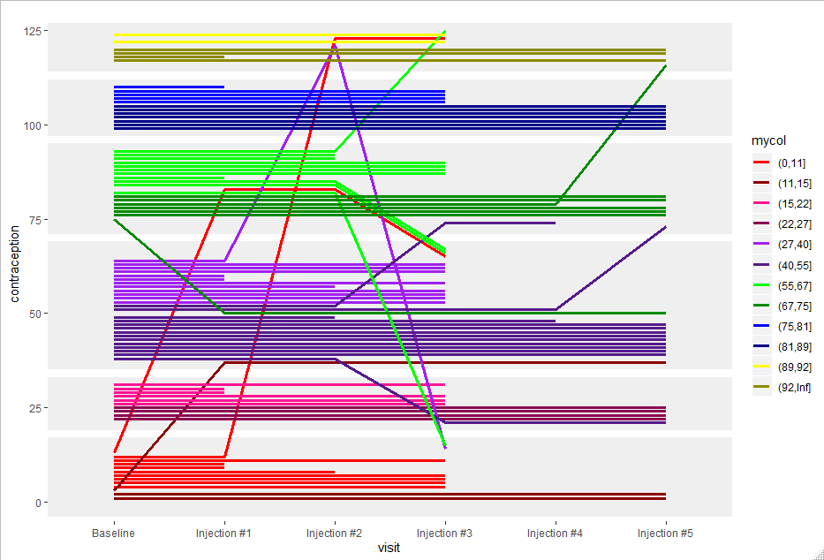
No Hormonal Contraception
Not of Reproductive Potential
Oral
Contraceptive
Injectable Contraceptive
Other
Contraceptive
Implantable Contraceptive
Cohort #1
Cohort #2
Cohort #1
Cohort #2
Cohort #1
Cohort #2
Cohort #1
Cohort #2
Cohort #1
Cohort #2
Cohort #1
Cohort #2
Baseline
Injection #1
Injection #2
Injection #3
Injection #4
Injection #5

