Supplementary Material

Figure S1. Summary of ITT-E participants by region and country

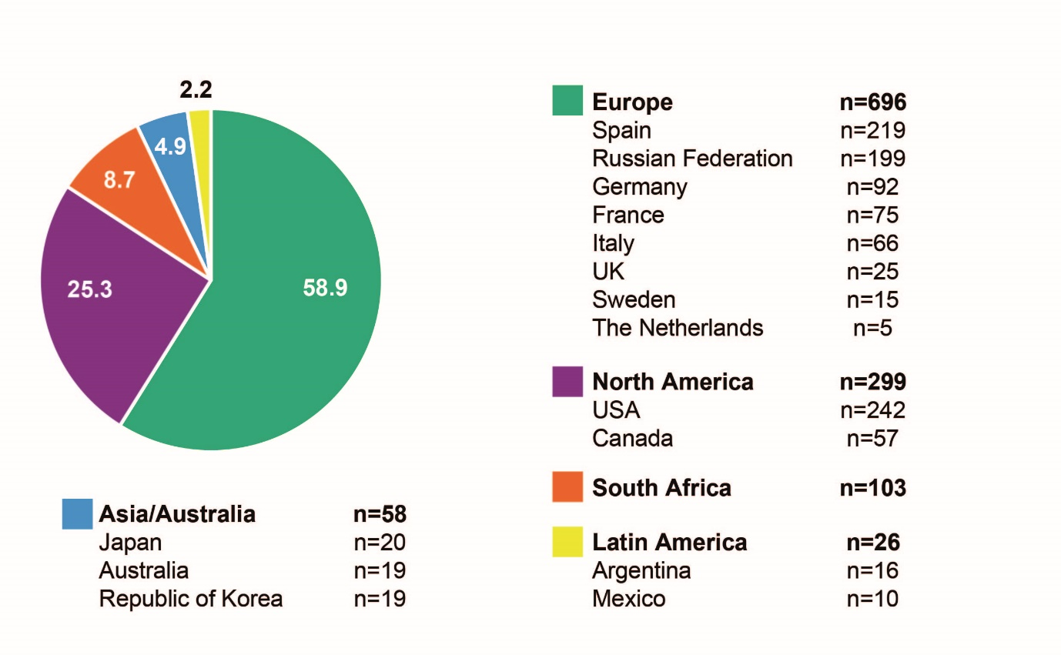
Numbers displayed in the chart are percentages.
ITT-E, intention-to-treat exposed.

Figure S2. Treatment difference in proportion (95% CI): Snapshot HIV-1 RNA ≥50 copies/mL at Week 48 by subgroup
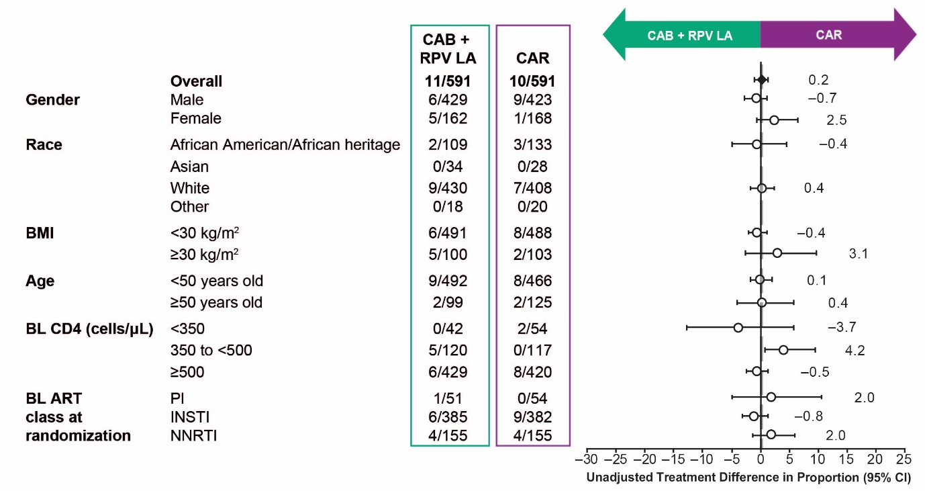

Dashed line represents the overall difference in proportion.
ART, antiretroviral therapy; BL, baseline; BMI, body mass index; CAB, cabotegravir; CAR, current antiretroviral therapy; CI, confidence interval; INSTI, integrase stand transfer inhibitor; LA, long-acting; NNRTI, non-nucleoside reverse transcriptase inhibitor; PI, protease inhibitor; RPV, rilpivirine.

Figure S3. Treatment difference in proportion (95% CI): Snapshot HIV-1 RNA <50 copies/mL at Week 48 by subgroup

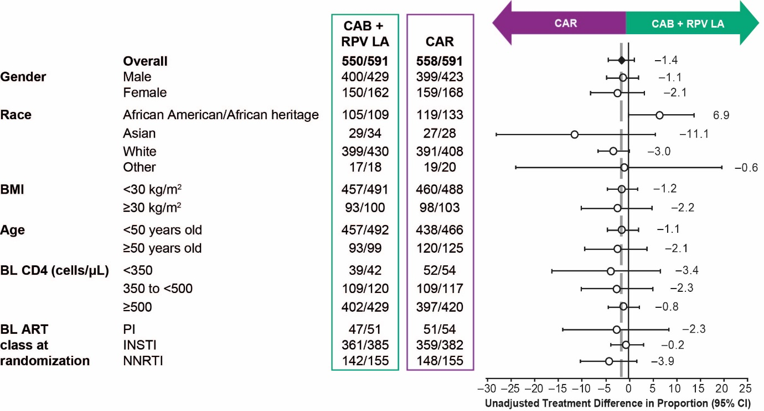
Dashed line represents the overall difference in proportion.
ART, antiretroviral therapy; BL, baseline; BMI, body mass index; CAB, cabotegravir; CAR, current antiretroviral therapy; CI, confidence interval; INSTI, integrase stand transfer inhibitor; LA, long-acting; NNRTI, non-nucleoside reverse transcriptase inhibitor; PI, protease inhibitor; RPV, rilpivirine.

Figure S4. Injection site reaction incidence by week during the maintenance phase
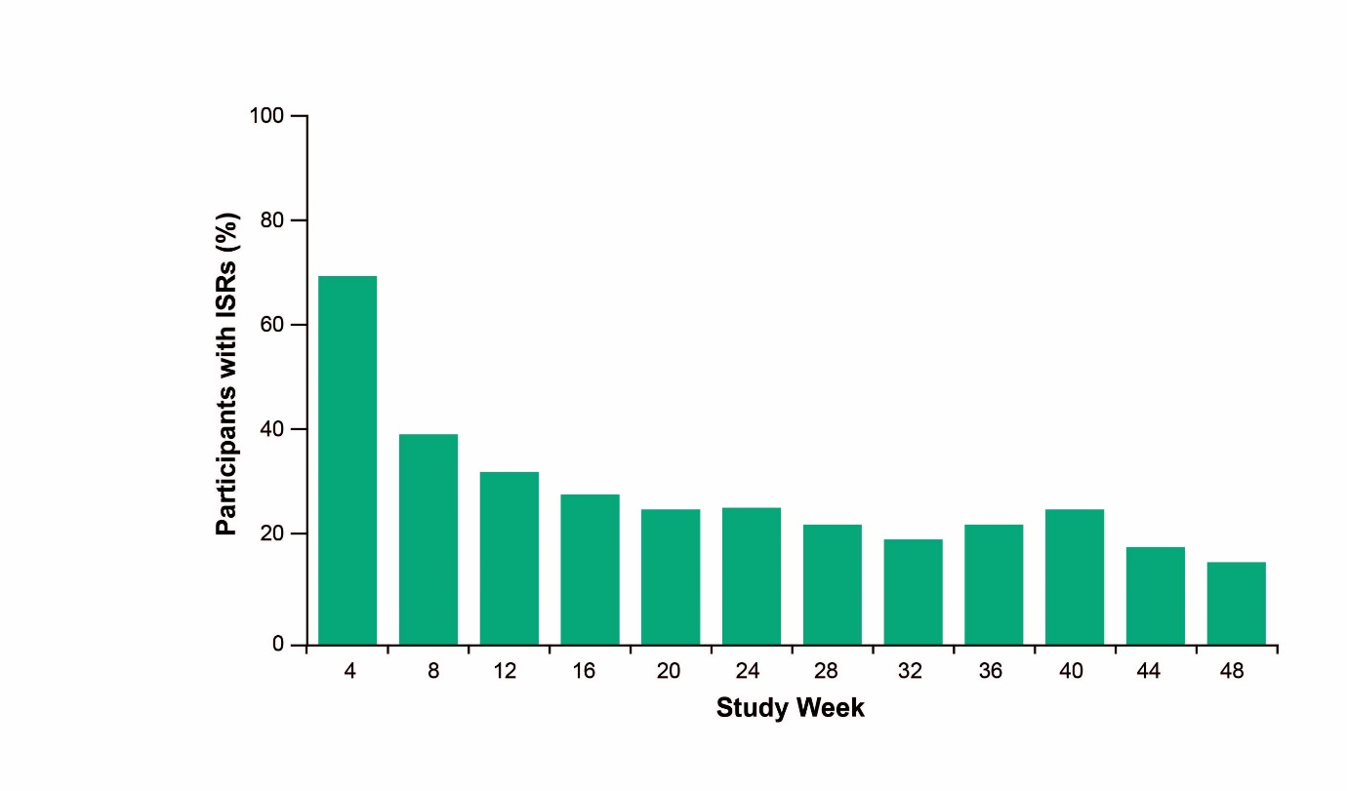
Bars represent the incidence of injection site reactions following each monthly intramuscular injection visit. Percentages are calculated relative to the number of participants at each visit.

ISR, injection site reaction.

Figure S5. Participant Satisfaction (HIVTSQs)

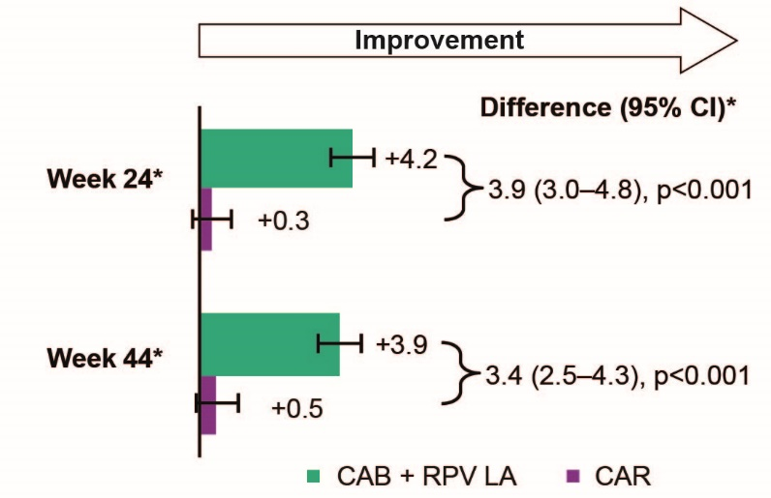

*Adjusted mean is the estimated mean change from baseline score by visit in each treatment calculated from a ANCOVA model including the covariates: baseline score, sex at birth, age (<50, ≥50 years), and race (white, non-white).
CAB, cabotegravir; CAR, current antiretroviral therapy; HIVTSQs, HIV treatment satisfaction questionnaire status version; LA, long-acting; RPV, rilpivirine.

Table S1. Injection site reactions: event-level summary – Maintenance Phase

Outcome, n (%), ITT-E | LA  n=591
Number of injections  Number of ISR events (events/injections)*  Grade 1  Grade 2  Grade ≥3 – severe | 14,682  3663 (25)  3063 (84)  565 (15)  34 (<1)
Injection site reactions*  Pain  Nodule  Induration  Swelling  Erythema  Warmth  Pruritus  Bruising  Hematoma  Discoloration  Reaction  Abscess  Anesthesia  Discomfort  Hemorrhage  Cellulitis  Cyst  Scar  Granuloma  Necrosis | 3087 (21)  140 (<1)  136 (<1)  86 (<1)  60 (<1)  47 (<1)  37 (<1)  24 (<1)  12 (<1)  6 (<1)  6 (<1)  5 (<1)  3 (<1)  3 <1)  3 <1)  2 (<1)  2 (<1)  2 (<1)  1 (<1)  1 (<1)
Withdrawals due to ISRs, participant n (%) | 6 (1)
*All event-level ISR percentages are calculated from the total number of injections. One ISR was not applicable for grading. A single injection could result in more than one ISR.

CAB, cabotegravir; ISR, injection site reaction; ITT-E, intention-to-treat exposed; LA, long-acting; RPV, rilpivirine.

