Supplemental Figure 1. Geometric mean plasma concentration-time profile of MTX in participants with co-administration of TFV-based antiretroviral therapy. Error bars indicate standard error.
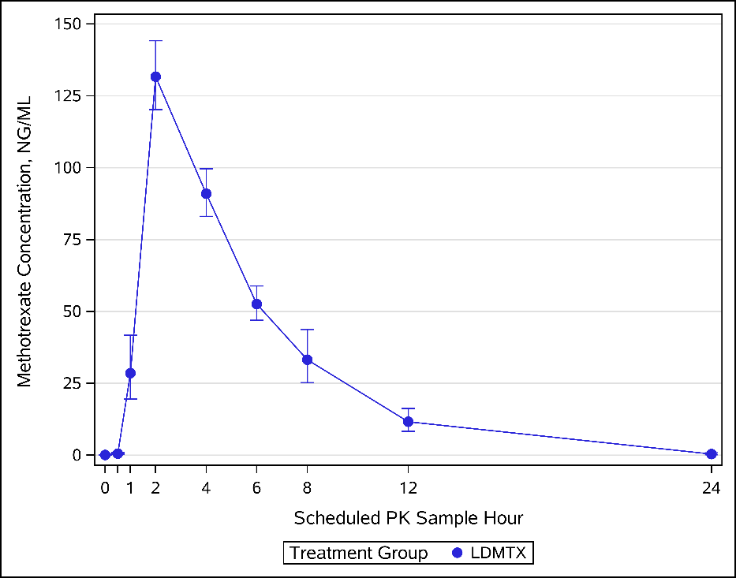

Supplemental Figure 2. Geometric mean plasma concentration-time profile of MTX in participants with and without co-administration of a concomitant protease inhibitor (PI). Error bars indicate standard error.

