Diagnostic accuracy of the INSHI consensus case definition for the diagnosis of paradoxical tuberculosis-IRIS

Cari Stek, Jozefien Buyze, Joris Menten, Charlotte Schutz, Friedrich Thienemann, Lisette Blumenthal, Gary Maartens, Tom Boyles, Robert J. Wilkinson, Graeme Meintjes, and Lutgarde Lynen

Online Supplement

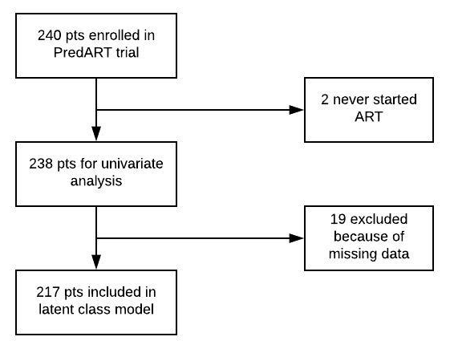

Figure S1 Flow of participants

Table S1 LCA-predicted sensitivity and specificity of variables in alternative latent class models.

 | Model with variables selected based on unadjusted OR > 5.0 or < 0.2 (5-model) |  | Model replacing maximum CRP with baseline urine LAM |  | Model replacing fever with weight loss
Variable | LCA predicted sensitivity | LCA predicted specificity | LCA predicted sensitivity | LCA predicted specificity | LCA predicted sensitivity | LCA predicted specificity
Respiratory symptoms | 0.59 | 0.84 | 0.60 | 0.83 | 0.56 | 0.81
Night sweats | 0.61 | 0.98 | 0.59 | 0.96 | 0.54 | 0.92
INSHI major 1 (new or enlarging lymph nodes) | 0.27 | 0.97 | 0.28 | 0.99 | 0.27 | 0.98
INSHI major 2 (new or worsening CXR abnormalities) | 0.36 | 0.97 | 0.36 | 0.96 | 0.34 | 0.96
INSHI major 4 (new or worsening serositis) | 0.02 | 0.99 | 0.02 | 1.00 | 0.03 | 1.00
Maximum C-reactive protein > 90 mg/l | 0.66 | 0.86 | - | - | 0.71 | 0.92
Maximum heart rate > 120 bpm | - | - | 0.76 | 0.77 | 0.76 | 0.79
Maximum temperature > 37.7 ⁰C | 0.41 | 1.00 | 0.42 | 0.99 | - | -
Nadir CD4 count < 50 cells/μl | - | - | 0.79 | 0.54 | 0.78 | 0.54
Baseline urine LAM (≥ 1) | - | - | 0.76 | 0.67 | - | -
Weight loss | - | - | - | - | 0.58 | 0.89

Table S2 LCA-predicted sensitivity and negative likelihood ratio of different cut-off values of CRP

CRP value (mg/ml) | LCA predicted sensitivity | LCA predicted negative likelihood ratio
> 10 | 0.99 | 0.07
> 20 | 0.97 | 0.09
> 30 | 0.95 | 0.13
> 40 | 0.93 | 0.15
> 50 | 0.92 | 0.13
> 60 | 0.88 | 0.20
> 70 | 0.80 | 0.27
> 80 | 0.77 | 0.28
> 90 | 0.73 | 0.30
> 100 | 0.64 | 0.39

