Supplemental Figure 1 for:

Data Architecture to Support Real-Time Data Analytics for the Population-based HIV Impact Assessments (PHIA)
Melissa Metz; Rebecca Smith; Rick Mitchell; Yen T. Duong; Kristin Brown; Steve Kinchen; Kiwon Lee; Francis M. Ogollah; Tafadzwa Dzinamarira; Vusumuzi Maliwa; Carole Moore; Hetal Patel; Hannah Chung; Helecks Mtengo; Suzue Saito

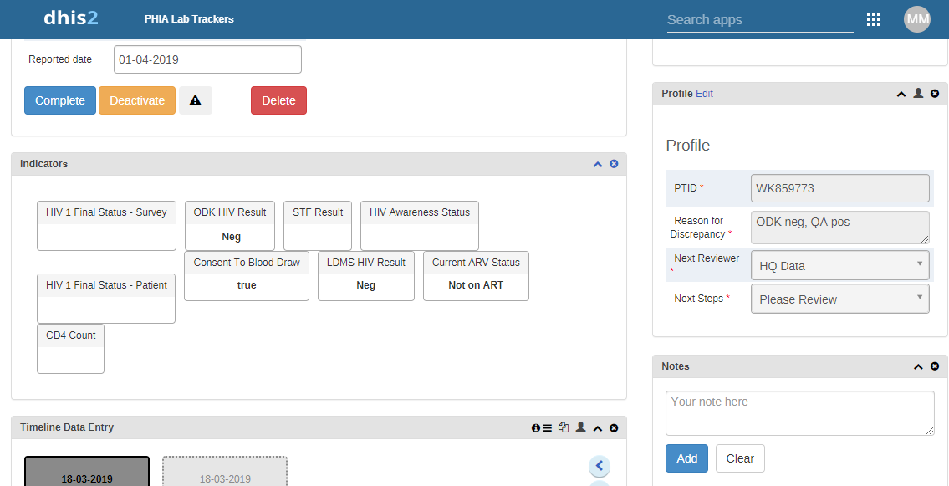
Supplemental Figure 1: Discrepant Case View from Population-Based HIV Impact Assessment Surveys (2015–2020)

The detail page of the discrepant case resolution tracking system. Timeline data include results of particular tests: household rapid tests, quality assurance retesting (sometimes multiple retesting), Geenius confirmatory tests, DNA polymerase chain reaction, and viral load testing. Indicators include the age range of the participant (children aged <18 months undergo different testing), whether the participant reported a previous HIV-positive diagnosis, and results of household testing. The profile includes the PTID, why the case was originally added, and the next reviewer. When cases are resolved, the indicators also include the final HIV status of the participant.

