Supplemental Table. Detailed analysis of all 33 cases. The patients are ordered based on the computer score ranging from -1.13 (atypical UIP) to 1.74 (classic UIP). Coronal and axial views of the lung parenchyma are shown with a window level of -500 HU and a width of 1400 HU.
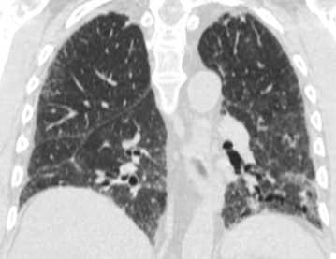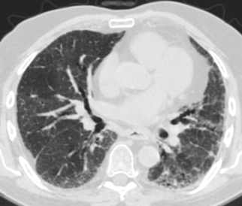  1. Computer score: -1.13 (atypical UIP) ✗  consensus: classic UIP  fellow 1: atypical UIP ✗  fellow 2: atypical UIP ✗ | 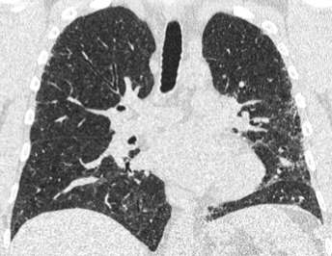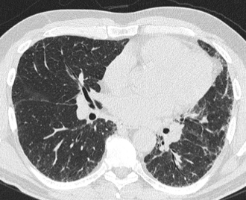  2. Computer score: -1.03 (atypical UIP) ✓  consensus: atypical UIP  fellow 1: atypical UIP ✓  fellow 2: atypical UIP ✓
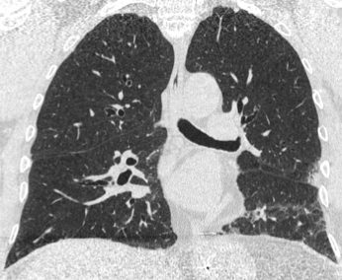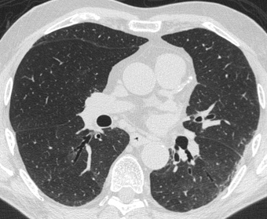  3. Computer score: -0.97 (atypical UIP) ✓  consensus: atypical UIP  fellow 1: atypical UIP ✓  fellow 2: atypical UIP ✓ | 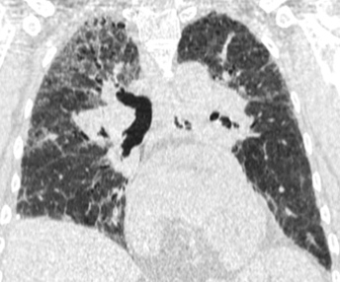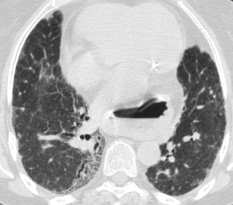  4. Computer score: -0.89 (atypical UIP) ✓  consensus: atypical UIP  fellow 1: atypical UIP ✓  fellow 2: atypical UIP ✓
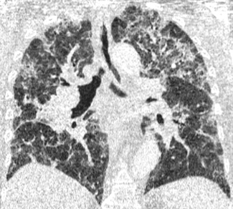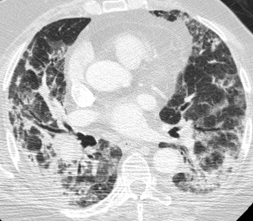  5. Computer score: -0.88 (atypical UIP) ✓  consensus: atypical UIP  fellow 1: atypical UIP ✓  fellow 2: atypical UIP ✓ | 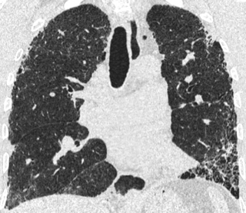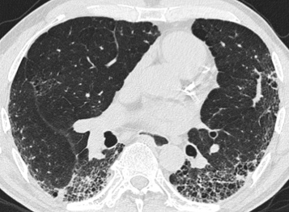  6. Computer score: -0.82 (atypical UIP) ✗  consensus: classic UIP  fellow 1: classic UIP ✓  fellow 2: classic UIP ✓
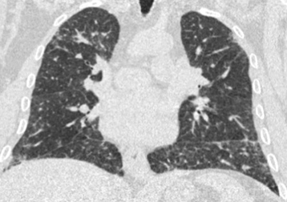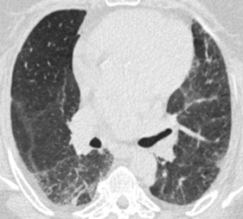  7. Computer score: -0.7 (atypical UIP) ✓  consensus: atypical UIP  fellow 1: atypical UIP ✓  fellow 2: atypical UIP ✓ | 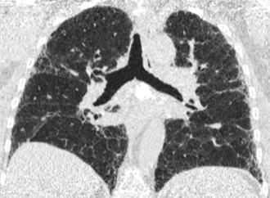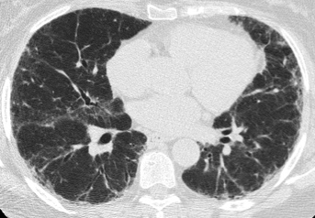  8. Computer score: -0.64 (atypical UIP) ✓  consensus: atypical UIP  fellow 1: atypical UIP ✓  fellow 2: atypical UIP ✓
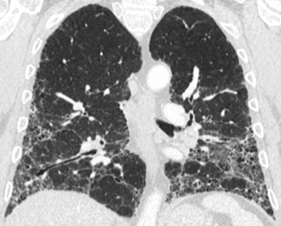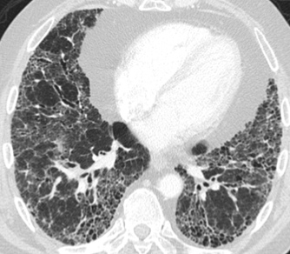  9. Computer score: -0.63 (atypical UIP) ✓  consensus: atypical UIP  fellow 1: classic UIP ✗  fellow 2: classic UIP ✗ | 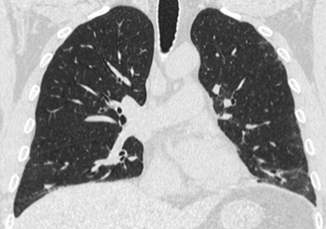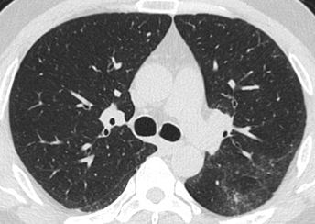  10. Computer score: -0.56 (atypical UIP) ✓  consensus: atypical UIP  fellow 1: atypical UIP ✓  fellow 2: atypical UIP ✓
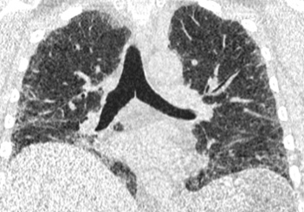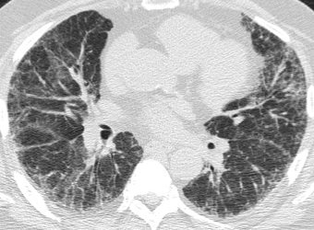  11. Computer score: -0.41 (atypical UIP) ✓  consensus: atypical UIP  fellow 1: atypical UIP ✓  fellow 2: atypical UIP ✓ | 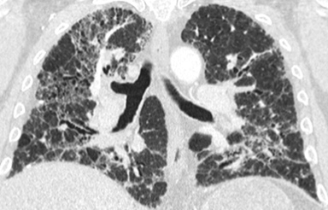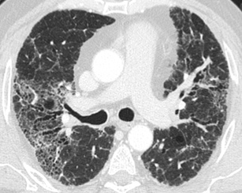  12. Computer score: -0.39 (atypical UIP) ✓  consensus: atypical UIP  fellow 1: atypical UIP ✓  fellow 2: atypical UIP ✓
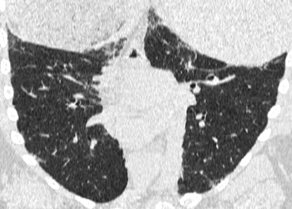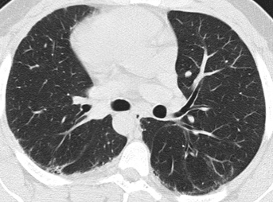  13. Computer score: -0.34 (atypical UIP) ✗  consensus: classic UIP  fellow 1: atypical UIP ✗  fellow 2: atypical UIP ✗ | 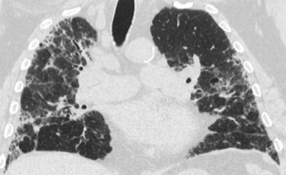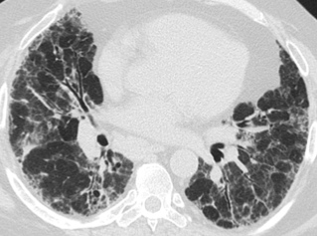  14. Computer score: -0.28 (atypical UIP) ✓  consensus: atypical UIP  fellow 1: atypical UIP ✓  fellow 2: atypical UIP ✓
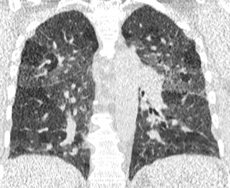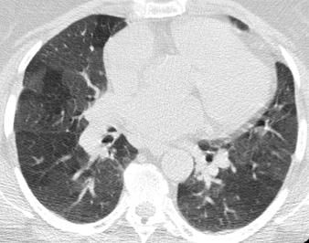  15. Computer score: -0.23 (atypical UIP) ✓  consensus: atypical UIP  fellow 1: atypical UIP ✓  fellow 2: atypical UIP ✓ | 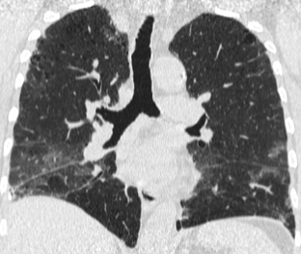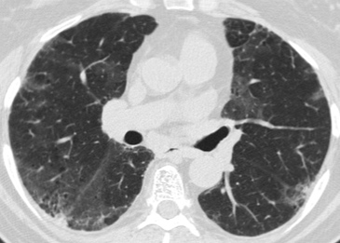  16. Computer score: -0.21 (atypical UIP) ✓  consensus: atypical UIP  fellow 1: atypical UIP ✓  fellow 2: atypical UIP ✓
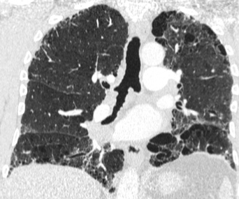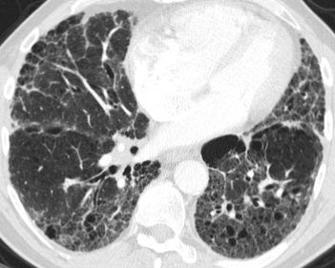  17. Computer score: -0.09 (atypical UIP) ✓  consensus: atypical UIP  fellow 1: classic UIP ✗  fellow 2: classic UIP ✗ | 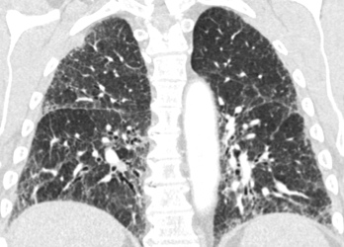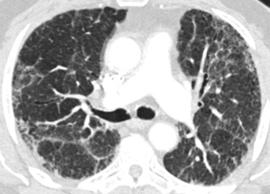  18. Computer score: -0.08 (atypical UIP) ✓  consensus: atypical UIP  fellow 1: atypical UIP ✓  fellow 2: atypical UIP ✓
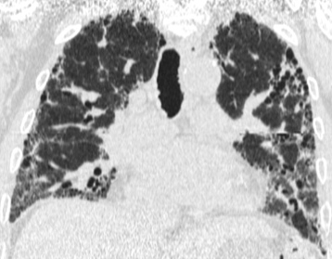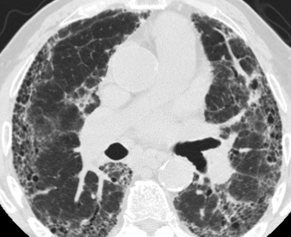  19. Computer score: 0.01 (classic UIP) ✓  consensus: classic UIP  fellow 1: classic UIP ✓  fellow 2: classic UIP ✓ | 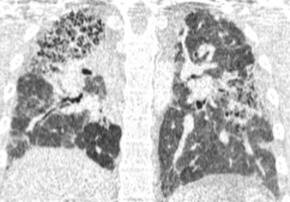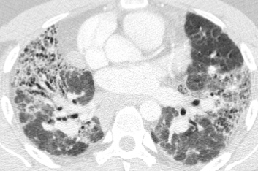  20. Computer score: 0.01 (classic UIP) ✗  consensus: atypical UIP  fellow 1: atypical UIP ✓  fellow 2: atypical UIP ✓
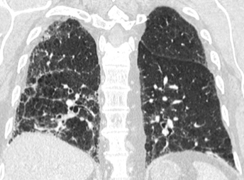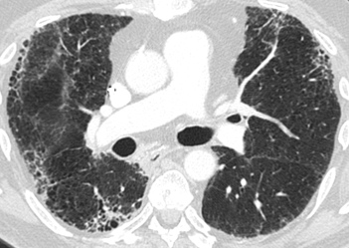  21. Computer score: 0.05 (classic UIP) ✓  consensus: classic UIP  fellow 1: classic UIP ✓  fellow 2: classic UIP ✓ | 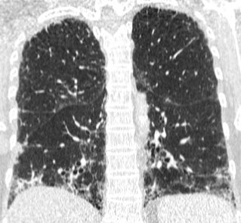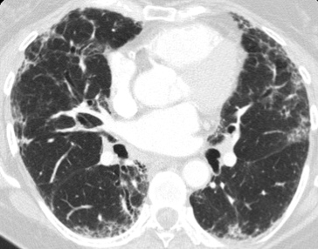  22. Computer score: 0.07 (classic UIP) ✓  consensus: classic UIP  fellow 1: classic UIP ✓  fellow 2: classic UIP ✓
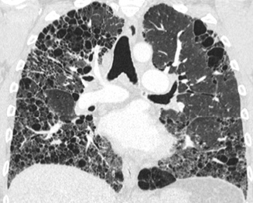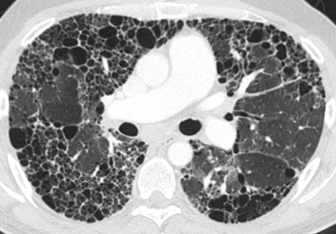  23. Computer score: 0.1 (classic UIP) ✓  consensus: classic UIP  fellow 1: classic UIP ✓  fellow 2: classic UIP ✓ | 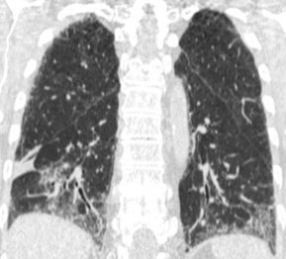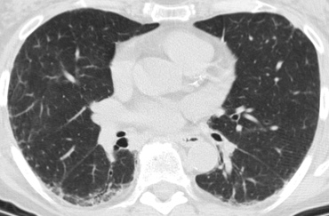  24. Computer score: 0.1 (classic UIP) ✗  consensus: atypical UIP  fellow 1: atypical UIP ✓  fellow 2: atypical UIP ✓
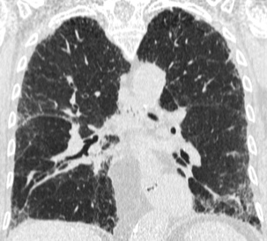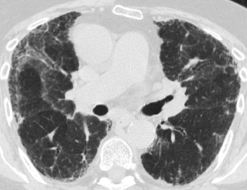  25. Computer score: 0.11 (classic UIP) ✓  consensus: classic UIP  fellow 1: atypical UIP ✗  fellow 2: atypical UIP ✗ | 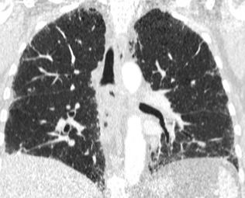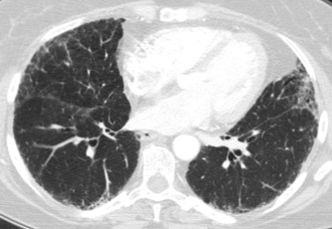  26. Computer score: 0.19 (classic UIP) ✓  consensus: classic UIP  fellow 1: atypical UIP ✗  fellow 2: atypical UIP ✗
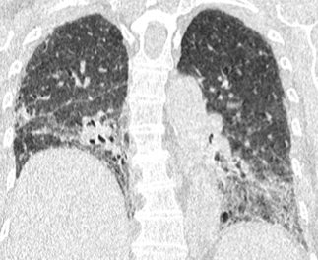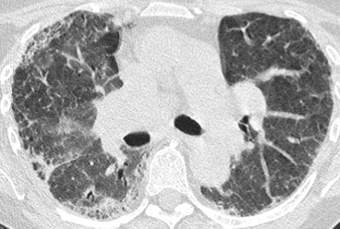  27. Computer score: 0.24 (classic UIP) ✗  consensus: atypical UIP  fellow 1: atypical UIP ✓  fellow 2: classic UIP ✗ | 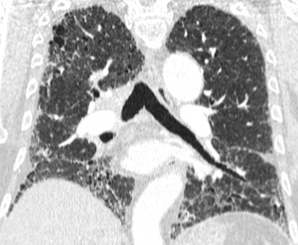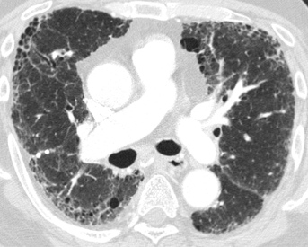  28. Computer score: 0.56 (classic UIP) ✓  consensus: classic UIP  fellow 1: classic UIP ✓  fellow 2: classic UIP ✓
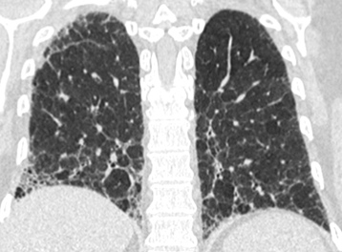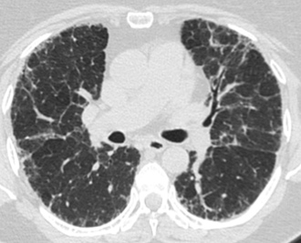  29. Computer score: 0.59 (classic UIP) ✓  consensus: classic UIP  fellow 1: classic UIP ✓  fellow 2: classic UIP ✓ | 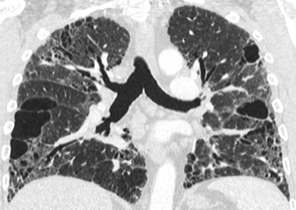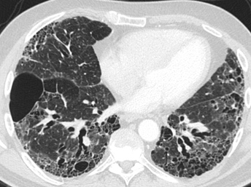  30. Computer score: 0.6 (classic UIP) ✓  consensus: classic UIP  fellow 1: classic UIP ✓  fellow 2: classic UIP ✓
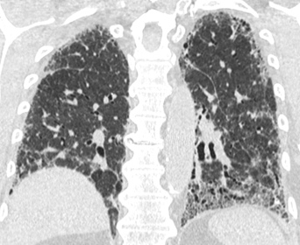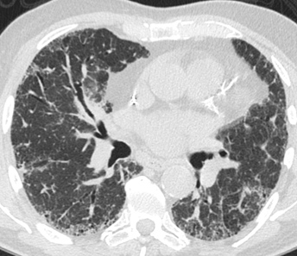  31. Computer score: 0.78 (classic UIP) ✓  consensus: classic UIP  fellow 1: classic UIP ✓  fellow 2: classic UIP ✓ | 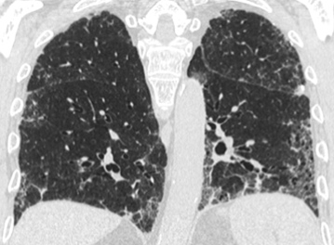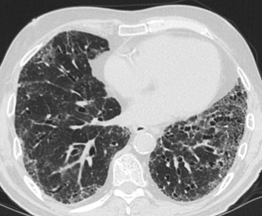  32. Computer score: 1.17 (classic UIP) ✓  consensus: classic UIP  fellow 1: classic UIP ✓  fellow 2: classic UIP ✓
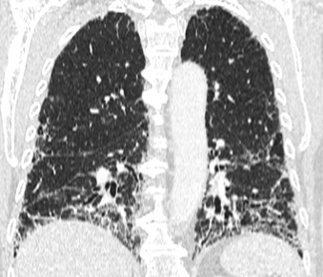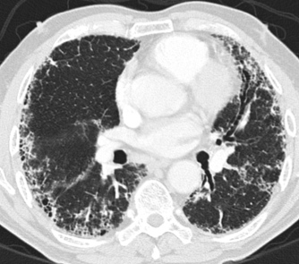
33. Computer score: 1.74 (classic UIP) ✓
consensus: classic UIP
fellow 1: classic UIP ✓
fellow 2: classic UIP ✓

