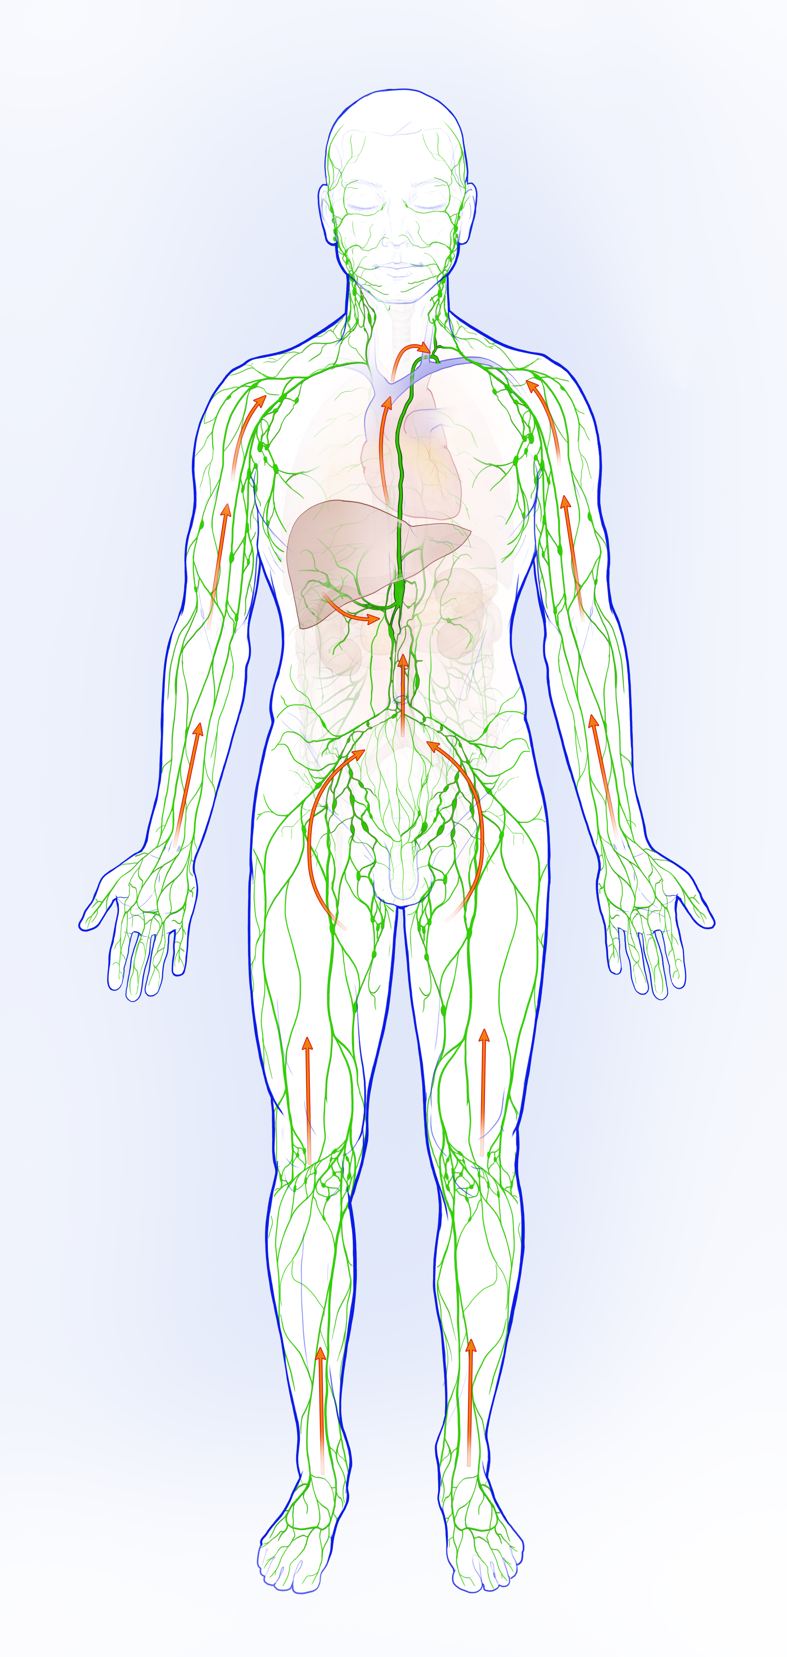
Supplementary Figure 1. Schematic illustration of the human lymphatic system. Arrows indicate flow direction of lymph under normal conditions.

