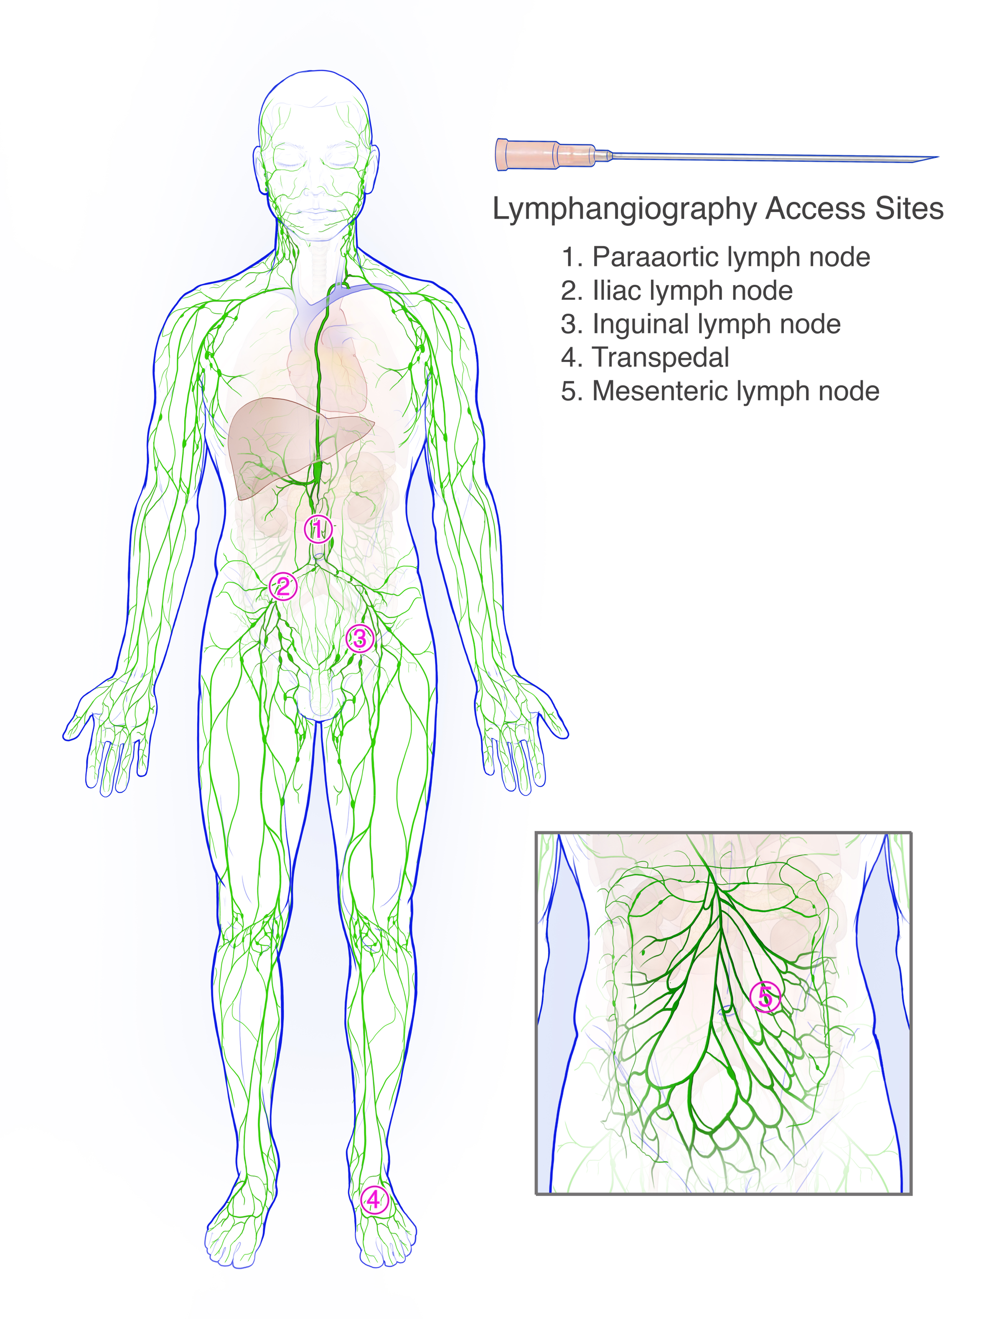

Supplementary Figure 2. Schematic illustration of the lymphatic system showing typical access sites for transpedal and transnodal lymphangiography.

