Supplemental Digital Content

Table 1
Gd extraction yield values for the cortex samples from the untreated animals spiked with GBCA standards.
Type of protocol | Sample type | Brain zone | Extraction efficiency (%)
 |  |  | Spiked blanks (untreated animals)
 |  |  | Gadoterate | Gadobenate | Gadodiamide
Water extraction | W1 | cortex | 72±0 | 65±6 | 64±3
Urea extraction | W1 | cortex | 96±9 | 85±8 | 85±9

Fig. 1
Control of the stability of the intact GBCA form during sample processing and the analysis. SEC-ICP-MS chromatograms of water and urea-soluble fractions of the samples from untreated animals spiked with GBCAs standards.
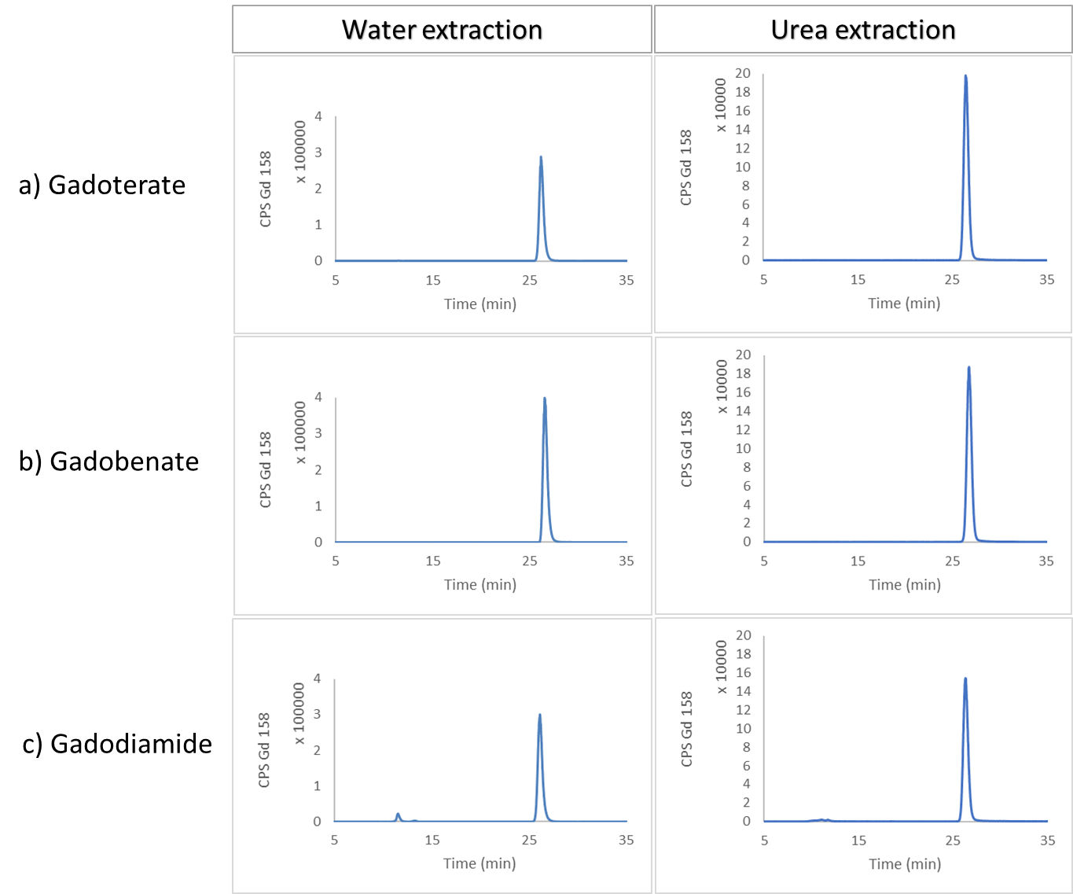

Fig. 2
Calibration of Superdex 75 column.
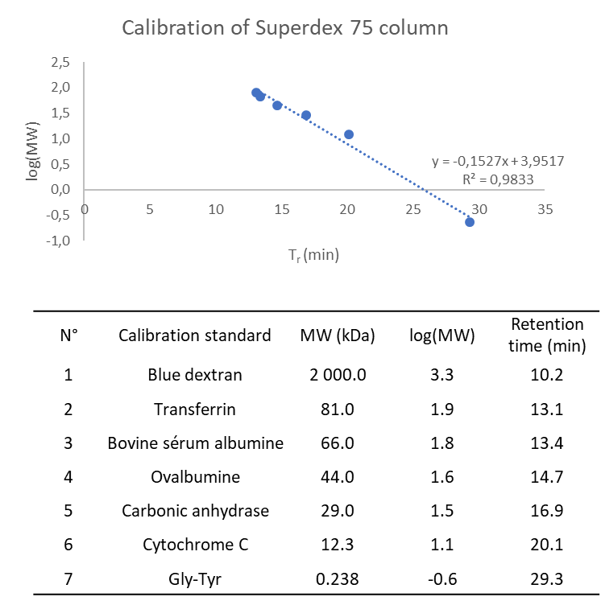

Fig. 3
Calibration of Superdex 200 column.
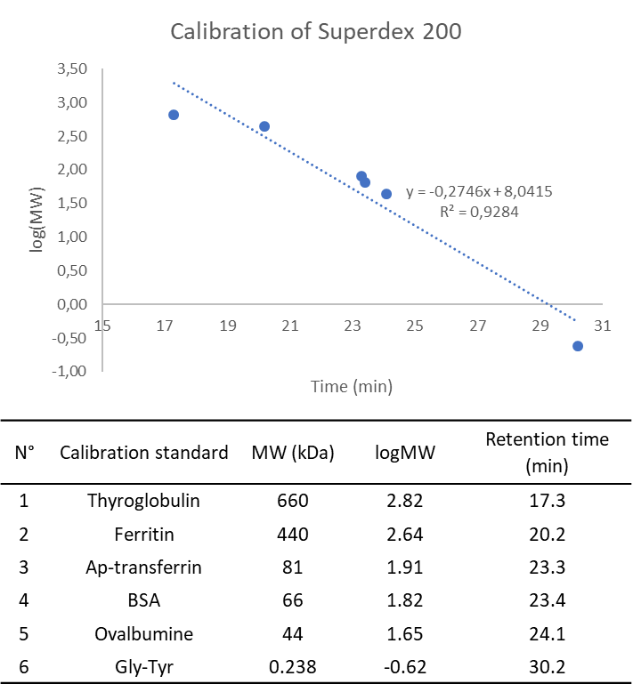

Fig. 4
Column Superdex 200 recovery obtained for water-soluble and urea-soluble fractions of real samples of cortex and cerebellum obtained using sequential extraction. Data points for each group are n=2.
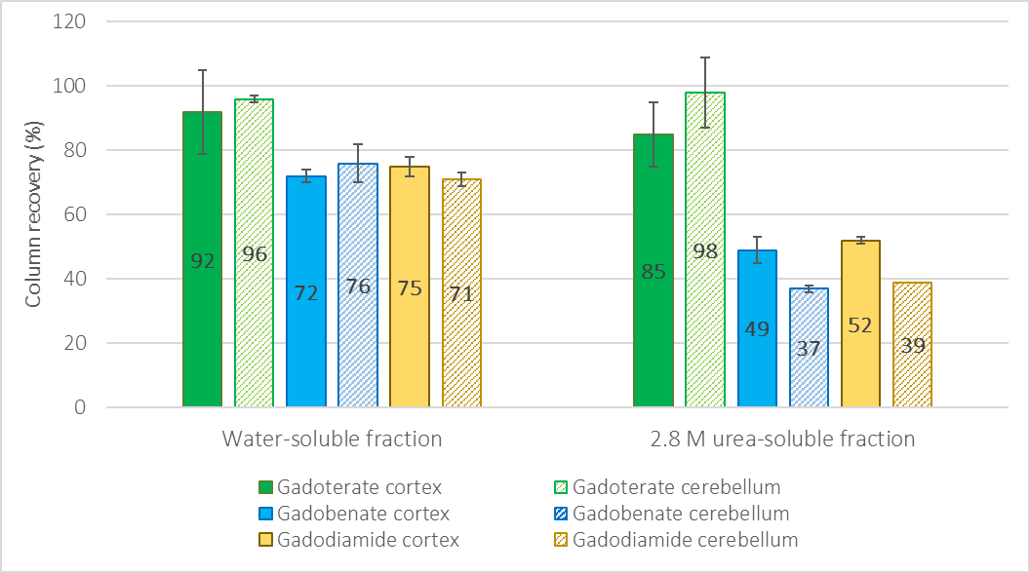

Fig. 5
SEC-ICP-MS chromatogram of ¹⁵⁸Gd and ⁵⁴Fe of urea-soluble fraction of the cerebellum after treatment with a) gadoterate, b) gadobenate and c) gadodiamide.
