Online supplementary materials

Plasma Neutrophil Elastase and Elafin as Prognostic Biomarker for Acute Respiratory Distress Syndrome: a multicenter survival and longitudinal prospective observation study

Zhaozhong Zhu², ScD, TiehuaWang¹, MD, Zhuang Liu³, MD, Liang Yi⁴, MD, Zhixu Yang⁴, MD, Weishuai Bian⁵, MD, Wei Chen⁵, MD, Shupeng Wang⁶, MD, Gang Li⁶, MD, Ang Li³, MD, Greg S. Martin⁷, MD/MS, Xi Zhu¹, MD

Supplemental Methods and Results

Clinical Trial Registration: NCT02944279
Clinical data collection
Data were retrieved from medical records including age, gender, race, height, weight, history of tobacco and alcohol use, medical history of ARDS, diabetes, and liver disease. Physical examination, vital signs, and laboratory test results in the first 24 hours after admission to ICU were collected to calculate the acute physiological and chronic health evaluation (APACHE II) score for severity of illness.
Diagnosis of ARDS
Two pulmonary and critical care physicians diagnosed ARDS according to the Berlin standard. Any disagreements between reviewers were resolved by consulting a third independent senior physician.

Table S1. Association of plasma biomarker levels with ARDS mortality
Biomarker | 28-day mortality |  | 60-day mortality
 | Hazard ratio | P | Hazard ratio | P
HNE day 1 | 1.76 | p<0.001 | 1.76 | 0.002
HNE day 3 | 1.58 | 0.08 | 1.58 | 0.06
HNE day 7 | 1.70 | 0.006 | 1.70 | p<0.001
PI3 day 1 | 0.49 | 0.005 | 0.50 | 0.003
PI3 day 3 | 0.43 | p<0.001 | 0.43 | p<0.001
PI3 day 7 | 0.64 | 0.12 | 0.70 | 0.18

Cox regression model adjusted age, gender, APACHE II, PI3 concentration level (ng/ml) was converted to natural log scale for hazard ratio calculation to approximate a normal distribution.

Table S2. Comparison of models for predicting ARDS mortality using single conventional clinical criteria, single biomarkers, combined conventional clinical criteria with biomarkers
Models | 28-day mortality | 60-day mortality
 | AUC (95% CI) | AUC (95% CI)
APACHE II | 0.60 (0.52-0.69) | 0.59 (0.50-0.68)
Berlin categories | 0.61 (0.53-0.68) | 0.58 (0.50-0.65)
Pao2/Fio2 | 0.66 (0.57-0.74) | 0.62 (0.53-0.71)
HNE | 0.59 (0.50-0.68) | 0.58 (0.49-0.68)
PI3 | 0.67 (0.59-0.75) | 0.66 (0.58-0.74)
HNE+PI3 | 0.76 (0.69-0.83) | 0.74 (0.67-0.82)
HNE+PI3+APACHE II | 0.80 (0.73-0.87) | 0.78 (0.71-0.85)
HNE+PI3+APACHE II+Berlin | 0.81 (0.74-0.88) | 0.79 (0.71-0.86)

Abbreviations: AUC, area under the curve; CI, confidence interval; Berlin stands for Berlin (PaO₂/FIO₂) categories, day 1 levels HNE and PI3 were used to calculate discriminative prognostic performance.

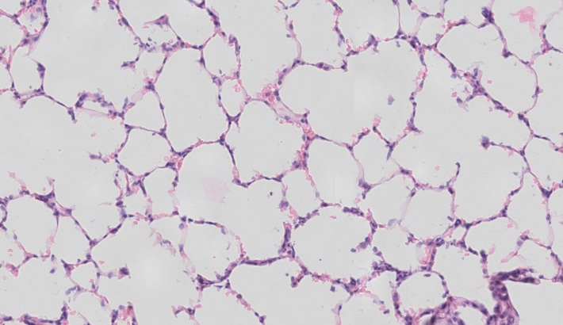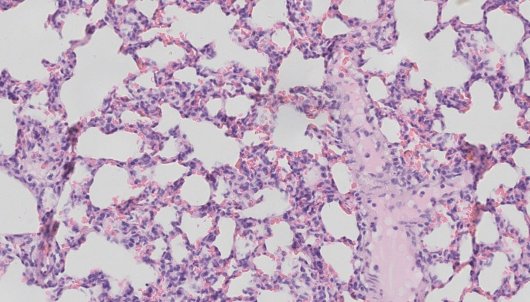
A B
Figure S1. Normal lung (A) vs ARDS lung (B) histology H&E staining. Normal lung tissue histology shows a “clean” space between lung tissues, whereas neutrophils accumulate and diffuse at ARDS lung at the ARDS onset.

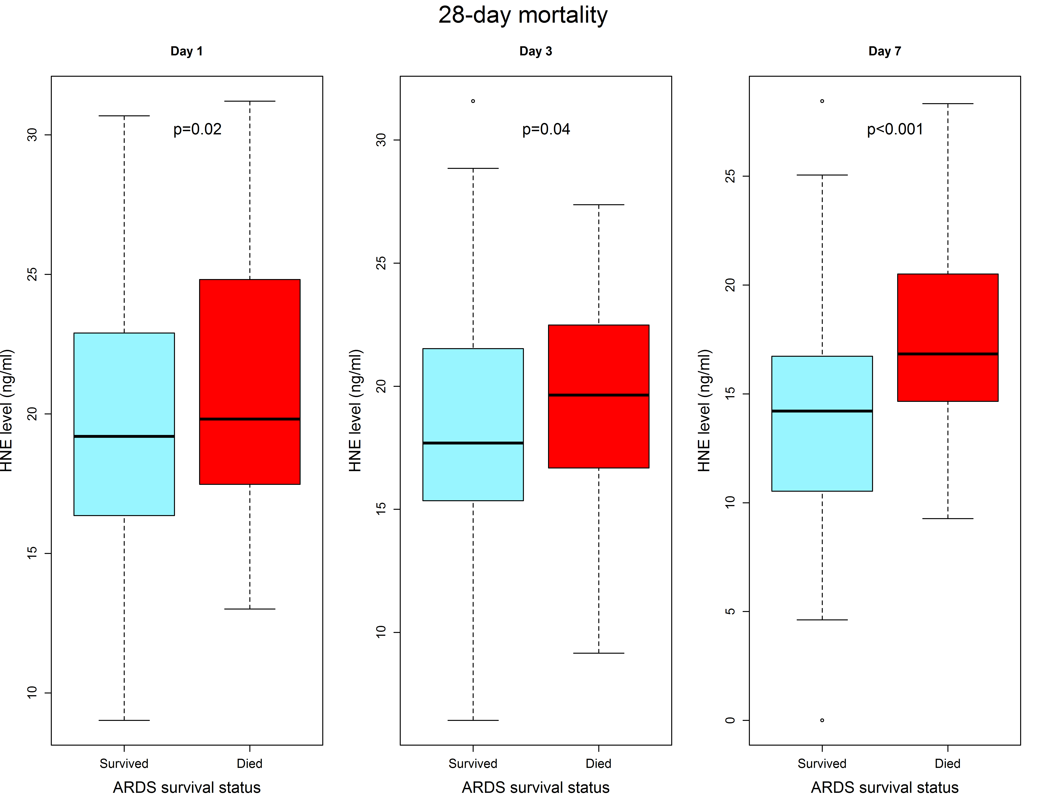
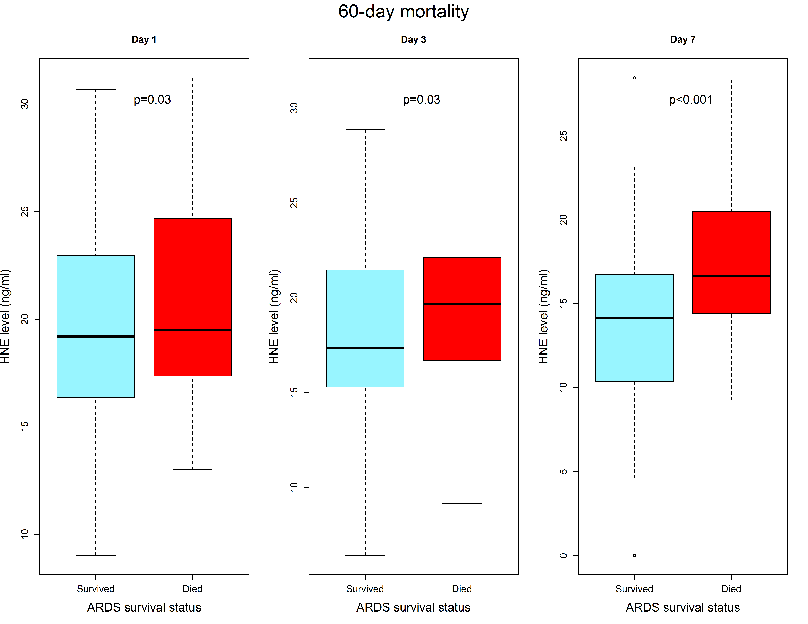
Figure S2. Human neutrophil elastase (HNE) levels were significantly higher in ARDS non-survivors than survivors.
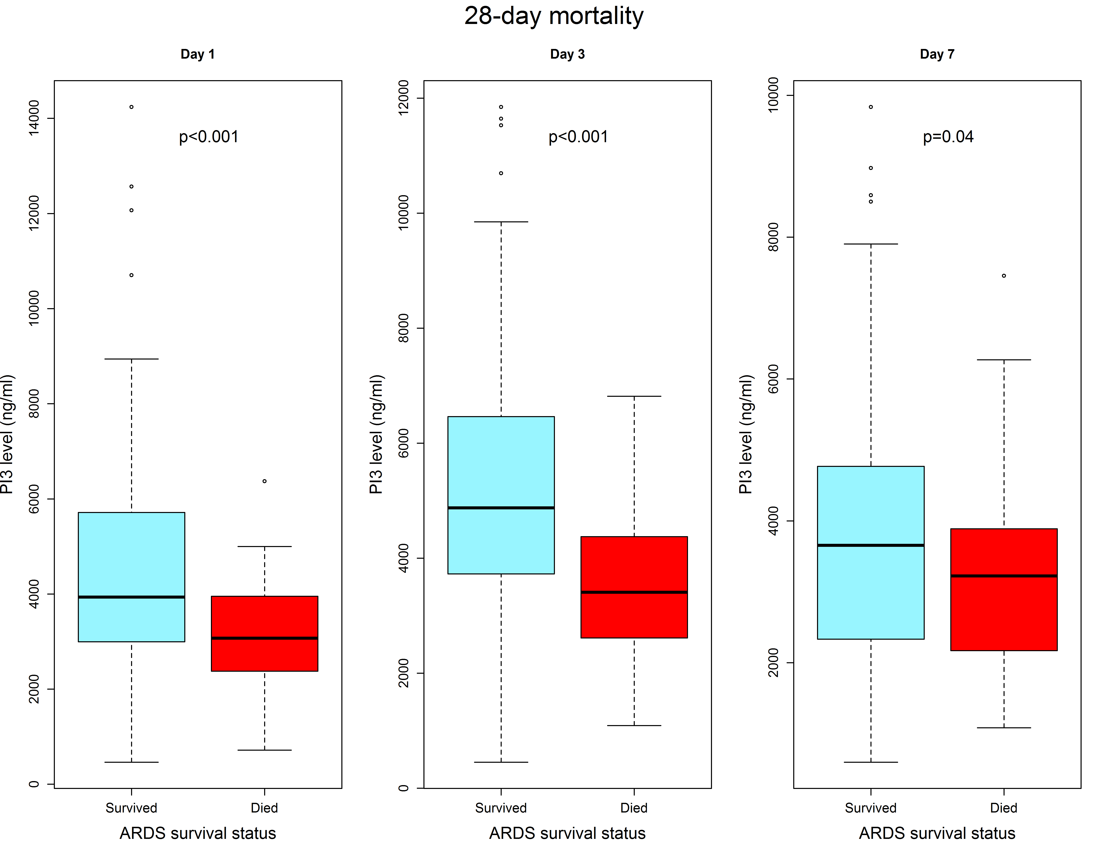
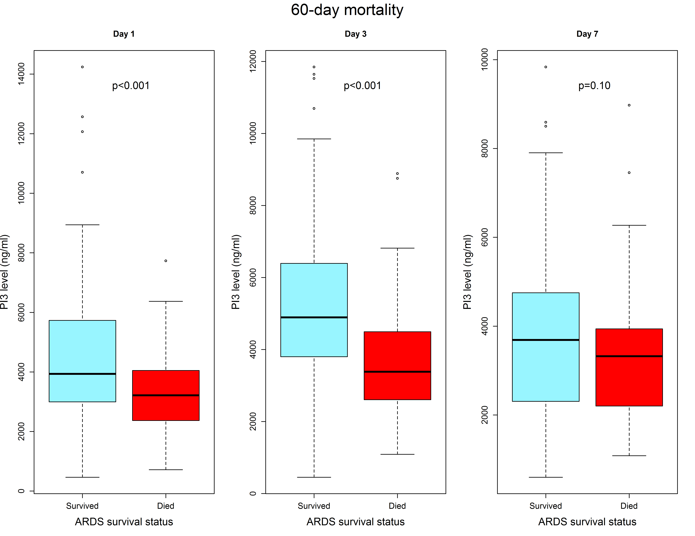
Figure S3. Elafin (PI3, peptidase inhibitor 3) levels were significantly lower in ARDS non-survivors than survivors.
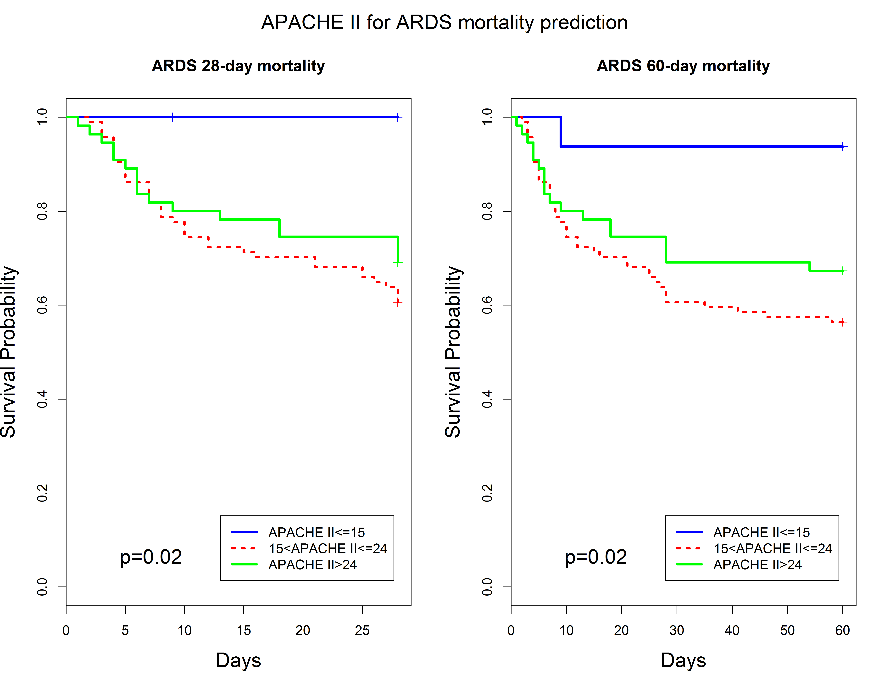
Figure S4. APACHE II score performance for ARDS mortality prediction in this cohort. We used Kaplan-Meier curves to measure the ARDS patients’ time-to-death among three groups of APACHE II score: 1. APACHE II≤15; 2. 15<APACHE II≤24, PI3<median; 3. APACHE II>24. And we found APACHE II categories can predict ARDS 28-day and 60-day mortalities (P=0.02 for both, log-rank test Mantel-Cox), but not as well as HNE and PI3 combination.

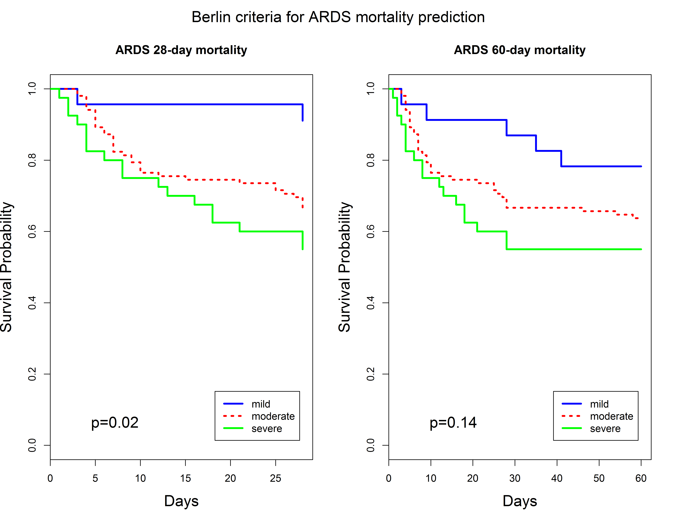
Figure S5. Berlin criteria performance for ARDS mortality prediction in this cohort. We used Kaplan-Meier curves to measure the ARDS patients’ time-to-death among three groups of Berlin category: 1. Mild; 2. Moderate; 3. Severe. And we found Berlin categories can predict ARDS 28-day (P=0.02), not on 60-day mortalities (P= 0.14, log-rank test Mantel-Cox), but not as well as HNE and PI3 combination.

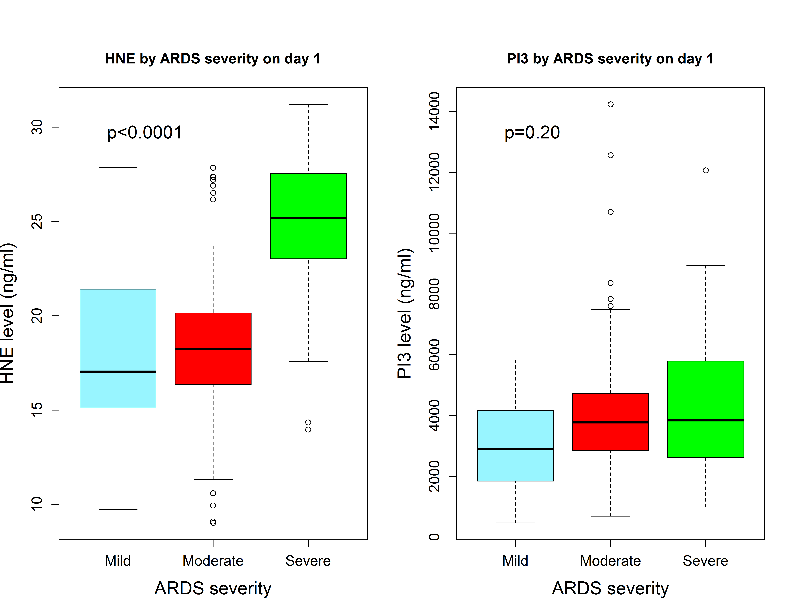
Figure S6. Relationship between plasma biomarkers and ARDS severity (Berlin PaO₂/FIO₂ categories, PaO₂/FIO₂>200 as mild, 100< PaO₂/FIO₂≤200 as moderate, PaO₂/FIO₂≤100 as severe). On day 1, plasma HNE (p<0.0001), but not PI3 (p=0.20), correlated with worsening Berlin categories.

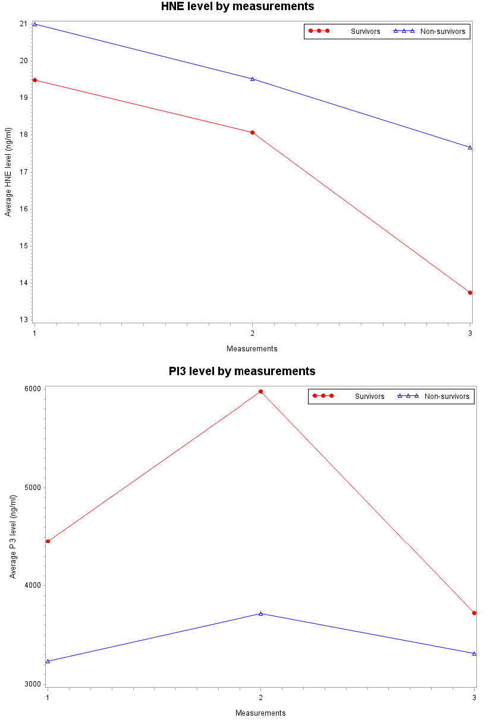
Figure S7. Plasma HNE and PI3 concentration levels in day 1, day 3 and day 7. HNE levels were constantly higher in ARDS non-survivors than survivors from day 1 to day 7. PI3 levels were constantly lower in ARDS non-survivors than survivors from day 1 to day 7. Due to consumption of HNE and PI3 during the disease progression, the concentration of HNE decreased over time, a delayed effect was observed in PI3 in response to HNE.

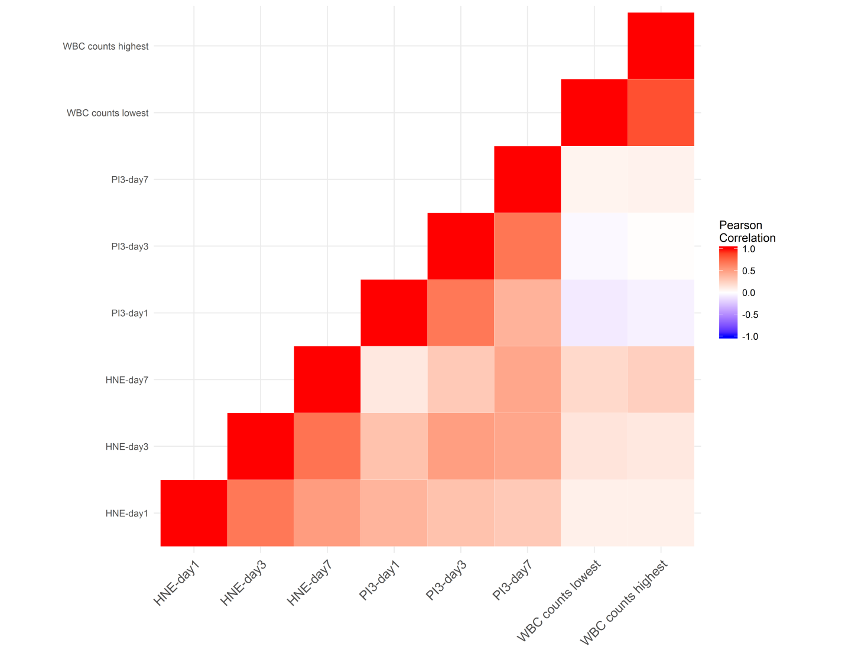
Figure S8. Heatmap of correlation among plasma HNE and PI3 concentration levels in day 1, day 3 and day 7 with the lowest and highest white blood cell (WBC) counts. HNE levels were positively correlated with WBC counts, whereas PI3 levels were negatively correlated with WBC counts

