**ON THE ROLE OF ILLNESS DURATION AND NUTRIENT RESTRICTION IN CHOLESTATIC ALTERATIONS THAT OCCUR DURING CRITICAL ILLNESS**

**Supplemental file**

Marc Jenniskens1, Fabian Güiza1, Marlies Oorts2, Sarah Vander Perre1, Sarah Derde1, Thomas Dufour1, Steven Thiessen1, Pieter Annaert2, Greet Van den Berghe1, Lies Langouche1

1 Clinical Division and Laboratory of Intensive Care Medicine, Department of Cellular and Molecular Medicine, KU Leuven, Belgium.

2 Drug Delivery and Disposition, Department of Pharmaceutical and Pharmacological Sciences, KU Leuven, Belgium.

**Corresponding author:** Lies Langouche, PhD, Clinical Division and Laboratory of Intensive Care Medicine, KU Leuven, Herestraat 49, B-3000 Leuven, Belgium. Phone: 32-16330524; Fax: 32-16344015; E-mail: [lies.langouche@kuleuven.be](mailto:greet.vandenberghe@med.kuleuven.be)

**Disclosure:** The authors have no conflicts of interest to disclose.

**Funding:** Methusalem Program of the Flemish Government (GVdB and LL) via the KU Leuven University (METH/08/07); by an ERC Advanced grant (AdvG-2012-321670) to GVdB from the Ideas Program of the European Union 7th framework program.

**Running head:** Cholestatic alterations in critical illness

**Supplemental file**

**Supplemental data 1: Material and Methods**

**Supplementary table 1: Mobile phase gradient of bile acid analysis**

**Supplementary table 2: Parent-, daughter m/z ratios and collision energies of BA and the internal standard**

**Supplementary table 3: List of used genes**

**Supplementary table 4: Model performance automated nuclear classifier FXR and RXR**

**Supplementary table 5: Serum BA profile measured using LCMS**

**Supplementary figure 1: Patient selection human data set**

**Supplementary figure 2: Caloric intake human data set**

**Supplementary figure 3: Gene expression of synthesis enzymes and nuclear receptors**

**Supplementary figure 4: Relative gene expression of hepatic TNFα and IL1β**

**Supplementary figure 5: Gene expression of additional hepatic transporters**

**Supplementary figure 6: Change in body weight and dry and wet liver weight of critically ill and healthy animals**

**Supplementary figure 7: Histological features of animals in critical illness**

**Supplementary figure 8: Gene expression of enzymes involved in liver growth and regeneration**

**Supplemental references**

**Supplemental Material and methods**

**Circulating bile acid quantification using mass spectrometry**

Samples were diluted with two volumes of ice-cold methanol (MeOH) (4°C), containing 200 μM d4-CA as internal standard, and centrifuged at 20,816 g for 15 min at 4°C. Then, samples were evaporated until dryness using a rotary vacuum evaporator (Martin Christ Gefriertrocknungsanlagen GmbH, Osterode am Harz, Germany) and reconstituted in a mixture of 50:50 MeOH:ammonium acetate buffer with acetic acid (5 mM; adjusted to pH 3.5). Finally, samples were centrifuged a second time at 20,816 g for 15 min at 4°C and stored at -20 °C until the day of analysis by LC–MS/MS.

BA analysis was performed on a TSQ Quantum Access™ triple quadrupole mass spectrometer, equipped with an electrospray ionization source (ESI) and coupled with Accela™ U-HPLC system (Thermo Fisher, Breda, The Netherlands). Data acquisition and peak integration were performed with the XcaliburR 2.0.7 and LCquanR 2.5.6 Software Packages, respectively. A Kinetex XB-C18 column (2.6 µm, 100 Å, 50 x 3 mm2) with an in-line KrudKatcher ultra HPLC filter (Phenomenex, Utrecht, The Netherlands) was used for optimal separation. The total run time was 12 min and the injection volume amounted to 25 µL (full loop mode). The column oven and sample tray temperatures were set at 30°C and 15°C, respectively. The flow rate was 450 µL/min and BAs were eluted using a gradient (Sup. Table 1). Analysis was performed using negative ESI mode with following parameters: capillary temperature 275°C, vaporizer temperature 300°C, sheath gas (N2) pressure 40 (arbitrary units), auxiliary gas (N2) pressure 45 (arbitrary units), ion sweep pressure 20 (arbitrary units), spray voltage 3500 V, and collision gas (Ar) 1.5 mTorr. Parent and daughter m/z ratios together with collision energies are shown in Sup. Table 2. Quality control (QC) concentrations were 50, 500 and 2000 nM. Intra- and interday precision of these QC samples was below 15 % for the high and middle high concentration and below 20 % for the low concentration. The calibration curves were linear in a range between 9.8 and 5000 nM.

Measured bile acid included ursodeoxycholic acid (UCDA), glycoursodeoxycholic acid (g-UCDA), tauroursodeoxycholic (t-UCDA), cholic acid (CA), glycocholic acid (g-CA), taurocholic acid (t-CA), chenodeoxycholic acid (CDCA), glycochenodeoxycholic acid (g-CDCA), taurochenodeoxycholic (t-CDCA), deoxycholic acid (DCA), glycodeoxycholic acid (g-DCA), taurodeoxycholic acid (t-DCA) and lithocholic acid (LCA)

**Immunoblot analysis**

For protein analyses, snap frozen liver tissue was homogenized using ceramic beads (Bertin, Montigny le Bretonneux, France) in cell lysis buffer containing phosphatase inhibitors. Protein content was measured using the Coomassie Protein Assay Reagent (Thermo Fisher, Aalst, Belgium). Equal amounts of protein were separated by electrophoresis on 4-20% tris-glycine polyacrylamide gels and transferred to nitrocellulose membranes. Membranes were blocked with Tris buffered saline containing 1% Tween 20%, and 5% Bovine Serum Albumin and incubated with primary antibody overnight at 4°C CYP7A1 (Santa Cruz biotechnologies, Dallas, USA) and CYP27A1 (Thermo Fisher, Aalst, Belgium) and subsequently with HRP linked secondary antibodies (Dako, Glostrup, Denmark) for 30 min. Immunoblots were developed using enhanced chemiluminescence technology (PerkinElmer, Vilvoorde, Belgium) and analyzed using the Syngene G-Box chemi XX6 and manufacturer’s software (Syngene, Cambridge, United Kingdom).

**Quantifying nuclear size using a machine learning classifier**

In brief, a circular mask was used to eliminate the periphery of the image from further analyses, which is more susceptible to lens artifacts. Second, Otsu thresholding was performed on the hue, saturation and value channels to select the pixels likely to be part of the nuclei (1). Third, morphological operations were performed on the selected pixels to generate segments. Fourth, only segments of sufficient size and solidity were kept. Henceforth these segments were considered the automatically identified image nuclei. The size of each nucleus was computed as the area of the corresponding segment, which is equivalent to the number of pixels in the segment.

**Quantifying nuclear FXR and RXR staining using a machine learning classifier**

To develop the classifier, automatically identified nuclei in a set of images were manually labeled by a blinded researcher as either stained or not stained. A total of 15 descriptive features were generated for each nucleus. These comprised the mean, standard deviation, median, 25th and 75th percentiles of the hue, saturation and value of all the pixels belonging to each segment. These features and the manual labels were used to train a Logistic Regression classifier and a Gaussian Process classifier (2, 3), the final classification for each nucleus was the average of these two models. To verify portability and robustness, the developed models were externally validated in an independent set of previously unseen images. Performance of the used models are shown in Sup. Table 4.

Supplementary table 1: Mobile phase gradient of bile acid analysis. The buffer consisted of 5 mM ammonium acetate (pH adjusted to 3.5 with acetic acid).

|  |  |  |  |  |
| --- | --- | --- | --- | --- |
| **Time** | **ACN (%)** | **MeOH (%)** | **H2O (%)** | **Buffer (%)** |
| **0** | 0 | 5 | 91 | 4 |
| **0.5** | 0 | 5 | 91 | 4 |
| **1.0** | 13 | 48 | 35 | 4 |
| **5.0** | 13 | 48 | 35 | 4 |
| **7.0** | 19 | 48 | 29 | 4 |
| **8.9** | 19 | 48 | 29 | 4 |
| **9.0** | 33 | 48 | 15 | 4 |
| **10.4** | 33 | 48 | 15 | 4 |
| **10.5** | 0 | 5 | 91 | 4 |
| **12.0** | 0 | 5 | 91 | 4 |

Supplementary table 2: Parent-, daughter m/z ratios and collision energies of the bile acids and internal standard d4-CA.

|  |  |  |  |
| --- | --- | --- | --- |
| **Bile acid** | **Parent m/z** | **Daughter m/z** | **Collision energy** |
| **TUDCA – TCDCA - TDCA** | 498.258 | 124.05 | 52 |
| **GUDCA – GCDCA – GDCA** | 448.275 | 74.250 | 43 |
| **TCA** | 514.257 | 124.05 | 52 |
| **GCA** | 464.269 | 74.250 | 41 |
| **UDCA – CDCA - DCA** | 391.256 | - | 0 |
| **CA** | 407.252 | 343.252 | 37 |
| **LCA** | 375.228 | - | 0 |
| **D4-CA (IS)** | 411.286 | 347.153 | 37 |

**Supplementary table 3:** Used genes

|  |  |  |
| --- | --- | --- |
| **Gene symbol (mus musculus)** | **Alternative name** | [**Product name (Applied biosystems)**](https://bioinfo.appliedbiosystems.com/genome-database/gene-expression.html) |
| Nr1h4 | FXR | Mm00436425_m1 |
| Nr2b1 | RXRα | Mm00441185_m1 |
| Nr0b2 | SHP | Mm00442278_m1 |
| Cyp7a1 | Cyp7a1 | Mm00484150_m1 |
| Cyp27a1 | Cyp27a1 | Mm00470430_m1 |
| Cyp8b1 | Cyp8b1 | Mm00501637_s1 |
| Slc10a1 | NTCP | Mm00441421_m1 |
| Slo1a1 | Oatp1a1 | Mm01267415_m1 |
| Slco1b2 | Oatp1b2 | Mm00451510_m1 |
| Abcb11 | BSEP | Mm00445168_m1 |
| Abcc2 | MRP2 | Mm00496899_m1 |
| Abcc3 | MRP3 | Mm00551550_m1 |
| Abcc4 | MRP4 | Mm01226381_m1 |
| Slc51b | OSTb | Mm01175040_m1 |
| Abcb4 | MDR2 | Mm00435630_m1 |
| Slc4a2 | AE2 | Mm00436617_m1 |
| IL1b | IL1b | Mm00434228_m1 |
| TNFa | TNFa | Mm00443258_m1 |
| TFGβ | TFGβ | Mm01178820_m1 |
| HGF | HGF | Mm01135184_m1 |
| EGF | EGF | Mm00438696_m1 |
| Gfer | ALR | Mm00517744_m1 |
| Rn18S | Rn18S | Mm03928990_g1 |

**Supplementary table 4:** Model performance automated nuclear classifier for FXR and RXR staining

|  |  |  |
| --- | --- | --- |
| **FXR:** | Development set | Validation set |
| Accuracy | 90.51% | 85.75% |
| Sensitivity | 88.73% | 87.25% |
| Specificity | 88.73% | 83.61% |
| AUROC | 0.968 | 0.920 |
| **RXR:** | Development set | Validation set |
| Accuracy | 87.70% | 84.74% |
| Sensitivity | 87.17% | 89.69% |
| Specificity | 88.68% | 81.94% |
| AUROC | 0.956 | 0.939 |

Model performance automated nuclear classifier for FXR and RXR staining. The following are results for classification performance in the development and validation sets for the FXR as well as the RXR receptor. For both receptors, the cutoff used to classify all images is the same cutoff used to determine accuracy, sensitivity and specificity and AUROC were similar for the development and validation set.

**Supplementary table 5:** Serum BA profile measured using LCMS. Data are presented as median + IQR (25th – 75th interval). a: all samples were below the lower limit of quantification. b: values below the lower limit of quantification were manually set to the lower limit of quantification (4.88nmol/L), also for calculation of total bile acids. Abbreviations: CA: Cholic Acid, T-CA: Tauro-Cholic Acid, G-CA: Glyco-Cholic Acid, CDCA: Chenodeoxycholic Acid, T-CDCA: Tauro- Chenodeoxycholic Acid, G-CDCA: Glyco- Chenodeoxycholic Acid, DCA: Deoxycholic ACID, T-DCA: Tauro-Deoxycholic Acid, G-DCA: Glyco-Deoxycholic Acid, UDCA: Ursodeoxycholic Acid, T-UDCA: Tauro- Ursodeoxycholic Acid, G-UDCA: Glyco- Ursodeoxycholic Acid, LCA: Lithocholic Acid. Number of animals/group: Healthy ad libitum fed: 30h: n=11, Day-3: n=15, Day-5: n=9, Day-7: n=12. Healthy caloric restricted: 30h: n=10, Day-3: n=8, Day-5: n=9, Day-7: n=8. Surgical critical illness: 30h: n=14, Day-3: n=11, Day-5: n=10, Day-7: n=8. Septic critical illness: 30h: n=14, Day-3: n=12, Day-5: n=10, Day-7: n=11.



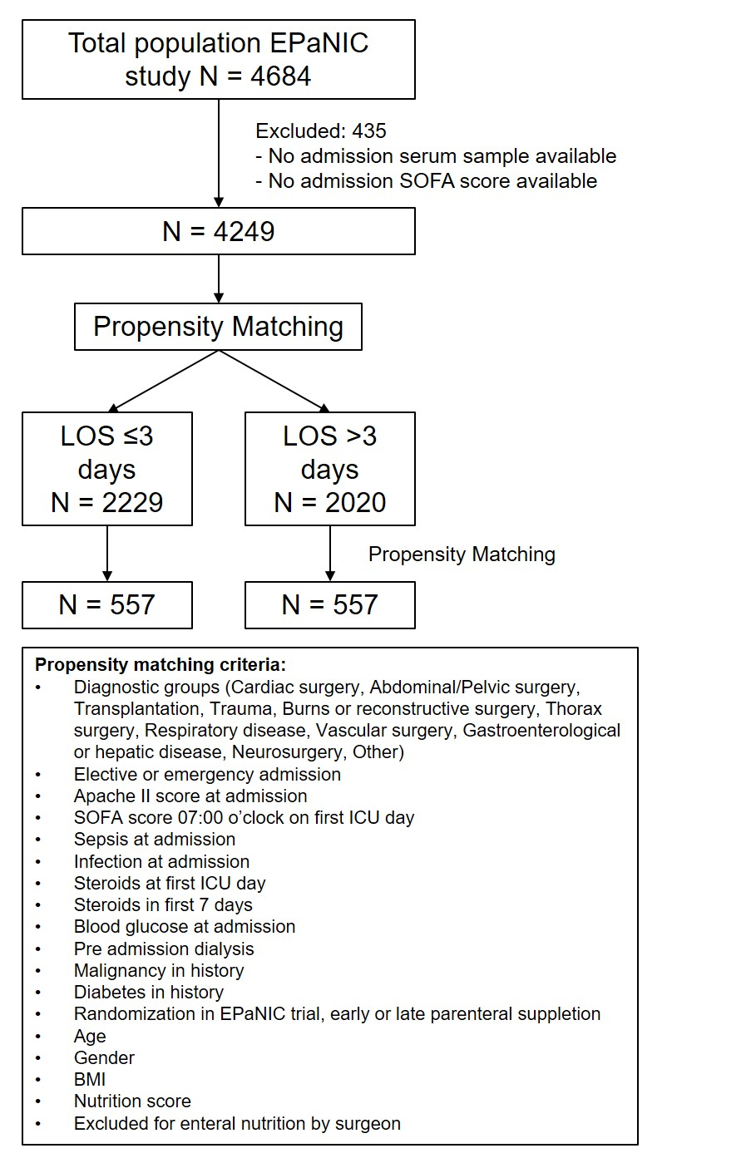

**Supplementary figure 1: Design propensity matching human study.** Used covariates in the propensity matching model are shown in the box.

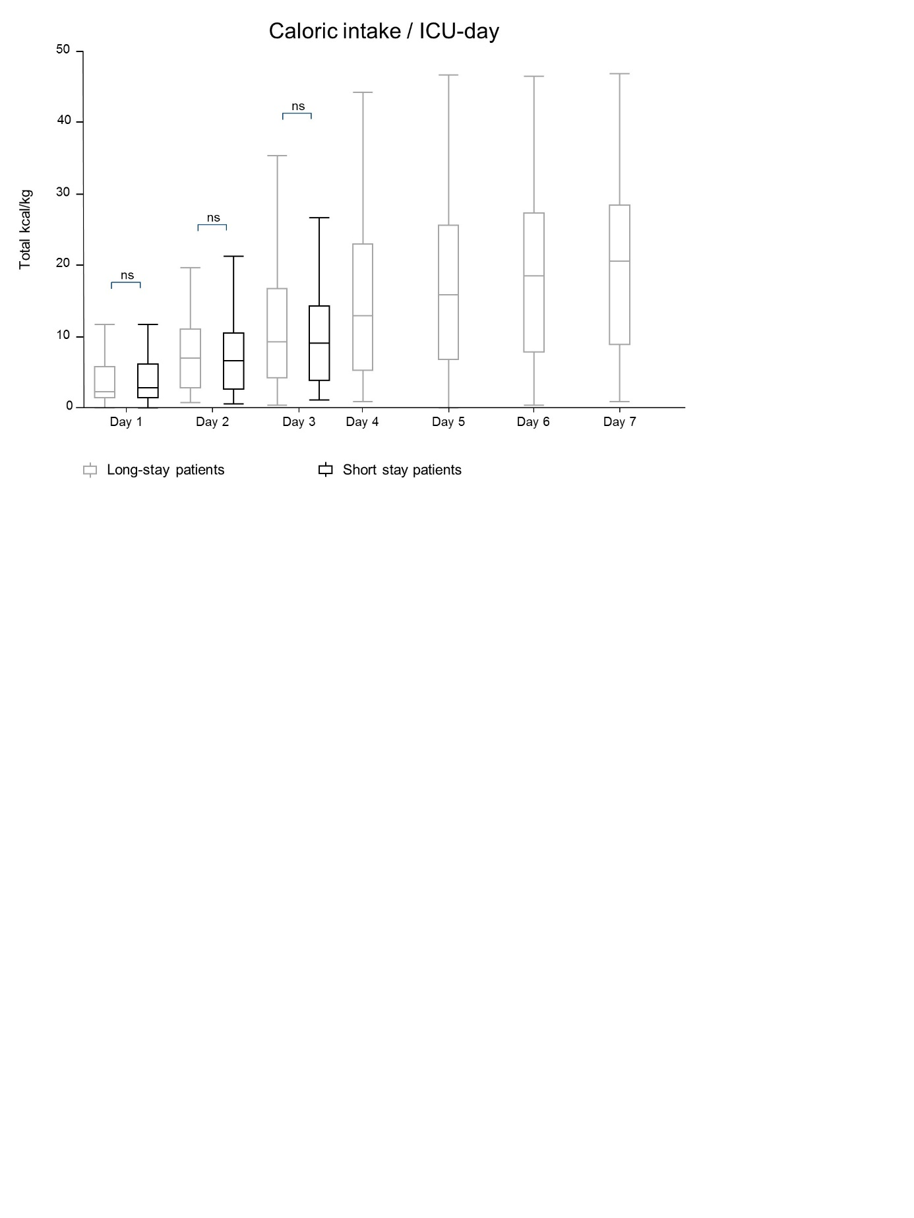

**Supplementary figure 2:** Caloric intake in the first ICU week of short- and long-stay patients of the human data set. Data are presented as median + IQR (25th – 75th interval)

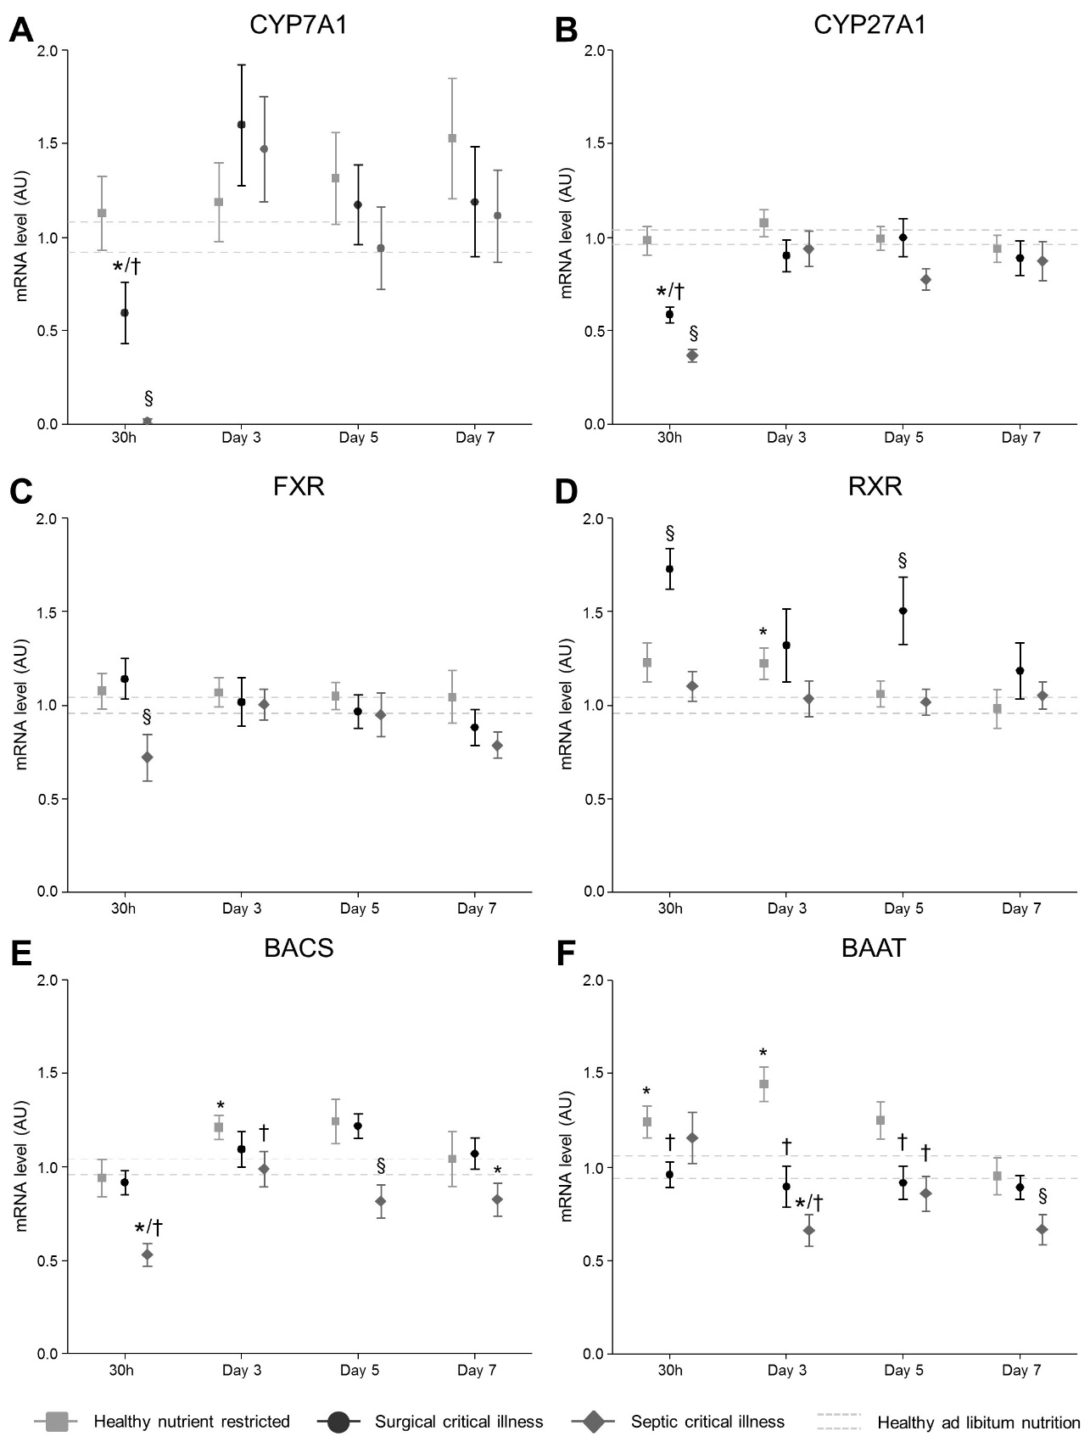 **Supplementary figure 3: gene expression of synthesis enzymes and nuclear receptors.** A, B: mRNA expression of bile acid synthesis enzyme CYP7A1 and CYP27A1. C, D: mRNA expression of the main regulating bile acid receptor FXR and its obligatory partner RXR. E, F: mRNA expression of the conjugating enzymes BACS and BAAT. Data are represented as mean ± SEM. The mean ± SEM of the healthy fed controls as average over all days are shown with the gray dashed lines. * P≤.05 compared to healthy fed controls, † P≤.05 compared to healthy nutrient-restricted animals, § P≤0.05 compared to healthy fed or nutrient-restricted animals and surgical critical illness. Number of animals/group as stated in figure 1.

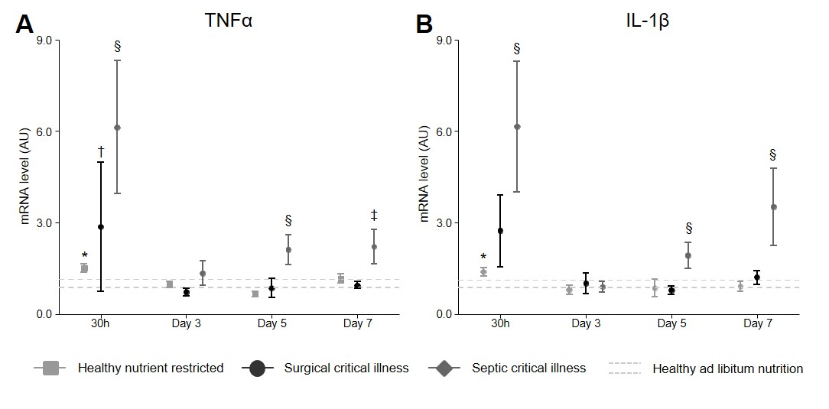 **Supplementary figure 4: Relative gene expression of hepatic TNFα and IL1β.** A, B:mRNA of cytokines TNFα and IL-1β. Data are represented as mean ± SEM. The mean ± SEM of the healthy fed controls as average over all days are shown with the gray dashed lines. * P≤.05 compared to healthy fed controls, ‡ P≤.05 compared to surgical critical illness, § P≤0.05 compared to healthy fed controls, healthy nutrient-restricted animals and surgical critical illness. Number of animals/group as stated in figure 1.

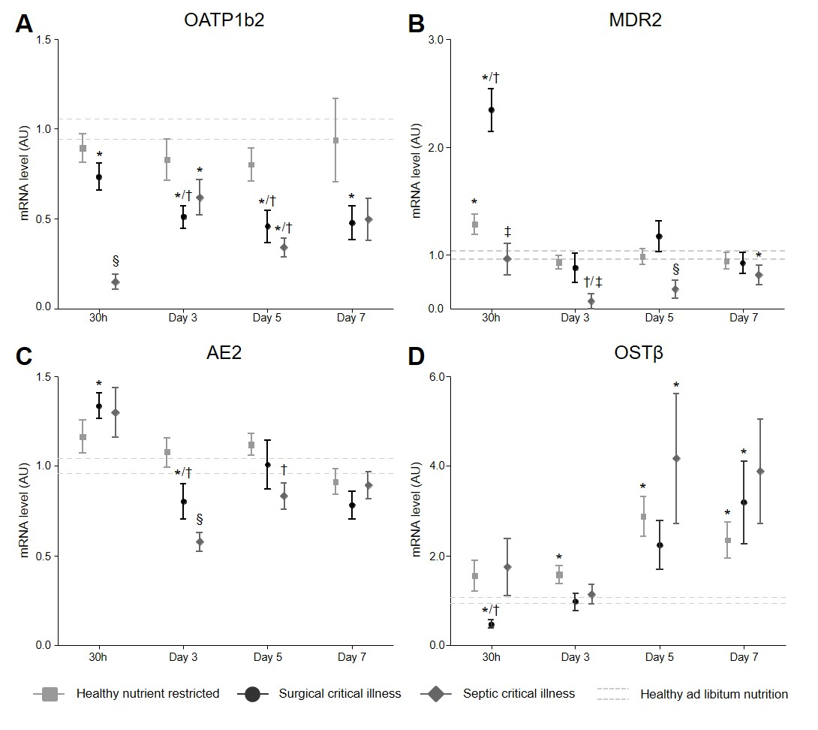 **Supplementary figure 5: gene expression of additional hepatic transporters.** A: mRNA expression of the basolateral uptake transporter OATP1b2. B: MDR2 mRNA expression. C: AE2 mRNA expression. D: mRNA expression of the beta subunit of basolateral efflux transporter OST. Data are represented as mean ± SEM. The mean ± SEM of the healthy fed controls as average over all days are shown with the gray dashed lines. * P≤.05 compared to healthy fed controls, † P ≤.05 compared to healthy nutrient-restricted animals, ‡ P≤.05 compared to surgical critical illness, § P≤0.05 compared to healthy fed controls, healthy nutrient-restricted animals and surgical critical illness. Number of animals/group as stated in figure 1.

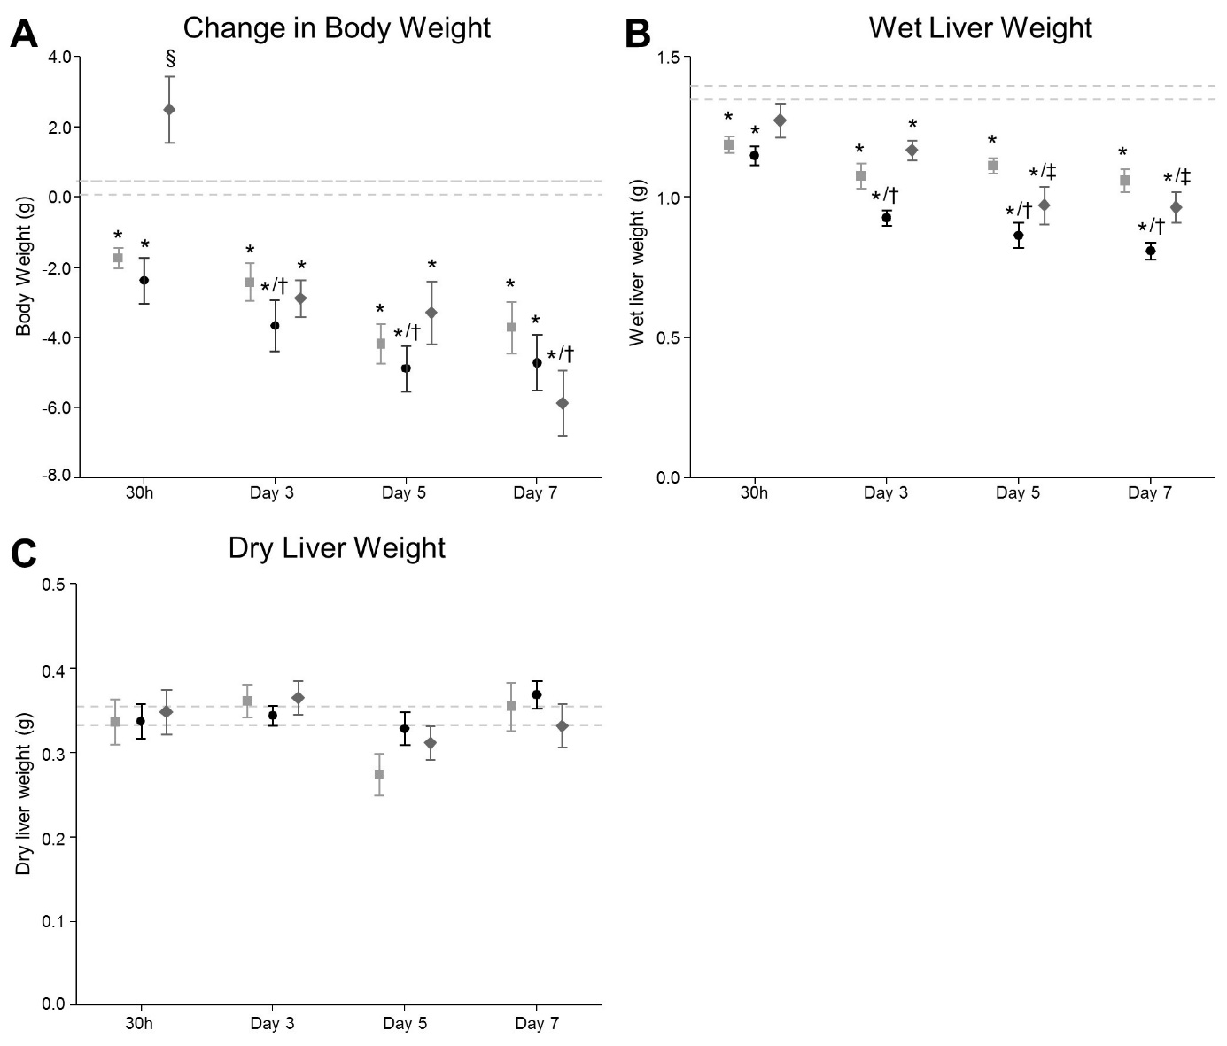

**Supplementary figure 6: Change in body weight and dry and wet liver weight of critically ill and healthy animals.** Data are represented as mean ± SEM. The mean ± SEM of the healthy fed controls as average over all days are shown with the gray dashed lines. * P≤.05 compared to healthy fed controls, † P≤.05 compared to healthy nutrient-restricted animals, ‡ P≤.05 compared to surgical critical illness, § P≤0.05 compared to healthy fed controls, healthy nutrient-restricted animals and surgical critical illness. Number of animals/group as stated in figure 1.

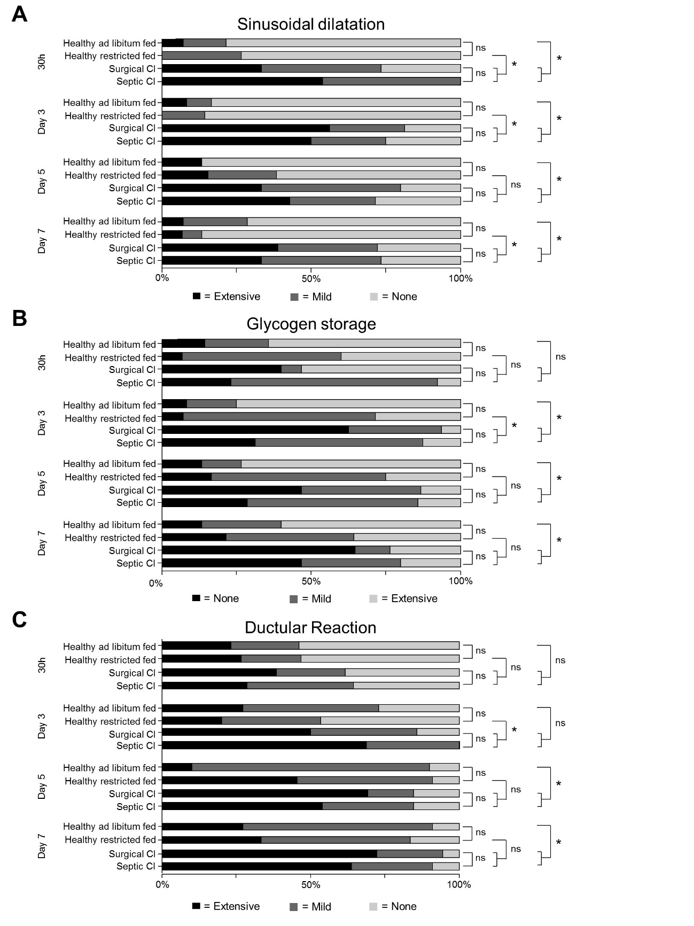

**Supplementary figure 7: Histological features of animals in critical illness.** A: Dilatation of sinusoids. B: Feathery composition of cytoplasm, indicating glycogen storage. C: Immunohistological CK7 staining, indicating ductular reaction. Data are represented as cumulative percentages of the respective group. * indicates P≤.05. Number of animals/group as stated in figure 1.

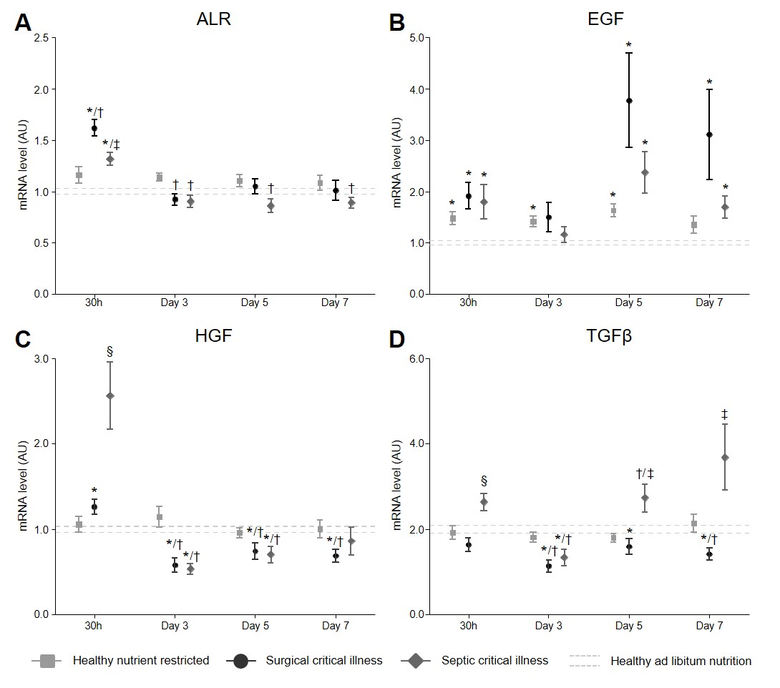

**Supplementary figure 8: gene expression of enzymes involved in liver growth and regeneration.** A: gene expression of Augmenter of Liver Regeneration (ALR). B: Gene expression of Epidermal Growth Factor (EGF). C: Gene expression of Hepatic Growth Factor (HGF). D: Gene expression of the growth inhibitor Transforming Growth Factor β (TGFβ). Data are represented as mean ± SEM. The mean ± SEM of the healthy fed controls as average over all days are shown with the gray dashed lines. * P≤.05 compared to healthy fed controls, † P≤.05 compared to healthy nutrient-restricted animals, ‡ P≤.05 compared to surgical critical illness, § P≤0.05 compared to healthy fed controls, healthy nutrient-restricted animals and surgical critical illness. Number of animals/group as stated in figure 1.

**Supplemental references**

1. Otsu N: A threshold selection method from gray-level histograms. *Automatica* 11(285-296):23-27, 1975.
2. Rasmussen CE, Nickisch H: Gaussian processes for machine learning (GPML) toolbox. *Journal of Machine Learning Research* 11(Nov):3011-3015, 2010.
3. Rasmussen C WC: Documentation for GPML Matlab Code, availible from <http://www.gaussianprocess.org/gpml/code/>.