Supplementary Data 1

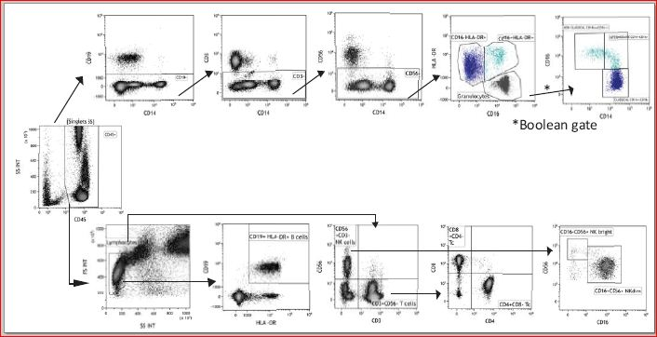

Supplemental Digital Content 1. Figure S1. Flow cytometric gating strategy for the main subpopulations of leukocytes. Monocytes were gated as reported by Abeles et al. (40) and a Boolean NOT gate was used to exclude granulocytes from the “Monocytes” gate. Monocyte subsets were identified as CD14⁺⁺CD16⁻ classical, CD14⁺CD16⁺ intermediate and CD14^{low}CD16⁺⁺ non-classical. Colored gates, on the CD16/HLA-DR plot, were used to distinguish classical (HLA-DR^{low}CD16⁻ dark blue) from intermediate and non-classical (HLA-DR⁺CD16⁺ light blue) subsets. Granulocytes were characterized as CD19⁻CD3⁻CD56⁻HLA-DR⁻CD16^{+/-}. Lymphocytes were identified based on their FS and SS features. B cells were characterized as CD19⁺HLA-DR⁺ and NK and T cells were characterized as CD3⁻CD56⁺ and CD3⁺CD56⁻, respectively.

