Supplementary Data 4

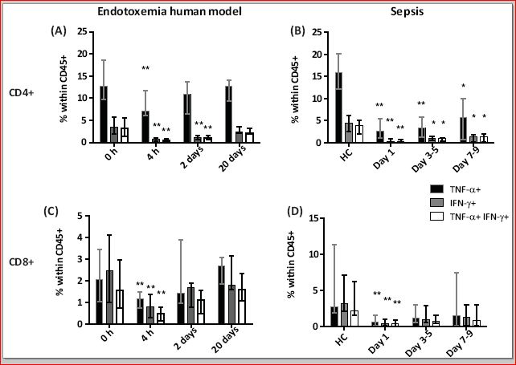

Supplemental Digital Content 4. Figure S4. Cytokine expression by CD4⁺ and CD8⁺ T cells in experimental endotoxemia and in sepsis patients calculated as the percentage of CD45⁺ cells present in the PBMC. (A - D) Percentages of TNF-α⁺, IFN-γ⁺ and TNF-α⁺/IFN-γ⁺ double positive (legend) CD4⁺ cells or CD8⁺ T cells in the experimental endotoxemia group (n=7) over time (C and E) and in HC (n=20) and sepsis patients on day 1 (n=23), days 3-5 (n=13) and days 7-9 (n=13) after onset of septic shock (D and F). Bars represent the median; error bars represent range. ***P<0.001, **P<0.01 and *P<0.05 compared to baseline or HC.

